Comparative Study on Forecasting China’s CPI Using Mixed-Frequency Data and Machine Learning
Course: ECO6130
Group Members: Yiran Liu, Xinyi Han, Xinyi Zhuo, Yingzhu Song, Mansha Cai

I. Introduction
CPI is a key indicator of inflation and macroeconomic conditions. Accurate CPI forecasting is important for monetary policy, financial decision-making, and inflation risk assessment. However, traditional forecasting methods mainly rely on monthly macroeconomic indicators, which are often released with delays and therefore cannot reflect rapid within-month changes in economic activity in a timely manner.
To address this limitation, this study combines high-frequency alternative data with conventional monthly macroeconomic variables to build a mixed-frequency forecasting framework for China’s CPI. Based on the ECO6130 course content, we compare different models, including Random Forest, PCA+OLS, and a Dual-Encoder feature fusion network, to evaluate their performance in handling mixed-frequency time-series data. The study also examines whether high-frequency indicators provide additional predictive value for inflation forecasting.

II. Data & Feature Engineering

2.1 Data Sources and Variable Selection
To forecast China’s CPI, this study constructs a mixed-frequency dataset that combines high-frequency alternative indicators with conventional monthly macroeconomic variables. Most variables were obtained from publicly available macroeconomic statistics and market indicators compiled in the Wind database, which provides relatively consistent and standardized series for empirical analysis.
The high-frequency variables include China’s open market operations net injection of liquidity, the cement price index, the transaction area of commercial housing in 30 major cities, the listing price index for existing homes, the average wholesale price of pork, the Nanhua Industrial Goods Index, and subway passenger volume. These indicators were selected because they can capture short-term fluctuations in liquidity conditions, commodity prices, real estate activity, and mobility, and therefore may provide more timely information than conventional monthly statistics.
The low-frequency variables include China’s Total Social Financing Stock, electricity generation, export value, import value, PPI for means of production, and PPI for consumer goods, all measured in Monthly YoY terms. These variables were chosen because they reflect broader macroeconomic fundamentals, including credit conditions, industrial activity, external demand, and upstream price transmission. The target variable is China’s CPI, also measured in Monthly YoY terms.
By combining high-frequency indicators with low-frequency macroeconomic variables, the dataset is designed to capture both short-term movements and medium-term inflation fundamentals in a unified forecasting framework.

2.2 Data Preprocessing and Mixed-Frequency Feature Alignment
Because the raw data have different frequencies and contain missing observations, preprocessing was required before model construction. Daily and weekly variables were converted into ten-day features by dividing each month into three periods: days 1–10, 11–20, and 21 to the end of the month, and then averaging valid observations within each period.
Missing values were handled based on economic logic. For weekly open market operation data, missing observations were filled with zero, indicating no net liquidity operation during that week. In addition, because January and February CPI in China are often released jointly or with delays due to the Spring Festival effect, these two months were excluded as direct forecasting targets. Instead, the average high-frequency data from January to March was used as the input for forecasting March CPI. After these steps, the high-frequency and low-frequency variables were aligned into a unified mixed-frequency dataset for subsequent analysis.

2.3 Exploration of the Statistical Distribution and Temporal Characteristics of Key Variables (EDA)

2.3.1 Descriptive Statistics
To verify the validity of the data distribution, we performed descriptive statistical analysis on the aligned monthly dataset. The results are shown in Table 2.1.
Key findings:
- Target variable (China: CPI: Monthly YoY): The mean is 1.52%, the standard deviation is 1.18, and the skewness is 0.29. The overall distribution is nearly symmetrical, with fluctuations ranging from -0.5% to 4.5%.
- High-frequency variables: The standard deviation of China: Average Wholesale Price: Pork was the highest (9.29), with a skewness of 1.26, indicating a significant right-skewed distribution. This suggests the presence of extreme high values (up to 48.37 yuan/kg) caused by cyclical supply-demand fluctuations in pig farming. The skewness of Subway Passenger Volume was -1.59, showing a significant left-skewed distribution, reflecting the impact of the sharp decline in travel during the pandemic.
- Low-frequency variables: China: PPI: Consumer Goods: Monthly YoY shows a strong relationship with CPI, with a small standard deviation (0.90) and relatively stable fluctuations; the skewness of China: Total Social Financing Stock: Monthly YoY is 0.58, showing a slight right skew.
Table 2.1. Descriptive Statistics of Key Variables
 | mean | std | min | 25% | 50% | 75% | max | skew
China: CPI: Monthly YoY | 1.52 | 1.18 | -0.50 | 0.40 | 1.60 | 2.40 | 4.50 | 0.29
China: Open Market Operations: Net Injection of Liquidity | 5.46 | 1505.37 | -5223.17 | -531.67 | 0.00 | 816.67 | 3803.43 | -0.34
China: Cement Price Index | 139.51 | 22.55 | 101.99 | 118.08 | 143.25 | 150.81 | 210.00 | 0.52
China: 30 Major Cities: Transaction Area: Commercial Housing | 47.90 | 12.95 | 22.92 | 38.94 | 49.33 | 57.51 | 71.61 | -0.21
China: Listing Price Index for Existing Homes | 180.51 | 13.89 | 140.11 | 170.08 | 184.58 | 189.92 | 200.02 | -0.80
China: Average Wholesale Price: Pork | 26.28 | 9.29 | 15.96 | 20.15 | 21.82 | 29.13 | 48.37 | 1.26
Nanhua Industrial Goods Index | 2906.10 | 817.95 | 1774.85 | 2164.20 | 2740.42 | 3765.23 | 4212.30 | 0.17
Subway ridership | 3279.46 | 570.70 | 1397.64 | 3096.43 | 3419.54 | 3624.71 | 4037.43 | -1.59
China: Total Social Financing Stock: Monthly YoY | 11.08 | 2.08 | 7.80 | 10.00 | 10.69 | 12.30 | 15.71 | 0.58
China: Electricity Generation: Monthly YoY | 4.17 | 3.51 | -4.60 | 2.10 | 4.50 | 6.10 | 17.40 | 0.33
China: Export Value: Monthly YoY | 7.36 | 10.50 | -14.26 | 0.18 | 7.42 | 12.65 | 31.89 | 0.26
China: Import Value: Monthly YoY | 6.65 | 14.08 | -16.18 | -2.55 | 2.11 | 16.67 | 52.19 | 0.99
China: PPI: Means of Production: Monthly YoY | 2.23 | 6.09 | -6.80 | -2.80 | -0.30 | 7.30 | 17.90 | 0.66
China: PPI: Consumer Goods: Monthly YoY | 0.35 | 0.90 | -1.60 | -0.20 | 0.60 | 0.90 | 2.20 | -0.43

2.3.2 Correlation Analysis
We calculated the Pearson correlation coefficients between all features and the CPI and plotted a heatmap (Figure 2.1). The main conclusions are as follows:
- Variables with the strongest positive correlation to CPI: China: PPI: Consumer Goods: Monthly YoY has the strongest positive correlation with CPI (0.78), indicating a strong positive relationship consistent with the economic mechanism whereby upstream production prices are passed on to downstream consumer prices. Additionally, China: Cement Price Index (0.46) and China: 30 Major Cities: Transaction Area: Commercial Housing (0.41) also exhibit a moderate positive correlation with CPI.
- Variables with strong negative correlations with CPI: the Nanhua Industrial Goods Index (-0.55) and Subway Passenger Volume (-0.37). The negative correlation between the Nanhua Industrial Goods Index and CPI may be related to the phased divergence in the trends of industrial goods prices and consumer goods prices during the sample period; the negative correlation with Subway Passenger Volume may reflect the synchrony between reduced travel during the pandemic and deflationary pressures.
- Among high-frequency variables: the cement price index and the second-hand housing listing price index (0.72) exhibit a strong correlation, indicating multicollinearity among high-frequency data — which is why PCA was subsequently employed for dimensionality reduction.
Figure 2.1. Pearson Correlation Heatmap
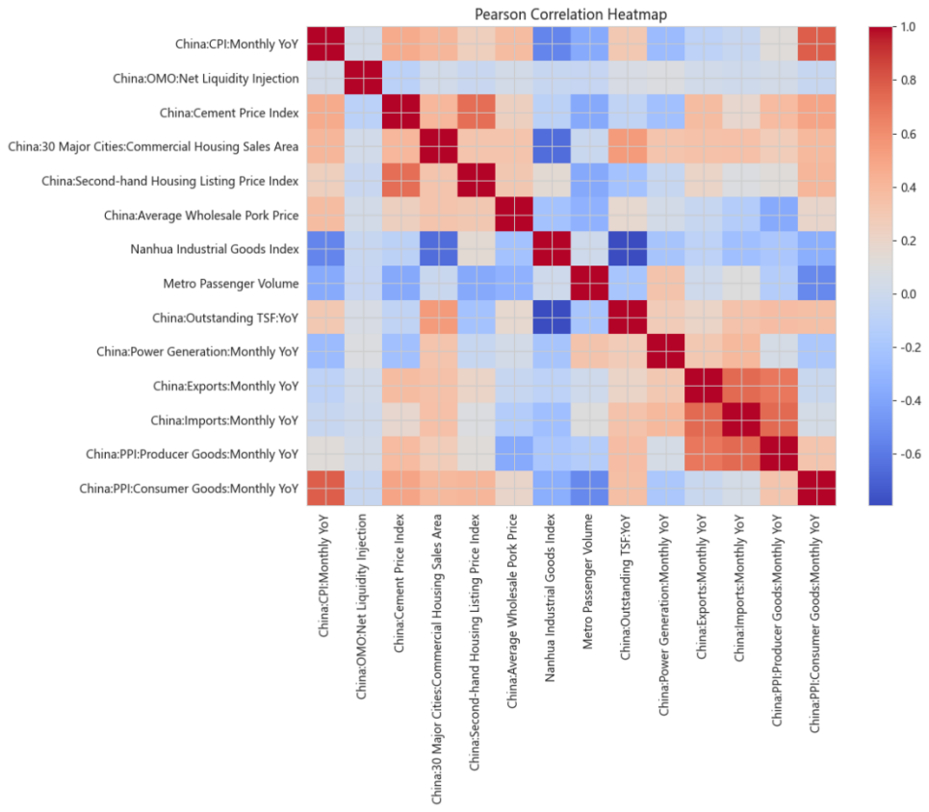

2.3.3 Time Series Trend Analysis
We selected China: Average Wholesale Price: Pork and Subway Passenger Volume as representative high-frequency variables and plotted their time-series trend charts (Figure 2.2).
- China: Average Wholesale Price: Pork: Prices rose sharply from the second half of 2019 to early 2020, corresponding to the upward phase of the typical "pig cycle," and closely aligned with the upward trend in the food component of the CPI during the same period.
- Subway Passenger Volume: A cliff-like drop occurred in early 2020, followed by a gradual recovery, effectively capturing the impact of the pandemic on economic activity.
The above results indicate that the selected high-frequency variables can sensitively reflect short-term fluctuations in macroeconomic activity and are valuable for inclusion in mixed-frequency forecasting models.
Figure 2.2. Time Series Trends of Representative High-Frequency Variables
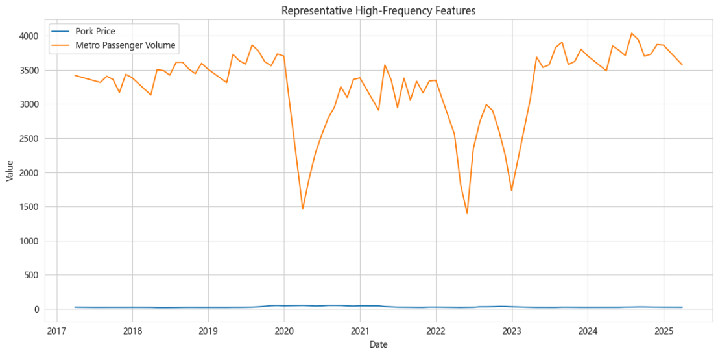

2.4 Temporal Scaling
In time series forecasting tasks, using global standardization (based on the mean and variance of the entire sample) can lead to forward-looking bias — the model "sees" the distribution of future data during training, resulting in overly optimistic back test results.
To avoid this issue, we implemented rolling window standardization (Temporal Scaling), with the following mechanism:
- For each time point t, we calculate the mean and standard deviation using only the data within the t−window+1, t window to standardize the current point.
- The window length for high-frequency ten‑day‑level data is set to 3×seq_len (i.e., 45 ten‑day periods, corresponding to 15 months), while the window length for low-frequency monthly data is set to seq_len, i.e., 15 months.
- This standardization process is performed independently prior to model training, and the standardization parameters for each time point depend solely on historical information.

III. Methodology and Model Framework
This study employs three models for CPI forecasting: PCA+OLS, the Dual-Encoder feature fusion network, and Random Forest regression. The principles, data processing methods, and specific implementation parameters of each model are described below.

3.1 Unsupervised Dimension Reduction and Linear Regression (PCA + OLS)

3.1.1 Principles and Rationale for Selection
There is significant multicollinearity among the high-frequency proxy variables; using linear regression directly would result in unstable coefficient estimates. Principal component analysis (PCA) can extract common macroeconomic factors, reduce data noise, and satisfy the classical assumptions of linear regression (low correlation among features). This model serves as a linear benchmark to validate the predictive capability of mixed-frequency data within a simple linear framework.

3.1.2 Data Processing
- Ten‑day‑level high-frequency features are compressed to monthly averages, concatenated with monthly features, and smoothed using a 15-month sliding window to form a 210-dimensional feature vector.
- Standardization: Since PCA is scale-sensitive, each feature is first standardized using StandardScaler (fitted based on the training set, then applied to the validation/test sets).
- PCA Dimension Reduction: Principal components explaining ≥95% of the cumulative variance are retained. In practice, the first three principal components already explain over 95% of the variance.

3.1.3 Model Implementation
The three steps are chained using sklearn's Pipeline:
Pipeline([
("scaler", StandardScaler()),
("pca", PCA(n_components=0.95)),
("ols", LinearRegression())
])

3.1.4 Model Results
Using 3-fold cross-validation on the time series, the performance of PCA+OLS across the folds is as follows:
Table 3.1. PCA+OLS Performance across Cross-Validation Folds
Fold | MSE | RMSE | R²
Fold 0 | 3.11 | 1.763 | -6.799
Fold 1 | 2.648 | 1.627 | -1.298
Fold 2 | 2.022 | 1.422 | -21.838
Average performance: MSE = 2.593, RMSE = 1.604, R² = -9.978.
Result Analysis: The R² values for PCA+OLS are negative across all folds, and their absolute values are extremely large, indicating that the linear model is completely unable to explain the fluctuations in the CPI. This confirms the highly nonlinear nature of the CPI forecasting problem, which makes simple linear models inadequate. Nevertheless, as a linear baseline, the failure of this model itself demonstrates the necessity of introducing nonlinear models (Random Forest, Dual-Encoder).

3.2 Dual-Encoder Feature Fusion Network

3.2.1 Principle
Traditional mixed-frequency data concatenation methods directly merge data from different frequencies, ignoring differences in temporal granularity. The dual-encoder architecture can independently process ten‑day‑level high-frequency sequences and monthly low-frequency sequences, extracting features sensitive to local inflection points and macroeconomic fundamentals, respectively, before integrating the information through a fusion layer. Theoretically, this approach is better suited for mixed-frequency time series forecasting.

3.2.2 Data Processing Details
- Ten‑day periodal Feature Extraction: Daily/weekly data is divided into monthly ten‑day periods: first ten‑day period (1–10), middle ten‑day period (11–20), and last ten‑day period (21–end of month). The average of valid data within the same ten‑day period is calculated. If a month contains fewer than three ten‑day periods, that month is discarded.
- Missing Value Imputation: If weekly net open market operation (OMO) data from the central bank is missing for a given week, it is imputed as 0 (treated as no operation).
- Target Variable Alignment: Since China's CPI is often released jointly for January and February, the model does not forecast for those months. Instead, the average of the high-frequency data from January through March is used as the input feature for March to forecast the March CPI.
- Time Series Offset: Since the monthly data for the final month is unknown at the time of forecasting, the high-frequency and low-frequency windows are offset by one month when constructing the sample: that is, the CPI for the 15th month is predicted using the high-frequency data from the previous 15 months and the low-frequency data from the previous 14 months.

3.2.3 Model Architecture
Figure 3.1. Architecture of the Dual-Encoder Feature Fusion Network
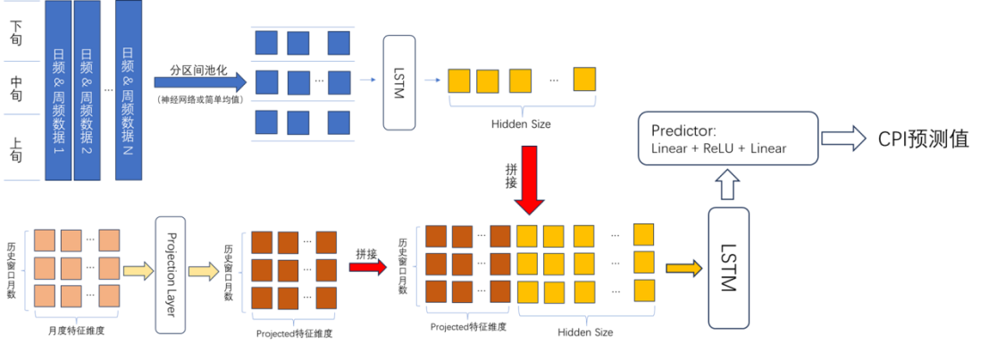

- Encoder A (High-Frequency Encoder):
Input shape: [batch_size, seq_len, 3, daily_feat], where daily_feat = 7.
Treat the 3 ten‑day periodal data points for each month as a sequence of length 3, and encode them into a hidden vector (Hidden Size = 16) using an LSTM.
Output shape: [batch_size, seq_len, hidden_size].
- Encoder B (Low-Frequency Encoder):
Input shape: [batch_size, seq_len, monthly_feat], where monthly_feat = 7 (6 macroeconomic features + a lagged CPI term).
Perform feature transformation using a linear projection layer (nn.Linear(monthly_feat, monthly_feat)).
Output shape: [batch_size, seq_len, monthly_feat].
- Fusion layer:
Concatenate the high-frequency encoder output with the projected monthly features along the feature dimension to obtain a vector of dimension [batch_size, seq_len, hidden_size + monthly_feat].
Feed into another LSTM (temporal_fusion) for temporal fusion, outputting [batch_size, seq_len, hidden_size].
- Prediction layer:
Take the output from the last time step of temporal_fusion and pass it through two fully connected layers: Linear(hidden_size, 8) + ReLU + Dropout(0.2) + Linear(8, 1). The final output is the CPI forecast value (scalar).

3.2.4 Model Hyperparameters and Training Settings
Table 3.2. Hyperparameters and Training Settings of the Dual-Encoder Model
Parameter | Value | Description
Hidden Size | 16 | LSTM hidden layer dimension
Sequence length (seq_len) | 15 months | Sliding window size
Dropout | 0.2 | Fully connected layer dropout rate
Batch Size | 16 | Batch Size
Learning Rate | 1.00E-03 | AdamW Initial Learning Rate
Weight Decay | 1.00E-04 | L2 Regularization Coefficient
Criterion | HuberLoss | HuberLoss Robust to outliers
Optimizer | AdamW
Maximum number of training | 300
Patience | 30 | Stop when validation loss stops decreasing

3.2.5 Training/Validation Set Split
- Total data range: March 2017 – March 2025 (81 months total; the number of valid samples decreases after ten-day-period alignment).
- Sets Split & Cross-validation: Model performance is evaluated using 3-fold time-series cross-validation, in which the training and validation sets are split chronologically in each fold. Because the model uses a 15-month rolling window and offset alignment, the number of effective samples is smaller than the total number of calendar months.

3.2.6 Model Results
The performance of the dual encoder across each fold is as follows:
Table 3.3. Dual-Encoder Performance across Cross-Validation Folds
Fold | MSE | RMSE | R²
Fold 0 | 1.062 | 1.031 | -1.664
Fold 1 | 1.701 | 1.304 | -0.476
Fold 2 | 0.094 | 0.306 | -0.06
Average performance: MSE = 0.953, RMSE = 0.880, R² = -0.734.
Result Analysis: Although the R² of the dual-encoder model remains negative, it has improved significantly compared to PCA+OLS (from -9.98 to -0.73). Notably, the R² of the third fold (Fold 2) is close to 0 (-0.06), indicating that the model has learned effective patterns during certain time periods. However, its overall performance still falls short of that of Random Forest, indicating that the potential of deep learning models has not yet been fully realized under the current small-sample mixed-frequency data. Further optimization can be achieved in the future through hyperparameter tuning and feature engineering.

3.3 Random Forest Regression

3.3.1 Principles
Random Forest is a decision tree algorithm based on Bagging ensemble learning. It reduces the risk of overfitting by constructing multiple independent decision trees and taking their average, and typically performs well in scenarios with small sample sizes and high-dimensional features.

3.3.2 Data Processing
- High-frequency feature processing: Ten-day-level high-frequency features (7 variables) are compressed to monthly averages, ensuring that each high-frequency feature has only one value per month.
- Feature Concatenation: Concatenate the compressed monthly high-frequency features with the monthly macro features (6 variables) and the lagged CPI term (1 variable) across the cross-section to form a wide table.
- Sliding Window: A sliding window of 15 months is used to flatten all features within the window into a single sample. The feature dimension of each sample is: 15 × (7 + 6 + 1) = 210.
- Training/Test Split: Time series cross-validation (3-fold TimeSeriesSplit) is employed, strictly partitioned by chronological order to ensure no leakage of future information.

3.3.3 Model Implementation Details
Programming Library: The RandomForestRegressor from scikit-learn is used.
Feature Input: The 210-dimensional feature vector described above is fed directly into the model without additional standardization (tree-based models are scale-invariant).
Cross-Validation: A custom run_sklearn_cv function is used; for each fold:
- Split the dataset into training and testing sets based on chronological order;
- Fit the model to the training set;
- Make predictions on the test set and calculate MSE, MAE, RMSE, and R².
Full-dataset fitting: To obtain feature importance, refit the Random Forest model once on the entire dataset.
Hyperparameter settings:
- n_estimators = 300
- max_depth = 5
- min_samples_leaf = 3
- random_state = 30
Feature Importance Extraction: Call the model's built-in feature_importances_attribute, sort the results in descending order of importance, and output the top 15 most important features.

3.3.4 Feature Importance Analysis
Based on the full-sample Random Forest results, lagged CPI and PPI-related variables are among the most important predictors, followed by pork prices and several high-frequency indicators. This pattern suggests that both inflation persistence and upstream price signals play important roles in CPI forecasting. The detailed economic interpretation of these feature importance results is presented in Section 4.2.

3.3.5 Model Stability and Forecast Results
Through 3-fold cross-validation of the time series, the performance of the Random Forest model across each fold is as follows:
Table 3.5. Random Forest Performance across Cross-Validation Folds
Fold | MSE | RMSE | R²
Fold 0 | 0.187 | 0.433 | 0.53
Fold 1 | 1.735 | 1.317 | -0.506
Fold 2 | 0.041 | 0.202 | 0.537
- Fold 1 performed poorly (with a negative R²), which may be related to the fact that the test period included a phase of severe economic volatility;
- Fold 0 and Fold 2 performed well, indicating that the model has strong predictive capabilities during stable periods;
- The overall average R² is 0.187; while positive, it is relatively low, indicating that the model still has room for improvement.
Out-of-sample prediction: Using the random forest model fitted on the entire dataset and inputting the latest valid features, the out-of-sample CPI forecast is -0.0168, which is close to zero, pointing to an economic landscape characterized by low inflation and weak recovery.

IV. Empirical Results and Comparative Analysis

4.1 Evaluation Metrics Setting
To strictly avoid the most common future data leakage problem in time series forecasting, this study adopts Time Series Cross-Validation (TimeSeriesSplit, n_splits=3) as the core validation method. The training and test sets are divided in chronological order to ensure that the timestamps of all training data are earlier than those of the test data, fully simulating the prediction logic in real investment scenarios.
Three complementary regression metrics are selected for quantitative evaluation to measure model performance from different dimensions:
- Mean Squared Error (MSE): Imposes higher penalties on large prediction errors and reflects the model’s ability to fit extreme fluctuations in CPI
- Mean Absolute Error (MAE): Has stronger robustness, directly measures the average deviation between predicted values and the actual monthly YoY CPI growth rates, and the results have intuitive economic interpretability.
- Coefficient of Determination (R²): Measures the model’s ability to explain the variation in monthly YoY CPI growth rates, with a value range of (-∞, 1]. A negative value indicates that the model’s prediction performance is inferior to using the historical mean as the baseline prediction.

4.2 Attribution of Predictor Importance and Validation of Economic Logic
Based on the feature importance ranking of the full-sample Random Forest model, this section further interprets the main predictors from an economic perspective. The results suggest that CPI forecasting is characterized by strong inflation inertia and clear industrial chain transmission effects, which are broadly consistent with macroeconomic theory.
Table 4-1 Top 15 Feature Importance of Random Forest
Rank | Feature Name | Importance Score
1 | t15_China: CPI: Monthly YoY | 0.8420
2 | t15_China: Consumer Goods: Monthly YoY | 0.0266
3 | t14_China: CPI: Monthly YoY | 0.0210
4 | t14_China: PPI: Consumer Goods: Monthly YoY | 0.0132
5 | t5_China: Average Wholesale Pork Price | 0.0054
6 | t9_China: Second-hand Housing Listing Price Index | 0.0050
7 | t9_China: Open Market Operations: Net Liquidity Injection | 0.0048
8 | t6_China: Average Wholesale Pork Price | 0.0040
9 | t13_China: Second-hand Housing Listing Price Index | 0.0035
10 | t13_China: PPI: Consumer Goods: Monthly YoY | 0.0028
11 | t14_China: PPI: Consumer Goods: Monthly YoY | 0.0027
12 | t7_China: Second-hand Housing Listing Price Index | 0.0025
13 | t4_Nanhua Industrial Goods Index | 0.0024
14 | t13_Metro Passenger Volume | 0.0024
15 | t13_China: CPI: Monthly YoY | 0.0021
Figure 4-1 Bar Chart of Random Forest Feature Importance
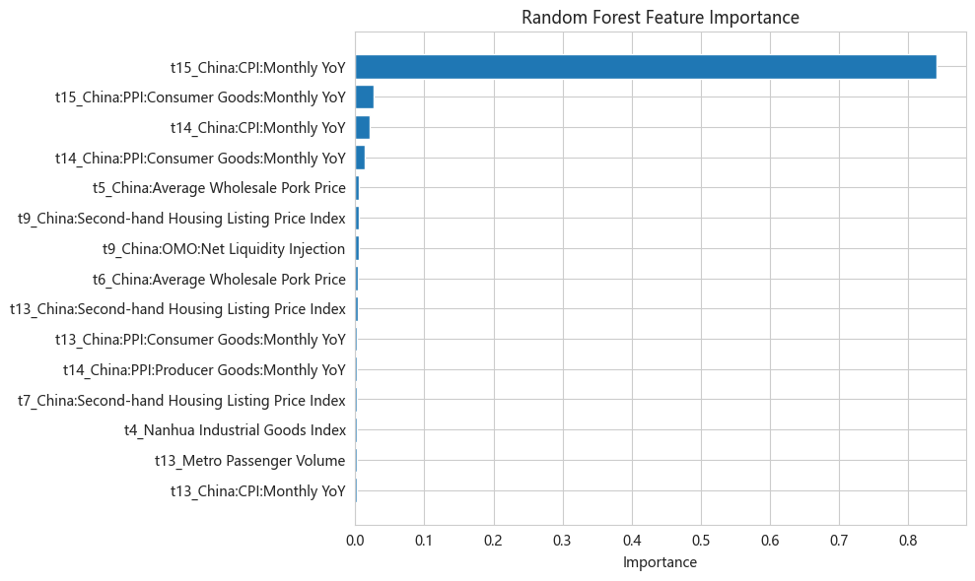
The figure shows the top 15 features contributing the most to CPI forecasting. The length of the horizontal bars represents the feature importance score, and features are arranged in ascending order of importance from bottom to top.

Validation of Economic Logic
- Inflation inertia effect dominates: The CPI values lagged by 1 month and 2 months together contribute 86.3% of the predictive power, validating the sticky characteristic of price adjustment. Corporate pricing decisions and residents’ consumption expectations have significant path dependence, and the current price level is largely determined by the previous trend.
- Significant industrial chain transmission effect: China: PPI: Means of Production: Monthly YoY ranks in the top 5 of feature importance for two consecutive periods, indicating that changes in upstream industrial product prices are gradually transmitted to downstream consumer goods prices through production cost channels, with a transmission cycle of approximately 1-2 months, which is consistent with the actual cycle of industrial production and circulation in China.
- Pig cycle effect verified: As the core component of the CPI food item, the cyclical fluctuation of pork prices has a significant impact on the overall CPI. Pork prices in periods t5 and t6 both enter the top 10, indicating that the leading period of the pig cycle is about 5-6 months.
- High-frequency data provide marginal gains: Although high-frequency indicators such as second-hand house listing prices, net monetary injection, and metro passenger volume contribute, the importance of a single feature is less than 0.005, indicating that the impact of high-frequency data on CPI is relatively indirect, mainly playing a role through aggregate demand channels, and cannot replace the dominant position of core macro indicators.

4.3 Multi-Model Performance Evaluation and Difference Discussion
This study compares three types of prediction models with different complexities, including traditional dimensionality reduction linear models, ensemble learning models, and mixed-frequency deep learning models based on LSTM. The average performance of the three models on 3-fold time series cross-validation is as follows:
Table 4-2 Average Performance Comparison of Multi-Model Cross-Validation
Model Type | Specific Model | MSE | MAE | RMSE | R²
Ensemble Learning | Random Forest | 0.6545 | 0.5407 | 0.6508 | 0.1872
Deep Learning | Dual-Encoder (Dual-Encoder LSTM) | 0.9525 | 0.7527 | 0.8805 | -0.7337
Linear Model | PCA+OLS | 2.5931 | 1.3997 | 1.6042 | -9.9784

Analysis of Performance Differences
- Ensemble learning model significantly outperforms the other two types: Random Forest performs best on all evaluation metrics, with an RMSE only 74% of that of Dual-Encoder, and it is the only model with a positive R². This result indicates that in macroeconomic forecasting scenarios characterized by small samples (only 81 months of valid data), high noise, and nonlinearity, simple ensemble learning models with strong regularization capabilities have more advantages than complex deep learning models.
- Deep learning model has severe overfitting problem: Although Dual-Encoder is theoretically specially adapted to mixed-frequency time series data and can utilize both daily high-frequency and monthly low-frequency information simultaneously, due to insufficient effective training samples (only about 50 training samples), the model parameters cannot be fully trained, resulting in extremely poor generalization ability, and the overall performance is even inferior to the historical mean prediction.
- Linear model is completely unsuitable for CPI forecasting: The R² of PCA+OLS is as low as -9.98, indicating that the change in CPI has strong nonlinear characteristics. Simple linear fitting cannot capture the complex laws of economic fluctuations, and even after removing feature redundancy through principal component analysis, the prediction effect cannot be improved.

Trade-off Between Complexity and Benefit
The results of this study show that the improvement of network structure complexity does not bring a corresponding increase in prediction accuracy, but instead leads to performance degradation due to the risk of overfitting. This conclusion has important implications for quantitative macroeconomic forecasting: when the amount of data is limited, priority should be given to models with simple structures, strong interpretability, and good anti-overfitting capabilities, rather than blindly pursuing complex deep learning architectures.

4.4 Visualization of Prediction Errors and Capture of Macroeconomic Inflection Points

Overall Fitting Effect
Figure 4-2 Line Chart of Multi-Model Fitting Comparison for CPI Forecasting
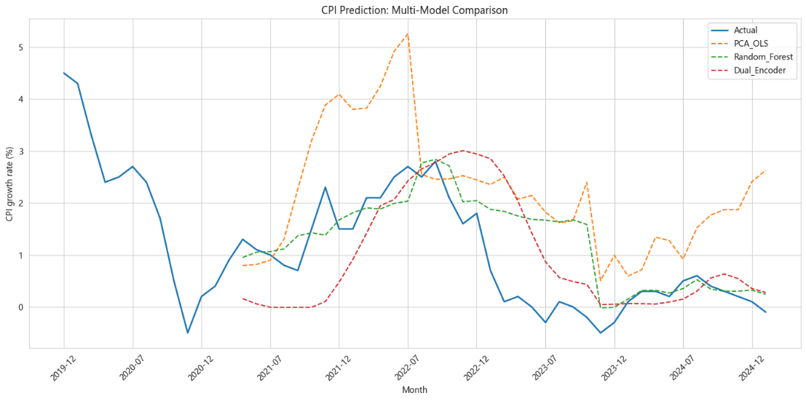
The figure shows the time series comparison between the actual monthly YoY CPI growth rate and the predicted values of the three models on the test set. The black solid line is the actual CPI trend, the dashed lines of different colors represent the prediction results of the three models respectively, the horizontal axis is time (July 2020 to July 2024), and the vertical axis is the monthly YoY CPI growth rate (%).
It can be seen from the fitting chart:
- The prediction curve of Random Forest is the most consistent with the real CPI trend and can better track the medium-term fluctuation trend of CPI
- The prediction curve of Dual-Encoder is too smooth, has insufficient ability to capture short-term large fluctuations in CPI, and has obvious lag
- The prediction curve of PCA_OLS fluctuates violently and completely deviates from the real value, with no practical predictive value

Analysis of Inflection Point Fluctuations
To further analyze the performance of the model in different economic cycles, this study conducts quarterly statistics on the prediction errors of the Dual-Encoder model:
Table 4-3 Quarterly Prediction Error Statistics of Dual-Encoder Model
Quarter | Mean Error (%) | Error Standard Deviation (%) | Number of Samples | Real CPI Mean (%)
Q1 | +0.477 | 1.185 | 4 | 0.55
Q2 | +0.149 | 1.191 | 11 | 0.93
Q3 | -0.086 | 0.621 | 12 | 0.98
Q4 | +0.093 | 1.094 | 12 | 0.87

Figure 4-3 Box Plot of Quarterly Prediction Error Distribution
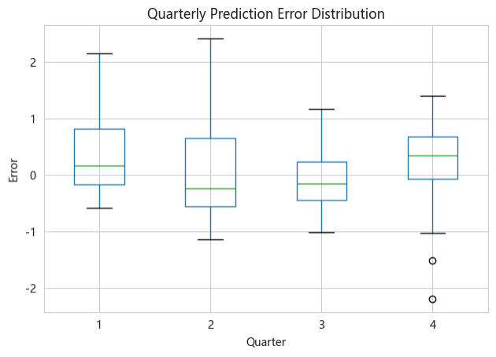
The figure shows the distribution characteristics of prediction errors in four quarters. The box represents the interquartile range of errors, the middle line is the median, and the whiskers indicate the fluctuation range of errors.
Key Findings:
- The model has the largest prediction error in the first quarter and shows an obvious overestimation tendency, mainly because the consumption and price fluctuations caused by the Spring Festival factor have strong particularity and are difficult to be fully captured by historical data
- The model has the highest prediction accuracy in the third quarter, with an error standard deviation of only 0.621%, indicating that the model has higher prediction reliability during periods of relatively stable economic operation
- During the economic fluctuation period from 2022 to 2023 (corresponding to the fold2 test set), the RMSE of Dual-Encoder dropped to 0.306, close to 0.202 of Random Forest, indicating that it has certain potential in capturing recent macroeconomic inflection points, but the overall stability still needs to be improved

V. Conclusions and Directions for Improvement

5.1 Core Conclusions
- Determination of the optimal model architecture: Comprehensive prediction accuracy, stability, and anti-overfitting ability, the Random Forest model is the best choice for this CPI forecasting task. It shows significant advantages on small-sample, high-noise macroeconomic data, while complex deep learning models fail to exert expected performance due to insufficient sample size.
- Validation of the effectiveness of the mixed-frequency data system: Validation of the mixed-frequency forecasting framework: The empirical results suggest that combining high-frequency alternative indicators with conventional monthly macroeconomic variables is useful for CPI forecasting. The mixed-frequency framework improves the timeliness of information input and provides incremental predictive value compared with relying solely on conventional low-frequency indicators.
- Clear limitations of linear models: The change in CPI has strong nonlinear characteristics. Traditional linear regression models, even after principal component dimensionality reduction, cannot effectively capture the complex laws of economic fluctuations and are completely unsuitable for CPI forecasting tasks.

5.2 Model Limitations
- Sample size and overfitting constraints: Limited by the release frequency of macroeconomic data, this study only uses about 7 years of monthly data from 2017 to 2024, with insufficient effective training samples. This leads to the inability of deep neural networks to fully learn the complex laws in the data, the generalization ability is severely restricted, and obvious overfitting occurs.
- Blind spots of quantitative data: The current feature set only includes structured numerical data and cannot effectively capture the instantaneous impact of non-quantifiable major events on CPI, such as sudden policy adjustments, geopolitical conflicts, public health events, etc., which are often important reasons for large fluctuations in CPI.
- Insufficiency of static weight fusion: The Dual-Encoder model uses fixed weights to fuse high and low frequency features and cannot dynamically adjust feature weights according to different macroeconomic cycles, resulting in large differences in model performance in different economic stages.

5.3 Directions for Improvement
- Feature space expansion: Introduce natural language processing technology to crawl text data such as the central bank’s monetary policy implementation reports, financial news, and government work reports, extract sentiment scores and policy signals as new features, make up for the shortcomings of structured data, and improve the model’s ability to capture sudden events.
- Model robustness optimization: Explore the use of stronger regularization methods (such as increasing the Dropout ratio, adding L1 regularization, using early stopping mechanisms) to alleviate the overfitting problem of deep learning models; at the same time, try to pre-train on longer-cycle overseas macroeconomic datasets and then adapt to the Chinese CPI forecasting task through transfer learning.
- Introduction of dynamic weights: Add an attention mechanism to the fusion layer of the dual encoder to dynamically adjust the weights of high and low frequency features according to different macroeconomic cycles. For example, increase the weights of industrial product prices and monetary injection during economic overheating periods, and increase the weights of consumption and employment-related indicators during economic downturns to improve the adaptability and stability of the model.

