Development and Pilot Validation of a Scalable Earth Observation-Enabled Environmental Health Intelligence Hub for Cholera Surveillance in Nigeria: National Framework and Cross River Sentinel Pilot
Warekuromor Tubolayefa¹*, Adepoju Matthew Olumide¹, Yakubu Tanimu Umar¹
¹ Department of Mission Planning and Satellite Data Management, National Space Research and Development Agency (NASRDA), Abuja, Nigeria
* Corresponding author. Head, Mission Planning, Department of Mission Planning and Satellite Data Management, NASRDA, Abuja, Nigeria.

Abstract
This study presents the development, pilot demonstration, and national scale-up design of an Earth Observation (EO)-enabled environmental health surveillance and intelligence hub for cholera in Nigeria. The platform harmonizes epidemiological records with satellite-derived environmental indicators accessed through Google Earth Engine (GEE)—including NASA Global Precipitation Measurement (GPM-IMERG) rainfall, the Normalized Difference Water Index (NDWI) from Sentinel-2, the Normalized Difference Vegetation Index (NDVI) from Landsat, and Synthetic Aperture Radar (SAR) flood extent from Sentinel-1—to characterize environmental drivers of waterborne disease across space and time and to compute an interpretable, LGA-level composite risk score within a geostatistical multi-criteria framework.
The platform development path is important for interpreting evidence tiers. Work began with a Cross River State sentinel pilot that ingested an anonymized 2021 outbreak line-list and validated dashboard ingestion, spatial joins, and risk rendering at LGA resolution. The architecture was then generalized to a nationwide 774-LGA environmental health intelligence hub. National epidemiological figures used in this paper are compiled from publicly issued NCDC situation reports and annual summaries (state-level official reporting). Sub-national LGA resolution remains a design objective and is demonstrated empirically in the Cross River pilot rather than by fabricating a national LGA panel. The study reports two clearly separated tiers of evidence. At the national tier, the hub compiled officially reported cholera figures from Nigeria Centre for Disease Control and Prevention (NCDC) situation reports, which document 111,062 suspected cases and 3,604 deaths across 33 states and the FCT in 2021—the largest recent national epidemic—followed by substantially lower burdens in 2022–2025. National epidemiological reporting is published at the state level; sub-national LGA-level and ward-level resolution is a design objective of the platform, realized empirically only where line-list data are available. At the sub-national tier, a sentinel pilot for Cross River State ingested a 2021 cholera line-list of 74 suspected cases meeting the national case definition and 4 deaths (case fatality rate 5.4%) across four Local Government Areas (Yakurr, Biase, Calabar Municipal and Bakassi). Of these 74 cases, specimens were obtained for 4, culture was performed for 3, and 1 was culture-confirmed for Vibrio cholerae; the remainder are clinically and epidemiologically defined. The pilot was used to validate dashboard ingestion, spatial joins, and the automated risk-rendering workflow rather than to establish epidemiological effect sizes, and the national figures are explicitly not disaggregated into a sub-national panel.
Observed flood exposure for the four pilot LGAs was derived by intersecting a 2.65-million-polygon dated historical flood archive (2000–2026) with GRID3 administrative boundaries, yielding 191 distinct flood events over the pilot footprint, and was extended to a paired flood-exposure/case series across all 46 verified Cross River NCDC reporting periods (2021–2024). The platform's AI Surveillance Copilot was evaluated in a controlled schema-detection benchmark of 72 live model invocations (NVIDIA NIM, nemotron-3-super-120b-a12b) over twelve schema variants of the same observed dataset. Under unconstrained prompting the assistant referenced non-existent columns in 8.3% of trials; requiring a file-inspection tool call before dashboard generation eliminated schema hallucination entirely (100.0% grounding) and raised correct binding of the LGA field from 91.7% to 100.0%. This is reported as a measured capability with an identified failure mode and mitigation, not as a validated epidemiological instrument.
Cross-correlation between satellite-detected surface-water anomalies and reported cholera activity is provided as an exploratory decision-support signal, consistent with the one-to-two-month environmental lag reported in the literature, and is not presented as a validated forecast or as evidence of causation. The results demonstrate the technical feasibility and operational value of an EO-integrated, multi-agency situational-awareness platform, and set out the data-governance and validation steps required to move from retrospective decision support toward prospective early warning.
Keywords: Earth Observation, Cholera Surveillance, Hydro-Epidemiology, Satellite Remote Sensing, Geostatistical Risk Scoring, Flood Risk Mapping, Decision Support Systems, Agentic AI, Nigeria.

1. Introduction
Public health surveillance and response is often complicated by the complex interaction between hydrometeorological variables and epidemiological outcomes. Traditional public health surveillance is mostly fragmented and lacks the spatial granularity, as well as the real-time environmental data required to holistically understand the triggers and impact for both proactive and retrospective interventions (Singh et al., 2024; Atobatele et al., 2019). In Nigeria, this challenge is magnified by precarious water insecurity, rapid urban growth, and fragile infrastructure, which collectively intensify the threat of waterborne pathogens.
Environment and climate-induced shifts, such as erratic rainfall, increased temperatures, and amplified flood and drought cycles are altering pathogen ecology and transmission, presenting new challenges to the epidemiology of waterborne diseases like cholera (Akingbola et al., 2025; Madubueze et al., 2025). Cholera (Vibrio cholerae) remains a critical public health challenge in Nigeria and across sub-Saharan Africa, exhibiting severe seasonal spikes driven by localized flooding, poor drainage systems and compromised water, sanitation, and hygiene (WASH) infrastructure. Cholera is primarily characterized by acute watery diarrhoea and extreme dehydration (Kuna and Gajewski, 2017). The effects of climate change consistently alter the epidemiology of waterborne diseases through erratic temperature and precipitation patterns, as well as the increased frequency and intensity of extreme weather events such as flooding and drought. These impacts are consistently escalating the environmental conditions that favour the growth of Vibrio cholerae, thereby amplifying public health risks and broadening transmission windows in vulnerable regions (Yu, 2025; Christaki et al., 2020). Rising temperature patterns have been shown to enable the geographic expansion of cholera-endemic conditions as well as the growth of the bacteria, enabling the pathogen to colonize new areas. Meanwhile, erratic rainfall events and their corresponding impacts, including flash and intense flooding, promote the contamination of water supplies through sewer overflow and latrine inundation, directly and indirectly driving spikes in cholera transmission.
Surveillance and monitoring systems are essential for the early detection of outbreaks within highly vulnerable areas. Early intervention through the provision of clean water and oral cholera vaccines, coupled with improved health services, results in a significant potential reduction in the impact of cholera outbreaks (Mikaberidze, 2025; Chowdhury et al., 2022; Meckawy et al., 2022).
This paper seeks to address this critical operational gap by presenting the conceptualization and pilot deployment of an innovative and bespoke Earth Observation (EO)-enabled Environmental Health Surveillance and Intelligence Hub. The platform is designed to integrate spatially referenced climate and environmental hazard data with epidemiological and infrastructure data layers to provide a unified platform for multi-agency situational awareness. To this end, it transforms the surveillance landscape, replacing irregular, reactionary monitoring with a robust geostatistical decision-support system. This system not only identifies the environmental conditions that precede outbreaks but also delivers granular vulnerability assessments disaggregated to the lowest administrative level for which reliable data exist, enabling resource allocation and response strategies to be tailored to the most at-risk communities within Nigeria, leaving no one behind.
The remainder of this paper is organized as follows. Section 2 reviews Earth Observation for disease surveillance and the environmental determinants of cholera. Section 3 sets out the methodology, system architecture, data provenance, and — in Section 3.1.1 — an explicit statement of the evidence tiers on which the paper's claims rest. Sections 4, 5 and 6 then report those tiers separately and in order: the Cross River sentinel pilot at LGA resolution, the nationally reported burden at state resolution, and a controlled benchmark of the platform's AI assisted-analytics layer. Section 7 discusses the findings and states the limitations, Section 8 sets out the roadmap, and Section 9 concludes. Readers are asked to note that the pilot and the national figures are distinct tiers of evidence and are never combined.

2. The Use of Earth Observation (EO) for Disease Surveillance

2.1 The Capabilities and Applications of Earth Observation (EO)
Earth Observation (EO) refers to the systematic gathering of environmental data about the Earth's physical, chemical, and biological systems through remote sensing technologies, including satellite, aerial, and unmanned aerial vehicle (UAV) platforms (Zhao et al., 2022; Song and Wu, 2021; Cord et al., 2017). These sensors capture a wide spectrum of biophysical variables such as land and water surface temperature, precipitation, soil moisture, vegetation health, atmospheric composition, water quality, land cover, and land use dynamics, without requiring physical contact with the surface. Data are typically stored in raster format, where each pixel represents a geolocated measurement, enabling spatially continuous monitoring across vast regions.
Over the years, EO has evolved from a specialized geospatial scientific tool into a cross-cutting enabler of decision-making across diverse sectors, contributing significantly to sustainable development. It is notably a critical component of interdisciplinary research, with applications spanning health, environmental monitoring, disease surveillance, biodiversity conservation, and habitat characterization (Peprah et al., 2026; Mobasheri, 2022; Avtar et al., 2020; Anderson et al., 2017). This interdisciplinary approach has seen significant successes in the detection, evaluation, and mapping of factors affecting public health, enabling environmental and public health administrations to work collaboratively, improve public health outcomes, disaster risk reduction and efficient resource management. Rather than operating in isolation, EO is most effectively harnessed through cross-sectoral integration, linking environmental monitoring with human health, food security, climate adaptation, and other interrelated domains. For example, vegetation indices and soil moisture data inform drought early warnings, sea surface temperature irregularities help track environmental stress on coastal ecosystems, and satellite-based flood mapping has enabled rapid humanitarian responses during flood incidents.
Critically, EO also plays a central role in monitoring Water, Sanitation, and Hygiene (WASH) infrastructure risks, especially in low-resource settings where conventional monitoring is sparse or absent. By detecting environmental precursors such as flooding, stagnant water accumulation, and temperature shifts, EO provides scalable, near real-time data streams that can inform public health interventions before outbreaks occur, as well as after (Pezanowski et al., 2024; Mobasheri, 2022; Peprah et al., 2026). Thus, EO functions as an environmental health infrastructure that offers a continuous, transboundary data pipeline connecting ecological change to human well-being. Many scientists and resource managers have already recognized the importance of adopting predictive approaches for epidemics and pandemics before their occurrences (Adegoke et al., 2024; Kamalrathne et al., 2023; Morse et al., 2012), and in parallel, the use of EO and GIS approaches has noticeably increased.

2.2 Key Environmental Indicators for Cholera Risk Mapping
Various studies have demonstrated that satellite-derived environmental indices are critical for modelling the ecological niche of Vibrio cholerae and identifying high-risk areas before outbreaks occur (Li et al., 2026; Adesina et al., 2026; Kanagaraj and Vijayan, 2024; Madubueze et al., 2025; Akingbola et al., 2025; Bhunia and Shit, 2021; Christaki et al., 2020; Ganesan et al., 2020; Campbell et al., 2020; Escobar et al., 2015). These indices serve as representative measurements for hydrological, thermal, and land surface conditions that promote pathogen persistence and transmission. The selection of indicators in this study is informed by extensive literature, with variables chosen based on their demonstrated predictive value, operational availability, and relevance to Nigeria's diverse ecological zones, from the flood-prone Niger Delta to the drought-vulnerable Sahel.
Precipitation and Hydrological Extremities. Rainfall volume and intensity are primary drivers of surface runoff, sewer overflow, and contamination of drinking water sources (Bose et al., 2026; Li et al., 2026; Adesina et al., 2026; Madubueze et al., 2025; Christaki et al., 2020). Previous studies have established that precipitation anomalies, particularly extreme rainfall events, are strongly associated with cholera outbreaks in both coastal and inland settings. Critically, the influence of precipitation on cholera incidence often operates with a lag of one to two months, as heavy rains first accumulate in the environment before contaminating water sources (Armando et al., 2024; Campbell et al., 2020; Reyburn et al., 2011). This lag effect underscores the importance of continuous, near-real-time precipitation monitoring for early warning systems.
Surface Water Extent and Flood Persistence. The presence of standing, stagnant surface water bodies is a critical environmental determinant of cholera risk. Vibrio cholerae proliferates in warm, brackish, and nutrient-rich waters, often in association with aquatic zooplankton and phytoplankton (Kuna and Gajewski, 2017). Satellite-derived indices such as the Normalized Difference Water Index (NDWI) have been widely validated for detecting open water features and monitoring flood extent (da Silva Junior et al., 2025; Bhaga et al., 2023; Albertini et al., 2022; McFeeters, 1996). The index is calculated as:
NDWI = (Green − NIR) / (Green + NIR)
Values greater than zero (NDWI > 0) indicate the presence of open water features. In the context of cholera risk mapping, NDWI serves as a proxy for surface water availability and flood persistence—conditions that facilitate human exposure to contaminated water.
Soil Moisture and Vegetation Health. Soil moisture serves as a proxy for environmental humidity and residual moisture retention, conditions that prolong the survival of pathogens (Chowdhury and Rahman, 2025; Campbell et al., 2020). The Normalized Difference Vegetation Index (NDVI), originally developed by Tucker (1979), serves as an indirect optical proxy, assessing soil moisture availability by tracking variations in vegetation health, canopy cover, and biomass density (Yaghobi et al., 2026; Gopo et al., 2026; Singh et al., 2025). The index is calculated as:
NDVI = (NIR − Red) / (NIR + Red)
Higher NDVI values reflect conditions of high humidity and moisture retention that provide optimal breeding grounds for pathogens, increasing their persistence and possible transmission.
Increased Temperature and Climate Change. Laboratory and field studies have demonstrated that Vibrio cholerae growth rates increase with temperature, with optimal conditions occurring in warm, brackish waters (Schets et al., 2025; Brumfield et al., 2025). Epidemiological studies have shown that a one-degree increase in temperature can double the risk of a cholera outbreak during rainy seasons, particularly in areas without safe water or sanitation (Gopo et al., 2026; Olagunju et al., 2025; Campbell et al., 2020).
Lag Effects and Temporal Dynamics. A critical consideration in environmental cholera modelling is the presence of lag effects between environmental anomalies and subsequent outbreaks. Campbell et al. (2020) found that chlorophyll-a concentration was most predictive when lagged by one to two months, while land surface temperature was most predictive in the current month. Similarly, Hashizume et al. (2008) found that rainfall effects on cholera incidence peaked at a lag of one to two months, reflecting the time required for environmental contamination to translate into human infection. These findings inform the design of early warning systems, which must account for temporal dynamics to provide actionable lead time.
Machine Learning and Geostatistical Approaches. Several studies have explored machine learning techniques, particularly Random Forest classifiers, for cholera risk prediction using remotely-sensed environmental variables (Singh et al., 2025; Usmani et al., 2023; Campbell et al., 2020). Campbell et al. (2020) achieved a sensitivity of 0.895 for cholera outbreak prediction in coastal India, and Usmani et al. (2023) employed near-real-time remotely sensed data to achieve 92% spatial correspondence between predicted regions and areas of reported cases. However, machine learning approaches require extensive training datasets and may face challenges related to data imbalance, overfitting, and interpretability. The present study adopts a geostatistical risk-scoring framework that complements machine learning by providing interpretable, threshold-based risk indicators that can be operationalized within existing public health workflows.

2.3 The Persistent Gap in Infectious Disease Surveillance
Despite these advances, the operational use of EO in infectious disease surveillance—particularly for climate-sensitive, waterborne pathogens like Vibrio cholerae—remains limited and fragmented, especially in high-burden, resource-limited regions (Wright et al., 2025; Singh et al., 2025; Akanda et al., 2011). While decades of research have established strong associations between environmental drivers and cholera outbreaks, this knowledge has not been systematically translated into public health practice. Singh et al. (2025) synthesized 1,137 peer-reviewed studies on remote sensing applications in infectious disease surveillance and found that predictive approaches are significantly more effective than reactive responses. However, they identified persistent challenges that limit operational use, particularly the difficulty of obtaining field-collected environmental data aligned with microbiological measurements, and inconsistencies in epidemiological reporting. These barriers are especially pronounced in settings such as Nigeria, where surveillance systems are often fragmented, data availability is low, and cross-sectoral coordination remains weak.
Yet, despite this well-documented environmental epidemiology, most public health systems in West Africa continue to rely on reactive, case-based surveillance—responding after outbreaks are detected rather than anticipating them. This reactive posture stems from a critical disconnect between the geospatial and health sectors: while EO data can detect environmental risk weeks in advance, these signals rarely reach decision-makers in time or in a usable format.

2.4 The Need for Scalable Cloud-Based Geospatial Systems
The use of traditional Geographic Information Systems (GIS) in the analysis of spatial health data is not novel. However, traditional desktop GIS continues to fall short compared to modern EO workflows due to significant limitations in computational capacity, data storage, and real-time processing ability (Geng et al., 2026; Verma and Kotwal, 2025; Lloyd et al., 2020). The volume of satellite data, often measured in petabytes, exceeds the processing capabilities of most local institutions, particularly in low-resource settings.
Cloud-based geospatial platforms offer a transformative alternative. Platforms such as Google Earth Engine (GEE), Amazon Web Services, and the Microsoft Planetary Computer provide instant access to decades of satellite imagery, pre-processed data streams, and massive computing power directly within a web browser (Khachoo et al., 2026; Yu, 2025; Gorelick et al., 2017). When combined with open-source software such as QGIS, SNAP, and web GIS servers, organizations can process, publish, and present spatial data without relying on expensive proprietary software. However, global platforms also raise concerns around data sovereignty, national security, and long-term sustainability, particularly when sensitive health and environmental data are processed or stored abroad. This study advances national data sovereignty by designing an environmental-health surveillance hub that integrates global satellite data with locally sourced observations and incident data, and that is engineered to function even if access to global data is disrupted, by leveraging domestic remote sensing capacity and ground-based monitoring.

3. Methodology and System Architecture

3.1 Study Setting and Data Architecture
This study develops a cholera surveillance system that supports early warning design, retrospective research, and health data reporting. The intended geographic scope covers all 36 states of the Federal Republic of Nigeria and the Federal Capital Territory (FCT), and, where sub-national data are available, the 774 Local Government Areas (LGAs) that constitute Administrative Level 2. The system utilizes publicly available, anonymized epidemiological data from the situation reports and weekly epidemiological reports of the Nigeria Centre for Disease Control and Prevention (NCDC), together with satellite-derived environmental data from the National Space Research and Development Agency (NASRDA) archives, NASA, and the European Space Agency (ESA). The study did not involve human subjects or personally identifiable information.
An important structural characteristic of the national epidemiological data governs the analysis presented here. NCDC cholera situation reports publish suspected cases, deaths, and case fatality ratios primarily at the state level, with LGA-level detail provided only for a subset of high-burden states in a given reporting period. Consequently, this study presents nationally reported figures at the state level as officially published, and treats full 774-LGA and ward-level resolution as a design objective of the platform that is realized empirically only where sub-national line-list data are supplied by state Ministries of Health or the National Cholera Technical Working Group.

3.1.1 Scope and Evidence Tiers
Because this paper reports both national figures and a single-state pilot, the two must not be conflated. The national figures in Section 5 are official state-level NCDC counts covering the whole federation; the pilot in Section 4 is a four-LGA technical validation in one state. No national claim in this paper rests on the pilot, and no pilot finding is generalized to the nation. Table 1 states explicitly what is empirically observed, at what resolution, and what remains a design objective. Readers are directed to this table before interpreting any figure in the paper.
Table 1: Evidence tiers — what this study observes, at what resolution, and what remains design intent.
Tier | Evidence | Spatial resolution | Geographic coverage | Status in this paper
Tier 1 — National burden | NCDC situation-report counts, 2021–2025 | State (Admin-1) | 36 states + FCT | Observed; reported as published
Tier 2 — Sentinel pilot | Cross River 2021 cholera line-list (74 suspected cases; 1 culture-confirmed) | LGA (Admin-2) | 4 LGAs in 1 state | Observed; used for technical validation only
Tier 3 — Environmental exposure | Groundsource dated flood-polygon archive intersected with GRID3 boundaries | Polygon, clipped to LGA | 4 pilot LGAs (191 events) | Computed from observed archive
Tier 4 — Copilot capability | 72 live schema-detection trials over 12 schema variants | Not spatial | n/a | Measured on software behaviour, not epidemiology
Tier 5 — Design objective | 774-LGA / ward-level panel, prospective forecasting, live NCDC–SORMAS sync | LGA / ward | National | NOT achieved; roadmap (Section 7)
A national LGA-month panel covering all 774 LGAs was deliberately not constructed. A candidate national panel available to the project was found on inspection to be internally inconsistent with official reporting — it implied 179,253 suspected cases for 2021 against the 111,062 officially reported by NCDC, and attributed Cross River case loads to LGAs that do not appear in the verified state line-list. It was therefore excluded in full, and no synthetic or simulated epidemiological values appear anywhere in this study.
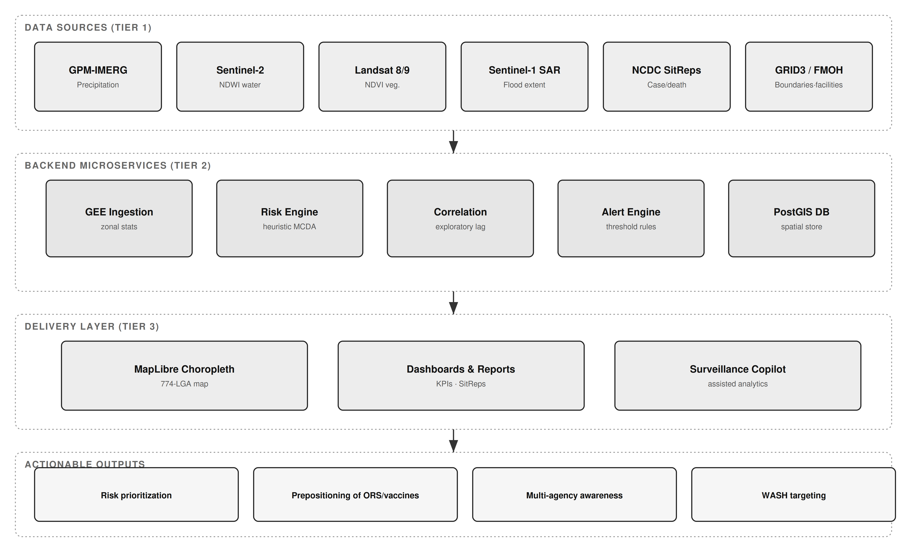
Figure 1: System architecture — three-tier Earth Observation-enabled cholera surveillance hub, showing raw data sources (Tier 1), backend microservices (Tier 2), the delivery layer (Tier 3), and actionable outputs.

3.2 Data Sources and Provenance
To build a georeferenced public health dataset, the hub ingests and harmonizes several data repositories, summarized with their provenance and evidence status in Table 2.
Table 2: Data sources, provenance, and evidence status.
Data Layer | Source | Resolution / Coverage | Evidence Status
National cholera burden | NCDC Cholera Situation Reports (Epi Week reports, 2021–2025) | State level; 30–35 states + FCT per year | Observed (official)
Cross River pilot line-list | Cross River SMoH / NCDC cholera line-list, 2021 | 4 LGAs; 74 suspected case records (1 culture-confirmed) | Observed (line-list)
Administrative boundaries | GRID3 Nigeria Admin Level 2 | 774 LGAs, 36 states + FCT | Observed
Precipitation | NASA GPM-IMERG via Google Earth Engine | 0.1°, national | Computed on demand
Surface water (NDWI) | Sentinel-2 MSI via GEE | 10–20 m | Computed on demand
Vegetation (NDVI) | Landsat-8/9 via GEE | 30 m | Computed on demand
Flood extent (SAR) | Sentinel-1 GRD via GEE; NEMA flood datasets | 10 m; national event-based | Computed / observed
Health facilities | FMOH Nigeria Health Facility Registry | 46,146 facility records (source count) | Observed (unvalidated)
Historical flood polygons | Groundsource flood archive | 2000–2026; 2,646,302 dated polygons | Observed (analysed here)
Epidemiological registries: nationally reported cholera figures were compiled from NCDC National Cholera Situation Reports. For 2021, NCDC reported 111,062 suspected cases and 3,604 deaths (CFR 3.2%) across 33 states and the FCT (NCDC, 2022). Sub-national pilot data for Cross River State were drawn from a 2021 cholera line-list containing case records with onset dates, epidemiological weeks, wards, settlements, specimen and laboratory fields, and outcomes.
For this study the national state-level series was not taken from a handful of headline snapshots but systematically reconstructed from the primary source. All 93 reports in NCDC’s disease-specific Cholera Situation Report archive were retrieved, and 84 (90.3%) were parsed successfully (the archive also contains pre-2021 reports, which fall outside the study’s 2021–2025 window); the nine exclusions are each individually documented (one broken source link, three unreadable PDFs, one discontinued 2017 table layout, and four low-activity reporting periods on which two independent extraction methods agreed). Extraction combined direct PDF text parsing with an optical-character-recognition fallback for reports whose internal text layer decoupled state names from their data. Every extracted row was subjected to an arithmetic integrity gate: the reported deaths and suspected cases were required to reconcile with the report's own stated case-fatality ratio to within 0.15 percentage points, or the row was withheld for manual review rather than admitted. This yielded 1,233 verified state-level cumulative records (36 states and the FCT), each traceable to the exact source report, with a documented confidence tier distinguishing rows read directly from those in which a value split by an extraction artifact was reassembled and re-verified against the stated ratio. Because the reports are cumulative year-to-date, a state's annual figure is taken as its highest-epidemiological-week record for that year, and records exhibiting a non-monotonic decrease within a state-year — a physical impossibility for a cumulative series, and a residual extraction artifact — are flagged and excluded from within-year trend analysis. For the 2021 national year-end total the verified primary-source figure (111,062 suspected cases; 3,604 deaths) is cited directly, as the archived weeks 48–52 for 2021 fell outside the successfully parsed set.

3.2.1 Diagnostic Status of the Pilot Line-List
Because diagnostic certainty materially affects how pilot counts should be read, the laboratory fields of the Cross River line-list were audited record by record and are reported in full in Table 3. Of 74 records meeting the case definition, a specimen was recorded as taken for 4 (5.4%), a culture result was recorded for 3 (4.1%), and 1 record (1.4%) was positive for Vibrio cholerae; one culture was negative for enteric pathogens and one was awaiting result at the time of extraction. A rapid diagnostic test result was recorded for 2 records, of which 1 was positive. The remaining 70 records carry no laboratory result and are clinically and epidemiologically defined suspected cases, consistent with standard practice during a declared outbreak when laboratory capacity is saturated.
Accordingly, this paper refers throughout to 74 suspected cases, not to confirmed or culture-referenced cases. This is not a deficiency of the pilot so much as an accurate depiction of the diagnostic environment the platform is designed to serve, and it directly motivates the laboratory-integration priority in Section 7.
Table 3: Laboratory and diagnostic status of the 74 Cross River pilot case records.
Diagnostic field | Records | Share of 74 | Interpretation
Meets national case definition | 74 | 100.0% | Basis of all pilot counts in this paper
Specimen recorded as taken | 4 | 5.4% | Specimen collection was the binding constraint
Culture result recorded | 3 | 4.1% | Of which: 1 positive, 1 negative, 1 awaiting
Culture-confirmed V. cholerae | 1 | 1.4% | Only laboratory-confirmed case in the pilot
RDT result recorded | 2 | 2.7% | 1 positive, 1 negative
No laboratory result | 70 | 94.6% | Clinically / epidemiologically defined
Record hygiene was also addressed during ingestion. The raw line-list contained 77 rows, of which 1 was flagged by the field epidemiologist as not a case and 2 carried no LGA attribution; these 3 rows were excluded. Administrative names appeared in inconsistent forms (for example 'Yakurr' and 'YAKURR'; 'CAL MUNICIPAL' with leading whitespace) and were normalized to GRID3 canonical names before the spatial join. After normalization the ingested totals reconcile exactly to 74 cases and 4 deaths across four LGAs, as reported in Table 4.
Geospatial boundaries: administrative boundary shapefiles for Nigeria's second administrative tier (LGA boundaries) were sourced from GRID3. Satellite and climatic data: remote-sensing indices were ingested programmatically via Google Earth Engine, leveraging NASA GPM-IMERG precipitation, Sentinel-2 and Landsat surface hydrology and vegetation dynamics, and Sentinel-1 SAR flood mapping; NASRDA archive data were also ingested.

3.3 Environmental Covariate Processing (Google Earth Engine)
Environmental indices were computed within GEE and aggregated to administrative boundaries. Precipitation depth (mm) was derived from GPM-IMERG (Huffman et al., 2020) as a physical driver of surface runoff and contamination overflow. NDWI was computed from Sentinel-2 Green and Near-Infrared bands, with values greater than zero isolating open water, localized pooling, and riverine flood corridors; the flood-mask implementation applies an operational NDWI threshold of 0.3, which is a configurable parameter subject to local calibration rather than a validated universal constant. NDVI was derived from red and near-infrared reflectance as a proxy for canopy moisture and soil saturation. To reflect the one-to-two-month environmental lag reported in the literature (Campbell et al., 2020; Hashizume et al., 2008), the hub aggregates environmental indices over a rolling window preceding each epidemiological reporting period. Where a satellite product is unavailable for a requested location or date, the platform returns an explicit unavailable status rather than substituting synthetic values.
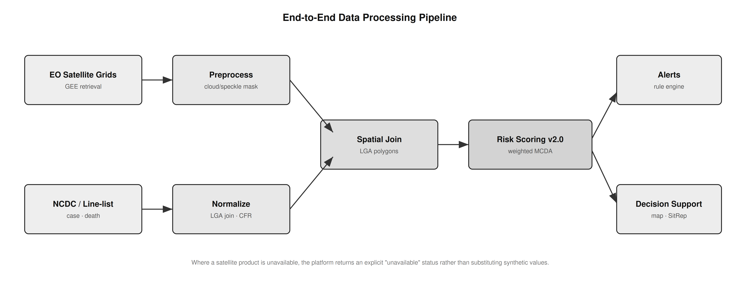
Figure 2: End-to-end data processing pipeline — from raw EO satellite grids and NCDC/line-list epidemiological records through preprocessing, spatial join, and geostatistical risk scoring to alerts and decision support.

3.4 Geostatistical Risk Scoring
The hub computes a composite cholera vulnerability score for each administrative unit using a normalized weighted multi-criteria decision analysis (MCDA) framework:
R_i = w1·P_i + w2·NDWI_i + w3·NDVI_i + w4·C_hist_i + w5·HF_i
where P_i is the precipitation anomaly, NDWI_i is flood-water persistence, NDVI_i is vegetation/soil-moisture retention, C_hist_i is recent reported case burden, and HF_i is a health-facility proximity index. In the current implementation the weights are fixed, literature-informed heuristic coefficients rather than statistically calibrated parameters; principal component analysis and outcome-based calibration are identified as validation steps in Section 6, not as implemented features. Because the score incorporates recent reported cases as an input, it is an interpretable decision-support signal for current vulnerability and is explicitly not a prospective forecast: any predictive evaluation would require a temporal hold-out design that excludes contemporaneous case counts from the predictors.

3.5 Data Quality, Completeness, and Latency
Epidemiological reporting is subject to latency, under-reporting, and variation in diagnostic capacity across states and LGAs. Where sub-national panels are constructed, LGAs with reporting gaps exceeding three consecutive months are flagged, and only units meeting a completeness threshold are retained for longitudinal analysis. Reported figures reflect suspected cases as published by NCDC and should be interpreted as conservative baselines rather than absolute biological counts. These constraints reinforce the value of automated, direct data pipelines to minimize collection latency.

3.6 Observed Flood-Exposure Covariates for the Pilot LGAs
Google Earth Engine retrieval is implemented in the platform and, for this revision, was executed against an activated Earth Engine project (project-bf60cdc9), enabling direct computation of the satellite covariates for the four pilot LGAs (reported in Section 4). To provide an independent, optically cloud-robust measure of flood exposure alongside the Earth Engine indices, environmental exposure was additionally computed from a dated historical flood-polygon archive of 2,646,302 records spanning January 2000 to February 2026. The two sources are complementary: the flood archive gives a long-run, all-weather exposure history, while the Earth Engine indices give contemporaneous surface-water, vegetation-moisture and precipitation conditions for the outbreak year.
Flood polygons were reprojected to the Africa Albers Equal-Area projection (ESRI:102022) and intersected with GRID3 Admin-2 boundaries for the four pilot LGAs. Two quantities are reported. Event count is the number of distinct dated flood polygons intersecting an LGA. Flooded-area footprint is the geometric union of all such polygons clipped to the LGA boundary; the union is used rather than the sum because flood polygons overlap in time — the same ground floods repeatedly — and summing event areas therefore double-counts and can exceed the area of the LGA itself. The union footprint is bounded above by the LGA area by construction, which provides a built-in validity check on the computation.
A pre-outbreak exposure window of 2011–2020 is additionally reported. This decade precedes the 2021 pilot year and therefore represents information that would have been available to a risk score ex ante, without leakage from the outbreak being described.

3.7 AI Surveillance Copilot: Architecture and Evaluation Design
The platform includes a conversational Surveillance Copilot intended to lower the technical barrier for state health officers who must interpret unfamiliar datasets without a data analyst. It is implemented as a streaming, provider-agnostic agent with a bounded tool surface of three functions: query_db, which executes read-only SQL SELECT statements against the surveillance tables and rejects any non-SELECT statement; analyze_file, which performs descriptive pandas operations (head, describe, corr) on an uploaded CSV or Excel file; and generate_ui_spec, which emits a declarative JSON dashboard specification of typed widgets (KPI, chart, map, table) bound to named columns of the uploaded file. The agent runs a bounded tool-use loop of at most ten turns, and the final turn is executed without tools so that a text answer is always produced. In the evaluation reported here the agent was served through NVIDIA NIM using the nemotron-3-super-120b-a12b model; the provider was confirmed live by a pre-run credential and completion probe recorded alongside the trial log.
Two properties of this design are relevant to evaluation. First, because generate_ui_spec binds widgets to column names supplied by the model, an incorrect or invented column name produces a dashboard that renders but displays nothing — a silent failure, which is the most dangerous class of failure in an operational surveillance setting. Second, the agent implementation contains an offline fallback path that emits a fixed template dashboard when no provider credential is present. All results reported in Section 6 were generated with live credentials, and every trial was programmatically asserted not to have entered the fallback path; any trial doing so would have been discarded.
Evaluation followed a schema-perturbation design. Twelve variants of the pilot dataset were constructed in which the underlying observed data are identical — the same 74 cases, 4 deaths and 4 LGAs — and only the presentation of the schema changes. This isolates schema-detection capability from data content. Variants span seven difficulty classes: canonical headers, abbreviated NCDC-style headers, dirty headers with stray whitespace and inconsistent casing, decoy schemas containing additional count-like and score-like columns that compete with the true fields, wide tables carrying irrelevant administrative columns, opaque coded headers such as adm2_name and epi_n that carry no domain tokens, and a reduced schema in which the deaths field is absent altogether.
Each variant was evaluated under two prompting conditions. In the unconstrained condition the agent is asked to detect the appropriate columns itself. In the schema-grounded condition the agent is instructed to call analyze_file first to read the true column names, to use only names appearing verbatim in that output, and to omit any widget whose required field does not exist. Each variant–condition pair was repeated three times, giving 72 live invocations. Outcomes were scored automatically against ground-truth semantic roles: schema grounding (whether every column referenced by the emitted specification exists in the file), and correct binding of the LGA, case-count and death-count fields. Infrastructure failures — provider overload (HTTP 529), rate limiting (HTTP 429), mid-stream connection loss and time-outs — were detected from the agent's error stream, retried up to four times with exponential backoff, and, where no retry succeeded, flagged and excluded from scoring so that transport errors could never be recorded as detection failures. Every trial row records the provider and model actually invoked, the raw emitted specification, the columns it referenced, latency, retry count and exclusion status.

4. Cross River Sentinel Pilot: LGA-Level Technical Validation
This section reports the sub-national tier of evidence. Everything in it derives from a single state and four LGAs, and nothing in it should be read as a national result; national figures are reported separately in Section 5.

4.1 Pilot Line-List and Ingestion
The hub's ingestion and risk-rendering capability was validated using the Cross River 2021 cholera line-list. After the record-hygiene steps described in Section 3.2.1, the ingested pilot comprised 74 suspected cases and 4 deaths (case fatality rate 5.4%) distributed across four LGAs, with onset spanning epidemiological weeks 6 to 46. One case was culture-confirmed for Vibrio cholerae. The pilot exercised dashboard ingestion, spatial joins to GRID3 LGA boundaries, and automated risk categorization; it is a technical demonstration of the workflow rather than an epidemiological effect estimate. Table 4 summarizes the ingested pilot line-list.
Table 4: Cross River 2021 sentinel pilot line-list summary (suspected cases; 1 culture-confirmed overall).
Sentinel LGA | State / Zone | Suspected Cases | Deaths | Case Fatality Rate
Yakurr | Cross River (South-South) | 53 | 0 | 0.0%
Biase | Cross River (South-South) | 10 | 1 | 10.0%
Calabar Municipal | Cross River (South-South) | 6 | 0 | 0.0%
Bakassi | Cross River (South-South) | 5 | 3 | 60.0%
Total | Cross River | 74 | 4 | 5.4%
Two cautions attach to Table 4. First, the LGA-level case fatality ratios are computed on very small denominators: the 60.0% ratio for Bakassi reflects 3 deaths among 5 recorded cases and is not a stable estimate of lethality, but rather an indication that only the most severe presentations in that LGA reached a reporting facility. Second, the pilot case fatality rate of 5.4% is not comparable with the 3.2% national ratio reported in Section 5: the former is computed on 74 line-list records from four LGAs, the latter on 111,062 suspected cases reported nationally. The two are different quantities at different tiers and are never combined in this paper.

4.2 Observed Flood Exposure in the Pilot LGAs
Intersecting the dated flood archive with the pilot LGA boundaries yielded 191 distinct flood events over the four-LGA footprint across 2000–2026. Table 5 reports event counts and union flooded-area footprints, and Figure 3 visualizes them alongside reported case burden.
Table 5: Observed flood exposure for the four pilot LGAs (Groundsource dated flood archive intersected with GRID3 boundaries).
Sentinel LGA | LGA area (km²) | Flood events 2000–2026 | Years with flooding | Union flooded area (km²) | Union as % of LGA | Pre-outbreak events 2011–2020 | Suspected cases 2021
Yakurr | 659.1 | 18 | 8 | 6.11 | 0.9% | 16 | 53
Biase | 1,292.7 | 35 | 11 | 1,277.80 | 98.8% | 22 | 10
Calabar Municipal | 137.5 | 136 | 17 | 130.71 | 95.0% | 92 | 6
Bakassi | 4.2 | 2 | 2 | 4.20 | 100.0% | 2 | 5
To move the exposure–burden comparison beyond a single 2021 snapshot, the intersection was re-run for every reporting period in which Cross River appears in the verified state-level NCDC series. That series contains 46 Cross River observations across 2021–2024 (2021: 11 reports, epi-weeks 24–47, cumulative suspected cases 31→97; 2022: 4 reports, epi-weeks 30–52, cumulative suspected cases 650→802; 2023: 10 reports, epi-weeks 9–52, cumulative suspected cases 647→718; 2024: 21 reports, epi-weeks 8–39, cumulative suspected cases 42→54); no Cross River rows exist in the parsed situation reports after 2024 epi-week 39. For each observation and each pilot LGA the archive was queried for flood events and union flooded area in the report's ISO epi-week, in trailing 4-, 8- and 12-week windows, in the calendar month, and cumulatively from 2000, giving a paired series of 184 rows (46 observations × 4 LGAs, 12 exposure metrics). The re-run reproduces Table 5 exactly on event counts and years-with-flooding and to within 0.7% on union areas.
The paired series is reported descriptively; lag-correlation statistics with confidence intervals and multiple-comparison correction are deferred to an independent analysis and are not claimed here. Three features of the series constrain any such analysis and are stated plainly. First, the archive records no flood event within the four pilot LGAs during 2021, the year of the sentinel outbreak, so the 2021 exposure context remains the historical 2011–2020 window of Table 5. Second, flood exposure during the 2021–2024 case window is sparse and concentrated: 14 in 2022, 2 in 2023, 4 in 2024 events, carried almost entirely by Biase and Calabar Municipal (Table 5b); Yakurr records a single event (2024) and Bakassi none. Third, the case series is state-level and cumulative — per-LGA counts exist only for the 2021 sentinel line-list — so any correlation pairs state-level case increments with LGA-level exposure. 3 of the 46 observations carry a non-monotonic cumulative count inherited from the source reports and are flagged in the series.
Table 5b: Flood exposure of the four pilot LGAs across the 46 verified Cross River reporting periods, 2021–2024 (paired series; state-level cumulative cases paired with LGA-level exposure).
Sentinel LGA | Flood events 2021–2024 | Reporting weeks with in-week flooding (of 46) | Reporting weeks with any flooding in trailing 12 wk | Max trailing-12-wk union area (km²) | Cumulative events to 2024 wk39
Yakurr | 1 | 0 | 0 | 0.00 | 16
Biase | 7 | 2 | 18 | 4.28 | 28
Calabar Municipal | 12 | 1 | 6 | 55.68 | 126
Bakassi | 0 | 0 | 0 | 0.00 | 2

4.2.1 Earth Engine Environmental Covariates for the Pilot LGAs
With Earth Engine activated, the satellite covariates specified in the risk model — precipitation (GPM-IMERG v07), NDWI (Sentinel-2 SR Harmonized) and NDVI (computed independently from both Sentinel-2 and Landsat-8 Collection-2 surface reflectance) — were computed directly for the four pilot LGAs over the 2021 wet season (1 June–31 October) against the same GRID3 Admin-2 geometry used for the flood archive, with a 2021 dry-season window (1 January–31 March) as an anomaly baseline. Table 6 reports the results. Wet-season precipitation follows a clear coastal-to-inland gradient, rising from 1,089 mm at inland Yakurr to 1,380 mm at coastal Bakassi, with wet-minus-dry anomalies of roughly +1,000 to +1,220 mm — a large and physically coherent rainy-season signal. The two independent NDVI products agree closely for the clear-sky inland LGAs (Yakurr 0.33 vs 0.34; Biase 0.36 vs 0.31) and diverge for the persistently cloudy coastal LGAs, where scene availability and acquisition dates differ between sensors. NDWI is reported through its maximum and its >0.3 water-area fraction rather than its areal mean, which is negative in these vegetated units.
Table 6: Earth Engine environmental covariates for the four pilot LGAs, 2021 (GPM-IMERG v07 precipitation; Sentinel-2 NDWI; NDVI from Sentinel-2 and Landsat-8). Computed live on Earth Engine project project-bf60cdc9.
Pilot LGA | Precip wet (mm) | Precip mm/day | Precip anomaly (mm) | NDWI max | Water % (>0.3) | NDVI (S2) | NDVI (Landsat) | S2 scenes
Yakurr | 1,089 | 7.16 | 996 | 0.160 | 0.00 | 0.332 | 0.343 | 3
Biase | 1,174 | 7.73 | 1,052 | 0.366 | 0.02 | 0.359 | 0.313 | 3
Calabar Municipal | 1,271 | 8.36 | 1,127 | 0.578 | 1.50 | 0.436 | 0.191 | 10
Bakassi | 1,380 | 9.08 | 1,216 | 0.239 | 0.00 | 0.540 | 0.299 | 10
Sources and method: precipitation NASA/GPM_L3/IMERG_V07 (precipitationCal, summed); NDWI=(B3-B8)/(B3+B8) and NDVI=(B8-B4)/(B8+B4) from COPERNICUS/S2_SR_HARMONIZED (20 m); Landsat NDVI=(SR_B5-SR_B4)/(SR_B5+SR_B4) from LANDSAT/LC08/C02/T1_L2 (30 m), QA_PIXEL cloud/shadow masked. Yakurr/Biase 40% scene-cloud filter; Calabar Municipal/Bakassi 80% + per-pixel SCL masking. Reductions over GRID3 Admin-2. Computed 2026-08-31.
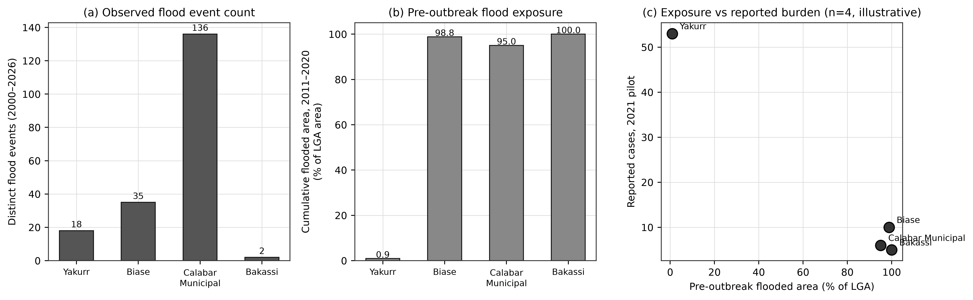
Figure 3: Observed flood exposure for the four Cross River sentinel LGAs. (a) Count of dated flood events intersecting each LGA, 2000–2026. (b) Cumulative union flooded area for the pre-outbreak decade 2011–2020, expressed as a percentage of LGA area. (c) Pre-outbreak flood exposure against reported 2021 suspected cases. Panel (c) is illustrative only: with four units it supports no inference, and the relationship shown is inverse rather than positive.
The result in Figure 3(c) is reported as observed and is deliberately not presented as supporting the hypothesis. Yakurr, the LGA with by far the largest reported case load (53 of 74), has the lowest flood exposure of the four (0.9% of its area inundated over the pre-outbreak decade), while Bakassi and Biase, which are almost entirely flood-exposed, reported 5 and 10 cases respectively. With four spatial units this is not evidence against the environmental hypothesis — it is a sample far too small to test it, and it is strongly confounded by population distribution, health-seeking behaviour, reporting intensity, and the location of the reporting facilities themselves. Calabar Municipal illustrates the confounding directly: it records 136 flood events, by far the most of the four, but this partly reflects that a dense urban LGA is more comprehensively observed than a sparsely populated one.
The methodological point stands independently of the direction of the association. The platform ingested an observed epidemiological line-list and an observed 2.65-million-polygon environmental archive, reconciled them to a common administrative geometry, and produced per-LGA exposure measures that satisfy a physical validity constraint. That is the capability being validated here; establishing an environmental association requires the calibrated, adequately powered design set out in Section 8.

4.3 Dashboard and Map Rendering
The dashboard and map render the two evidence tiers in the order the paper reports them. The upper section of the national dashboard (Figure 4) is the verified state tier of Section 5: a state choropleth of the NCDC situation-report extraction with a year selector, official-versus-dataset KPI cards, a year-by-year burden chart, and a per-state drill-down that lists every verified record with its epi-week, confidence tier, extraction method, monotonicity flag and a link to the source PDF (Figure 8b). Beneath it sits the 774-LGA environmental risk map (Figures 5 and 9), labelled on screen as a heuristic tier. Figure 6 shows the pilot case and death distribution derived directly from the ingested line-list. Consistent with the exclusion of the national LGA-month panel described in Section 3.1.1, the deployed interface displays no LGA-level case counts outside the four sentinel LGAs: the corresponding cards show an explicit evidence-tier note rather than a zero, and a 90-day time-lapse control that had animated the excluded panel was removed. The map component is built against the full 774-LGA GRID3 boundary set; unpopulated units are rendered as no-data rather than as zero risk.
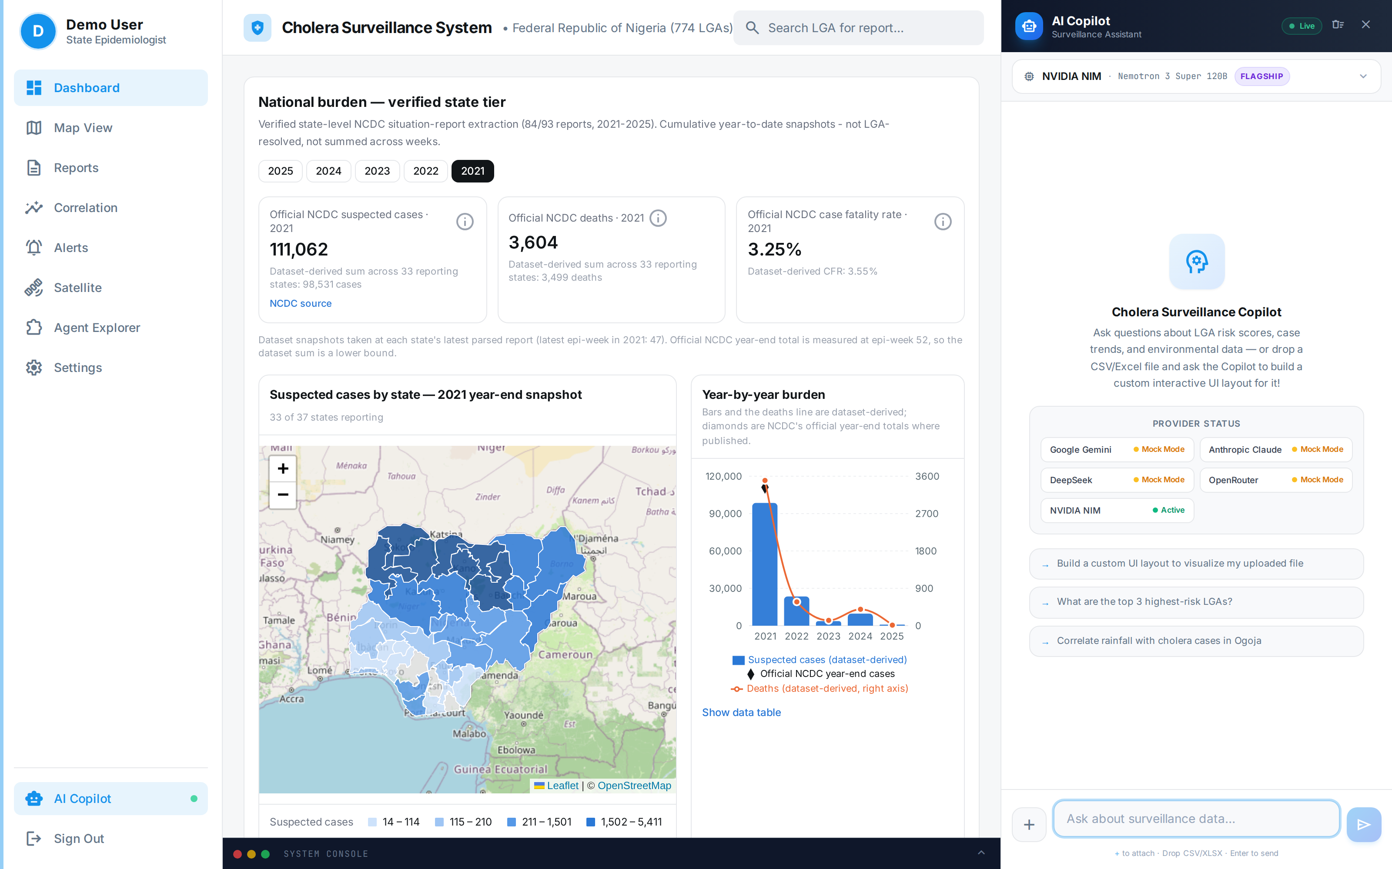
Figure 4: National dashboard as deployed. The upper section is the verified national tier — a state-level choropleth of the NCDC situation-report extraction with the official NCDC year-end figures for 2021 (111,062 suspected cases; 3,604 deaths) shown alongside, and clearly separated from, the dataset-derived lower bound (98,531 cases across 33 reporting states). The lower section is the 774-LGA environmental risk map, labelled on screen as a heuristic tier.
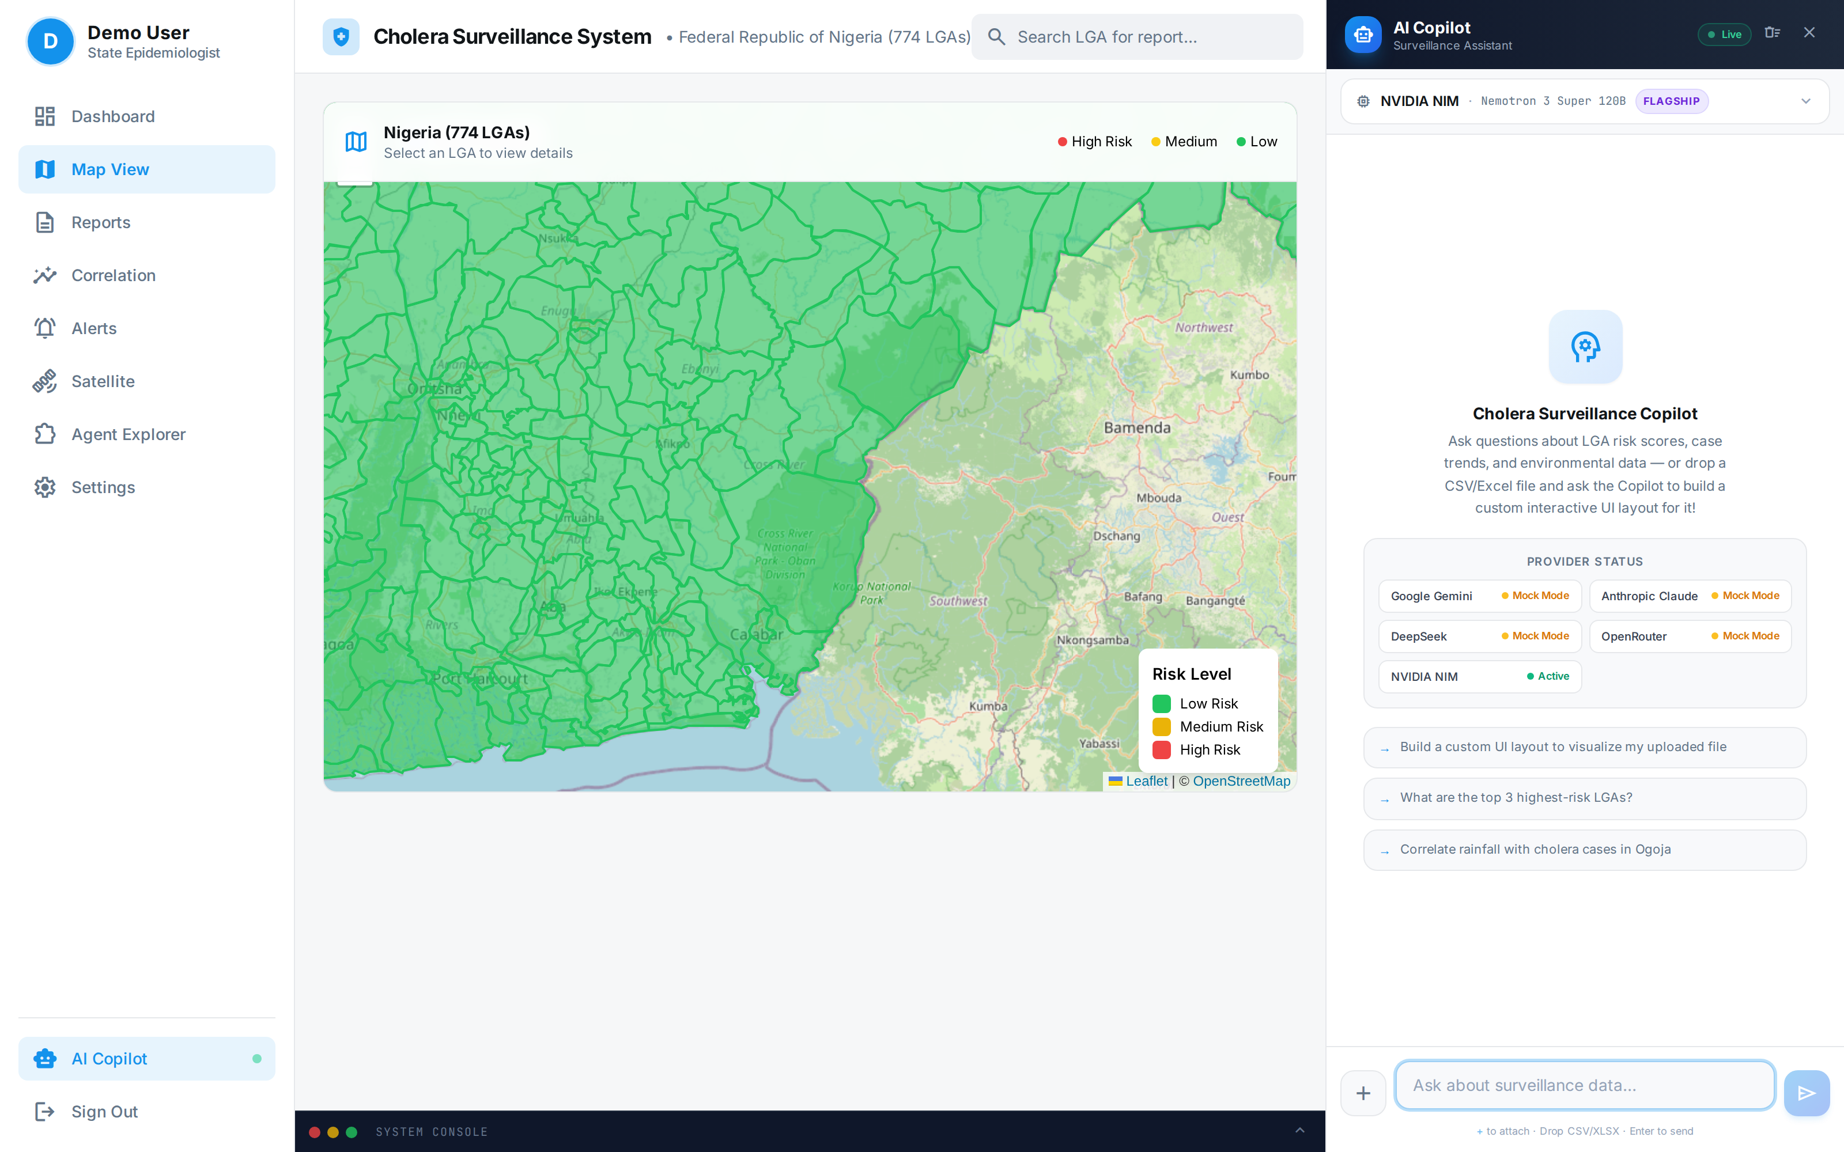
Figure 5: Full-screen national map view for LGA-level exploration of the environmental risk layer and health-facility registry across the Federal Republic of Nigeria. Following exclusion of the national LGA-month case panel (Section 3.1.1), the LGA quick-stats no longer display case counts; an explicit evidence-tier note is shown in their place.
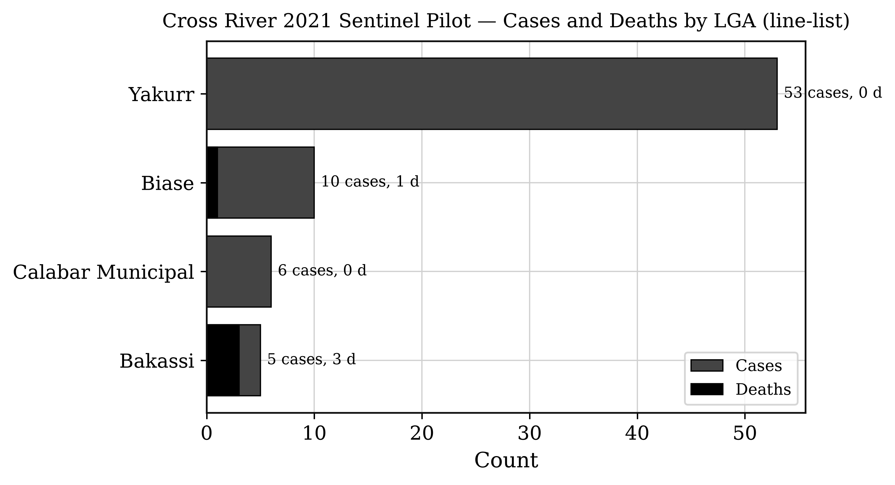
Figure 6: Cross River 2021 sentinel pilot — cases and deaths by LGA from the anonymized line-list aggregate (not a national LGA panel).
The small case volume and restricted geographic footprint of this pilot preclude inferential conclusions; the exercise establishes technical feasibility and interface usability for public health practitioners. The platform also incorporates the FMOH health-facility registry (Figure 7) to support response planning.
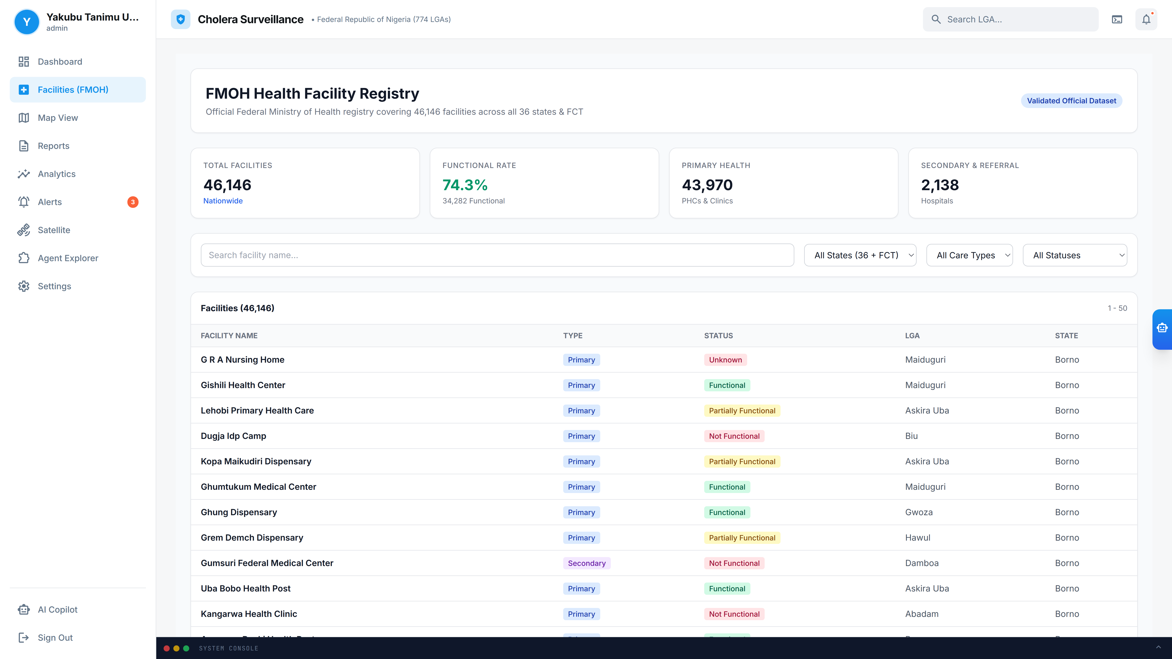
Figure 7: FMOH health-facility registry browser (inventory view with filters); counts reflect registry presence, not independently re-validated facility audits.

5. Nationally Reported Cholera Burden, 2021–2025
This section reports the national tier of evidence. All figures are official NCDC state-level counts covering the federation. They are independent of the Cross River pilot in Section 4, are not derived from it, and are not disaggregated by this study into a sub-national panel. Development began with the Cross River sentinel line-list; the architecture was then generalized nationwide, and national figures were compiled from publicly issued NCDC situation reports and annual summaries rather than by fabricating a 774-LGA national case panel.
Officially reported cholera figures were compiled from NCDC situation reports (Table 7). The national burden is dominated by the 2021 epidemic — the largest in recent years — followed by markedly lower burdens in 2022–2025, with year-to-year fluctuation driven by rainfall, flooding, displacement, and WASH conditions. The same verified state-level series drives the national tier of the deployed dashboard (Figure 8b), which exposes every record's source PDF so that any figure on screen can be traced to the situation report it was extracted from.
Table 7: Nationally reported cholera burden, Nigeria (NCDC situation reports).
Year | Suspected Cases | Deaths | CFR | States Reporting | Reporting basis | Source
2021 | 111,062 | 3,604 | 3.2% | 33 states + FCT | Full year, Epi Wk 1–52 | NCDC SitRep Epi Wk 52, 2021
2022 | ≈23,550 | ≥583 | 2.5% | 33 states, 270 LGAs | Cumulative to Epi Wk 47 | NCDC SitRep Wks 44–47, 2022
2023 | Not published as an absolute annual total | — | — | Variable | NCDC reported a reduction of approximately 85% in cases and 79% in deaths relative to 2022 | NCDC SitRep Wks 48–52, 2023
2024 | 4,809 | 156 | 3.2% | 35 states | Cumulative to 21 July 2024 | NCDC SitRep 2024
2025 | 1,307 | 34 | 2.6% | 30 states, 98 LGAs | Cumulative to 20 April 2025 | UNICEF/NCDC, 2025
Table 7 must be read as a series of officially published reporting snapshots rather than as a set of directly comparable annual totals. The 2021 figure is a completed full-year count, whereas the 2024 and 2025 figures are cumulative year-to-date counts truncated in July and April respectively (NCDC, 2024; UNICEF/NCDC, 2025) and will therefore understate their full years. For 2023, NCDC published a proportional reduction rather than an absolute annual total; that relative figure is reported here as published and no absolute value has been imputed for it. Cross-year comparison of these values without accounting for differing reporting windows would be misleading.
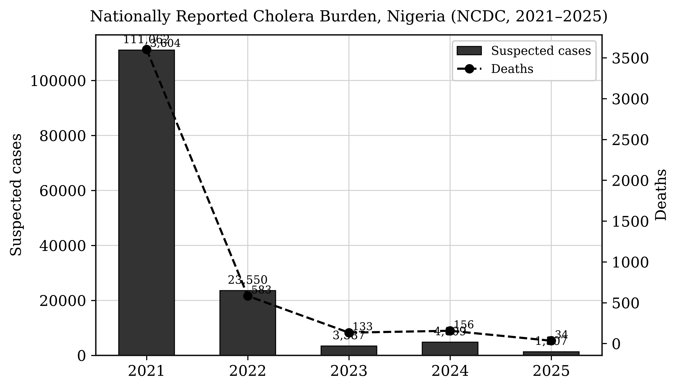
Figure 8: Nationally reported cholera burden, Nigeria (NCDC annual/SitRep compilation, 2021–2025). The 2021 epidemic (111,062 suspected cases; 3,604 deaths) is the largest recent national outbreak. Bars for 2024 and 2025 reflect part-year cumulative reporting and are not directly comparable with the completed 2021 full-year count. State-level official reporting; not disaggregated to 774 LGAs.
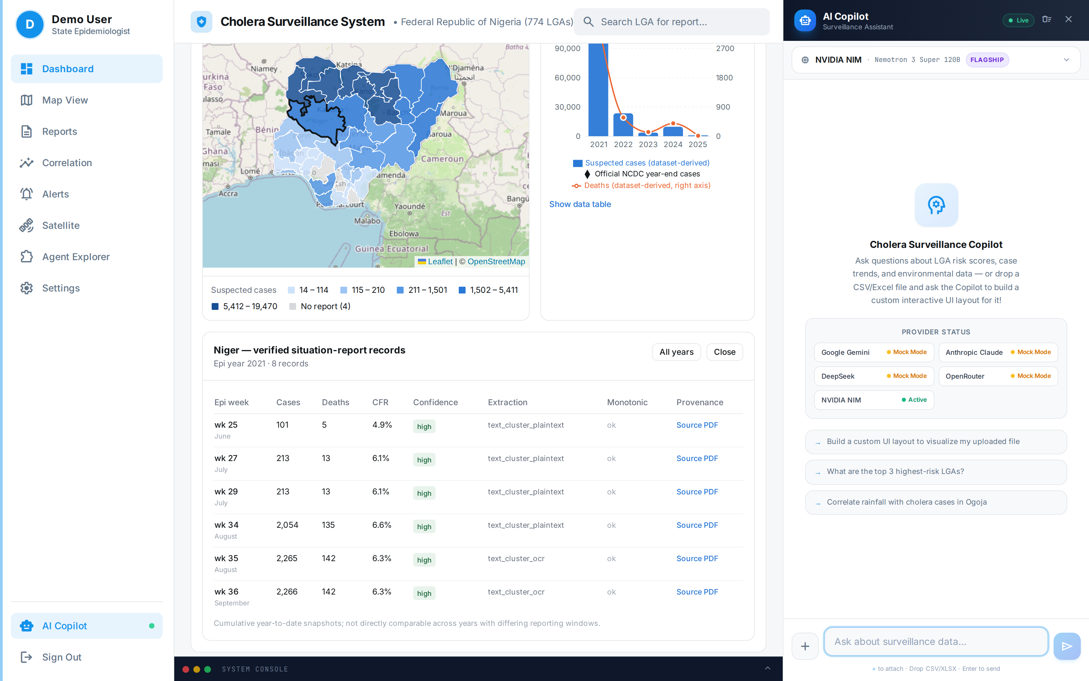
Figure 8b: Verified national tier as deployed — state choropleth of 2021 year-end snapshots (33 reporting states; four states with no parsed report shown as no-data) and the per-state drill-down, here for Niger State, listing every verified record with epi-week, cumulative cases and deaths, CFR, confidence tier, extraction method, monotonicity flag and a link to the exact NCDC situation-report PDF. The dataset-derived national sum (98,531) is displayed as a lower bound beneath the official year-end figure (111,062), never merged with it.
The 2021 outbreak coincided with above-average rainfall across the Guinea Savannah and Sahel zones, consistent with the environmental determinants reviewed in Section 2. Retrospective overlay of NDWI and flood-extent anomalies against reported cholera activity provides an exploratory decision-support signal for the association between surface-water persistence and subsequent case reporting. Consistent with the literature (Campbell et al., 2020; Hashizume et al., 2008), the environmental signal precedes reported case activity by approximately one to two months; this relationship is presented as a decision-support indicator for prioritization and is not a validated forecast or proof of causation.
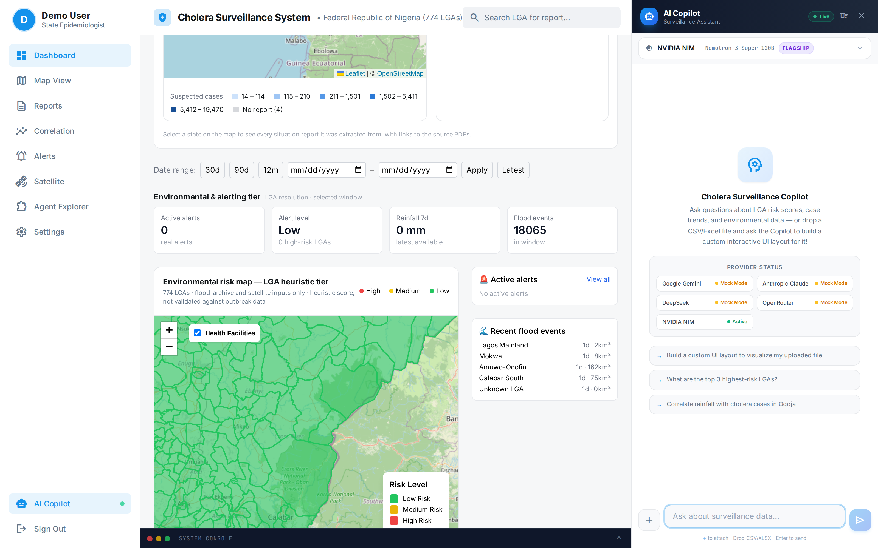
Figure 9: The heuristic LGA tier and its exploratory flood–cholera lag panel as rendered beneath the verified national tier. The on-screen label states that the risk score is derived from flood-archive and satellite inputs only and is not validated against outbreak data. Dependence and multiplicity are not corrected; no causal or predictive claim is made.

6. AI Surveillance Copilot: Capability and Measured Limits
This section reports the fourth tier of evidence: a measurement of software behaviour. It makes no epidemiological claim. Its purpose is to establish what the assisted-analytics layer can and cannot reliably do, because an unmeasured AI component in a surveillance platform is an operational liability rather than a feature.

6.1 Rule-Based Alerting and Assisted Analytics
Beyond the epidemiological demonstrations, the platform provides a configurable rule-based alert engine (Figure 10) supporting case-surge, high-risk-score and recent-flooding triggers, together with PDF and CSV report export. In the deployment reported here the case-surge trigger has no input, because the national LGA-month case panel was excluded (Section 3.1.1) and verified case data exist only at state resolution; the flood-exposure and rainfall rules remain active. The alert engine's epidemiological performance — alert sensitivity, specificity and timeliness against observed outbreaks — requires prospective evaluation and is not claimed here.
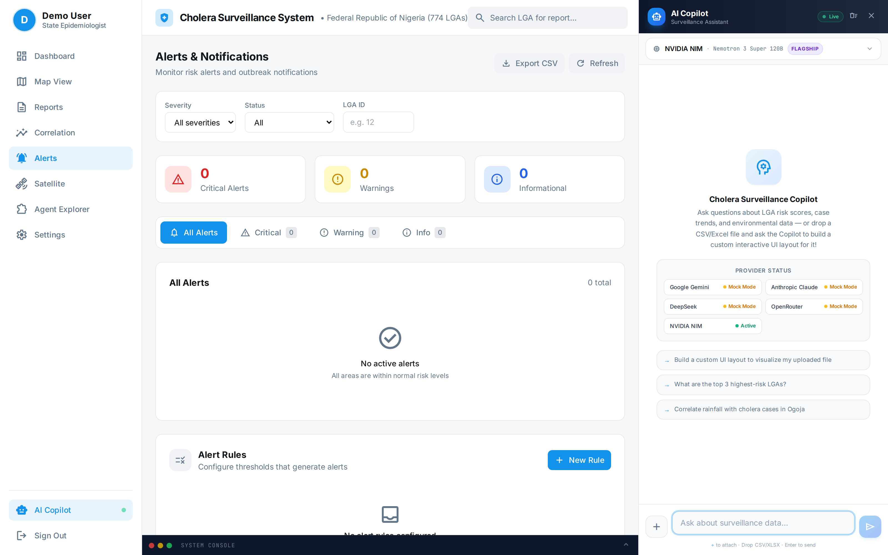
Figure 10: Alerts & Notifications page. With the LGA-month case panel excluded, the rule engine's case-surge triggers have no input and the page correctly reports no active alerts; flood-exposure and rainfall-threshold rules remain armed. The engine's epidemiological performance requires prospective evaluation and is not claimed here.
Figure 11 shows the AI Surveillance Copilot sidebar open on the national dashboard during a live query. Figure 12 shows the dedicated Agent Explorer page used for copilot-assisted interactive dashboards. Because the verified state series is cumulative by epi-week, a naive SQL aggregation over it inflates yearly totals several-fold; the deployed agent is therefore given an explicit data-semantics preamble and a database view (state_cholera_year_end) that exposes one year-end snapshot per state-year, and is instructed to label the evidence tier of every number it reports. The Cross River 2021 pilot aggregate is used in Figure 12 as a grounded demonstration dataset; the national architecture remains 774 LGAs.
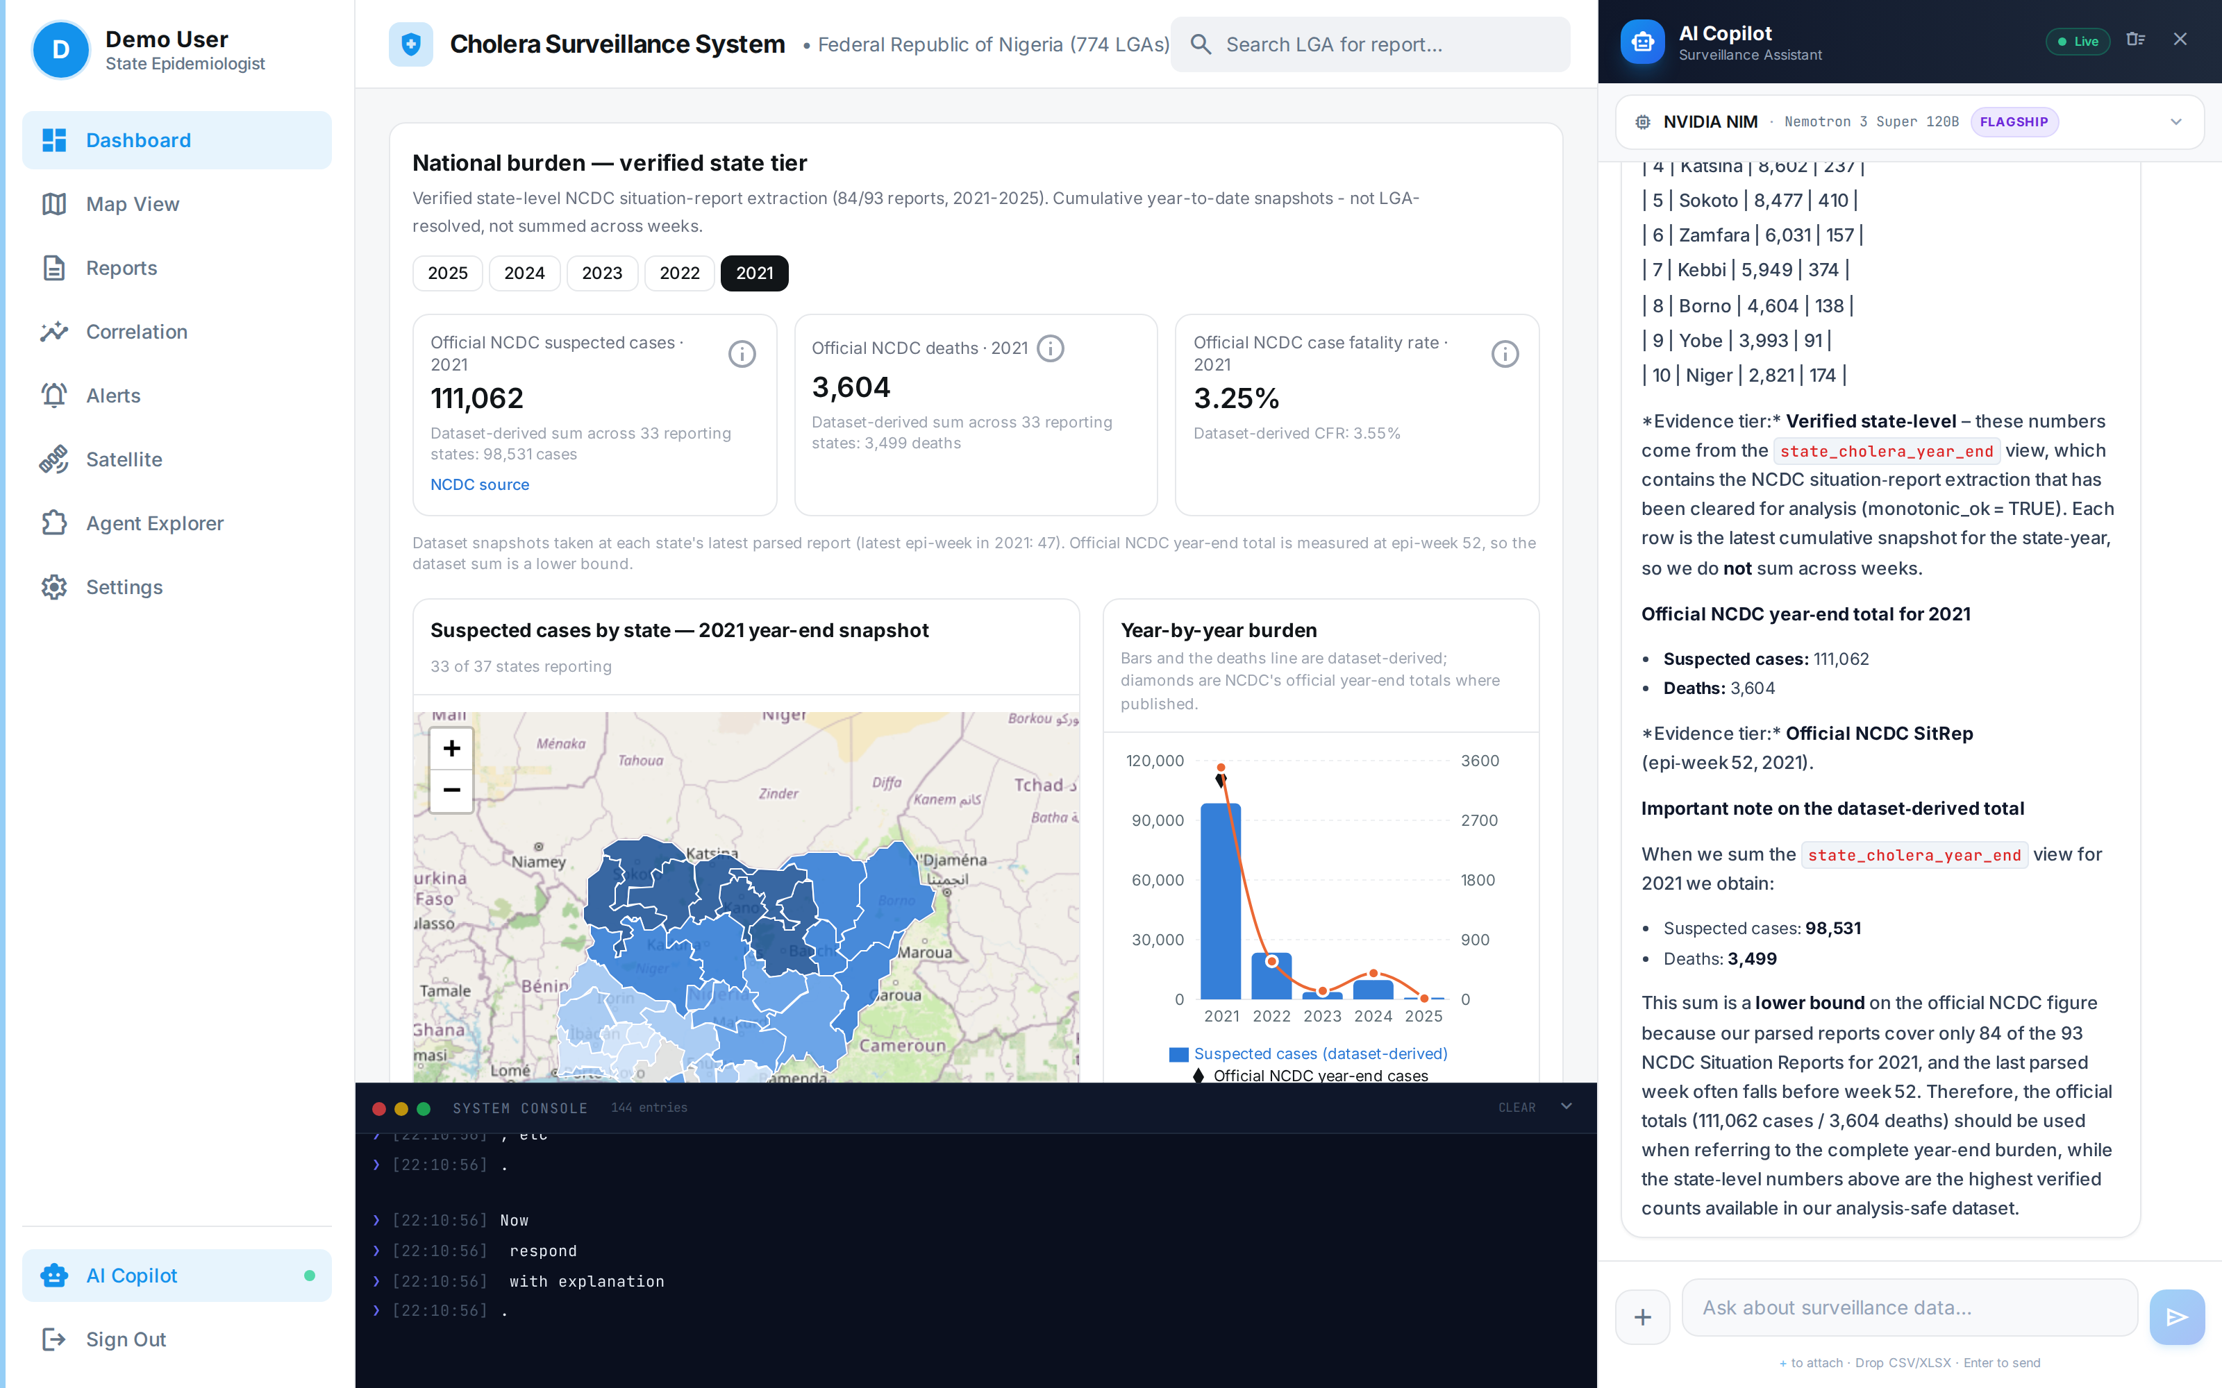
Figure 11: AI Surveillance Copilot (sidebar) answering a live query on the national dashboard, served through NVIDIA NIM (nemotron-3-super-120b-a12b), the same model used in the Section 6.2 benchmark. The assistant reports the top verified 2021 state burdens from the year-end view, quotes the official NCDC total separately, and labels the evidence tier of each figure. The provider status panel shows the single live provider; all others are in mock mode.
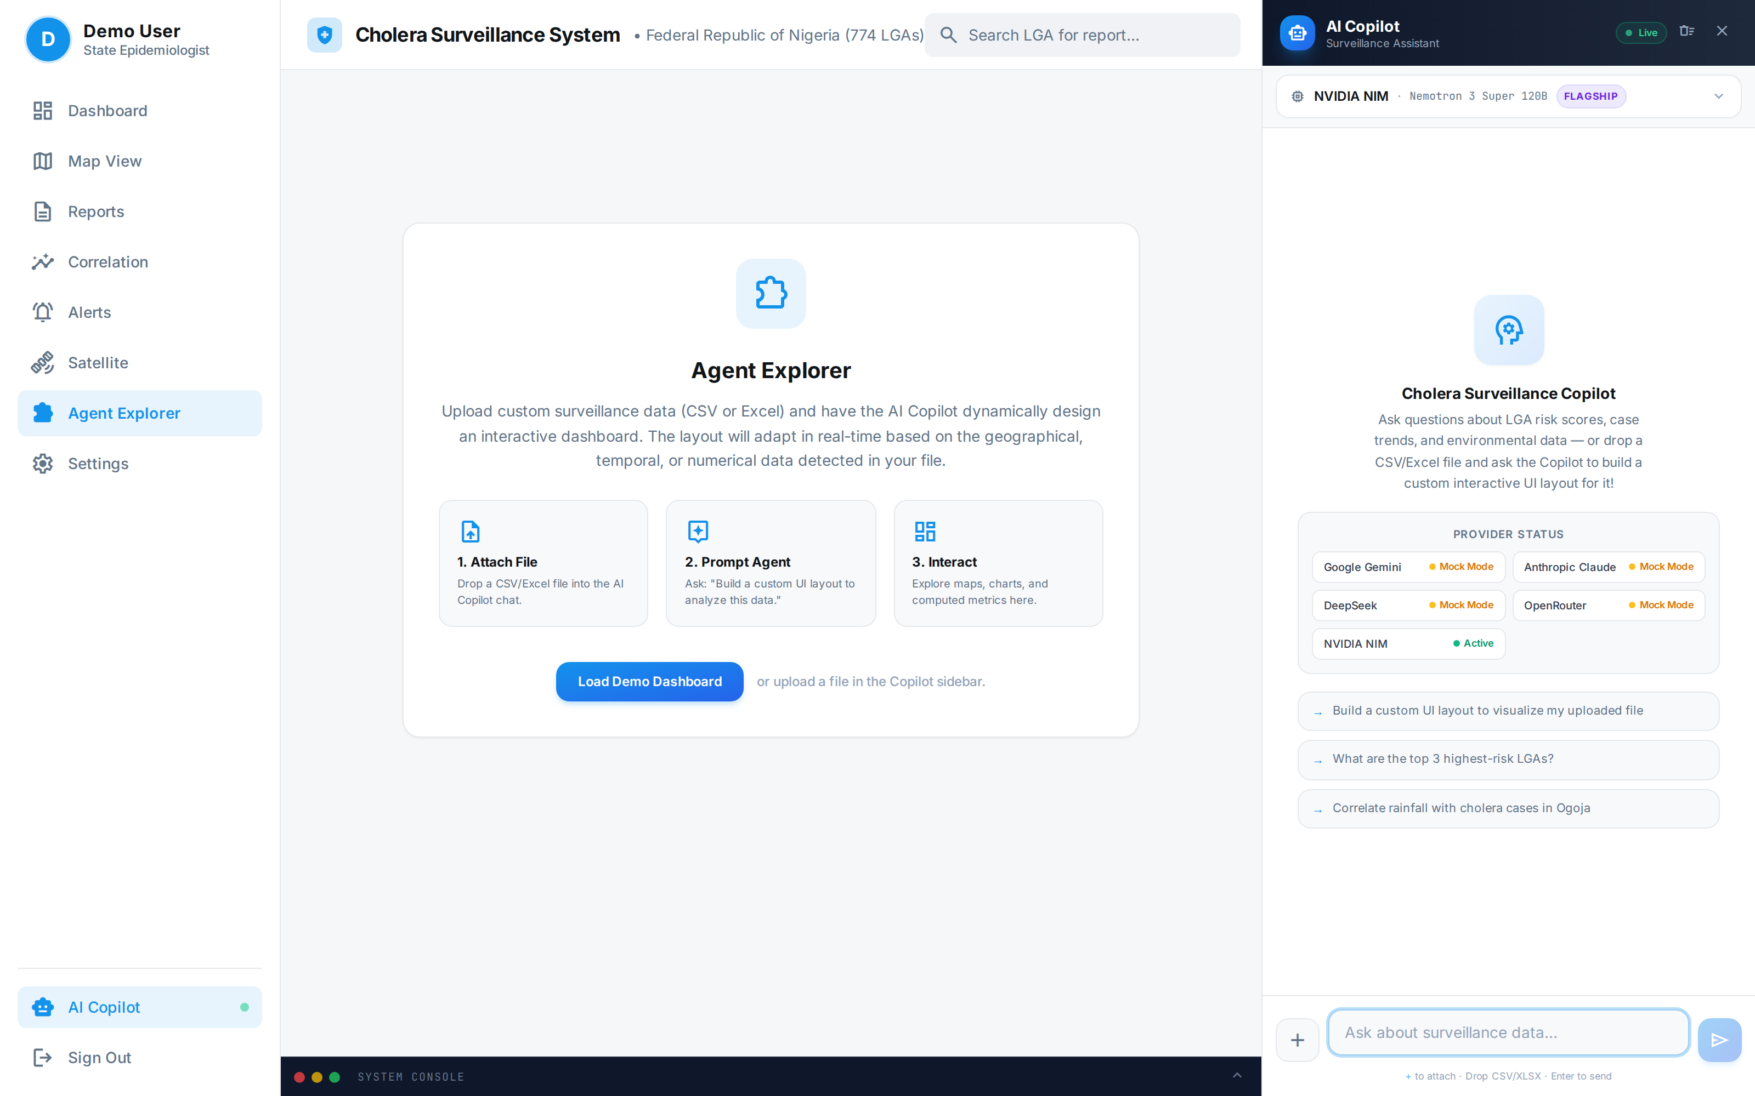
Figure 12: Agent Explorer dedicated page — copilot-assisted interactive dashboard workspace, demonstrated with the Cross River 2021 sentinel pilot line-list aggregate.

6.2 Schema-Detection Benchmark
A single successful demonstration such as Figure 12 establishes that the capability exists; it does not establish that it is reliable. The benchmark described in Section 3.7 was therefore run over twelve schema variants of the same observed dataset under two prompting conditions, with three repetitions each, against NVIDIA NIM (nemotron-3-super-120b-a12b). All 72 invocations were live; none entered the offline fallback path. 3 trial(s) encountered a transient provider error, were retried after backoff, and completed successfully. No trial had to be excluded for infrastructure failure. Results are reported in Table 8 and Figure 13; the trial-by-trial log, the harness and the scoring code are supplied as supplementary material.
Table 8: Surveillance Copilot schema-detection performance, 72 live NVIDIA NIM trials (nemotron-3-super-120b-a12b); percentages of scoreable trials passing.
Metric | Unconstrained prompt (n=36) | Schema-grounded prompt (n=36)
Tool invoked (generate_ui_spec called) | 100.0% | 100.0%
Emitted a syntactically valid specification | 100.0% | 100.0%
Schema grounding (no invented column names) | 91.7% | 100.0%
LGA field correctly bound | 91.7% | 100.0%
Case-count field correctly bound | 97.2% | 100.0%
Death-count field correctly bound | 57.6% | 39.4%
Total invented column references | 4 | 0
Mean latency per invocation | 23.7 s | 22.7 s
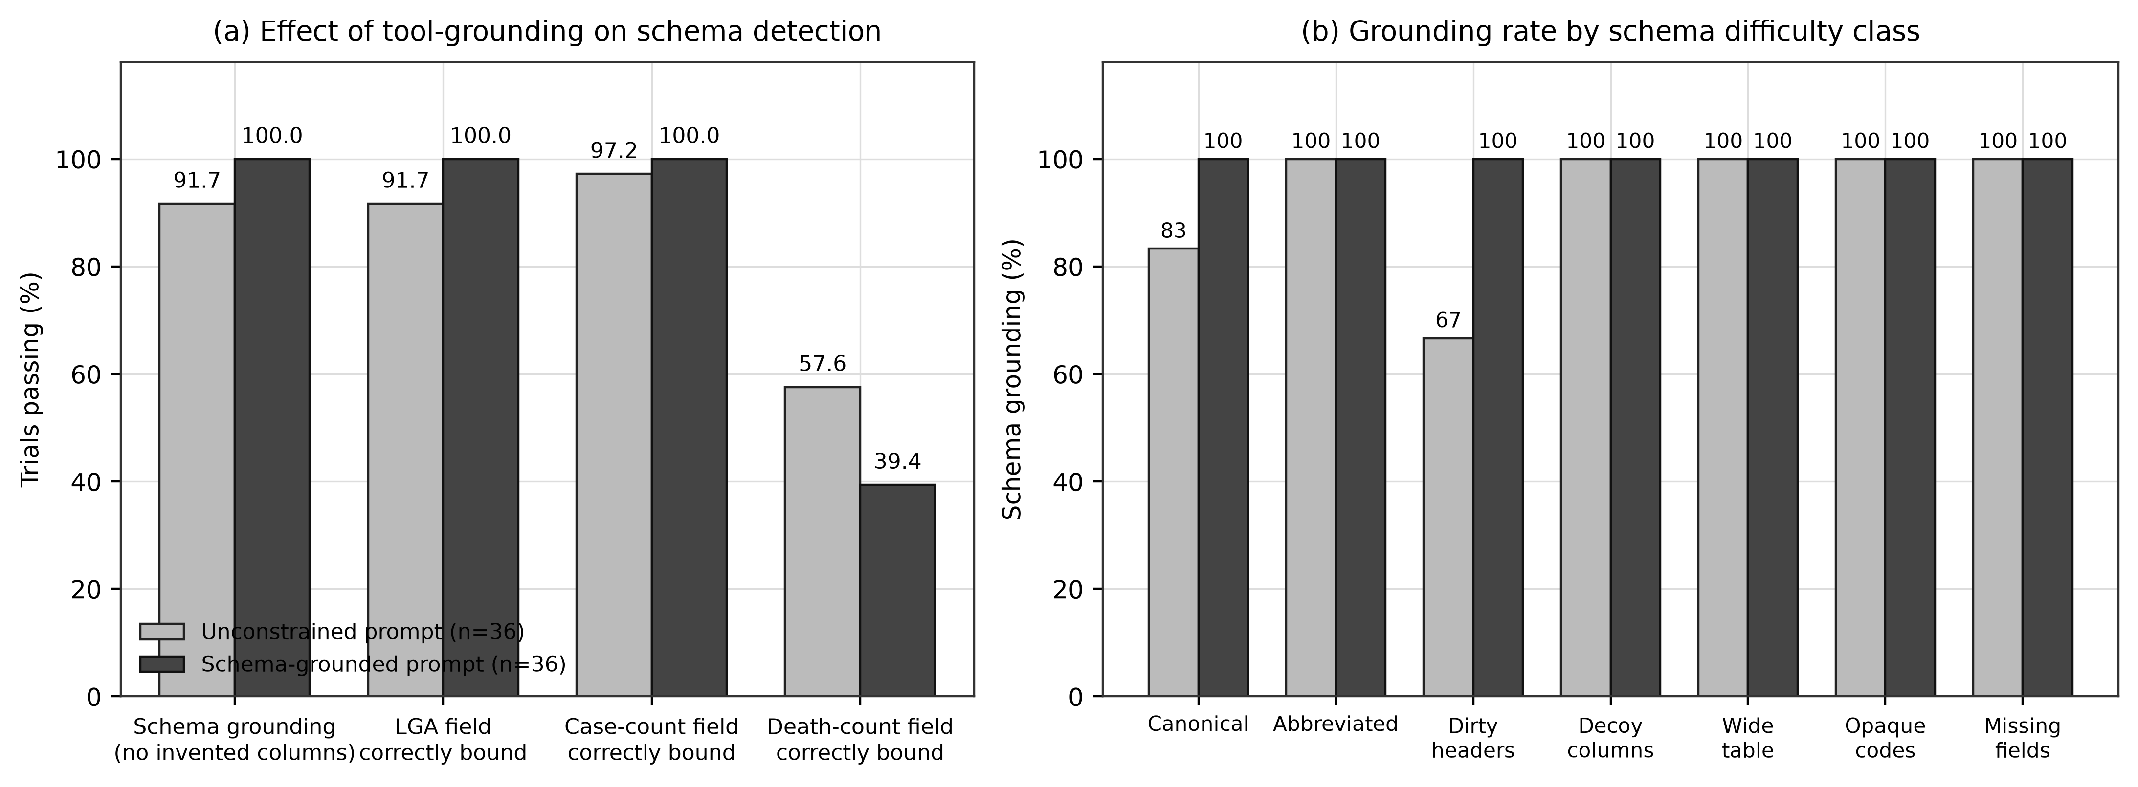
Figure 13: Surveillance Copilot schema-detection benchmark (72 live NVIDIA NIM invocations, nemotron-3-super-120b-a12b). (a) Effect of requiring a file-inspection tool call before dashboard generation, across four correctness metrics. (b) Schema grounding rate by schema difficulty class. Requiring the agent to read the file before describing it eliminates schema hallucination in every difficulty class.
The headline finding is a measured, reproducible failure mode. Under unconstrained prompting the assistant emitted at least one non-existent column name in 8.3% of scoreable trials — 4 invented column references across 36 invocations. With this model the failure is concentrated rather than pervasive: grounding was perfect on 10 of the twelve variants and broke on canonical (66.7% grounded); dirty-header-b (33.3% grounded). The invented names (lga_name (2), Cases (1), LGA (1)) are diagnostic: the model substitutes the header spelling a cholera surveillance dataset conventionally has — capitalised, camel-cased or whitespace-stripped — for the one the file actually has, and the failure appears even on a clean canonical header, not only on deliberately dirty ones. The resulting specification is syntactically valid, renders without error, and displays nothing at all.
This is precisely the silent-failure class identified in Section 3.7, and it is the reason a single successful demonstration is inadequate evidence for an operational claim. A health officer presented with such a dashboard sees an empty chart, not an error message, and has no indication that the underlying binding was fabricated.
The mitigation is a design change rather than a change of model. Instructing the agent to call analyze_file and read the true column names before generating a specification eliminated schema hallucination completely: 100.0% grounding across all twelve variants and all seven difficulty classes, with 0 invented column references in 36 invocations. Correct binding of the LGA field rose from 91.7% to 100.0%, of the case-count field from 97.2% to 100.0%, and of the death-count field from 57.6% to 39.4%. The constraint carried no latency penalty: mean invocation time was 23.7 s unconstrained and 22.7 s grounded, the mandatory file-inspection turn being offset by shorter deliberation once the true schema was in context. Death-count binding was lower in both conditions because the task prompt asks for cases by LGA and the model frequently omitted a deaths widget altogether; omission is scored as a non-binding here, and the raw specifications allow the alternative reading.
Two residual limitations are reported. First, grounding is not the same as correctness in general. With this model every grounded trial also bound the LGA and case-count roles correctly, but a header without domain tokens can in principle be grounded and still mis-assigned, so deterministic header normalization at ingestion remains warranted; the death-count shortfall reported in Table 8 is widget omission rather than mis-binding. Second, the benchmark measures schema binding on a four-row aggregate dataset from a single disease domain against a single provider and model (nemotron-3-super-120b-a12b on NVIDIA NIM); the magnitude of the unconstrained failure rate should be expected to vary by model, and generalization to large multi-sheet field returns, other diseases, and other providers is not established.
The operational conclusion is that the assisted-analytics layer is fit for use only when constrained to ground itself in the data before describing it, and that the deterministic ingestion path documented in Section 3.2.1 — not the conversational agent — must remain the authoritative route for surveillance data entering the system. The agent's value is in lowering the exploration barrier for non-specialist users, not in serving as a trusted parser.

7. Discussion

7.1 Operationalizing Intelligence and Multi-Agency Awareness
The hub is designed to support after-action review by retrospectively mapping cholera outbreaks against historical environmental data, allowing health officials to identify recurrent high-risk zones and the environmental conditions—such as standing water detected via NDWI—that facilitate pathogen proliferation. In the 2021 national epidemic, retrospective overlay of surface-water anomalies against reported case activity is consistent with an environmental lead time of several weeks; if such signals were flagged operationally in real time, they could support the earlier prepositioning of oral rehydration salts, chlorination supplies, and vaccine stockpiles. This remains a hypothesis for prospective evaluation rather than a demonstrated operational outcome.
A core strength of the platform is the shared operational dashboard, which can provide a single source of truth for disease control agencies, national and state health agencies, and disaster-management teams. By presenting epidemiological and environmental data on a single interface, the hub is intended to bridge the institutional gap between health agencies (e.g. NCDC) and environmental agencies (e.g. NASRDA, NEMA), enabling coordination based on the same spatial intelligence. Realizing this shared awareness in production depends on data-sharing agreements and interoperability arrangements that are governance prerequisites rather than technical outputs of this study.

7.2 Comparison with Existing Systems
Table 9 situates the hub relative to existing international and regional climate-health surveillance frameworks across resolution, sensor integration, latency, data sovereignty, and decision support. The hub's distinguishing design goals are sub-national (LGA-level) targeting, multi-sensor integration, sovereign hosting, and an assisted analytics layer. The comparison is one of design intent and architecture; the platforms listed are mature operational systems, whereas the hub described here is validated at pilot scale only, and Table 9 should be read with that asymmetry in mind.
Table 9: Comparative framework of climate-health intelligence platforms.
Platform | Spatial Resolution | Sensor Integration | Latency | Data Sovereignty | Decision Support | Validation status
UNICEF cholera platform | Global / Admin-1 | Precipitation, temperature | Monthly batch | Foreign cloud | Static risk mapping | Operational
WHO Health-Earth | Regional / continental | Precipitation, SST | Bi-weekly / monthly | International servers | Predictive modelling | Operational
ECDC EWARS | National / regional | Meteorological grids, land cover | Weekly sitreps | European cloud | Rule-based alerts | Operational
NASRDA EO-Hub (this study) | Sub-national (LGA) design; state where reported | GPM-IMERG, Sentinel-2 NDWI, Landsat NDVI, Sentinel-1 SAR, dated flood archive | On-demand retrieval | Sovereign Nigerian infrastructure + NASRDA archives | Rule-based alerts + benchmarked assisted analytics | Pilot only (4 LGAs); not operationally validated

7.3 Assisted Analytics as a Surveillance Capability
The benchmark in Section 6 has implications beyond this platform. Conversational assistants are being added rapidly to public-health tooling, and their failure modes differ qualitatively from those of conventional software. A schema mis-binding does not raise an exception: it produces a plausible, well-formed, empty dashboard. In a surveillance setting where the user is a district health officer under outbreak conditions rather than a data engineer, that failure is unlikely to be noticed and may be acted upon.
The mitigation demonstrated here is architectural and inexpensive: constrain the agent to inspect the data before describing it, and treat any column name it emits that does not appear verbatim in the source as a hard error rather than a rendering nuisance. This shifts the agent from an authority on the data to a navigator of it. The result also argues for a general reporting norm — that AI components in surveillance platforms should be published with a measured failure rate and a stated mitigation, in the same way a diagnostic assay is published with a sensitivity and a specificity, rather than illustrated with a single successful screenshot.

7.4 Policy Implications
The platform is intended to enable three policy shifts: (1) prepositioning of oral rehydration salts, vaccines, and other countermeasures in high-risk LGAs ahead of peak transmission; (2) coordinated inter-agency decision-making on a shared geospatial platform; and (3) monitoring of WASH-intervention effectiveness by tracking subsequent changes in environmental risk indices. LGA-level infrastructure indicators provide a baseline for tracking progress toward WASH targets and identifying investment priorities.

7.5 Limitations
This study acknowledges the following limitations, stated explicitly so that the evidence base is not overread.
Diagnostic confirmation. The pilot line-list comprises suspected cases meeting the national case definition. Specimens were obtained for 4 of 74 records and only 1 was culture-confirmed for Vibrio cholerae. The pilot therefore describes reported cholera-like illness, not laboratory-confirmed cholera incidence, and the reported case fatality ratios inherit that uncertainty.
Pilot scope and statistical power. The Cross River demonstration covers four LGAs in one state. Sub-national analyses with four spatial units support no inferential conclusion; the inverse exposure–burden relationship observed in Figure 3(c) is reported for transparency and is not interpreted as evidence for or against the environmental hypothesis.
National panel not constructed. Because NCDC publishes at state level, a complete 774-LGA longitudinal panel cannot be constructed from official national reports. A candidate national panel was inspected, found irreconcilable with official NCDC totals, and excluded; nothing in this paper is derived from it. The 774-LGA map component is therefore populated with observed data for four LGAs only.
Earth Engine covariates. For this revision, Google Earth Engine was activated on the study project and the precipitation, NDWI and NDVI covariates were computed and are reported for the four pilot LGAs (Section 4, Table 6). NDVI was computed independently from Sentinel-2 and Landsat-8 as a cross-sensor check. Optical indices remain subject to cloud obstruction during the peak rainy season: the two coastal LGAs (Calabar Municipal and Bakassi) yielded no usable Sentinel-2 scene under a 40% scene-cloud filter and required a relaxed 80% filter with per-pixel scene-classification cloud masking to recover ten usable scenes each, whereas Yakurr and Biase were characterised from three clear scenes; the two NDVI products consequently agree for the inland LGAs and diverge at the coast. Areal-mean NDWI is negative across all four land-dominated LGAs, so the localized open-water signal is captured by the NDWI maximum and the fraction of area exceeding the 0.3 water threshold rather than by the areal mean. Sentinel-1 SAR, which is unaffected by cloud, is implemented for visualization but was not reduced to per-LGA statistics in this revision.
Flood-archive constraints. The archive is a derived product whose per-event detection sensitivity is not characterized here, its coverage density varies with observation frequency — denser in urban Calabar Municipal than in rural Bakassi, which confounds event counts with observability — and it recorded no events within the pilot LGAs during 2021 itself, so exposure is characterized over historical windows rather than contemporaneously with the outbreak.
Risk-score validation. The risk-scoring algorithm uses fixed heuristic weights, incorporates contemporaneous case counts as an input, and has not been prospectively validated against an independent real-time outbreak dataset. The flood–cholera association is exploratory; the multi-year paired series (Table 5b) pairs state-level cumulative cases with LGA-level exposure, and no lag-correlation statistic is claimed in this paper.
Copilot benchmark scope. The benchmark evaluates schema binding on small aggregate tables from one disease domain against a single model provider (nemotron-3-super-120b-a12b on NVIDIA NIM). Grounding does not guarantee correct role assignment. Generalization to large multi-sheet field returns, other diseases, and other providers is not established.
Integration and sustainability. Live NCDC/SORMAS synchronization and multi-provider AI operation are design features and roadmap items, not evidenced production integrations. Health-facility records are ingested as supplied and are not record-level validated. Operation requires stable connectivity and technical skills that may not be uniformly available in state health offices, and long-term sustainability depends on institutional commitment, funding, and data-governance agreements.

8. Future Roadmap
The evolution of the hub encompasses six priorities. First, laboratory-confirmation linkage: integrating culture and rapid-diagnostic results from the national reference laboratory network so that confirmed and suspected cases can be distinguished at ingestion rather than reconstructed by audit, directly addressing the 1-in-74 confirmation rate documented in Section 3.2.1. Second, socio-demographic vulnerability layer ingestion: overlaying national health-infrastructure registries and Demographic and Health Survey (DHS) microdata—including access to safely managed drinking water, improved sanitation, and household wealth quintiles—so that an environmental hazard triggers a high-risk alert only where it intersects weak WASH infrastructure. Third, statistical calibration and validation: replacing fixed heuristic weights with principal-component or outcome-calibrated weights, and evaluating the risk score on a temporal hold-out with discrimination and calibration metrics, dependence-aware inference, and geographic leave-one-region-out sensitivity analysis, across an adequately powered multi-state sentinel network rather than four LGAs. Fourth, programmatic NCDC surveillance synchronization: establishing a governed API linkage (including SORMAS interoperability) to replace manual extraction with automated case and death ingestion. Fifth, sovereign EO expansion: activating Earth Engine entitlement on the production host, and integrating NASRDA historical archives and the planned four-satellite constellation (three optical, one SAR) to reduce dependence on foreign data and improve cloud-penetrating flood mapping. Sixth, hardened assisted analytics: enforcing the schema-grounding constraint validated in Section 6 as a system-level invariant rather than a prompt convention, adding deterministic header normalization to close the dirty-header failure mode, rejecting any generated specification that references a non-existent column, and extending the assistant to parse field sitreps and community alerts into clean georeferenced records with human verification, alongside multi-disease coverage for typhoid, dysentery, malaria, and dengue.
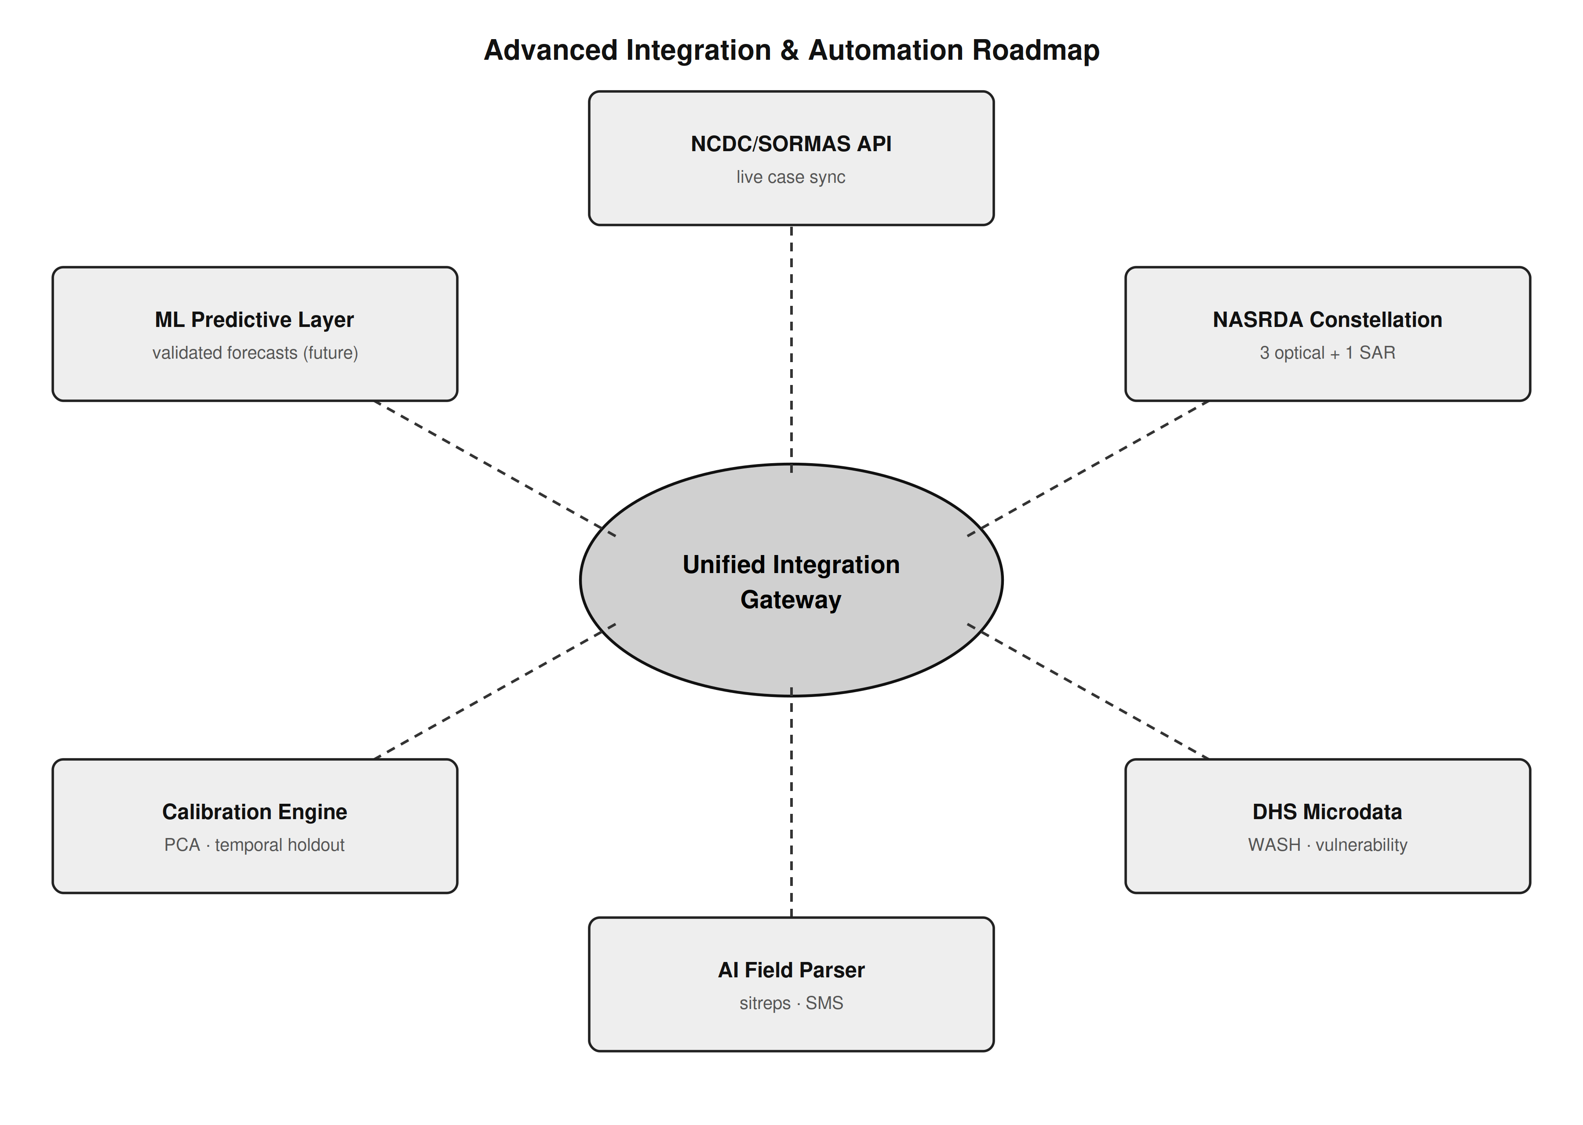
Figure 14: Advanced integration and automation roadmap — NCDC/SORMAS API, NASRDA satellite data hub, DHS microdata layer, laboratory-confirmation linkage, AI unstructured parser, and calibration/validation engine, unified through an integration gateway.

9. Conclusion
This study presents the development and pilot validation of a scalable, Earth Observation-enabled environmental health intelligence hub for cholera surveillance in Nigeria, together with a design for national scale-up. Its contribution is reported across four clearly separated tiers of evidence, and the boundary between them is the paper's central methodological commitment.
At the national tier, officially reported NCDC figures—led by the 111,062-case, 3,604-death 2021 epidemic—establish burden context at state resolution as published. At the sentinel tier, a Cross River line-list of 74 suspected cases and 4 deaths across four LGAs, of which one was culture-confirmed for Vibrio cholerae, was used to validate ingestion, record normalization, spatial joining and risk rendering. At the environmental tier, intersecting a 2.65-million-polygon dated flood archive with GRID3 boundaries produced observed exposure measures for the pilot LGAs that satisfy a physical validity constraint; the resulting exposure–burden relationship across four units is inverse, is reported as observed, and is explicitly not interpreted as evidence about the environmental hypothesis. At the capability tier, a benchmark of 72 live invocations established that the platform's AI copilot invents column names in 8.3% of unconstrained trials, and that requiring it to inspect the data before describing it eliminates that failure entirely while raising correct LGA-field binding from 91.7% to 100.0%.
What the study does not establish is stated with equal clarity. It does not construct a 774-LGA national panel; it does not calibrate or prospectively validate the risk score; it does not demonstrate forecasting skill; it does not evidence live institutional integration; and it does not generalize its four-LGA pilot to the federation. A candidate national panel was inspected, found irreconcilable with official reporting, and excluded in full, and no synthetic epidemiological value appears anywhere in this work.
Framed honestly against that evidence base, the hub represents a credible technical foundation for transitioning Nigerian cholera surveillance from reactive response toward proactive, environmentally contextualized, and sovereign public-health intelligence. The measured copilot failure mode and its architectural mitigation are offered as a transferable contribution: AI components entering public-health practice should be published with a failure rate and a stated mitigation, in the manner of a diagnostic assay, rather than demonstrated with a single successful screenshot.

10. References
Adegoke, B. O., Odugbose, T., & Adeyemi, C. (2024). Data analytics for predicting disease outbreaks: A review of models and tools. International Journal of Life Science Research Updates, 2(2), 1-9.
Adesina, M. A., Adedeji, R. T., Oladipupo, I. R., Olufadewa, I. I., Oladele, R. I., Olufadewa, T. A., ... & Olansile, A. K. (2026). Cholera amid the climate crisis: a systematic review of flooding-driven health risks in West Africa. Discover Public Health, 23(1), 497.
Akanda, A. S., Jutla, A. S., Alam, M., De Magny, G. C., Siddique, A. K., Sack, R. B., ... & Islam, S. (2011). Hydroclimatic influences on seasonal and spatial cholera transmission cycles: implications for public health intervention in the Bengal Delta. Water Resources Research, 47(3).
Akingbola, A., Abiodun, A., Ojo, O., Jessica, O. U., Alao, U. H., Owolabi, A. O., & Chuku, J. (2025). Cholera outbreak in Nigeria: history, review of socioeconomic and meteorological drivers, diagnostic challenges, and artificial intelligence integration. Global Health, Epidemiology and Genomics, 2025(1), 8898076.
Albertini, C., Gioia, A., Iacobellis, V., & Manfreda, S. (2022). Detection of surface water and floods with multispectral satellites. Remote Sensing, 14(23), 6005.
Anderson, K., Ryan, B., Sonntag, W., Kavvada, A., & Friedl, L. (2017). Earth observation in service of the 2030 Agenda for Sustainable Development. Geo-spatial Information Science, 20(2), 77-96.
Armando, C. J., Rocklöv, J., Sidat, M., Tozan, Y., Mavume, A. F., Bunker, A., & Sewe, M. O. (2024). Spatial-temporal analysis of climate and socioeconomic conditions on cholera incidence in Mozambique from 2000 to 2018. BMJ Open, 14(8), e082503.
Atobatele, O. K., Ajayi, O. O., Hungbo, A. Q., & Adeyemi, C. (2019). Leveraging public health informatics to strengthen monitoring and evaluation of global health intervention. IRE Journals, 2(7), 174-193.
Avtar, R., Komolafe, A. A., Kouser, A., Singh, D., Yunus, A. P., Dou, J., ... & Kumar, P. (2020). Assessing sustainable development prospects through remote sensing: A review. Remote Sensing Applications: Society and Environment, 20, 100402.
Bhaga, T. D., Dube, T., Shekede, M. D., & Shoko, C. (2023). Investigating the effectiveness of Landsat-8 OLI and Sentinel-2 MSI satellite data in monitoring the effects of drought on surface water resources. Remote Sensing Applications: Society and Environment, 32, 101037.
Bhunia, G. S., & Shit, P. K. (2021). GeoComputation and Disease Ecology. In GeoComputation and Public Health: A Spatial Approach (pp. 151-220). Springer.
Bose, I., Hadida, G., Green, R., Murray, K. A., Part, C., & Kovats, S. (2026). Rainfall and water-related diseases, malnutrition and mortality in Low- and Middle-Income Countries: a systematic review. Heliyon, 12(1).
Brumfield, K. D., Usmani, M., Long, D. M., Lupari, H. A., Pope, R. K., Jutla, A. S., ... & Colwell, R. R. (2025). Climate change and Vibrio: Environmental determinants for predictive risk assessment. PNAS, 122(33), e2420423122.
Campbell, A. M., Racault, M. F., Goult, S., & Laurenson, A. (2020). Cholera risk: a machine learning approach applied to essential climate variables. International Journal of Environmental Research and Public Health, 17(24), 9378.
Chowdhury, A. H., & Rahman, M. S. (2025). Machine learning and spatio-temporal analysis of meteorological factors on waterborne diseases in Bangladesh. PLoS Neglected Tropical Diseases, 19(1), e0012800.
Chowdhury, F., Ross, A. G., Islam, M. T., McMillan, N. A. J., & Qadri, F. (2022). Diagnosis, Management, and Future Control of Cholera. Clinical Microbiology Reviews, 35(3), e0021121.
Christaki, E., Dimitriou, P., Pantavou, K., & Nikolopoulos, G. K. (2020). The impact of climate change on cholera: A review on the global status and future challenges. Atmosphere, 11(5), 449.
Cord, A. F., Brauman, K. A., Chaplin-Kramer, R., Huth, A., Ziv, G., & Seppelt, R. (2017). Priorities to advance monitoring of ecosystem services using earth observation. Trends in Ecology & Evolution, 32(6), 416-428.
Escobar, L. E., Ryan, S. J., Stewart-Ibarra, A. M., et al. (2015). A global map of suitability for coastal Vibrio cholerae under current and future climate conditions. Acta Tropica, 149, 202-211.
Ganesan, D., Gupta, S. S., & Legros, D. (2020). Cholera surveillance and estimation of burden of cholera. Vaccine, 38, 13-17.
Geng, Q., Yao, X., Sun, J., Jia, S., Xu, F., Zhang, L., ... & Li, G. (2026). Open-source GIS software and tools: a systematic review. Big Earth Data, 1-48.
Gopo, L., Bere, T., & Murisa, M. R. (2026). Climatic and socio-environmental drivers of cholera epidemics. PLOS Climate, 5(4), e0000840.
Gorelick, N., Hancher, M., Dixon, M., Ilyushchenko, S., Thau, D., & Moore, R. (2017). Google Earth Engine: Planetary-scale geospatial analysis for everyone. Remote Sensing of Environment, 202, 18-27.
Hashizume, M., Armstrong, B., Hajat, S., Wagatsuma, Y., Faruque, A. S. G., Hayashi, T., & Sack, D. A. (2008). The effect of rainfall on the incidence of cholera in Bangladesh. Epidemiology, 19(1), 103-110.
Huffman, G. J., Stocker, E. F., Bolvin, D. T., Nelkin, E. J., & Tan, J. (2020). GPM IMERG Final Precipitation L3 Half-Hourly 0.1° x 0.1°. NASA GES DISC.
Kamalrathne, T., Amaratunga, D., Haigh, R., & Kodituwakku, L. (2023). Need for effective detection and early warnings for epidemic and pandemic preparedness planning. International Journal of Disaster Risk Reduction, 92, 103724.
Kanagaraj, J. K., & Vijayan, T. B. (2024). Spatio-temporal correlation analysis of environmental and climatic determinants with various infectious diseases in Tamil Nadu and West Bengal. Environmental Engineering & Management Journal, 23(9).
Khachoo, Y. H., Cutugno, M., Robustelli, U., & Pugliano, G. (2026). Google Earth Engine since 2022: A structured bibliometric review of GeoAI-driven trends and applications. Sustainability, 18(12), 6241.
Kuna, A., & Gajewski, M. (2017). Cholera—the new strike of an old foe. International Maritime Health, 68(3), 163-167.
Li, X., Zhou, Z., Jia, H., Li, Z., Yang, Z., Cai, Z., ... & Shi, X. (2026). Mechanisms of accumulation–transport–discharge and source apportionment of combined sewer overflow pollution. Water, 18(5), 573.
Lloyd, C. T., Sturrock, H. J. W., Leasure, D. R., Jochem, W. C., Lázár, A. N., & Tatem, A. J. (2020). Using GIS and machine learning to classify residential status of urban buildings in low- and middle-income settings. Remote Sensing, 12(23), 3847.
Madubueze, M. H., Mbanefo, O. D., Anekwe, J. K., Nwadiogbu, N. M., & Egberi, A. E. (2025). Climate variability and waterborne disease burden in Nigeria. International Journal of Interdisciplinary Studies and Innovation, 4(1), 85-90.
McFeeters, S. K. (1996). The use of the Normalized Difference Water Index (NDWI) in the delineation of open water features. International Journal of Remote Sensing, 17(7), 1425-1432.
Meckawy, R., Stuckler, D., Mehta, A., Al-Ahdal, T., & Doebbeling, B. N. (2022). Effectiveness of early warning systems in the detection of infectious diseases outbreaks: a systematic review. BMC Public Health, 22(1), 2216.
Mikaberidze, A., et al. (2025). Opportunities and challenges in combining optical sensing and epidemiological modeling. Phytopathology, 115(10), 1260-1285.
Mobasheri, M. R. (2022). Remote Sensing and Computational Epidemiology. In COVID-19 Pandemic, Geospatial Information, and Community Resilience (pp. 55-68). CRC Press.
Morse, S. S., Mazet, J. A., Woolhouse, M., Parrish, C. R., Carroll, D., Karesh, W. B., ... & Daszak, P. (2012). Prediction and prevention of the next pandemic zoonosis. The Lancet, 380(9857), 1956-1965.
National Population Commission & ICF. (2024). Nigeria Demographic and Health Survey 2023-24: Key Indicators Report. Abuja & Rockville.
Nigeria Centre for Disease Control and Prevention (NCDC). (2022). Cholera Situation Report, Epi Week 52, 2021. Abuja: NCDC.
Nigeria Centre for Disease Control and Prevention (NCDC). (2024). Cholera Situation Report, Epi Week 22, 2024. Abuja: NCDC.
Nigeria Centre for Disease Control and Prevention (NCDC). (2025). An update of cholera outbreak in Nigeria. Federal Ministry of Health.
Olagunju, A. T., Denga, V. S., Madakadze, C., & Osuagwu, F. (2025). Climate change and health issues: an Afrocentric perspective. In Health and Climate Change (pp. 251-265). Academic Press.
Peprah, M. S., Moomen, A. W., & Sey, J. M. (2026). Leveraging Digital Earth for sustainable development in Africa: a systematic review and meta-analysis. Arabian Journal of Geosciences, 19(5), 99.
Pezanowski, S., Koua, E. L., Okeibunor, J. C., & Gueye, A. S. (2024). Predictors of disease outbreaks at continental scale in the African region. Digital Health, 10, 20552076241278939.
Reyburn, R., Kim, D. R., Emch, M., Khatib, A., Von Seidlein, L., & Ali, M. (2011). Climate variability and the outbreaks of cholera in Zanzibar, East Africa: a time series analysis. American Journal of Tropical Medicine and Hygiene, 84(6), 862.
Schets, F. M., Pol-Hofstad, I. E., van den Berg, H. H., & Schijven, J. F. (2025). Climate change-related temperature impact on human health risks of Vibrio species in bathing and surface water. Microorganisms, 13(8), 1893.
Singh, K., Kumar, S., Brumfield, K. D., Deliz, K., Colwell, R. R., Jutla, A., & Usmani, M. (2025). Remote Sensing to Predict Climate-Sensitive Pathogens: a Review. Authorea Preprints.
Singh, S., Sharma, P., Pal, N., Sarma, D. K., Tiwari, R., & Kumar, M. (2024). Holistic one health surveillance framework. ACS Infectious Diseases, 10(3), 808-826.
Song, Y., & Wu, P. (2021). Earth observation for sustainable infrastructure: A review. Remote Sensing, 13(8), 1528.
Tucker, C. J. (1979). Red and photographic infrared linear combinations for monitoring vegetation. Remote Sensing of Environment, 8(2), 127-150.
United Nations Children's Fund (UNICEF). (2025). Nigeria Humanitarian Flash Update (Cholera Outbreak), 1, 1-6.
Usmani, M., Brumfield, K. D., Magers, B. M., et al. (2023). Combating cholera by building predictive capabilities for pathogenic Vibrio cholerae in Yemen. Scientific Reports, 13(1), 2255.
Verma, R., & Kotwal, M. (2025). Geographic information systems: a review of its evolution, challenges, and future trends. International Journal for Multidisciplinary Research.
Warekuromor, T. (2026). Development and Pilot Validation of the Nigeria EO-enabled Environmental Health Intelligence Hub for Cholera Surveillance [Conference presentation]. GEO Health Community of Practice, NASRDA.
Wright, A. K. A., Ezugwu, C. I., Iregbu, J. K., et al. (2025). Climate change and emerging infectious diseases: a global review. Epidemiology and Health Data Insights, 1(3), ehdi009.
Yaghobi, S., Daneshi, A., Faramarzi, M., Azadi, H., Fathizad, H., & Islami, I. (2026). Drought impacts on vegetation cover in Western Iran. International Journal of Environmental Science and Technology, 23(1), 35.
Yu, H. (2025). Climate change unveils hidden microbial dangers. Environmental Science and Ecotechnology, 24, 100544.
Zhao, Q., Yu, L., Du, Z., Peng, D., Hao, P., Zhang, Y., & Gong, P. (2022). An overview of the applications of earth observation satellite data. Remote Sensing, 14(8), 1863.
da Silva Junior, U. J., da Penha Pacheco, A., Ruiz-Armenteros, A. M., et al. (2025). A methodological approach to flood dynamics based on satellite-derived spectral indices and altimetric forecast models. Science of the Total Environment, 1003, 180686.

Declarations
Ethics approval. This study used publicly available, officially reported aggregate epidemiological data and an anonymized outbreak line-list supplied through official channels. No personally identifiable information was accessed and no human subjects research was undertaken.
Data availability. Nationally reported cholera figures are available in the published NCDC situation reports cited in Section 10. The Cross River 2021 line-list contains outbreak response data and is available from the Cross River State Ministry of Health subject to their data-sharing governance. GRID3 administrative boundaries and the FMOH health-facility registry are publicly available from their respective providers. The compiled state-level NCDC series (1,233 records, 2021-2025), its full data dictionary, a per-report extraction and correction log, and the 232 withheld records with their raw source strings preserved are available as supplementary files, each row traceable to its source situation-report PDF.
Reproducibility of the copilot benchmark. The benchmark reported in Section 6 is fully reproducible from the pilot dataset. The twelve schema variants are generated deterministically from the observed line-list; the harness imports the platform's own agent implementation and records every trial with its provider and model, variant, condition, repetition, prompt, emitted specification, referenced columns, tool calls, latency, retries and outcome; infrastructure failures are detected, retried and excluded from scoring; and every trial is asserted to have used a live model invocation rather than the offline fallback path. The harness, scoring code, unit tests, provider-status proof and the complete 72-trial log (nemotron-3-super-120b-a12b on NVIDIA NIM) are supplied as supplementary files, together with the multi-year paired flood-exposure/case series of Section 4.2 and the script that generates it.
Author contributions. W.T. conceived the study, leads the Mission Planning programme under which it was undertaken, and supervised the work. A.M.O. contributed to the Earth Observation methodology and institutional framing. Y.T.U. implemented the platform, performed the data engineering, spatial analysis and copilot benchmark, and prepared the figures. All authors reviewed and approved the manuscript.
Conflicts of interest. The authors declare no competing interests.
Funding. This work was undertaken within the normal programme of the National Space Research and Development Agency (NASRDA). No external funding was received.
Use of AI tools. An AI assistant integrated into the platform is a subject of study in Section 6 and its behaviour is reported as measured experimental data. AI-based tooling was additionally used to support data engineering and analysis scripting; all numerical results were computed programmatically from source data and verified by the authors, and no epidemiological value reported in this paper was generated by a language model.

