Plants vs. Zombies Heroes: New Leaf Balance changes!

Version: 1.0-alpha1
Release date: 12/07/2024
Notes: Guardian class is now rebalanced. Some cards still need more tweaking, but hey, this is one class finished.

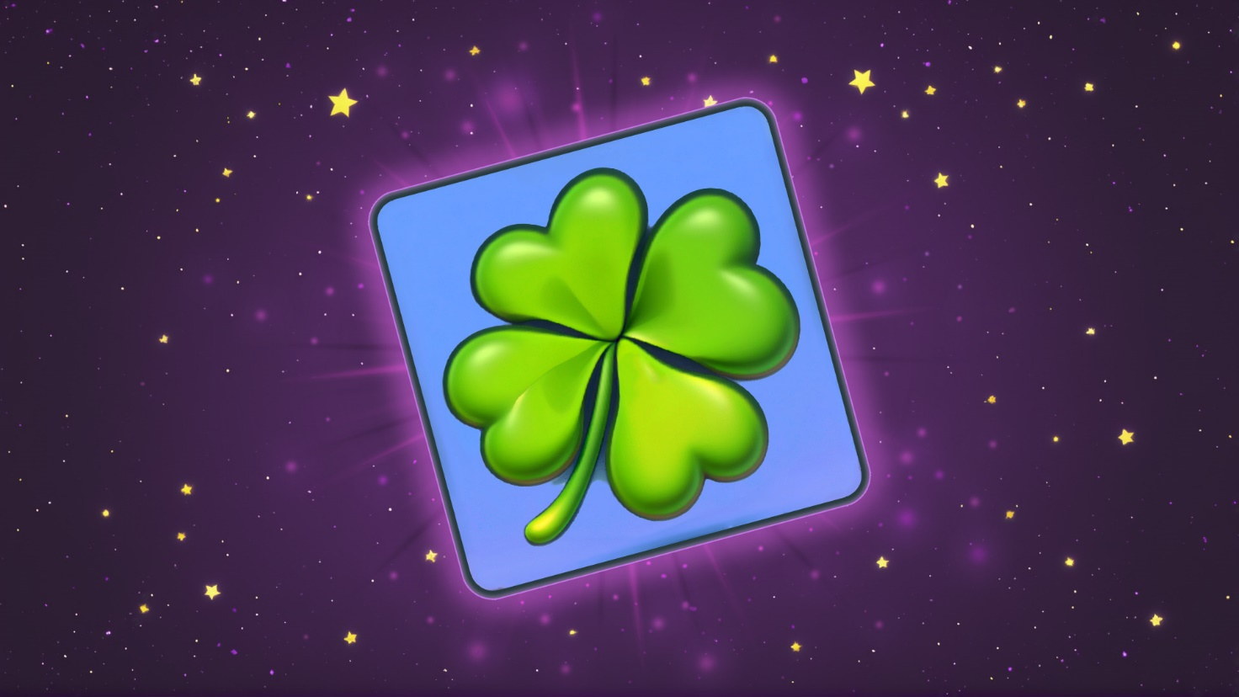

Contents
Plants 3
Guardian 3
Zombies 5
Crazy 5

Plants

This is practically the first major patch of the mod. In this patch, I have only worked on Guardian cards. And Fruitcake, lol.
Green means a buff, Red means a nerf, and Purple means a rework.

Guardian
Sting bean: 1 cost, 2/1 → 0 cost, 1/1
Cactus: 2 cost, 1/5 → 1 cost, 1/4
Gardening gloves: 2 cost → 1 cost
Potato mine: 2 damage when destroyed → 3 damage when destroyed
Sea shroom: 2 cost → 1 cost
Water chestnut: 0/8 → 0/10
Gilly bean: 3/2 → 3/3
Spineapple: 0/3 → 0/4
Prickly pear: 4 cost → 3 cost
Steel magnolia: 2/2 → 2/3
Red stinger: 2/7 in front, 7/2 behind → 3/5 in front, 5/3 behind
Body-Gourd: 3/6 → 4/6

Forget-me-nuts: 2/1 → 1/1
Galacta: 2/2 → 2/1
Tricarratops: 1/3 → 0/3
Shamrocket: 3 cost → 4 cost. For now.
Pecanolith: 0/7 → 0/6. Nut decks have been buffed hard, so this is deserved, you’ll see.
Doom-shroom: 5 cost → 8 cost, “Costs 2 less, if your hero has 8 HP or less. Zombie Hero conjures a card that costs 5 or more”. This card is very hard to balance. Originally wanted it cost to be whatever amount of sun you made this turn, but that’s hard to code.
Blockbuster: 3/3 → 2/3. Sorry. Might reverse later. Also, it stopped working for some reason, lol.

Primal potato mine: now does 2 damage, but draws a card when destroyed. Interesting competition with regular Potato mine. Seems to me each one is better in its own way now.
Mirror nut: 0/8 → 0/4, Bullseye.
Smackadamia: 5 cost, 4/4 → 4 cost, 3/3. “When played: heal all your Nuts for 2. Make a Wall-Nut.”
Tough beets: 6/1 → 5/1. “Start of Tricks: give a Plant Bullseye for this turn.”
Guacadile: 4 cost, 4/3 → 5 cost, 4/4. Now does 4 damage in this lane, not to a zombie here.
Gravitree: 7/7 → 6/5, now has ability “While there is a Zombie here, this card is Untrickable.”
Soul patch: 5/10 → 3/10. “When another plant is destroyed, this plant heals itself for 1”. Doesn’t die to rocket science anymore

Zombies

Crazy
Exploding fruitcake: 7 damage → 5 damage

