Plants vs. Zombies Heroes: Sprouted Balance changes!

Version: 1.0-alpha2
Release date: 16/07/2024
Description: rebalanced the Kabloom class, renamed the mod to “Sprouted”. Also, I’m coding strictly in VS Code now, so no bugs or nothing

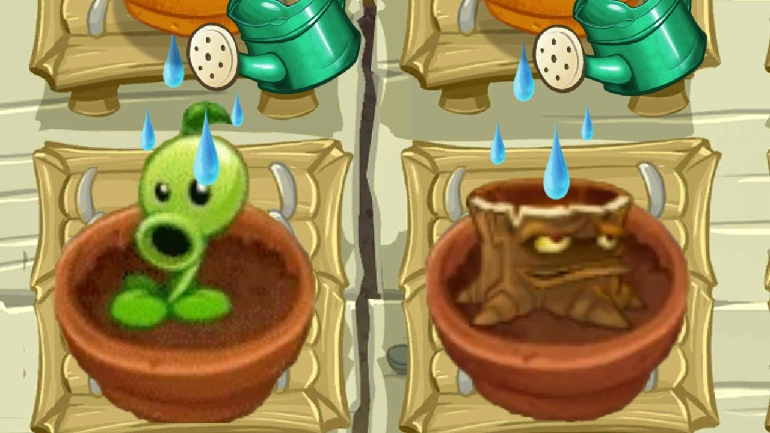

Contents
Plants 3
Guardian 3
Kabloom 3
Bug fixes 5

Plants

Green means a buff, Red means a nerf, and Purple means a rework. Bold means change might be especially influential.

Guardian
Loco coco: now has ability “Nut evolution: All plants with 3 attack or less have their attack set to 3.”

Shamrocket: now kills zombies with 5 attack or more, not 4

Kabloom
Hot lava: 1 cost → 0 cost
Poison mushroom: 1/1, Antihero II → 2/1, Antihero I
Seedling: 0/1 → 0/2
Shelf-shroom: 2/2 → 2/3
Berry angry: now draws a card
Cosmic mushroom: 2/2 → 3/1
Invasive species: 3 cost, 2/4 → 2 cost, 1/4
Ringleader: 3 cost, 0/1 → 4 cost, 0/3
Poison ivy: 1/3, Antihero IV → 2/3, Antihero III
Punish-shroom: 2/2 → 2/3
Strawberrian: 3/2 → 3/1, but does damage in all 3 lanes. Good old days
Sour grapes: 2/2 → 3/2
Guava: 5 cost, 2 damage → 2 cost, 1 damage
Bluesberry: 5 cost, 3/3 → 4 cost, 3/2
Electric blueberry: does 6 → 5 damage, but “When played: get +3/+0 this turn.”
Pomegranate: now spawns seedlings here and next door!
Sizzle: 5 cost → 4 cost
Poison oak: 4/5 → 5/6
Grapes of wrath: 6/6 → 6/4, can target anything, not just Zombie Hero. This was WAY harder to implement than it might seem.

Pair of pears: 4 cost, 2/2 → 3 cost, 3 cost, 2/1. “Gain a 0 cost Pear Pal.”
Mushroom grotto: 3 cost → 2 cost, “When a plant is played here: gain a Puff-Shroom. Activates once per turn.”

Bug fixes

Blockbuster: evolution actually works now

