高考口语测试模拟卷Test 1
I.SPEAKING
Section A
Directions: Read aloud the following two sentences. For each sentence, you will have thirty seconds to prepare and fifteen seconds to read.

1.With the sound of a drum, the person disappears as if by magic!
2.Although it was a time of prosperity and enormous social and cultural change, it was also a time of class conflict and oppression.

Section B
Directions: Read aloud the following passage. You will have one minute to prepare and thirty seconds to read.
Speaking
In 1881 the number of women who had graduated from college was small, and those who had achieved this milestone cherished the companionship of their peers. One autumn 17 of these women gathered for a meeting in Ellen Swallow Richards's chemistry laboratory at MIT. In January of the following year, G5 women met in Boston. Their purpose was the creation of a group to support women’s education. Marion Talbot, one of the first women to enroll at Boston University, described some of the projects she thought they might take on.

Section C
Directions: Ask two questions about each situation given below. At least one special question should be asked about each situation.
Questions 1-2 : Your friends has been preparing for singing contest . Ask him about it .
Question 1:
Question 2:

Questions 3-4: You find in the school newspaper an advertisement for volunteers to help in the library . You call to ask for more information.
Question 3:
Question 4:

Section D
Directions: You will have one minute to prepare and another minute to talk in at least five sentences about the following pictures. Begin your talk with the sentence given:
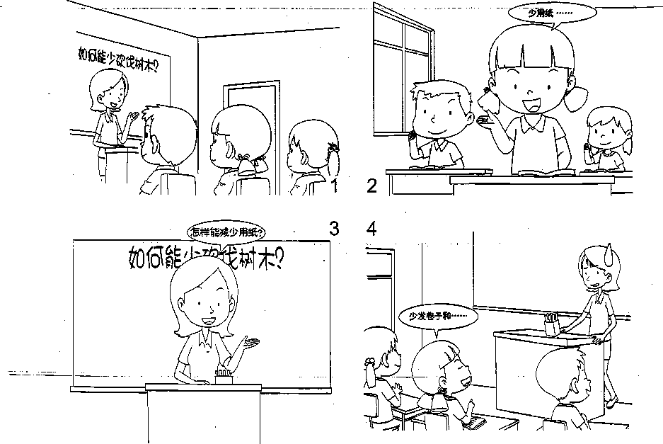

II. LISTENING AND SPEAKING
Section A
Directions: In Section A, you will hear four sentences. Make quick responses to the sentences you have heard.
Listening and Speaking
l.________________________________________________
2.________________________________________________
3.________________________________________________
4.________________________________________________

Section B
Directions: In Section B, you will hear a short passage. The passage, will be read twice. After you hear the passage, answer the first question with the information you hear and the second questions in your own opinion with at least 3 sentences. For the first question, you will have 30 _seconds, to prepare and 30 seconds to talk. For the second question, you will have one minute to prepare and another minute to talk!
II. Listening and Speaking
Questions:
1.How did the speaker feel before and after the laughter class?
2.What do you usually do if you’re upset about your study?

录音内容
II. LISTENING AND SPEAKING
Section A
1. Would you please pass me the salt again?
2.How do you like your new school?
3.I'm really sorry to have kept you waiting for so long.
4. This is a gift for you from us all.

Section B
Listen to the following speaker talking about the Laughter Club.
The first Laughter Club was started in Mumbai, India, in 1995 by Dr Madan Kataria. "Everyone's naturally good at laughing — ifs the universal language. We want people to feel happy with their lives!" says Dr Kataria. There are now more than 500 Laughter Clubs in India and over 1,300 worldwide.
So, what happens at a Laughter Club? I went along to my nearest club in South London to find out. I was quite nervous about it , to be honest ----I wasn't keen on the idea of laughing with a group of strangers, and I was worried about looking stupid. First, our laughter teacher told us to clap our hands and say "ho ho ho, ha ha ha," while looking at each other. Amazingly, it works. After ten minutes everybody in the room was laughing for real — and some people just couldn't stop! At the end of the class I was surprised by how relaxed and calm I felt. So if you're upset about something at work or just fed up with your daily routine, then start laughing. You might be very pleased with the results!

推荐答案
I. SPEAKING
Section C
1.What song are you going to sing in the contest?
2.When will the contest be held? .
3.How often should a volunteer help in the library every week?
4.What should a volunteer do?

Section D
Students in Class One are talking about how to protect the environment
Miss Li asks, What can we do to stop the trees from being cut down?" Mary raises her hand and says, “By using, less paper, because paper is made from wood” "Good idea." Miss Li says, "What measures can we take to use less paper?" Mary smiles and answers, “Miss .Li, would you please give us fewer papers in tests and assignments? That’ll be a，great way to save trees.” Miss Li .feels really embarrassed and at a loss for words.

II. LISTENING AND SPEAKING
Section A
1. Of course. Here you are. / There it is.
2. It's big and very beautiful. / A nice school, really.
3. That's all right. / Never mind.
4. Thank you very much. / You are so kind.
Section B
1. The speaker felt nervous and worried about laughing with a group of strangers before the class, but he/she felt surprised by how relaxed and calm after the class.
2. If I'm upset about my study, first I will stop what I'm studying and take a short break. Then maybe I will listen to some music or watch TV and have some snacks. If none of the above works, I will talk with my friends or my parents about my trouble. They can always give me encouragement and useful advice.

