高考口语测试模拟卷Test 2
I.SPEAKING
Section A
Directions: Read aloud the following two sentences. For each sentence, you will have thirty seconds to prepare and fifteen seconds to read.
1."What could be better than no more cast?" asks Bonk.
2.Poets and novelists also bore witness to the poverty, hopelessness, and helplessness that was the lot of countless child workers living at the beginning of the 20th century.

Section B
Directions: Read aloud the following passage. You will have one minute to prepare and thirty seconds to read.
An earthquake happens when the earth actually moves under the ground. Many hundreds of earthquakes take place every year, especially under the sea. We don't even know that they are happening. If earthquakes happen in or near large cities, they can cause problems. The moving ground makes buildings shake and fall down. It causes cracks in the ground which may open up into very deep holes. People, animals and objects can fall into these holes and be lost forever. Water, gas and electricity pipes may be damaged. The result is flooding and fire. Fire is the greatest danger during an earthquake, because it can destroy so much in such a short time

Section C
Directions: Ask two questions about each situation given below. At least one special question should be asked about each situation.

Questions1-2: You want to book a table for today's dinner, so you call the restaurant.
Question 1:
Question 2:

Questions 3--4: Your deskmate is reading a newly-published novel . You ask him about it.
Question 3:
Question 4:

Section D
Directions: You will have one minute to prepare and another minute to talk in at least five sentences about the following pictures. Begin your talk with the sentence given:
It is March 5th, a day that people are encouraged to do good deeds in memory of Lei Feng.
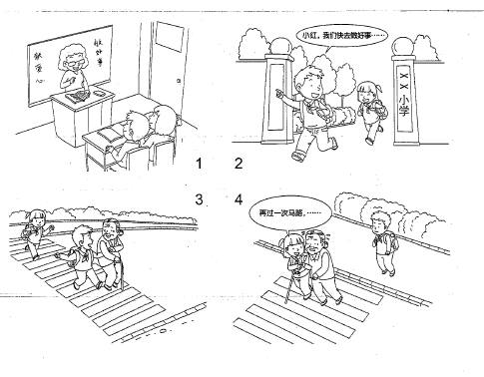

II. LISTENING AND SPEAKING
Section A
Directions: In Section A, you will hear four sentences. Make quick responses to the sentences you have heard.
l.________________________________________________
2.________________________________________________
3.________________________________________________
4.________________________________________________

Section B
Directions: In Section B, you will hear a short passage. The passage will be read twice. After you hear the passage, answer the first question with the information you hear and the second question in your own opinion with at least 3 sentences. For the first question, you will have 30 seconds to prepare and 30 seconds to talk. For the second question, you will have one minute to prepare and another minute to talk .

Questions:
- What are Bob Martin and Peter Holden interested in?
- Why are you or your friends crazy about? Why?

录音内容
II. LISTEN1NG AND SPEAKING
Section A
1. I'd like to talk about the plan with you. Would tomorrow morning be convenient?
2. Where would you like to go for a walk?
3. Sorry I didn't quite catch what you said just now.
4. I'm so excited that I've finally got the offer!

Section B
Listen to the following speaker talking about two people's interest
Whether it’s collecting coins, supporting your favorites football team, or just shopping, most people have some kind of interest But what happens when that interest become the most important thing in your life?
Take Bob Martin for example, in 1988,he went to see the musical Cats at the New London Theatre. He enjoyed it so much that he went to see it again. And again. And again ... every week for fourteen years! He travelled 52,000 miles and saw the show 795 times, spending a total of £20,000.K! don't drink, smoke or run a car, so I could just about afford it," says the 71-year-old. But sadly Bob is now looking for a new hobby. The show closed last year after a sixteen-year run in London.
For some it's musicals that keep them coming back for more. For others, it's-------fast food. Peter Holden, from Washington DC, eats an average of two McDonald's and says," I'm a collector of the McDonald dining experience."He is 1.9 meters tall and weighs 90 kilograms — he says he doesn't put on weight partly because he is lucky and partly because he doesn't eat the fries.

推荐答案
Section C
1. Is there any table available for today’s dinner?
2. When should I arrive at the latest?
3. Who is the author of the novel?
4. What do you think of the novel?

Section D
It is March '5th, a day that people are encouraged to do good deeds in memory of Lei Feng. So, in class, the teacher tells the students that each of them should do a good deed. After class, Xiao Ming and Xiao Hong run out of school and look for a chance to do some good deeds. Suddenly, Xiao Ming finds an old lady walking with a stick. It seems that she wants to cross the road. He runs up to her immediately and. offers to help her go across the road. When they arrive at the other side of the road, Xiao Hong, who is following, runs up to the lady at once and says, "Granny, please let me help you cross the road once again. It's our task to do a good deed. Thank you very much."

II. LISTENING AND SPEAKING
Section A
1. OK. I’m available tomorrow morning. / Sorry, I’m busy tomorrow morning.
2. How about the park around the corner? / Just along the road to the bus stop.
3. That’s all right. I will say it again. / Never mind, I can repeat it.
4. Congratulations! / Well done!
Section B
1. Bob Martin is interested in the musical Cats. Peter Holden is interested in McDonald’s meals.
2. One of my friends is crazy about collecting hair clips although she doesn't wear them very often. She has a box full of hair clips with different cartoon figures on them,such as Mickey Mouse, Hello Kitty and so on. Why does she like hair clips so much? She says it's because her parents didn't buy her any hair clip when she was a little girl no matter how much she liked it.What a shame!

