高考口语测试模拟卷Test 3
I .SPEAKING
Section A
Directions: Read aloud the following two sentences. For each sentence, you will have thirty seconds to prepare and fifteen seconds to read.
Speaking
1. Where would you prefer to live, in a small town or in a big city?

2.Recently the World Conservation Union said that more than 12,000 species face the risk of extinction, including one bird in eight, 13% of the world's plants and 25% of all mammals.

Section B
Directions: Read aloud the following passage. You will have one minute to prepare and thirty seconds to read.
When I was 17,1 read a quote that went something like: “If you live each ..day as if it was your last, someday you’ll most certainly be right.” It made an impression on me，and since then, for the past 33 years, I have looked in the mirror every morning and asked myself: If today were the last day of my life, would I want to do what I am about to do today?, And whenever the answer has been “No” for too many days in a row, I know I need to change something.

Section C
Directions: Ask two questions about each situation given below. At least one special question should be asked about each situation.
Questions 1—2： Your mother lost her mobile phone. Ask two questions in order to help her find it.
Question 1:
Question 2:

Questions 3-4: You call a university. Ask two questions about the summer course you want to take.
Question 3:
Question 4:

Section D
Directions: You will have one minute to prepare and another minute to talk in at least five sentences about the following pictures. Begin your talk with the sentence given:
Last Monday was Chinese Mid-Autumn Festival.
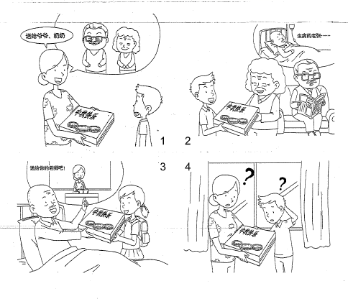
II. LISTENING AND SPEAKING
Section A
Directions: In Section A, you will hear four sentences. Make quick responses to the sentences you have heard.
l.________________________________________________
2.________________________________________________
3.________________________________________________
4.________________________________________________

Section B
Directions: In Section B, you will hear a short passage. The passage will be read twice. After you hear the passage, answer the first question with the information you hear and the second question in your own opinion with at least 3 sentences. For the first question, you will have 30 seconds to prepare and 30 seconds to talk. For the second question, you will have one minute to prepare and another minute to talk.
Questions:
1. Why does Gordon choose bus to go to school?
2. What is the main cause for the heavy traffic in Shanghai in your opinion?

录音内容
Test 1
II. LISTENING AND SPEAKING
Section A
1. Ifs very good of you to help me with this essay writing problem.
2. Mum, I hope I can have an IPad like Jason's.
3. Excuse me, can you tell me how to use this machine to buy a ticket?
4. May I remind you that you borrowed my notes and l need them now?

Section B
Listen to the following speaker talking about a British boy who is at an international school in Shanghai.
Gordon is a fifteen-year-old British： boy； at an international school in Shanghai. His parents work for a British company that has recently opened an office there. Gordon really enjoys his new school. But the problem is that the school is 15 kilometers away from where the family lives. His parents were very worried about how Gordon was going to get to school, so for the first week they took Gordon by car. However, when they had to make sure that Gordon arrived at school at 8, they were late for work.
Gordon is quite keen to cycle, but Mother will not allow that because she is concerned about the heavy traffic on the roads. The taxi is quite expensive and it's usually difficult to get one in rush hour. There isn't direct subway route between his school and his home. Going by bus seems to be the best solution. Buses are cheaper and more frequent. There are other students on the bus and so he has the opportunity to talk with his friends. Gordon now enjoys his journey to school.

推荐答案
SPEAKING
Section C
1. When did you last see your mobile phone?
2. Do you think you might leave it in the Kitchen or on the nightstand in the bedroom?
3. Do you have a computer course in your summer school this year?
4. When will the course start and when will it end?

Section D
Last Monday was Chinese Mid-Autumn Festival. Ming Ming's mother asked him to take a box of moon cakes to his grandparents. Grandma was so delighted since she liked the moon cakes. But Grandpa wanted to give the cakes to their neighbor Lao Zhang, who was ill in bed for quite-a long time, Lao Zhang was grateful to his daughter's teacher, and so he asked his daughter to give the cakes to her teacher, who happened to be Ming Ming's mother. Ming Ming and his mother were surprised to see the box of cakes back to them.

LISTENING AND SPEAKING
Section A
1. You are welcome. / Don't mention it.
2. OK, you can have one as a birthday present next month. / What? You want, another one?
3. Certainly. First you choose your destination, then put the money into the slot and get your ticket here. / Sorry, I don't know how to use it either.
4. Oh, sorry, I’ll give them back to you right away. / What? I asked Mary to give
them to you yesterday.
Section B
1. Buses are cheaper and more frequent and he can meet other students on bus.
2. In my opinion the main cause for the heavy traffic is an increasing number of private cars on the roads. Some families even have two or three cars. Each usually only carries one person or two and this is a big waste of resources.

