高考口语测试模拟卷Test 4
I.SPEAKING .
Section A
Directions: Read aloud the following two sentences. For each sentence, you will have thirty seconds to prepare and fifteen seconds to read.

Speaking:
1.If you're not doing anything special, why don’t you come and spend the weekend with us?
2.As for pollution and food safety problems, we will Upgrade China’s economic development model to enable people to enjoy dean air and safe drinking water and food.

Section B
Directions: Read aloud the following passage. You will have one minute to prepare and thirty seconds to read.

Speaking
Peoples of China and Fiji can enter each other’s country without a visa. The visa waiver is only for trips of less than 30 days. Those who plan to stay longer, for leisure, work or media activity, must apply for visas. Fiji in the South Pacific Ocean is attracting a growing number of Chinese holidaymakers with its beautiful tropical beaches and leisure programs. Now direct flights are operated between Hong Kong and Fiji.

Section C
Directions: Ask two questions about each situation given below. At least one special question should be asked about each situation.
I. Speaking
Questions 1—2: Your family is invited to your cousins wedding. You ask your mother two questions about it.
Question 1:
Question2:

Speaking Section C
Questions 3—4: You are picking up your little brother at his school gate, but you can’t find .him. You ask the porter...

Question 3:
Question 4:

Section D
Directions: You will have one minute to prepare and another minute to talk in at least five sentences about the following pictures. Begin your talk with the sentence given:
The boys are getting ready for a long-distance race.
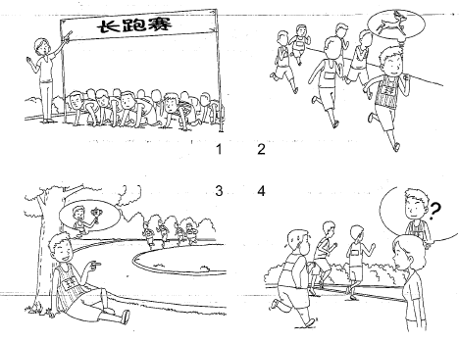

II. LISTENING AND SPEAKING
Section A
Directions: In Section A, you will hear four sentences. Make quick responses to the sentences you have heard.
l.________________________________________________
2.________________________________________________
3.________________________________________________
4.________________________________________________

Section B
Directions: In Section B, you will hear a short passage. The passage will be read twice. After you hear the passage, answer the first question with the information you hear and the second questions in your own opinion with at least 3 sentences. For the first question, you will have 30_seconds to prepare and 30 seconds to talk. For the second question, you will have one minute to prepare and another minute to talk.
Questions：
1. What are two of the problems parents face while choosing a bedtime story book for their kids?
2. Which book would you like to read again? Please explain the reasons to support your choice.

录音内容
Section A
1. Natasha! How nice to see you! What are you doing these days?：
2. Why do you keep so many birds at home?
3. What about a quick drink on the way back?
4. Do you think that young people enjoy life more than old people do?

Section B
Listen to the following speaker talking about the problems in choosing a bedtime story book for kids.

Most parents, I suppose, have had experienced of. reading a bedtime story to their children. And they must have realized how difficult it is to write a good children's book. Either the author has aimed too high, so that children can't follow the story, or the story seems to be talking down to the readers.
The, best children's books keep a balance between these two: to satisfy both the child who hears the story and the adult who reads it. However, there are very few books like this, so the problem of find it able bedtime story is not easy to solve. If you leave children to choose what they like to read in a bookshop or library, they will have a look at the books full of stories and jokes, which will worry teachers and right-thinking parents. Perhaps, we parents should stop forcing our children to accept our taste in reading.

推荐答案
speaking
I. SPEAKING
Section C
1. Where and when is the wedding to be held?
2. Should we buy something for the new couple as a wedding present?
3. Can I go into the classroom to see if my brother is there?
4. What time does the last period end?
Section D
The boys are getting ready for a long-distance race. The teacher gives the signal and the race starts. When Wang Ping is running, he is like a deer. He can run much faster than the other runners. Now he is extremely pleased to see that it will take the rest of them quite a while to catch up with him, and he is sure that it is impossible for them to do so. He sits under a tree, taking a rest and laughing at a fat boy who is far away behind him. At the end of the race, the fat boy wins the third place. But where is Wang Ping? The teacher is wondering.

II. LISTENING AND SPEAKING
Section A
1. Hi, nice to see you too. I am training to be a volunteer. / Fancy seeing you here.
2. Birds are so cute and they are very clever. / These are not mine. My grandpa keeps them.
3. Thanks, but I really should get back home as soon as possible. / Fine. I would like to have a cup of coffee.
4. The younger you are, the more possibilities you have. / The retired people enjoy life more since they have both the money and the time.

Section B
1. Some of the bedtime books are too difficult for kids to understand. Some of the books are not interesting for the parents to read.
2. I will read again the book called Chinese Cinderella by Adeline Yen Mah, who is a Chinese American. It is a true story of an unwanted daughter after her mother died. She was bullied by her half brothers and step mother, and neglected by her father, but she was outstanding in her school learning. Now she is a successful well-known writer. The book is written in English and it is easy to read. For both the language learning and touching story, this book is worth reading again.

