高考口语测试模拟卷Test 5
I.SPEAKING
Section A
Directions: Read aloud the following two sentences. For each sentence, you will have thirty seconds to prepare and fifteen seconds to read.
1.Do you think government should spend as much as possible exploring outer space?

2.As soon as I got home from school, Aunt Lucy noticed the silver medal dangling from the left breast pocket of my school uniform.

Section B
Directions: Read aloud the following passage. You will have one minute to prepare and thirty seconds to read.
Opening our eyes in the morning, we must tell ourselves, "Today is the best day of all days!" No matter what happened yesterday, it is all in the past and there is no way to change it. Don’t let yesterday’s troubles influence today’s good mood! While beginning work each day, no matter how busy or under pressure we are, we shouldn't complain and we shouldn't let our mood be affected. A cry is just for a day, and so is a laugh. So why then shouldn’t we maintain our best mood to get through each day?

Section C
Directions: Ask two questions about each situation given below. At least one special question should be asked about each situation.
Questions 1—2: You find it difficult to decide which computer you should buy. So you ask the shop assistant.
Question 1：
Question 2:

Questions 3—4: You want to go to Yu Garden by subway.
Ask a passer-by two questions for the information.
Question 3:
Question 4：

Section D
Directions: You will have one minute to prepare and another minute to talk in at least five sentences about the following pictures. Begin your talk with the sentence given:
There is a big hole in the road in front of Lao Wang’s house.
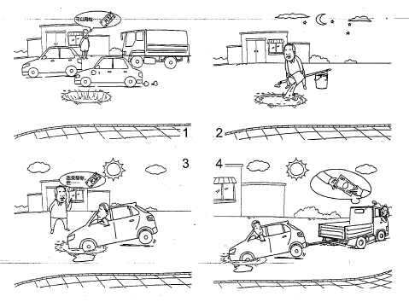

II. LISTENING AND SPEAKING
Section A
Directions: In Section A, you will hear four sentences. Make quick responses to the sentences you have heard.
l.________________________________________________
2.________________________________________________
3.________________________________________________
4.________________________________________________

Section B
Directions: In Section B, you will hear a short passage. The passage will be read twice. After you hear the passage, answer the first question with the information you hear and the second question in your own opinion with at least 3 sentences. For the first question, you will have 30 seconds to prepare and 30 seconds to talk. For the second questions you will have one minute to prepare and another minute to talk.
Questions:
1. What exact conflict did the speaker have between what he was doing and what he should do?
2. Give an example of any conflict you have experienced between what you are doing and what you should do.

录音内容
Section A
1. There is a message for you/Andrew. Here you are.
2. Oh no, not again! I am always making the same mistake.
3. Please do come and stay with us again next time you are here in Shanghai.
4. Whatever you do, you mustn’t touch that switch!

Section B
Listen to the following speaker talking about a problem he had in his first year in high school.
In my first year in high school, I was fascinated with video games. I played them day and night and I wasn't studying enough. I was failing mathematics, which was my hardest subject. But I wanted to go to a good university. It means I must do well in mathematics. I know my mathematics score could play an important role in determining whether or not I was able to be accepted by a good university. However, I couldn't give up playing video games. I was completely torn. Then I found an excuse. See, the only class I was doing really badly in was math. I was Okay with other subjects. I wouldn't take mathematics as major and I might learn computer game designing in the university.

推荐答案
I. SPEAKING
Section C
1. Which is the latest model of this brand?
2. If I buy this model, can you install the soft wares on this list for me?
3. Excuse me, which subway line can I take to go to Yu Garden?
4. Where should I get off to change line 10 to Yu Garden?
Section D
There is a big hole in the road in fronfof Lao Wang's hduse. It is a quite busy road and cars passing by try to avoid the hole. At night, Lao Wang fills the hole with water so that the drivers of the cars can't see how deep the hide is during the day. One man drives his car into the hole and cannot drive out. Lao Wang helps him to pull the car out. Then Lao Wang charges the driver a lot of money for doing this. Thaf s not a decent way to earn money!
II. USTENING AND SPEAKING
Section A
1. Thank you very much. / Oh, it's not for me. Ifs for Andy.
2. Never mind and this always happens. / Why can't you learn the lesson!
3. Oh that's really very kind of you to say so. /1 will, and I will repeat my visit to Shanghai very soon.
4. Never, I will never do it! / Thank you so much to remind me.
Section B
1. He was fascinated with video games, but he should have spent more time on
his school work.
2. I like junk food, such as chips and cola. Moreover, I like eating the junk food before going to bed. I know this is not good for my health and I should get rid of this bad habit and should have more exercises. However, I have an excuse that life is short and enjoy the life as I like.

