
高考口语测试模拟卷Test 6
I.SPEAKING
Section A
Directions: Read aloud the following two sentences. For each sentence, you will have thirty seconds to prepare and fifteen seconds to read.
Speaking
1.Do you think it is a good rule that people are not allowed to smoke in public places and office buildings?
2.Although Chinese Cinderella was written when I was in my late fifties, inside I am still the same little five-year-old yearning for the love, of my parents.

Section B
Directions: Read aloud the following passage. You will have one minute to prepare and thirty seconds to read.
I travelled to Hangzhou, capital of the 12th-century Southern Song Dynasty, in the comfortable seat of a bullet train. The fast train from Shanghai has made Hangzhou a much more accessible destination for foreign tourists. Chinese have been coming here for centuries, but foreigners are now arriving at this city in greater numbers. West Lake, with its 10 classical views that have inspired poets and painters down the ages, was last year made a UNESCO World Heritage Site.

Section C
Directions: Ask 1wo questions about each situation given below. At least one special question should be asked about each situation.

Questions 1-2: Your friend is playing the piano. Ask two questions about music.
Question 1:
Question 2:

Questions 3—4: You meet a foreigner who can speak Chinese fluently. You are curious and want to know more about him. You ask...
Question 3:
Question 4:

Section D
Directions: You will have one minute to prepare and another minute to talk in at least five sentences about the following pictures. Begin your talk with the sentence given:
I don't think it is good for high school students to take a part-time job like Xiao Ding and Li Li...
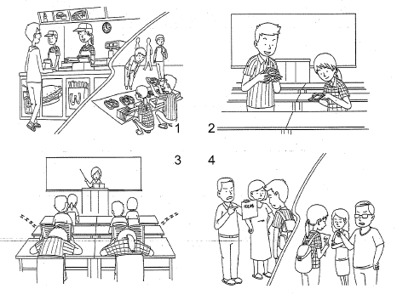

II. LISTENING AND SPEAKING
Section A
Directions: In Section A, you will hear four sentences. Make quick responses to the sentences you have heard.
l.________________________________________________
2.________________________________________________
3.________________________________________________
4.________________________________________________

Section B
Directions: In Section B, you will hear a short passage. The passage will be read twice. After you hear the passage, answer the first question with the information you hear and the second question in your own opinion with at least 3 sentences. For the first question, you will have 30. seconds to prepare and 30 seconds, to talk. For the second question, you will have one minute to prepare and another minute to talk!
Questions:
1. Describe a typical day the speaker spent at the camp.
2. Imagine you are working as a volunteer in a nursing home, what can you learn from this volunteer experience?

录音内容
Section A
1. Could you please stop making so much noise?
2. Louise, do you want me to try to fix your computer?
3. Ifs not a good idea to travel during the rush hour.
4. I was wondering if you^ come to have dinner at our house this Saturday evening.

Section B
Listen to the following speaker talking about his/her experience as a volunteer at a camp last year.

During last summer holiday, I was working as a volunteer at a camp in France, teaching sports activities to children aged 9 to 11. The camp was situated in an area close to a long, sandy beach.
The days at the camp were long and I had to get up at 6:30, and was not usually in bed before midnight. I often had no time to eat lunch, except perhaps for a sandwich. I taught swimming in the morning and basketball in the afternoon. I
also spent my evenings with these children, playing games, watching videos and singing.' One of the .reasons was accepted for the job: was..that l. :can't play the guitar. Generally my happiest times during the day were after dinner when the whole group went to the beach and chatted and sang.
The whole experience has made me think seriously about teaching as a job in the future.

推荐答案
I. SPEAKING
Section C
1. Is this piece composed by Bach?
2. What kind of music do you enjoy playing?
3. How long have you been living in China?
4. Where did you learn to speak Chinese?

Section D
I don't think it is good for high school students to take a part-time job like Xiao Ding and Li Li. My classmates Xiao Ding and Li Li are taking a part-time job in a fast-food restaurant after school. They are also selling shoes on Saturdays or Sundays. Jobs do bring some benefits to them and they are pleased to see the money they have earned. But they can't have enough sleep and they don't have enough energy to study. That is why they are sometimes dozing in class：
Moreover. Xiao Ding fails his exams and his parents are worried. Li Li nearly fails her exams and her mother is extremely angry. So I think a high school student should concentrate his efforts on study.

II. LISTENING AND SPEAKING
Section A
1. Sorry for disturbing you. / What do you mean by "so much noise"?
2. Thanks, but I've already had it taken care of. / Thank you very much. You are so kind.
3. No. It's better to avoid the rush hour. / We can't help it since we must arrive at school on time.
4. I'll look forward to it. / Thanks, but I don't think I can.

Section B
1. She had to get up at 6:30, and was not usually in bed before midnight. She taught swimming in the morning and basketball in the afternoon. In the evening she was playing games and watching videos.

2. Working as a volunteer in a nursing home will make me think about my responsibilities of taking care of the old people. Through talking with them I can learn their stories and experiences which will be valuable to my life. Helping others can give me the happiness and satisfaction.

