
高考口语测试模拟卷Test 7
I.SPEAKING
Section A
Directions: Read aloud the following two sentences. For each sentence, you will, have thirty seconds to prepare and fifteen seconds to read.
1.I just .don’t know what on earth we can tell him", maybe your uncle can help.

2. It gives me great pleasure to inform you that you have been chosen to receive a special award, and a cheque in your name is waiting to be claimed now.

Section B
Directions: Read aloud the following passage. You will have one. minute to prepare and thirty seconds to read.
Surely culture is about how one lives one's life, not the noises we make that is called language. Surely speaking one language — whether it be English or any other language — promotes greater understanding and breaks down barriers. Who really wants to live in a world of 2,000 languages? This makes communication with most of our fellow human beings impossible. Who cares whether ifs English, German or Cantonese — the more of us who talk to one another, the better.

Section C
Directions: Ask two questions about each situation given below. At least one special question should be asked about each situation.
Questions 1~2: You are getting lost in New York City. You may ask a passer-by...
Question 1:
Question 2:

Questions 3~4: You are on a trip to Australia； Now you are going through the immigration control. The officer might ask you...
Question 3:
Question 4:

Section D
Directions: You will have one minute to prepare and another minute to talk in at least five sentences about the following pictures. Begin your talk with the sentence given:
Tom and Mike were going to visit their grandparents by train on Saturday.
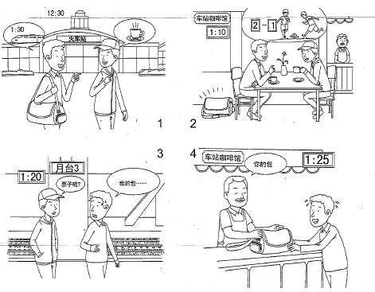

II. LISTENING AND SPEAKING
Section A
Directions: In Section A, you will hear four sentences. Make quick responses to the sentences you have heard.
listening and Speaking
l.________________________________________________
2.________________________________________________
3.________________________________________________
4.________________________________________________

Section B
Directions: In Section B, you will hear a short passage. The passage will be read twice. After you hear the passage, answer the first question with the information you hear and the second question in your own opinion with at least 3 sentences. For the first question, you will have 30 seconds to prepare and 30 seconds to talk. For the second question, you will have one minute to prepare and another minute to talk
Questions:
1. Who does Mrs. Hobson teach in the school?
2. What do you think of Mrs. Hobson’s job? And why?

录音内容
Section A
1. Where are you going during your vacation?
2. What did you think of the math test today?
3. What do you want for dinner tonight? It's seven O'clock：
4. Do send me your photos through Wechaft, Will you?

Section B
Listen to the following speaker talking about Mrs. Hobson's job.
Mrs. Hobson teaches within the state system. The children in these schools may have special physical difficulties, or they may have emotional and intelligence problem. The teachers are specially trained and they work together with teams of psychiatrists and doctors who study the problems and "development of each child. These schools try to get the child back into the normal state system as soon as possible. If this cannot be done, the child will still get an education specially designed for his or her problems.
Mrs. 'Hoson is particularly concerned with children who are extremely aggressive — so aggressive that a normal school cannot deal with them. She also teaches another kind of child who might be considered to be the exact opposite of ;aggressive, the so-called autistic child. A normal school cannot deal with an autistic child either. Both the aggressive and the autistic child are Mrs. Hobson's special concern.

推荐答案
I. SPEAKING
Section C
1. Excuse me, would you please tell me where l am?
2. Which way should I go if I want to see the Statue of Liberty?
3. Are you here on holiday or on business?
4. How long are you going to stay?

Section D
Tom and Mike were going to visit their grandparents by train on Saturday. They arrived at the train station at 12:30. After checking the train time, they knew their train would leave at 1:30 p.m. and on the platform 3. They decided to have some coffee to kill time before the train started. In the Station Cafe, Tom put his bag under the chair. They enjoyed the coffee and talked about a football match. At 1:10 p.m., they walked out of the Cafe, then went towards the platform 3. Suddenly, Mike asked Tom where the tickets were. Only then did Tom realize that he had left his bag in the Cafe. Their tickets were in the bag. Tom rushed to the Cafe. Tom was relieved when he saw his bag was on the counter in the Cafe. The waiter there kept it for them. It's 1:25 p.m. Tom only had 5 minutes to run back to the platform.

II. LISTENING AND SPEAKING
Section A
1. I was suggested going to Tibet. /1 haven't decided yet.
2. To me, calculation tests are not a cup of coffee, but this one was reasonable. / It's almost as easy as the one we had last week.
3. I've had enough meat at the lunch. Some fruit will do. / Thank you, but I'm not hungry now.
4. No problem. / Sure, I will.

Section B
1. Both the aggressive and the autistic-children.
2. Her job is very important. Though the children with emotional and intelligence problems couldn't study in normal schools, they need the education to help them to overcome their problems. Mrs. Hobson and the school she works in play an important role in this kind of education.

