高考口语测试模拟卷Test 8
I.SPEAKING
Section A
Directions: Read aloud the following two sentences. For each sentence, you will have thirty seconds to prepare and fifteen seconds to read.
1.Why don't you take, on your coat and make yourself comfortable?
2.I have just read your advertisement in an English- language newspaper published in my country, and I am now writing for further details of your accommodation.

Section B
Directions: Read aloud the following passage. You will have one minute to prepare and thirty seconds to read.
Mr. Jenkins, my old neighbor, was a very dull person who held only conventional ideas and led an extremely ordinary life. It came no great surprise when I discovered that his hobby was memorizing bus timetables. When asked, for example, how to get from a unknown part of the country to another' on a Wet Wednesday afternoon, he could detail precisely which buses one would have to take, where to change, and how long the journey would last, but he could never conceal the expression of excitement that overcame him when he had met such a challenge.

Section C
Directions: Ask two questions about each situation given below. At least one special question should be asked about each situation.
Questions 1—2: You are not feeling well today. You are calling your teacher and asking for leave. Your teacher may ask you...
Question 1:
Question 2:

Questions 3~4： You find your designate is having trouble in writing an essay. Ask two questions about it.
Question 3:
Question 4:

Section D
Directions: You will have one minute to prepare and another minute, to talk in at least five sentences about the following pictures. Begin your talk with the sentence given:
Xiao Ming’s grandparents are planning their life after retirement.
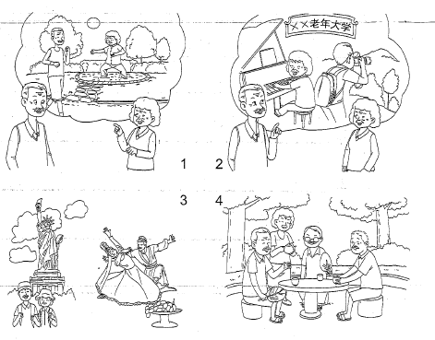
II. LISTENING AND SPEAKING
Section A
Directions: In Section A, you will hear four sentences. Make quick responses to the sentences you have heard.
l.________________________________________________
2.________________________________________________
3.________________________________________________
4.________________________________________________

II. Listening and Speaking
Section B
Directions: In Section B, you will hear a short passage. The passage will be read twice. After you hear the passage, answer the first question with the information you hear and the second question in your own opinion with at least 3 sentences. For the first question, you will have 30 seconds to prepare and 30 seconds to talk. For the second question, you will have one minute to prepare and another minute to talk.
Questions:
1. Why do most people move their body when listening to music that is more or less familiar?
2. What do you usually do when you listen to the music? Why?

录音内容
II. LISTENING AND SPEAKING
Section A
1. I'm going to the market today. Can I pick up anything for you?
2. I broke my ankle last Tuesday and now I have to be on walking sticks for six weeks .
3. What will we treat our guest at the dinner party on weekend?
4. I haven’t bought my sports shoes which I need at the physical training class tomorrow.

Section B
Listen to the following speaker talking about listening to music.
You surely are not surprised to be told that you usually listen to music not only with your ears but with your whole body. Few people can listen to music that is more or less familiar without moving their body or, more specifically, some part of their body. Often when one listens to a symphonic concert on the radio, he is tempted to direct the orchestra even though he knows there is a competent conductor on the job. Strange as this behavior may be, there is a very good reason for it. One cannot obtain all possible enjoyment from music unless he participates, so to speak, in its performance. The listener feels himself into the music with more or less pronounced motions of his body.
The muscles of the body actually participate in the mental process of thinking in the same way, but this participation is less obvious because it is less pronounced.

推荐答案
I. SPEAKING
Section C
1. What's wrong with you, Xiao Ming?
2. Anything I can do for you?
3. What s the topic of your essay?
4. Have you revised the organization of your draft?.

Section D
Xiao Ming’s grandparents are planning their life after retirement. To keep fit, they will go to park in the morning. Doing morning exercise can do good to their health. Grandma would like to play Taiji while grandpa prefers jogging. Taking courses they are interested in at a College, for the Senior is another thing they want to do. Playing the piano was grandma's dream when she was a little girl. Grandpa wants to learn1 photography. Traveling around the world will also be a part of. their life. Their first destination abroad is America and perhaps Xinjiang is the best place they want to visit in China. They will also spend some time meeting friends and relatives. Seeing films, eating delicious food together and talking about the news around the world will surely make their life more colourful.

LISTENING AND SPEAKING
Section A
1. No, thanks. / Some fresh vegetables, thank you.
2. I am sorry to hear that. / Is there anything I can do for you?
3. I don't know. I've totally run out of ideas what to buy and prepare. / Let's go to the supermarket and see what we can buy.
4. Me neither. / Don’t worry，you can use mine.
Section B
1. They can get all possible enjoyment from music in this way.
2. I usually move my head up and down with the rhythm. It is just a natural reaction to the music I like. Sometimes, when I feel the music is very peaceful and beautiful, I will close my eyes,listening to music. I understand it is the way people use to express their enjoyment.

