高考口语测试模拟卷Test 9
I. SPEAKING
Section A
Read aloud the following two sentence, you will have thirty seconds to prepare and fifteen seconds to read.
1. It doesn't matter what she thinks ---it's what you think that worries me.

2. We are interested in a holiday in the first week of June and would be most grateful if you could let us know whether you have a suitable cottage at this time.

Section B
Directions: Read aloud the following passage. You will have one minute to prepare and thirty seconds to read.
It happened again the other night. We're watching the weather report on television. A generic-looking man in a generic-looking suit slides back and forth before a map of the region, telling us we have nothing to worry about. Only a slight chance of an isolated thunderstorm after midnight. It is 6:30 p.m. He smiles, tells us to have a great evening and fades away to sports.
Less than an hour later, ifs pouring. And I mean pouring. It remains one of life's little mysteries to me how such well-intentioned and well-trained people using such high-tech equipment can be so wrong, and so often.

Section C
Directions: Ask two questions about each situation given below. At least one special question should be asked about each situation.
Questions 1 —2: A reporter from your school newspaper is interviewing you about your expense within a week. He may ask...
Question 1：
Question 2:
Questions 3—4: You missed the plane because of the traffic jam. You ask the staff in the airport...
Question 3:
Question 4:

Section D
Directions: You will have one minute to prepare and another minute to talk in at least five sentences about the following pictures. Begin your talk with the sentence given:
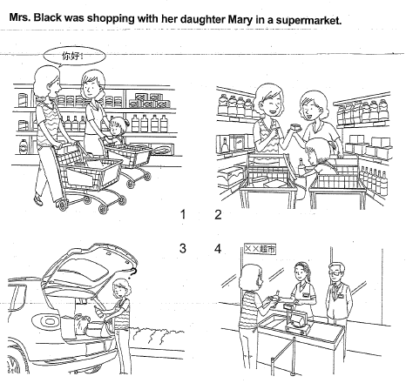
II. LISTENING AND SPEAKING
Section A
Directions: In Section A, you will hear four sentences. Make quick responses to the sentences you have heard.
l.________________________________________________
2.________________________________________________
3.________________________________________________
4.________________________________________________

Section B
Directions: In Section B, you will hear a short passage. The passage, will be read twice. After you hear the passage, answer the first question with the information you hear and the second question in your own opinion with at least 3 sentences. For the first question, you will have 30, seconds to prepare and 30 seconds to talk. For the second question, you will have one minute to prepare and another minute to talk.
Questions:
When did the women in Britain have the right to vote?
2. What sort of industries do you think is more suitable for women? Why?

录音内容
II. LISTENING AND SPEAKING
Section A '
1. Would you be interested in a tour of the city later?
2. I'm sorry to have left your umbrella in the dining room.
3. I went to San Francisco last week but didn't have time to look Mr. and Mrs. Ray
4. Oh, my god, I hate memorizing vocabulary.

Section B
Listen to the following speaker talking about great changes in .women’s position in Britain.
Since 1900 there have been great changes in women’s position in Britain. In 1900, for example, women spent almost all of their adult lives in having and taking care of children. This would go on until she was 55, if she was lucky enough to live that long.

In 1900, women had no right to vote. They could not even own property in marriage. The husband was the bread-winner and the 'lord and was if 'Women got the right to vote after the First World War. Other rights followed more slowly.
In 1900, the only professional jobs open to women were teaching. There were no women lawyers, engineers or architects. No women had high positions in politics. Today, women seem to have the best professional chances in education, as teachers and professors, in medicine, as doctors. Other good jobs for women can be found in the new industries like computer. Many of the top computer programmers and specialists are women. Women are also slowly winning some of the top positions in politics.

推荐答案
I. SPEAKING
Section C
1. Do you have pocket money?
2. How much money do you spend within a week?
3. What shall I do now since my plane has stopped checking in?
4. When does the next flight leave?
Section D
Mrs. Black was shopping with her daughter Mary in a supermarket,
Mary likes very much to stay in the shopping trolley. Mrs. Black was glad when she met her friend Jane. Then they were talking and walking along the goods shelves. Mary took a bottle of wine from the shelf as her mother usually did. But she put it into Jane's bag. The two women didn't notice what Mary did. It was not until that Jane was putting the goods into her car did she find the bottle in her bag. She was puzzled and couldn’t understand what had happened She thought for a while and decided to return the bottle of wine to the casher in the supermarket. Anyway, it was unpaid and it didn't belong to her.
II. LISTENING AND SPEAKING
Section A
1. I'd love that. Thanks. / Sounds nice..
2. Never mind. It is shining./That’s OK.
3. That was a pity. They were both so kind to us, / Why? How could you do that?
4. Well, it's a part of learning a second language. / Me too.
Section B
1. After the First World War.
2. I think, even today, teaching is still more suitable for women. Teaching is a job requiring a kindly and tender nature. Women usually possess this nature. They can treat their students as their own kids with patience and love. On the other hand, being teachers； women can enjoy more holidays than the women who work in other industries. It is a good profit for them and their families.

