高考口语测试模拟卷Test 10
I. SPEAKING
Section A
Directions: Read aloud the following two sentences . For each sentences, you will have thirty seconds to prepare and fifteen seconds to read.
1.Would you invest half a month’s salary on a single item of clothing?
2. Three years ago, my daughter took her exams, won a university place and decided to take a year off between leaving school and starting university.

Section B
Directions: Read aloud the following passage. You will have one minute to prepare and thirty seconds to read.
I was at a wedding recently, and this woman comes up to me and says, "Oh, I hear you're in the Special Olympics!” That’s about the biggest insult you could say to me. The Special Olympics are for people with severe mental disabilities. They are held every year in every city, and everyone gets' a hug and a ribbon at the end. The Paralympics aren’t like that. We train year-round. It’s very competitive — there's wheelchair basketball, fencing, powerlifting — it's not one of these disabled sports where people are like, “Oh, it's so good to see you out here. You just threw that one foot, and we’re so glad!”

Section C
Directions: Ask two questions about each situation given below. At least one special question should be asked about each situation.

Questions 1—2: Your mum is too busy to cook the lunch, so you call to order a home delivery. You may ask."
Question 1:
Question 2:
Questions 3—4: You lost your luggage at the airport. You ask the staff there for help. He may ask …
Question 3:
Question 4:

Section D
Directions: You will have one minute to prepare and another minute to talk in at least five sentences about the following pictures. Begin your talk with the sentence given:
Xiao Ming and his parents took a trip to New York to Visit his uncle’s last month.
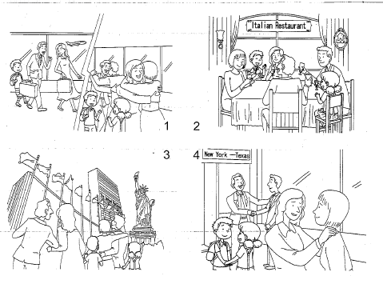
II. LISTENING AND SPEAKING
Section A
Directions: In Section A, you will hear four sentences. Make quick responses to the sentences you have heard.
l.________________________________________________
2.________________________________________________
3.________________________________________________
4.________________________________________________

Section B
Directions: In Section B, you will hear a short passage. The passage, will be read twice. After you hear the passage, answer the first question with the information you hear and the second questions in your own opinion with at least 3 sentences. For the first question, you will have 30 seconds to prepare and 30 seconds to talk. For the second question, you will have one minute to prepare and another minute to talk.
Questions:
1. What does the word “family” mean in that earlier time in America?
2. Which family type do you think is better, a nuclear family or an extended one? And why?

录音内容
II. LISTENING AND SPEAKING
Section A
1. Excuse me, could you bring me a glass of water, please?
2. Hi, Annie! You're looking better. Ifs nice to have you back.
3. Do you mind if I look at your notebook?
4. I can't find the kind of jogging shoes I want anywhere in the city.
Section B
Listen to the following speaker talking about the family.
When an American today says "my family is coming to visit , he or she is using family in the broad sense to include cousins, uncles, grandparents, or any other relatives who do not live with him or her. That is, this person is using/am//y the way it was used one hundred and fifty years ago when the majority of Americans were farmers. In that earlier time, of course, three or more generations lived under one roof — grandparents, their children, their children’s spouses, and their children and their children's children. Now, this kind of family can also be called an extended family, while a nuclear family includes only parents and their children.
But family is a very vague word. As a result, the expression immediate family has come into use. It means something between the narrowest use of family and the broadest one: usually the grandparents，their children，and their children’s children.

推荐答案
I. SPEAKING
Section C
1. Would you please send two pizzas and some chicken wings to No. 212, Hong Mei Road?
2. How soon can the delivery arrive?
3. What flight were you on?
4. Can you show me your luggage tag?
Section D
Xiao Ming and his parents took a trip to New York to visit his uncle last month. The flight was very pleasant. His uncle and the family met them at the airport. They were happy to see each other. They hugged and kissed. His uncle entertained them in an Italian restaurant. They had a lovely Italian dinner together in the evening. The next day they got up early and started their sightseeing in New
York. Then went to Central Park, and they also visited the United Nations building and the Statue of Liberty. Xiao Ming and his family went on with their trip in America for four wonderful days in New York. They were-sad to leave America. They invited his uncle's family to come to Shanghai for a visit. They said good-bye many times.
II. LISTENING AND SPEAKING
Section A
1. Sorry，but I’m not a waiter / Here it is.
2. Thanks, I just hope I can catch up on the work I’ve missed. / Thank you. I'm happy to see you again.
3. No, of course not. / Sorry, I left it in my dormitory.
4. Why not order them online? / Have you ever tried the shoe store at the end of the street?
Section B
1. Three or more generations lived under one roof.
2. I personally prefer an extended family. My grandparents live with us. They can help with the housework, such as shopping, washing and cooking. But sometimes when they feel ill, my parents can take them to hospital timely. And I like to see my grandparents waiting for me at home after my finishing a day's school. We live a happy life together.

