Three Products, Seven Questions
Products that solve a problem created by a larger company
Phan Ngoc Anh
23 September 2026
This study compares three products from the Product Hunt leaderboard for the week of 20 September 2026: Harbor, Termphin and Launchie. They sit in different categories, and I selected them because they share one property that is easy to test. In each case the problem being solved was created by a decision at a larger company, not by a limit in technology. I answer the seven required questions one at a time and compare all three products inside each question. That order is deliberate. Profiling each product separately hides the differences between them, while answering the same question three times makes those differences directly comparable. Each question ends with a short judgement on what the evidence supports and where it is weak.
Part 1. Product Study
Question 1. Product name and link
Harbor. Tagline: the Evernote alternative that puts its price in writing. Built by Spicer Matthews at Cloudmanic Labs. Launched this week, rank 5, 150 votes. Page: https://www.producthunt.com/products/harbor-2 (Product Hunt, 2026b).
Termphin. Tagline: SSH client with sessions that never drop. Built by Mikolaj and fmerian. Rank 6, 127 votes. Page: https://www.producthunt.com/products/termphin (Product Hunt, 2026d).
Launchie. Version 1.6.1 launched this week at rank 8 with 104 votes. The first release was October 2025, so the product is a year old. Built by Nick Friedrich alone. Page: https://www.producthunt.com/products/launchie (Product Hunt, 2026c).
Question 2. Who is it for, and why do people like it?
Harbor. Individual users, not teams. The maker states this limit openly rather than claiming a wider market. The target group is people holding years of notes in Evernote who have watched the price increase. The reason given for switching is predictable cost, not a missing feature.
Termphin. Engineers who operate servers from a phone. The makers name a second group directly: users who start AI coding agents such as Claude Code and then leave the machine. Comments concentrate on one point, that nothing has to be configured on the server.
Launchie. macOS users who had organised their applications into folders before Apple changed the system. The group is small but its complaint is specific. The evidence is thin at this stage, because no reviews are posted and the maker is still requesting feedback.
Two of the three define their user by something the user lost, not by a task the user wants to finish. That is a narrow definition, and it has one clear advantage: the claim can be verified by asking whether the loss was actually restored.
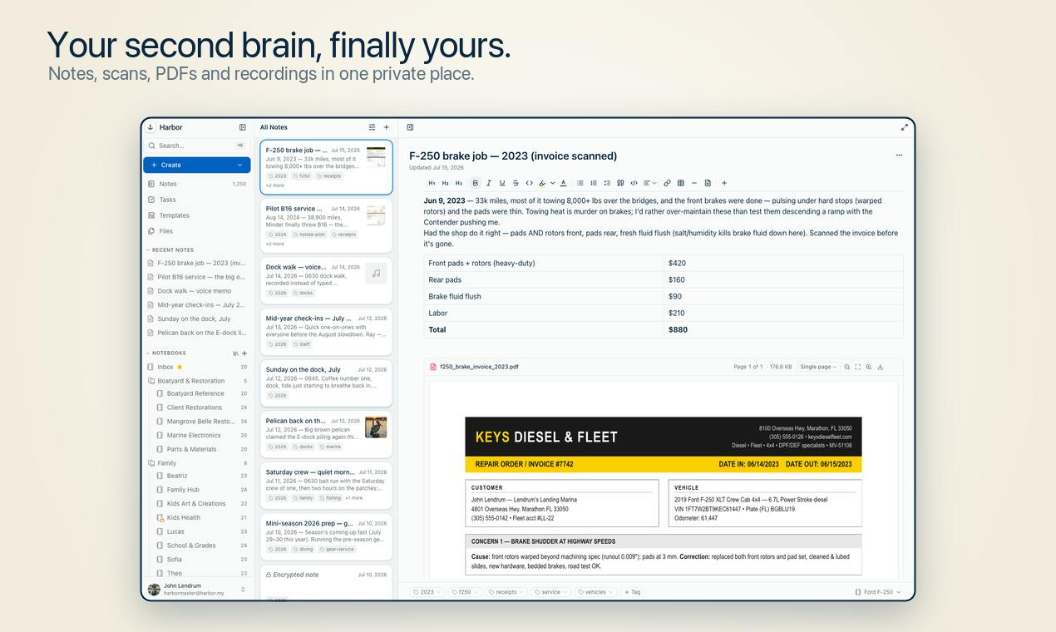
Figure 1. Harbor. Notes, scanned invoices, PDFs and voice memos in one place, searchable including handwriting.
Question 3. What problem does it solve?
Harbor. Evernote raised prices and restricted export. Harbor cites its own figure, that 54 percent of negative Evernote reviews mention price (Product Hunt, 2026b). The problem is not the amount charged. It is that the amount can change after the data is already stored, at which point leaving is expensive.
Termphin. A mobile connection fails routinely. The phone locks, signal drops, or the network switches to mobile data. When the connection dies the remote shell dies with it, and any long running job is lost. The cause sits outside the application, so a fix that lives only inside the application cannot work.
Launchie. Apple removed Launchpad in macOS 26 and did not restore it in 27. The replacement sorts applications automatically and offers no folders, so a layout built over several years was lost with no way to carry it forward.
All three problems originate in an external decision. This changes the standard these products are measured against. They do not need to beat a competing product. They need to be more stable than the organisation that caused the problem.
Question 4. How does it work?
Harbor. Native clients for Mac, Windows, iPhone, iPad, Android, the web and the command line. Import from Evernote takes one step. Notes can be encrypted individually. Search covers scanned documents and handwriting. Export is available on every plan, including the free one.
Termphin. On the first connection the app copies a small program written in Rust onto the server, using the same SSH session. That program holds the shell open on the server. A foreground service on the phone prevents the operating system from closing the socket. Reconnecting returns the same session with its output intact, and no server configuration is required from the user.
Launchie. A grid the user arranges directly. Unlimited folders, separate pages called Spaces, instant search and a Quick Access area. The paid tier adds wallpaper backgrounds, hot corners, hidden applications and pinch gestures.
The three differ in where the work is placed. Harbor solves its problem on the client, Launchie restores a system function, and Termphin moves the critical part onto the server. Termphin's choice is the strongest of the three, because it puts the fix on the only component that stays connected.
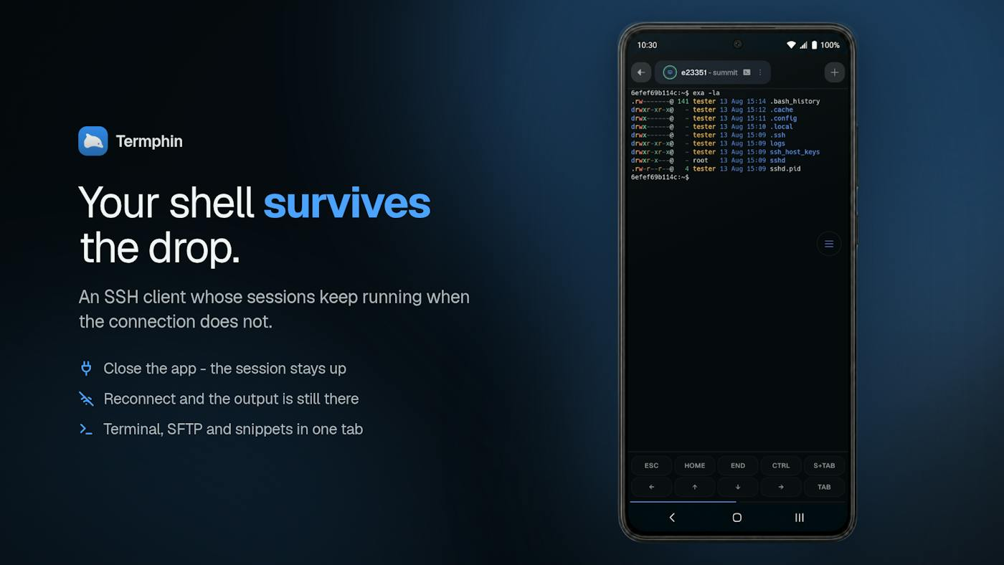
Figure 2. Termphin. The claim and the mechanism in one image: close the app, reconnect, the output is still there.
Question 5. What capabilities or AI does it use?
Harbor. No model of its own, and this appears to be deliberate. The stated position is that the user connects whichever assistant they already pay for, through an open API, a command line tool and MCP, with full export on every plan. The rest of the stack is ordinary: Stripe, Plausible, DigitalOcean. Building a model in would create exactly the dependency the product argues against, so its absence is consistent with the pitch.
Termphin. No model inside the product either, but it touches AI on both sides. It was built using Claude Code and Kilo Code, and one of its named user groups runs those agents on remote machines through it. The engineering that matters is the Rust helper and the Flutter client. Around them sit jump hosts, port forwarding, host key pinning, biometric lock and a key toolbar. The makers state there are no plugins, no extras and no account.
Launchie. None. The capability is restraint. It performs one function that used to exist, it is sold as a single purchase rather than a subscription, and the free tier is a working product rather than a trial.
This is the most informative of the seven questions. All three rank in the top ten of a week dominated by agent products, and none of them uses a model. The value they sell is control and reliability, and a model does not supply either.
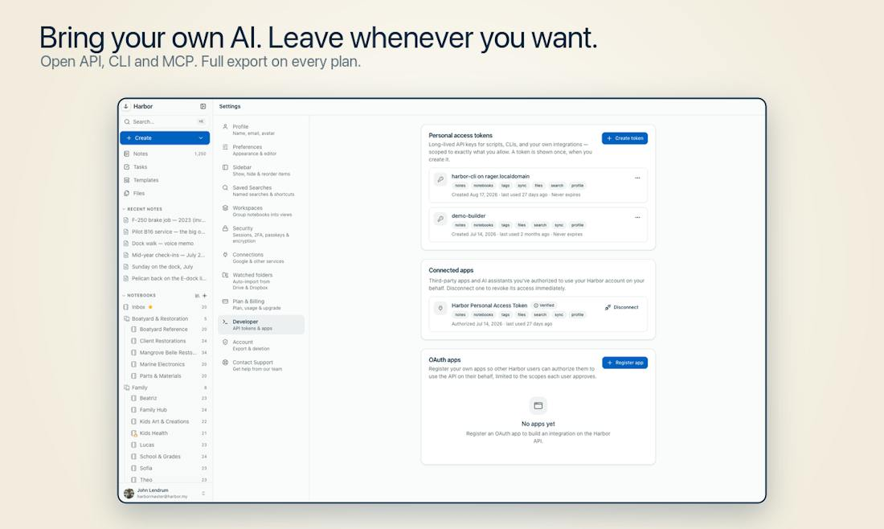
Figure 3. Harbor's position on lock in. The exit is documented as plainly as the features that keep the user.
Question 6. Is it easy to use?
Harbor. The hardest step, moving years of notes, is reduced to a single action, and the one posted review confirms the Evernote export worked. A single review at four stars is not sufficient evidence, so this is the least supported claim in the study.
Termphin. Easier than the standard alternative. Keeping a remote session alive normally means learning tmux or screen and configuring the server by hand. Termphin removes that step entirely, and the comments confirm it in practice.
Launchie. The learning cost is close to zero, because the interface reproduces one the users already knew. That is a structural advantage of rebuilding a removed feature rather than designing a new one.
In all three cases ease of use means removing a setup step, not simplifying an interface. They compete on the cost of starting rather than the cost of continuing, which suggests the first session is where these products are won or lost.
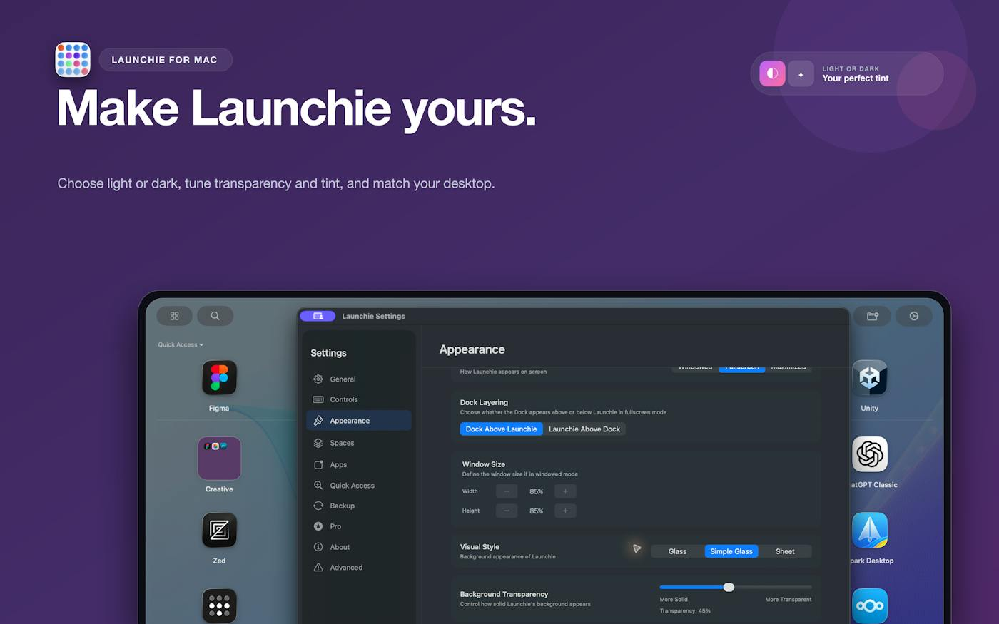
Figure 4. Launchie. The removed feature, rebuilt, with settings the original never offered.
Question 7. One detail I would borrow
Harbor. State the pricing rule as a number inside the product. Ten dollars a month, fixed for three years, then limited to ten percent a year, and a cancelled account becomes read only instead of being deleted. A commitment written as numbers can be checked later. A commitment written as intent cannot, which is why most of them are written that way.
Termphin. Put the fix at the point of failure, and make the setup invisible. The phone cannot be made reliable, so the session was moved to the machine that stays online, and the user is asked to configure nothing. The technical cost was paid by the makers rather than passed to the user.
Launchie. Treat a removed feature as a defined market. The users already understand the problem, so the cost of explaining the product is close to zero, and that explanation is normally the most expensive part of a launch.
Conclusion
None of these products competes with another product. Harbor competes with a pricing decision, Termphin with an unreliable network, and Launchie with a change made in an operating system release. Three consequences follow. First, the maker can be one person, because the requirement is a specific fix rather than a full platform. Second, the user arrives already convinced, because the problem was experienced directly. Third, and this is the part the launch pages do not mention, the main risk is not a competitor but a reversal by the company that caused the problem. If Evernote caps its pricing or Apple restores Launchpad, two of these three lose their central argument overnight. Termphin is the exception, because a mobile connection will not be made reliable by any company decision, which makes it the only one of the three with a problem that cannot be taken away from it.
Part 2. Product Idea
The three products in this study all protect a user from a decision made somewhere else, and my own idea follows the same line. I want to build Exit Check, a small service that keeps a working copy of your data outside the platforms you depend on and tells you what leaving each one would cost. The real problem is that the cost of leaving a service stays unknown until the moment you need to leave, which is also the moment you have the least time to deal with it. Exit Check would run each service's own export on a schedule, store the result in a folder the user controls, open the file to confirm it is readable rather than merely downloaded, and report what did not come out. It is for individuals and small teams who keep years of work inside subscription tools, which is the same group Harbor is aimed at. The product is deliberately plain: no model, no dashboard, one question answered honestly, which is how much it would actually hurt to leave.
References
Product Hunt. (2026a, September 20). Daily leaderboard, 20 September 2026. Retrieved September 23, 2026, from https://www.producthunt.com/leaderboard/daily/2026/9/20
Product Hunt. (2026b). Harbor. Retrieved September 23, 2026, from https://www.producthunt.com/products/harbor-2
Product Hunt. (2026c). Launchie. Retrieved September 23, 2026, from https://www.producthunt.com/products/launchie
Product Hunt. (2026d). Termphin. Retrieved September 23, 2026, from https://www.producthunt.com/products/termphin
Product Hunt. (2026e, September 14). Weekly leaderboard, week of 14 September 2026. Retrieved September 23, 2026, from https://www.producthunt.com/leaderboard/weekly/2026/38

