Three Products, Seven Questions
Products that solve a problem created by a larger company
Phan Ngoc Anh
23 September 2026
This study compares three products from the Product Hunt leaderboard for the week of 20 September 2026: Harbor, Termphin and Launchie. They sit in different categories, and I selected them because they share one property that is easy to test. In each case the problem being solved was created by a decision at a larger company, not by a limit in technology. I answer the seven required questions one at a time and compare all three products inside each question. That order is deliberate. Profiling each product separately hides the differences between them, while answering the same question three times makes those differences directly comparable. Each question ends with a short judgement on what the evidence supports and where it is weak.
Part 1. Product Study
Question 1. Product name and link
Harbor. Tagline: the Evernote alternative that puts its price in writing. Built by Spicer Matthews at Cloudmanic Labs. Launched this week, rank 5, 150 votes. Page: https://www.producthunt.com/products/harbor-2 (Product Hunt, 2026b).
Termphin. Tagline: SSH client with sessions that never drop. Built by Mikolaj and fmerian. Rank 6, 127 votes. Page: https://www.producthunt.com/products/termphin (Product Hunt, 2026d).
Launchie. Version 1.6.1 launched this week at rank 8 with 104 votes. The first release was October 2025, so the product is a year old. Built by Nick Friedrich alone. Page: https://www.producthunt.com/products/launchie (Product Hunt, 2026c).
Question 2. Who is it for, and why do people like it?
Harbor. Individual users, not teams. The maker states this limit openly rather than claiming a wider market. The target group is people holding years of notes in Evernote who have watched the price increase. The reason given for switching is predictable cost, not a missing feature.
Termphin. Engineers who operate servers from a phone. The makers name a second group directly: users who start AI coding agents such as Claude Code and then leave the machine. Comments concentrate on one point, that nothing has to be configured on the server.
Launchie. macOS users who had organised their applications into folders before Apple changed the system. The group is small but its complaint is specific. The evidence is thin at this stage, because no reviews are posted and the maker is still requesting feedback.
Two of the three define their user by something the user lost, not by a task the user wants to finish. That is a narrow definition, and it has one clear advantage: the claim can be verified by asking whether the loss was actually restored.
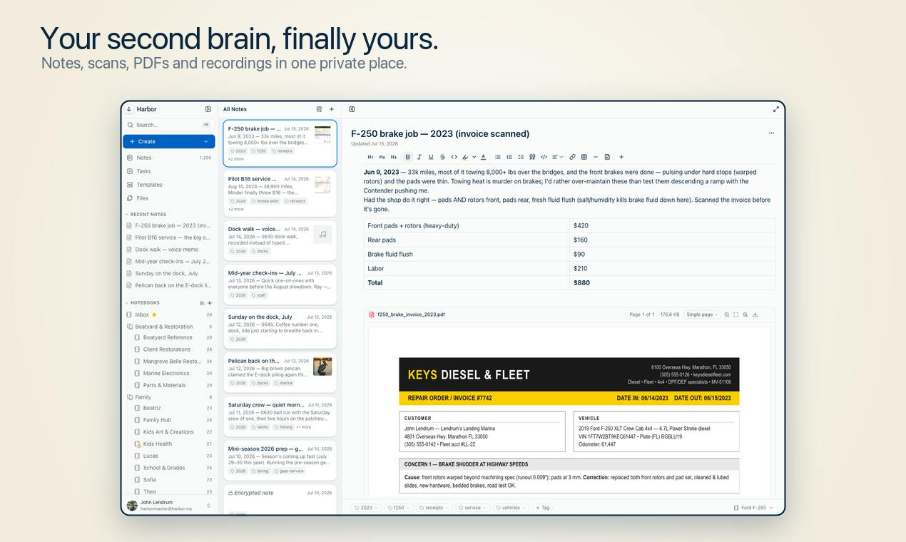
Figure 1. Harbor. Notes, scanned invoices, PDFs and voice memos in one place, searchable including handwriting.
Question 3. What problem does it solve?
Harbor. Evernote raised prices and restricted export. Harbor cites its own figure, that 54 percent of negative Evernote reviews mention price (Product Hunt, 2026b). The problem is not the amount charged. It is that the amount can change after the data is already stored, at which point leaving is expensive.
Termphin. A mobile connection fails routinely. The phone locks, signal drops, or the network switches to mobile data. When the connection dies the remote shell dies with it, and any long running job is lost. The cause sits outside the application, so a fix that lives only inside the application cannot work.
Launchie. Apple removed Launchpad in macOS 26 and did not restore it in 27. The replacement sorts applications automatically and offers no folders, so a layout built over several years was lost with no way to carry it forward.
All three problems originate in an external decision. This changes the standard these products are measured against. They do not need to beat a competing product. They need to be more stable than the organisation that caused the problem.
Question 4. How does it work?
Harbor. Native clients for Mac, Windows, iPhone, iPad, Android, the web and the command line. Import from Evernote takes one step. Notes can be encrypted individually. Search covers scanned documents and handwriting. Export is available on every plan, including the free one.
Termphin. On the first connection the app copies a small program written in Rust onto the server, using the same SSH session. That program holds the shell open on the server. A foreground service on the phone prevents the operating system from closing the socket. Reconnecting returns the same session with its output intact, and no server configuration is required from the user.
Launchie. A grid the user arranges directly. Unlimited folders, separate pages called Spaces, instant search and a Quick Access area. The paid tier adds wallpaper backgrounds, hot corners, hidden applications and pinch gestures.
The three differ in where the work is placed. Harbor solves its problem on the client, Launchie restores a system function, and Termphin moves the critical part onto the server. Termphin's choice is the strongest of the three, because it puts the fix on the only component that stays connected.
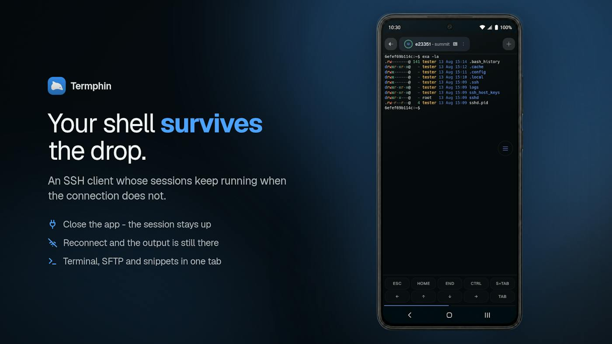
Figure 2. Termphin. The claim and the mechanism in one image: close the app, reconnect, the output is still there.
Question 5. What capabilities or AI does it use?
Harbor. No model of its own, and this appears to be deliberate. The stated position is that the user connects whichever assistant they already pay for, through an open API, a command line tool and MCP, with full export on every plan. The rest of the stack is ordinary: Stripe, Plausible, DigitalOcean. Building a model in would create exactly the dependency the product argues against, so its absence is consistent with the pitch.
Termphin. No model inside the product either, but it touches AI on both sides. It was built using Claude Code and Kilo Code, and one of its named user groups runs those agents on remote machines through it. The engineering that matters is the Rust helper and the Flutter client. Around them sit jump hosts, port forwarding, host key pinning, biometric lock and a key toolbar. The makers state there are no plugins, no extras and no account.
Launchie. None. The capability is restraint. It performs one function that used to exist, it is sold as a single purchase rather than a subscription, and the free tier is a working product rather than a trial.
This is the most informative of the seven questions. All three rank in the top ten of a week dominated by agent products, and none of them uses a model. The value they sell is control and reliability, and a model does not supply either.
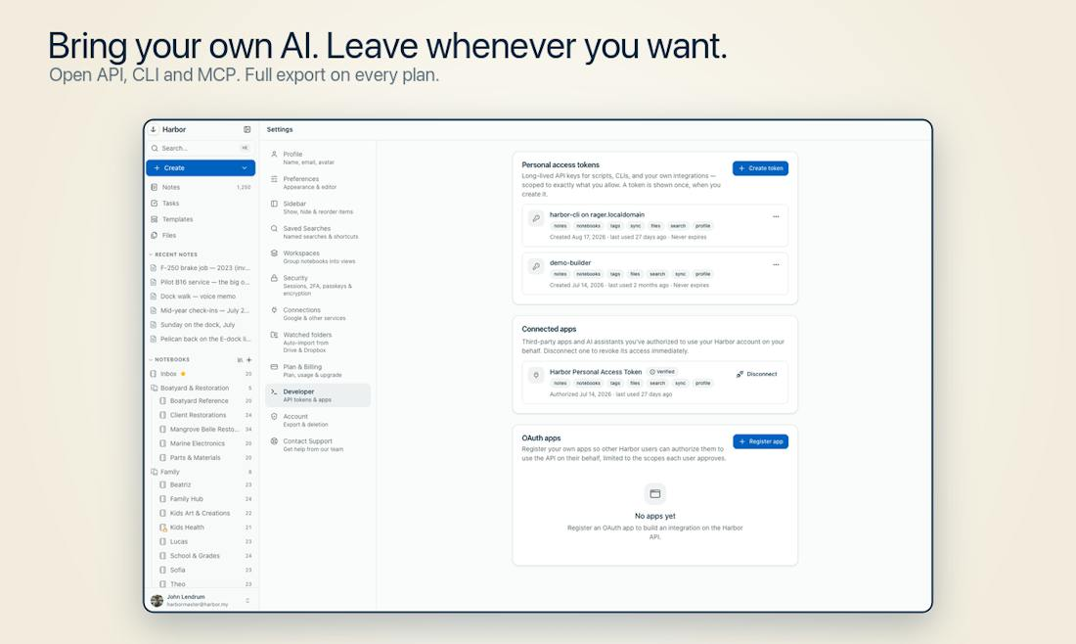
Figure 3. Harbor's position on lock in. The exit is documented as plainly as the features that keep the user.
Question 6. Is it easy to use?
Harbor. The hardest step, moving years of notes, is reduced to a single action, and the one posted review confirms the Evernote export worked. A single review at four stars is not sufficient evidence, so this is the least supported claim in the study.
Termphin. Easier than the standard alternative. Keeping a remote session alive normally means learning tmux or screen and configuring the server by hand. Termphin removes that step entirely, and the comments confirm it in practice.
Launchie. The learning cost is close to zero, because the interface reproduces one the users already knew. That is a structural advantage of rebuilding a removed feature rather than designing a new one.
In all three cases ease of use means removing a setup step, not simplifying an interface. They compete on the cost of starting rather than the cost of continuing, which suggests the first session is where these products are won or lost.
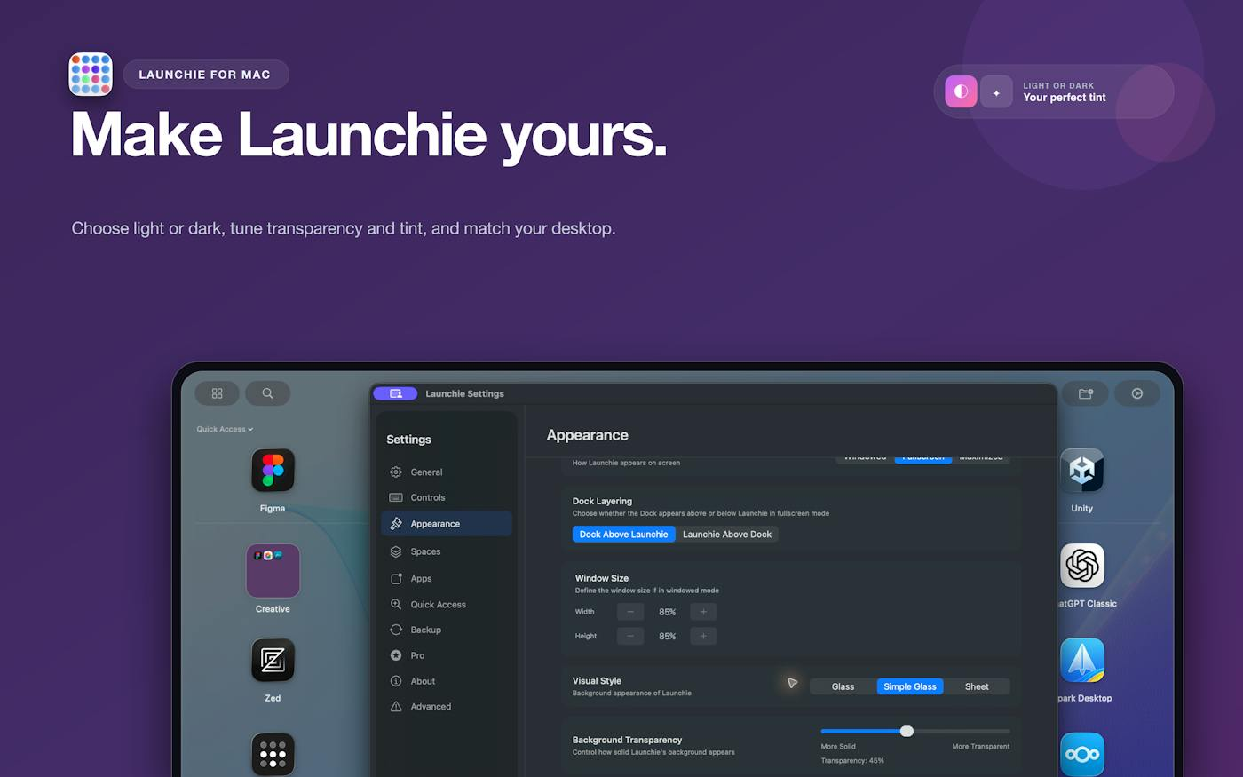
Figure 4. Launchie. The removed feature, rebuilt, with settings the original never offered.
Question 7. One detail I would borrow
Harbor. State the pricing rule as a number inside the product. Ten dollars a month, fixed for three years, then limited to ten percent a year, and a cancelled account becomes read only instead of being deleted. A commitment written as numbers can be checked later. A commitment written as intent cannot, which is why most of them are written that way.
Termphin. Put the fix at the point of failure, and make the setup invisible. The phone cannot be made reliable, so the session was moved to the machine that stays online, and the user is asked to configure nothing. The technical cost was paid by the makers rather than passed to the user.
Launchie. Treat a removed feature as a defined market. The users already understand the problem, so the cost of explaining the product is close to zero, and that explanation is normally the most expensive part of a launch.
Conclusion
None of these products competes with another product. Harbor competes with a pricing decision, Termphin with an unreliable network, and Launchie with a change made in an operating system release. Three consequences follow. First, the maker can be one person, because the requirement is a specific fix rather than a full platform. Second, the user arrives already convinced, because the problem was experienced directly. Third, and this is the part the launch pages do not mention, the main risk is not a competitor but a reversal by the company that caused the problem. If Evernote caps its pricing or Apple restores Launchpad, two of these three lose their central argument overnight. Termphin is the exception, because a mobile connection will not be made reliable by any company decision, which makes it the only one of the three with a problem that cannot be taken away from it.
Part 2. Product Idea
The three products in this study all protect a user from a decision made somewhere else, and my own idea follows the same line. Exit Check is a small service that keeps a working copy of your data outside the platforms you depend on, opens that copy to confirm it is readable rather than merely downloaded, and tells you in one sentence what leaving each platform would cost. I built a working prototype of it before writing this section, which is why the sections below are able to separate the parts of the idea I was able to test from the parts I was not, and to report the two places where building it changed my answer.
The problem
The cost of leaving a service stays unknown until the moment you need to leave, which is also the moment you have the least time to deal with it. This is not the same problem as backup. Most people already hold a copy of something. What they do not hold is an answer, because a folder of downloaded archives says nothing about whether the files open, whether anything is missing from them, or how many days of work sit between that folder and being operational somewhere else.
Three things go wrong quietly, and they are worth separating because they fail in different ways. Exports run once and then never again, so the copy ages until it describes a version of your work that no longer exists. Exports download and are never opened, and a truncated archive is indistinguishable from a complete one until the day somebody tries to use it. And exports leave things out by design, because comments, version history, permissions and the relationships between records are usually in no export format at all. None of the three is visible until the price changes, the free tier shrinks, the company is acquired, or the feature you organised your work around is withdrawn.
Why this problem cannot be taken away
The conclusion of Part 1 was that the main risk to Harbor and Launchie is not a competitor but a reversal by the company that caused the problem, and that Termphin is the exception because a mobile connection will not be made reliable by any company decision. That test is the reason I chose this problem rather than a more obvious one. No vendor has an incentive to publish what leaving them costs, so no vendor is going to solve it and remove the product. The problem is also spread across every platform a person uses rather than sitting inside one of them, which means there is no single company in a position to withdraw it even if one wanted to. It is Termphin shaped rather than Launchie shaped, and that was the property I was looking for.
What the product does
Four steps, and the third one is the product. First, it runs the platform's own published export on a schedule, daily, weekly or monthly, so the copy does not depend on anyone remembering. No new way out is invented, because inventing one would put the product in the position of arguing with the vendor about what the data is. Second, it writes the result to storage the user already controls, which matters because a service that held the only copy would be replacing one dependency with another, and that is not an exit. Third, it opens the archive and parses what is inside it, then compares the copy against the platform one item type at a time. Fourth, it reports the result as a single sentence: how many hours, how much money, and exactly what would be left behind.
Most tools in this area stop after the second step. The third is where the value is, because it converts a folder of archives into an answer, and it is the only step that can tell you something you did not already assume.
How the cost of leaving is measured
Each platform receives a score from 0 to 100. It is produced by six weighted factors, and every one of them is read from a field the user can inspect. What the export leaves behind carries the most weight at 0.32, followed by the cost of being operational somewhere else at 0.20. Whether another program can open the exported files and how fast the subscription price has moved carry 0.14 each. The work required to obtain the export at all, and what the platform does with your data after you stop paying, carry 0.10 each. Below 30 the service is portable, below 55 it is sticky, and above that it is trapped.
No model is involved anywhere in the product, and that is a decision rather than a limitation. Part 1 noted that all three products ranked in the top ten of a week dominated by agent products, and that none of them uses a model, because what they sell is control and reliability and a model supplies neither. The same logic applies more sharply here. The whole claim of this product is that a number can be trusted, so the number has to be one the user can take apart. In the prototype every factor is displayed next to the sentence it was derived from, which means a user who disagrees with a score can point at the line that produced it. This is the detail I said I would borrow from Harbor, which states its pricing rule as a number inside the product rather than as an intention. A commitment written as a number can be checked later.
What I built, and what it can already do
The prototype is one application that deploys as a single unit with no database, no background worker and no keys to configure. The portfolio in it is demo data covering six platforms whose export behaviour is publicly documented, and the connectors that would perform the transfer are simulated. Two things in it are not simulated: the scoring, and the archive checker.
The checker is the part worth showing first. An export archive can be dropped into it, and it is opened inside the browser rather than uploaded, so only the list of file names, sizes and parse results reaches the server. That choice began as an argument about principle, since a product that asks people to prove they can leave a platform should not begin by uploading everything they own to a new one, and it turned out to also solve the request size limit of the hosting it runs on. Inside the archive, every JSON, CSV, XML and note export file is parsed rather than counted, images are compared against their real first bytes, and the report names zero byte files, archives nested inside the archive, duplicated paths, file paths too long to restore, and metadata stranded in sidecar files that most importers ignore.
Run against a sample archive built from faults observed in genuine exports, it reports four files that are listed and do not parse, a photograph whose contents are an error page the export server returned, a signed contract that is zero bytes, and dates that are present in the archive and will be lost anyway because nothing reads them. That is the difference between a download and a backup, stated in a form somebody can act on.
Two things building it changed
The first version of the scoring put all six platforms between 34 and 64, which is a model that discriminates nothing and would have read as authoritative anyway. Two corrections fixed it, and both are more honest than what they replaced. A partial export was being counted as half, but ninety days retained out of six years and a formula that arrives as a static value are not the same kind of partial, so item types now carry a measured share of what actually survives. And a weighted average was hiding the single thing that mattered most, so one rule now overrides the arithmetic: if more than a quarter of what you hold cannot be exported at all, the service counts as trapped whatever the score says.
That second rule is the one I would not have found by reasoning about the idea. Slack on the free plan scores 53, which places it below the threshold, because the factors reward it for being quick to leave. It is quick to leave precisely because almost nothing can be retrieved, and 94 percent of six years of messages is already unreachable before anybody asks to cancel. A score that called that situation moderate would have been wrong in the one case the product exists to catch.
Who it is for, and what it would cost
Individuals and small teams holding years of work inside subscription tools, which is the same group Harbor is aimed at and defined the same way Part 1 observed those products defining their users: by something they stand to lose rather than by a task they want to finish. The price would be six dollars a month, fixed for three years and then limited to ten percent a year, written into the product as a number for the same reason Harbor writes its own. Cancelling would change nothing about the copies, because they are already on storage the user owns and were never held by this service in the first place. A product about the cost of leaving that is expensive to leave would not deserve to be believed.
What it deliberately is not
It is not a migration tool, because moving data is a different product with a different failure mode, and mixing the two would mean the measurement has an interest in the answer. It is not another place your data lives. It is not a dashboard to be visited, since the correct behaviour is silence until a number moves and then one sentence. And it is not an AI product, which in the week these three launched is worth stating plainly rather than apologising for.
Where the idea is weak
The engineering that remains is ordinary: one connector per platform, a queue for transfers too large to run inside a single request, and somewhere durable to keep state. The scoring also depends on comparing what you hold against what came out, and on several platforms the count of what you hold is only available on a paid tier, which would push a cost onto the product for every service it watches. The re-entry hours are currently estimates rather than measurements, and they carry a fifth of the weight.
The real risk is not any of those. It is that this product has the shape of insurance. People already suspect that leaving would be expensive and would rather not be told the number, which makes it easy to defer indefinitely. The evidence I have supports the measurement, and it does not yet support the demand. The strongest version of the answer is that the product is cheapest to sell on the day a platform announces a price rise, which is also the day it should send one sentence and nothing else, and that is a claim the prototype cannot test.
Judgement
What the evidence supports is that the question is answerable. A copy can be verified rather than assumed, the shortfall can be named item by item, and the result compresses into one sentence without becoming vague. What the evidence does not yet support is that anyone will pay to hear it before the day they need it. That is the same weakness the three products in Part 1 share and do not mention: each of them is bought by a user who has already been hurt once. The difference is that Evernote can cap its pricing and Apple can restore Launchpad, while no company can make the cost of leaving publicly known, because no company has ever wanted to.
References
Product Hunt. (2026a, September 20). Daily leaderboard, 20 September 2026. Retrieved September 23, 2026, from https://www.producthunt.com/leaderboard/daily/2026/9/20
Product Hunt. (2026b). Harbor. Retrieved September 23, 2026, from https://www.producthunt.com/products/harbor-2
Product Hunt. (2026c). Launchie. Retrieved September 23, 2026, from https://www.producthunt.com/products/launchie
Product Hunt. (2026d). Termphin. Retrieved September 23, 2026, from https://www.producthunt.com/products/termphin
Product Hunt. (2026e, September 14). Weekly leaderboard, week of 14 September 2026. Retrieved September 23, 2026, from https://www.producthunt.com/leaderboard/weekly/2026/38

