Flatology in major
This is about ear training. Each step may take several weeks, don't rush, don't mix steps too early.
Flatology is counterclockwise in the circle of 5th, the other way around is Sharpology.
The approach is to alter the scale you are actually playing to make the transition to the new tonic.

 | Hit Note | Example | Example | Example | Example
+ 0b | None | Modal, Techno, Pop | CΔ| CΔ| CΔ| CΔ|  CΔ| CΔ| CΔ| CΔ| | CΔ| CΔ| G7| G7|  G7| G7| CΔ| CΔ| | CΔ| CΔ| FΔ| FΔ|  G7| G7| CΔ| CΔ|
 | Sing circle  of nothing | 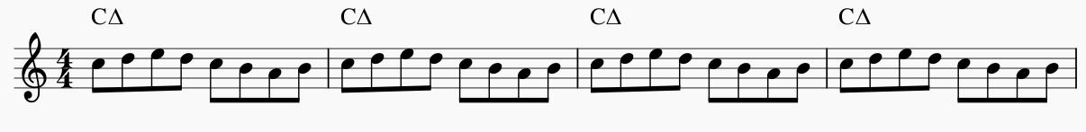
+ 1b | 7 | Sweet Georgia Brown | 4x A7| 4x D7|  4x G7| 4x CΔ| | CΔ| CΔ| CΔ| CΔ|  E7| E7| A7| A7|  D7| D7| G7| G7| | Rhythm Changes  Bridge
 | Sing circle  of 4th | 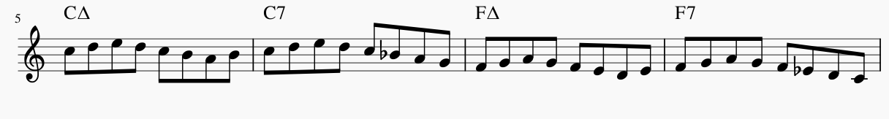
+ 2b | b3 | Afternoon  in Paris | CΔ | C-7 F7 | BbΔ | etc | Cherokee  bridge | C-7| F7| BbΔ| BbΔ|  Bb-7|F7|AbΔ|AbΔ|
 | Sing 1WT↓ circle | 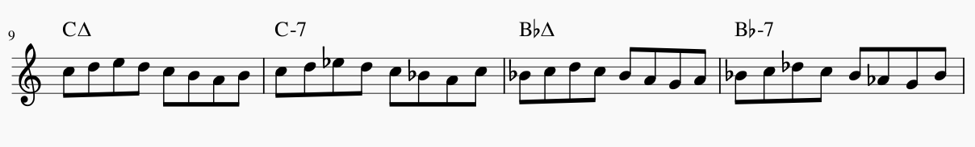
+ 3b | b13 | Yardbird Suite | CΔ| F-7Bb7| CΔ|
 | Sing 3HT↑  circle | 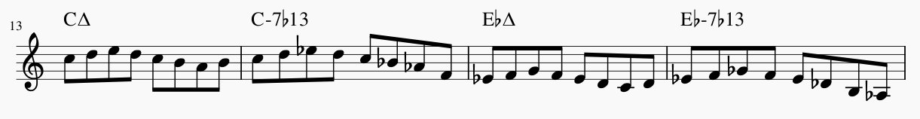
+ 4b | b2 | Whats's new | CΔ| Bb-7Eb7|AbΔ | Giant Steps |  | CΔEb7|AbΔB7...
 | Sing 2WT↓ circle | 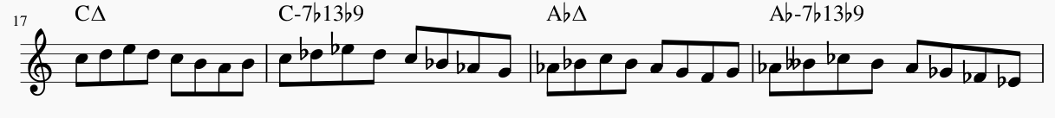
+ 5b | b5 | You stepped out of a dream | CΔ| CΔ| C#Δ| C#Δ | Find the Cherokeebridge....
 | Sing 1HT↑ circle | 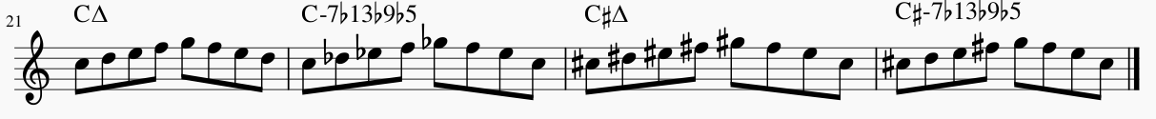

Sharpology in major
This is about ear training. Each step may take several weeks, don't rush, don't mix steps too early.
Sharpology is clockwise in the circle of 5th, the other way around is Flatology.
Adding 1# moves from CΔ to D7, not from CΔ to GΔ because you see this in countless standards.
The approach is to alter the scale you are actually playing.

 | Hit Note | Example | Example 1 | Example 2 | Example 3
+ 0# | None | Modal, Techno, Pop | CΔ| CΔ| CΔ| CΔ|  CΔ| CΔ| CΔ| CΔ| | CΔ| CΔ| G7| G7|  G7| G7| CΔ| CΔ| | CΔ| CΔ| FΔ| FΔ|  G7| G7| CΔ| CΔ|
 | Sing circle  of nothing | 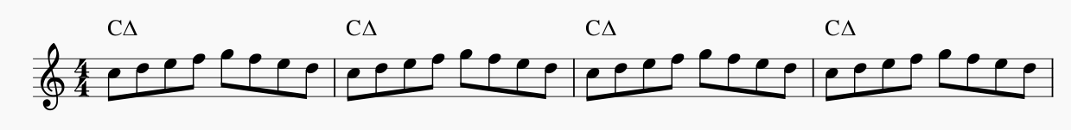
+ 1# | #11 | Take the A-Train | CΔ| CΔ| D7| D7|  D-7|G7| CΔ| CΔ|
 | Sing circle  of 5th | 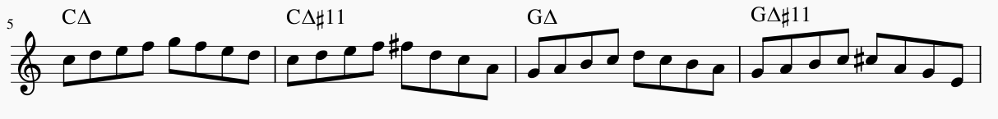
+ 2# | #1 | Rhythm Changes | CΔ | A7 | D7| G7| | CΔ| A7| D7| D7|  D-7|G7| CΔ| CΔ| | CΔ| CΔ| A7| A7|  D-7|G7| CΔ| CΔ|
 | Sing 1WT↑ circle | 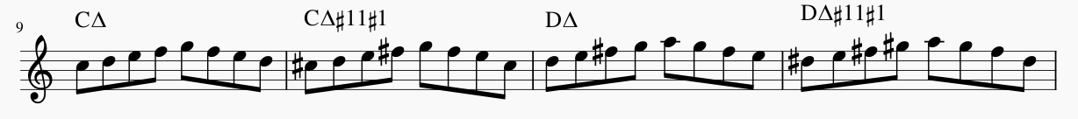
+ 3# | #5 | Confirmation, Rhythm Bridge | CΔ| E7| A7| A7|  D-7|G7| CΔ| CΔ| | CΔ| CΔ| E7| E7|  A7|D7| G7| CΔ| |  | Confirmation
 | Sing 3HT↓ circle | 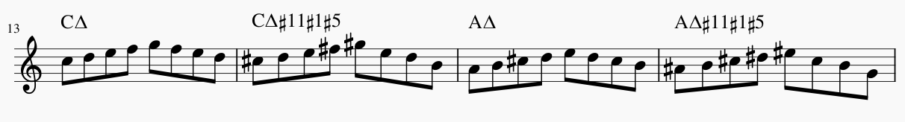
+ 4# | #2 | Mr Sandman, Grooving high | CΔ| B7| E7| A7|  D-7|G7| CΔ| CΔ | Giant Steps B | CΔ| F#-7 B7| EΔ  etc
 | Sing 2WT↑ circle | 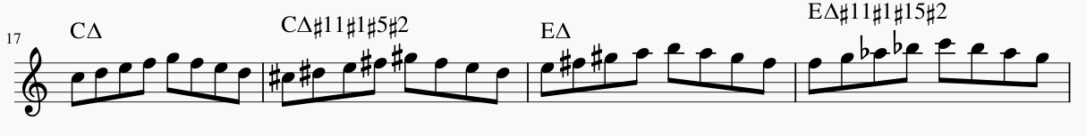
+ 5# | #6 | Airegin | CΔ| F#7| B7| E7|  A-D7|D-G7|CΔ|C | CΔ| CΔ| F#7| B7|  E-A7|D7-G7|CΔ|CΔ
 | Sing 1HT↓ circle | 