Majorisation
This is about eartraining. Each step may take several weeks, don't rush, don't mix steps too early.
Majorisation is clockwise in the circle of 5th, the other way around is Minorisation.
Adding 1# moves from CΔ to D7, not from CΔ to GΔ because you'll find this in countless standards.
The approach is to alter the scale you are actually playing.

 | Hit Note | Example | Example 1 | Example 2 | Example 3
+ 0# | None | Modal, Techno, Pop | CΔ| CΔ| CΔ| CΔ|  CΔ| CΔ| CΔ| CΔ| | CΔ| CΔ| G7| G7|  G7| G7| CΔ| CΔ| | CΔ| CΔ| FΔ| FΔ|  G7| G7| CΔ| CΔ|
 | Sing circle  of nothing | 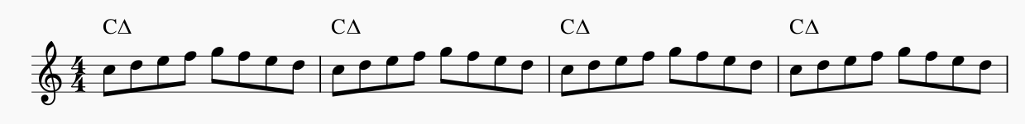
+ 1# | #11 | Take the A-Train | CΔ| CΔ| D7| D7|  D-7|G7| CΔ| CΔ|
 | Sing circle  of 5th | 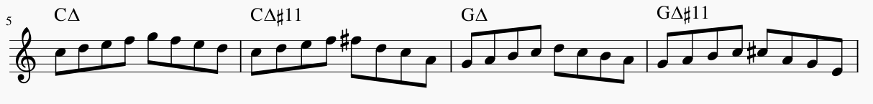
+ 2# | #1 | Rhythm Changes | CΔ | A7 | D7| G7| | CΔ| A7| D7| D7|  D-7|G7| CΔ| CΔ| | CΔ| CΔ| A7| A7|  D-7|G7| CΔ| CΔ|
 | Sing 1WT↑ circle | 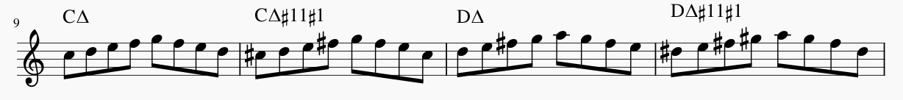
+ 3# | #5 | Confirmation, Rhythm Bridge | CΔ| E7| A7| A7|  D-7|G7| CΔ| CΔ| | CΔ| CΔ| E7| E7|  A7|D7| G7| CΔ| |  | Confirmation
 | Sing 2WT↓ circle | 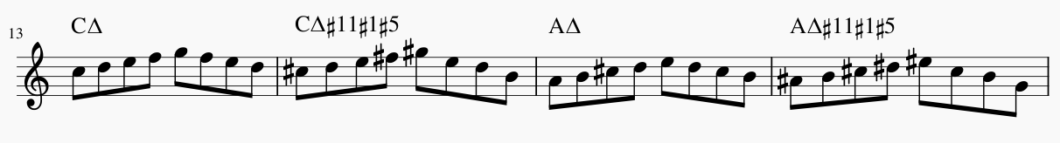
+ 4# | #2 | Mr Sandman, Grooving high | CΔ| B7| E7| A7|  D-7|G7| CΔ| CΔ | CΔ| CΔ| B7| B7|  E-A7|D7-G7|CΔ|CΔ
 | Sing 2WT↑ circle | 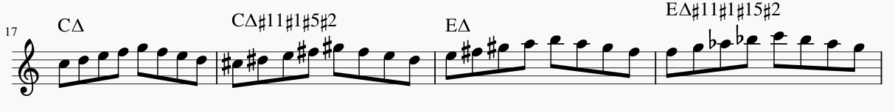
+ 5# | #6 | Airegin | CΔ| F#7| B7| E7|  A-D7|D-G7|CΔ|C | CΔ| CΔ| F#7| B7|  E-A7|D7-G7|CΔ|CΔ
 | Sing 1HT↓ circle | 