# Chapter 2: Analysis

Analysis is the systematic way of examination and evaluation of complex data that helps in understanding the cause or effect relationships and also relates to solving the problem and decision making.

# 2.1 Analysis Methodology

Methodology allows to make the analysis and design more manageable as it offers a structure to follow when working on a task. It is a bunch of practices which also clear out the problem with the scope of particular discipline.

There are various types of Information system Analysis and Design Methodologies. They are

* Hard System Methodology
* Soft System Methodology
* Combined soft/hard methodology
* Organization-oriented methodology
* People-oriented methodology
* Process-oriented methodology
* Object-oriented methodology

Among all the methodologies I have used Soft system methodology as it focuses on user requirements. It observes that user interaction is also the priority one as technical considerations whereas in other methodology like hard approach human activity is not considered as priority step.

Soft system Methodology is used in the project because:

* It helps in the greater interaction with user which helps to clear out the confusion and requirements can be gathered properly.
* It is used in information management, strategy and business analysis.
* It deals with problems in complex, human situations.
* It focuses more on user interaction as my project main motive can easily get fulfilled by this methodology.
* Here in this methodology different perspectives from various people can help to face all the challenges as open discussion is major one to discuss all the project solution.

Rich picture

Rich picture permit the advance planning and understanding of the system as it shows the view of the whole system. Here in rich picture there is no rules or guidelines as it is sketch by hand and involves structures, processes, issues or developments. It is used in the project because the rich picture directly engaged in sorting out the problem rather than thinking about the problem. Here also various techniques can be applied to gather information like PEST, SWOT analysis.

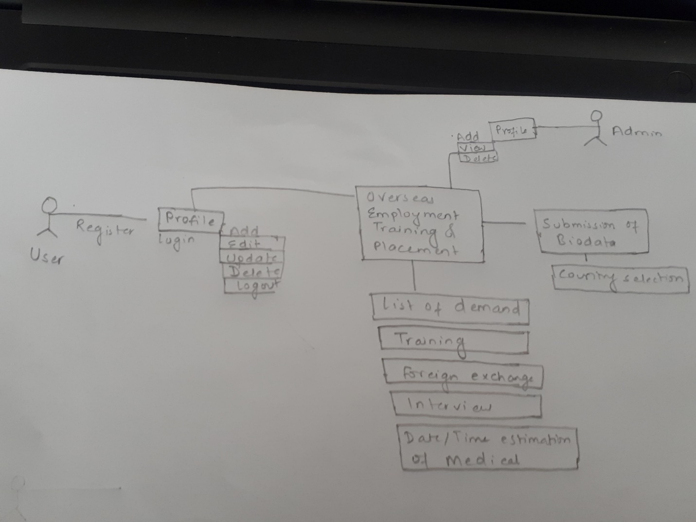

Figure Rich picture

Root definition

In root definitions, analyst needs to observe the aim of the system, means of achieving the aim and longer-term aim.

CATWOE

To increase the productivity and quality assurance for the project CATWOE can be used. CATWOE has various advantages as it provides open discussion of problems with different perspectives. A group of members are involved here to solve the problem as there also involves users to provide their views or update the requirement.

C=Customers/Clients

With the work of the organization they are the one who can/cannot get benefit.

A= Actors/Agents

They are directly involved with the system. As they separate out or show that are responsible in developing the project.

T=Transformations

Transformations relate to the data information as it finds out what happens to data and for the processes finds out what will be affected by development of system.

W= World view

Word view checks out the inside and outside working of the organization. And have research on whether that have influence on development system or not and in case if that is affecting the system what will they be.

O= Owners

It refers to the one who owns the organization. In this project Admin is the owner as they have the authority to make changes over the project.

E=Environment

During the project development, knowledge of political, social, economic, legal, technological is essential. As environment plays the role whether the project has limitation or can have better changes towards environment. Research must be done towards the environment to make the project reliable.

Conceptual Model

Rich picture and root definition is used to compose the conceptual model. It refers to how the system should function and what activities are necessary for processes to take place.

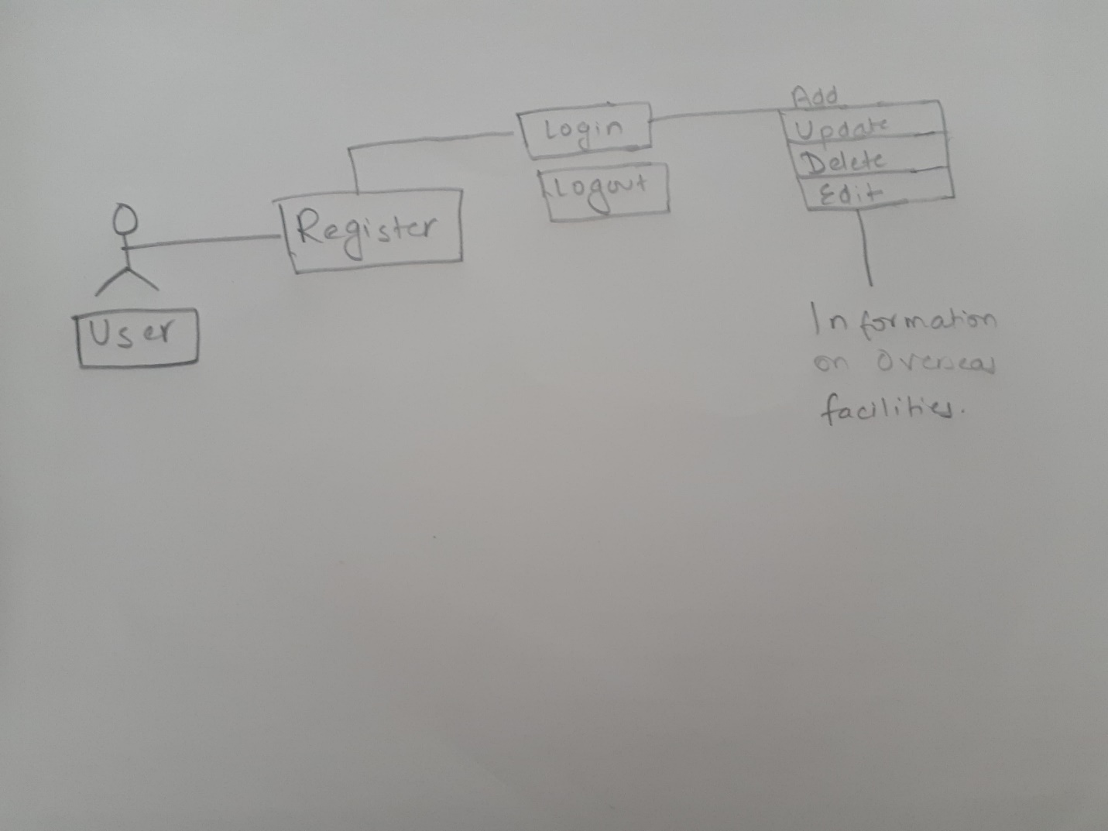

Figure Conceptual Model User

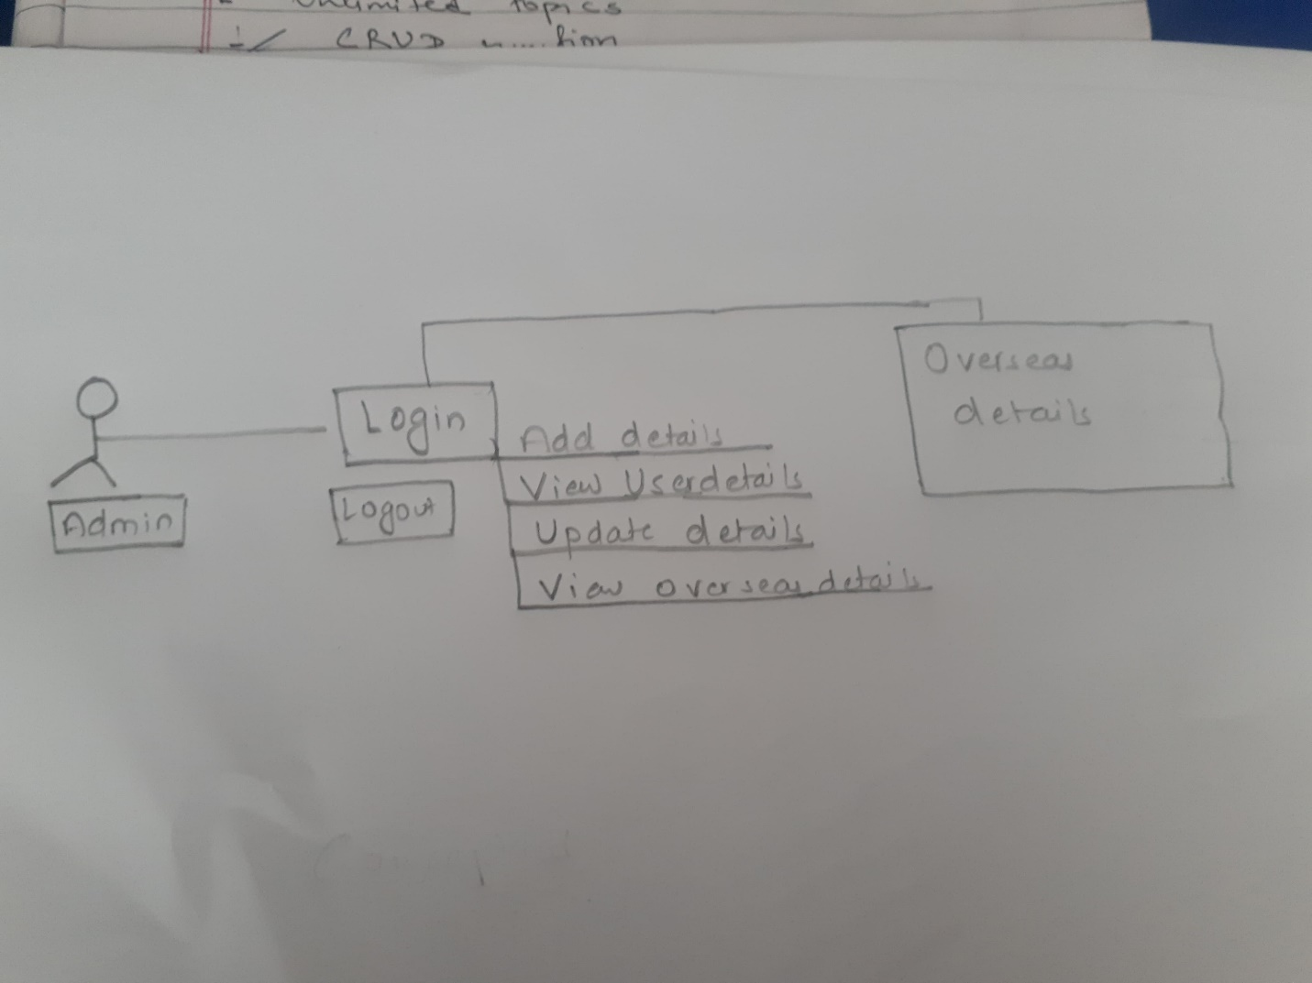

Figure Conceptual model Admin

# 2.2 Information Gathering Methodology

For the success of the project the right information is essential. Decision making and planning determines the success of the project. The planning like user’s expectation, satisfaction and understanding are key success of the project. There are various requirement gathering techniques that helps to manage the project and collect the information on several sources. They are

* Brainstorming
* Document Analysis
* Focus Group
* Interface Analysis
* Interview
* Observation
* Prototyping
* Requirements Workshop
* Reverse Engineering
* Survey
* Questionaire

I have separated out some of the major requirement gathering techniques that is used in my project are;

Brainstorming:

It is a group creativity work where people meet to gather the new ideas and find the solution for the specific problem. Every member in the group are welcomed with their own new thoughts without the limitation. After each idea are noted down rather than being criticized or ignored.

In my project brainstorming is used to collect all the new ideas as every member can actively provide their thoughts which can help the project to be more reliable and user-friendly.

Questionaire

It consists of the bunch of questions as it is the research platform which aims to gather information from the group of people. It is quite applicable as it is cheap and requires less effort to implement. It makes easier to compile data through the standardized answer.

In my project questionaire is used to gather the information in more systematic way. With the mass information to the related problem or going project helps to make the project most reliable and free of bugs.

Here is some small sample to the questionaire through which information can be gathered for further project.

* Which golf country do you prefer?

Option:

* Dubai
* Malaysia
* Qatar
* Others
* Do you have any experience towards the related job? (if necessary, job option like steel fixer, technicians, plumbers, other)
* Yes
* No
* Have you ever visited any other countries?
* Yes
* No
* Which visa category do you prefer?
* Tourist visa
* Working visa
* Dependent visa
* Have you ever visited any online website to apply any overseas?
* Yes
* No
* Is this overseas online facility appropriate?
* Yes
* No
* Not sure

Prototyping

It is an iterative process which is used in every phase of the project. Before the larger project is released prototyping is the initial stage where all the fixes and evolution is tested.In my project prototyping is used to sketch the project sample so that we can work on the concept of the candidate and can test the going process. This helps to go through all the requirement as per candidate and join them for further adding requirement process.

# 2.3 Feasibility Study

Feasibility study is practical term as it is to provide the reasons for developing the software which is within the estimated budget and time, adaptable to change and acceptable to users. It also helps to analyze whether the software supports the required/current technology and meet the organizational requirements.

Types of feasibility study

Technical feasibility

Technical feasibility confirms that the required technology is technically available or supports the requirements. In the project it is significant because it helps to manage the required hardware and software of the process. This feasibility also helps to determine whether the technical team having the knowledge of technical resources can complete the project in proper way or not. The project is technically feasible as the availability of hardware, software, database is open source. The only cost required is for domain and hosting which is not much. So manpower management system is feasible to develop.

Economic feasibility

Economic feasibility helps to calculate the financial cost of the project development. In the project it is significant because this feasibility helps to have cost analysis. If the project goes with high budget then it will affect the users as it won’t be reliable. The project is economically feasible to develop as there is no cost for software, database and the code is under our development. So, the project is economically feasible to develop.

Legal feasibility

Here it deals with the legal issues. In the project it is significant because it helps to clarify that the rules of government/ organization are applied in the development process. As it helps in the fulfillment of legal rules in the project. The government doesn’t have any strict rules towards overseas that can hamper the project. As the remaining using rules in past days are under its development so it is legally feasible.

Social feasibility

Here it deals with all the environment and people issues. In the project it is significant because it helps to complete the social requirements. If the project is affecting to the social being then it won’t be any usable project so project with environment friendly is most important. With the development of online overseas application mostly the people get benefitted as they have no any problem in investing the amount. It provides the best security with full insurance so this project is socially feasible.

# 2.4 Software Requirement Specification

It refers to the overall document that explains the system performance with its functional and non-functional requirements. As it describes about the features and behavior of the system. For the development of Software system maximum research or understanding must be available related to software system.

# 2.4.1 Functional Requirement

It refers to the function of the system. There involves hardware, software, data manipulation and processing which helps later to know about the achievement of the system.

|  |  |  |  |  |  |
| --- | --- | --- | --- | --- | --- |
| ID | Title | Description | Rational | Dependency | Remarks |
| F1 | Admin registration | Username and Password | Admin verification | none |  |
| sF2 | Admin Login | T checkout overall information. | View the details of project and candidate | F1 |  |
| F3 | User Registration | Personal information like name, phone, qualification and many more. | Users new account accessible | none |  |
| F4 | User Login | Username and Password | Verification of required users | F3 |  |
| F6 | Biodata Submission | Information for further process for working in foreign country. | Biodata is required to apply. | F3, F4 |  |
| F7 | Training | Learning the various job and being qualified to work in foreign countries. | Qualities with job and knowledge helps to find job easily. | F2, F4 |  |
| F8 | Interview | Selection to the candidate who are eligible to work. | Qualified candidate to have better job facilities. | F4 |  |
| F9 | Medical date/time estimation | Checking health condition so later work pressure won’t have any impact on body. | Fitness determine the work performance. | F2 |  |
| F10 | Flight data information | schedule to flight over and land. | To fly over at appropriate time. | F2 |  |
| F11 | Insurance | Coverup the damage. | Provides the compensation in case there occurs the damage. | F4 |  |
| F12 | Foreign exchange | To change the amount into usable country currency. | No use of amount if it is not changeable according to the use of country currency. | F2 |  |
| F13 | Admin profile edit | Username and Password | Edit Existing detail. | F2 |  |
| F14 | Update users’ profile | Information of their details like username, password | Upload of Missing data or cancel the unnecessary information. | F4 |  |
| F15 | Manage demand | Available of various platform of work to users. | Different candidate prefer different job category as demand is available job letter from the company. | F2 |  |

# 2.4.2 Non-Functional Requirement

It is also known as Quality of Service (QOS). It refers to all the requirements that are not covered by the functional requirements. It also explains on how the system should behave.

|  |  |  |  |
| --- | --- | --- | --- |
| ID | Title | Description | Rational |
| Nf1 | Security | Free from the potential harm or unverified account cannot easily access. | To have confidential information secure. |
| Nf2 | Availability | Whenever users wanted to access application, it should be available at any time. | To use the application at any particular time. |
| Nf3 | User-friendly | Should be easy to operate. | For users to operate the application easily. |
| Nf4 | Reliability | Application should operate for long period of time. | No validation can affect the running project and more users can easily access the application. |
| Nf5 | Effectiveness | User’s desired requirements should be fully involved. | Involves the users desired requirements and make it more effective. |

# 2.4.3 MoSCoW

It refers as MoSCoW prioritization or MoSCoW analysis. It is used in management, business analysis, project management and software development

Must have-

It is the most usable state. This points /requirement are non-negotiable as without these requirements the project won’t be complete or useable.

Should have-

It occupies second in the priority list. As this requirement are not vital but they count as the important needs in the project.

Could have-

It is valuable but doesn’t occur problem if these requirements are dropped. As if there occurs a risk in timescales these requirements are removed first.

Won’t have-

It won’t be implemented in the current development future as it can counts on the future use.

Functional

|  |  |  |
| --- | --- | --- |
| ID | Title/  Requirement | MoSCoW |
| 1 | Registration | Must have |
| 2 | Login | Must have |
| 3 | Demand available | Must have |
| 4 | Biodata Submission | Must have |
| 5 | Training | Should have |
| 6 | Medical date/time estimation | Must have |
| 7 | Interview | Should have |
| 8 | Notification of orientation class | Could have |
| 9 | Flight data information | Must have |
| 10 | Client/Company information | Should have |
| 11 | Insurance | Should have |
| 12 | Foreign Exchange | Should have |
| 13 | Payment report | Could have |
| 14 | Generate reports on no. of registration, list of selection/rejection | Must have |

Non-functional Requirement

|  |  |  |
| --- | --- | --- |
| 15 | Security | Must have |
| 16 | Availability | Should have |
| 17 | User-friendly | Must have |
| 18 | Reliability | Must have |
| 19 | Effectiveness | Should have |

# 2.4.4 Hardware and Software Requirement

|  |  |
| --- | --- |
| Hardware | Software |
| Processor: intel core i5 | Database: MySQL from XAMP |
| Ram: At least 1 GB | Operating system: Windows 10 |
| Storage: Minimum 1 GB | Sublime, any browser |
|  | Data visualization tool |
|  | Domain and hosting |

# 2.5 Usecase Diagram

It is the dynamic diagram in UML which helps in representing the dynamic requirements of system which will later be easy in the development process. It helps users to know how the system will interact /operate

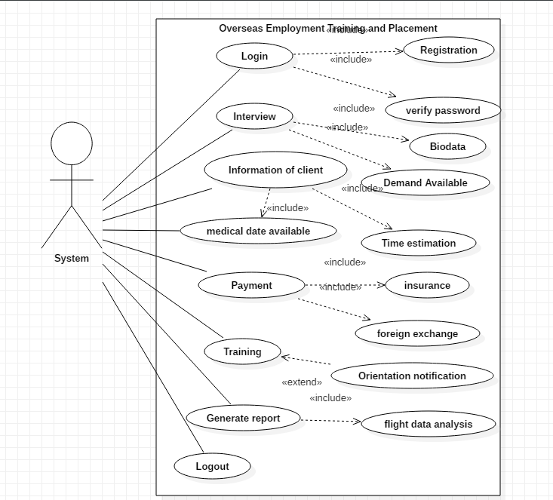

Figure use case System

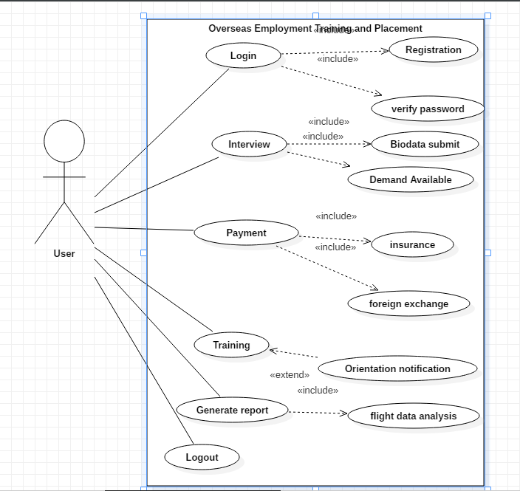

Figure use case User

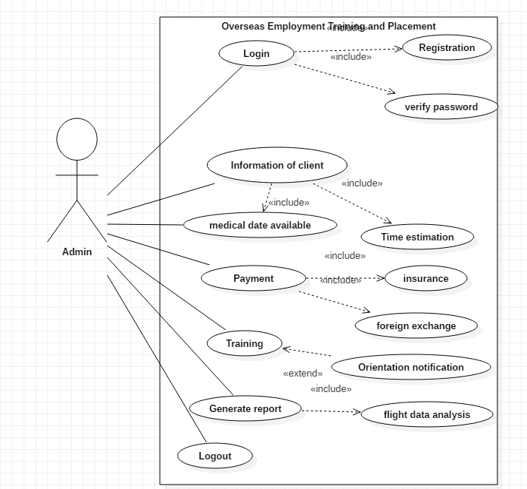

Figure Use case Admin

# 2.5.1 Natural Language Analysis (NLA)

NLA refers to natural language analysis. NLA helps to separate out the actual classes and methods. It is the step that helps in the further development of diagrams. Here all the nouns and verbs are separated out that are out of scope, has synonyms and has repetition and later actual class is generated. As verb indicates the methods and noun indicates the classes.

Here is the scenario:

This website is a website for Potala overseas which makes the easy process for candidate to move abroad. As it is only the overseas and placement which provides the training facility, insurance, foreign exchange and many more. This system guides the candidates to have well known information about the country and the work.

In the system for registration process users fills all their personal details like full name, address, phone, email, job category, qualification and many more. Users are allowed to search for the country, job demand and other facilities after they get logged in. Admin adds the list of demand, job category, medical date and time, flight date information and update it or delete the information related overseas or registered candidates. Also, candidate can view the details of the company and staff member.

|  |  |  |
| --- | --- | --- |
| Nouns | Verbs | Adjectives |
| Training, candidate, overseas  Staff, Registration, Login, category, qualification, placement | Create, Update, Delete, Edit, Add, Save, Search | Name, Address, Phone, email |

2.5.2 Class diagram

Class Diagram: Class diagram is useful in object-oriented programming (OOP). Class diagram is assembled as boxes, where each box has three rectangles inside. First top of the rectangle consists name of the class, middle rectangle consist attributes of the class and last rectangle consist methods of the class. It is a diagram in UML (Unified Modeling Language) where there is the dependency of relationship and source code among the classes.

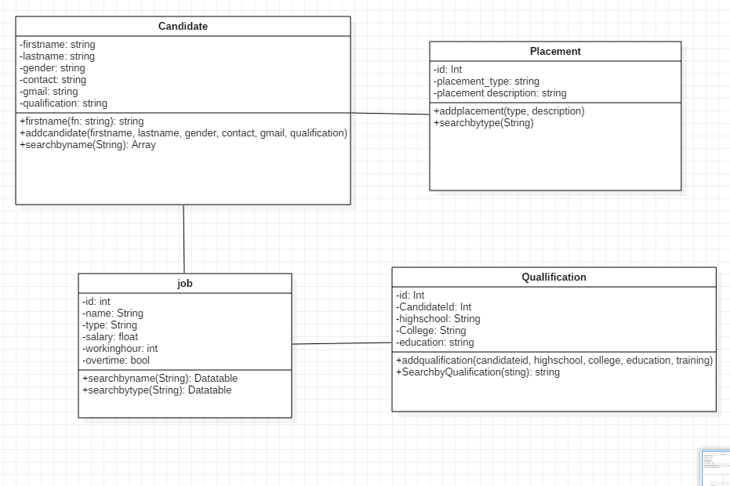

Figure Class diagram

# 2.6 System Architecture

The three-tier architecture is a software design pattern and client- server architecture which helps to maintain and develop data storage, data access and user interface as independent modules on separate platforms.

Presentation tier- It is the front-end layer in the 3-tier system that helps to display information related to services available on a website. It consists of the user interface. It communicates with other tiers by sending results to the browser and others tiers in network. It displays the content and information useful to an end user.

Application tier- It is also referred as the logic tier, middle tier, business logic as it supports the application core function. This tier is pulled from the presentation tier. It controls application functionality by performing detailed processing

Data tier- It is referred as the storage tier as it consists of a database and a program for managing read and write access to a database. It can be hosted on-premises or in the cloud.

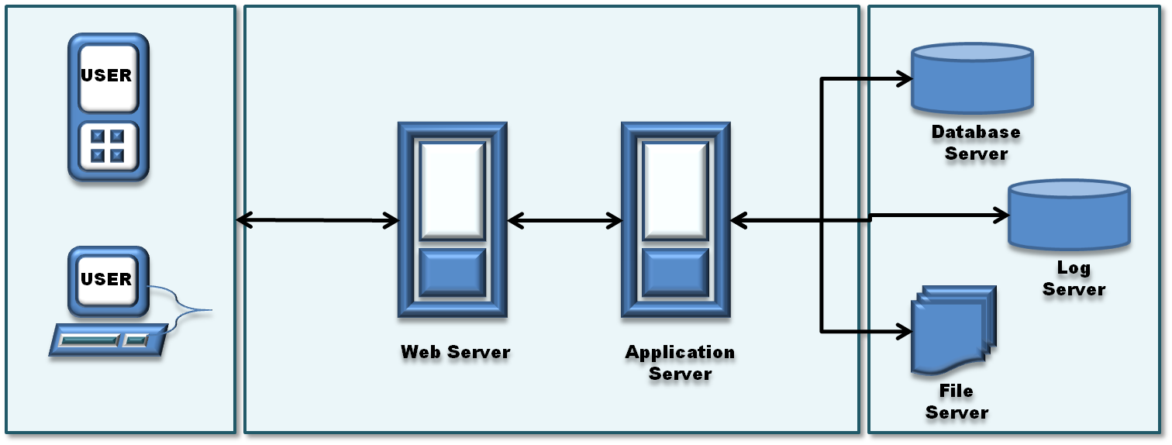

Figure 8 Three-tier architecture