# Chapter 3 Design

Design refers to the particular plan which is used to represent the overall work of the system. This is third phase in the Software Development cycle. It is the implementation of the idea organized in the early phases. This project design phases might generate a variety kinds of output, sketches, flowcharts, HTML screen design, sits trees, prototypes and more.

* Why Design:

Design phase is really important in the case of the Software Development cycle. The proposed designed may used to saved and revisit during the development of the software. Design restricts the repetition of the plan and increase the usages. The stage of the design provides the initial perception and the working strategies of the software product.

## 3.1 Structural modeling

This modeling includes the diagrammatic notation which is used to help the people to realize the system. This modeling includes the Data Flow diagram, Data dictionary, ER diagram and State transition diagram.

## 3.1.1 Final Class diagram

Definition:

Class diagram is useful in object-oriented programming (OOP). Class diagram is assembled as boxes, where each box has three rectangles inside. First top of the rectangle consist name of the class, middle rectangle consist attributes of the class and last rectangle consist methods of the class. It is a diagram in UML (Unified Modeling Language) where there is the dependency of relationship and source code among the classes.

Justification:

This diagram helps to understand the demand of the problem domain and to spot its components. This class diagram describes exactly how the system work, relationship between system components at many levels and how we plan to execute those components.

Notation used:

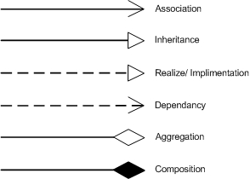

Class diagram used notation

## 3.1.2 Optional Diagram

DFD stands for Data flow diagram. DFD helps to map out the flow of information for any process or system. Here various notation are used. Dfd can be made in simple process as hand-sketch to big progressively designed that can handle the data.Here I have designed dfd of admin and user.

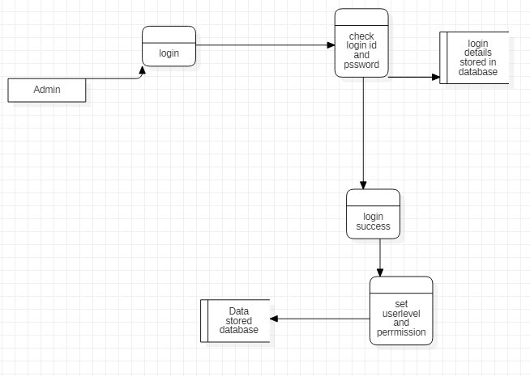

Figure 1 Admin Data flow diagram

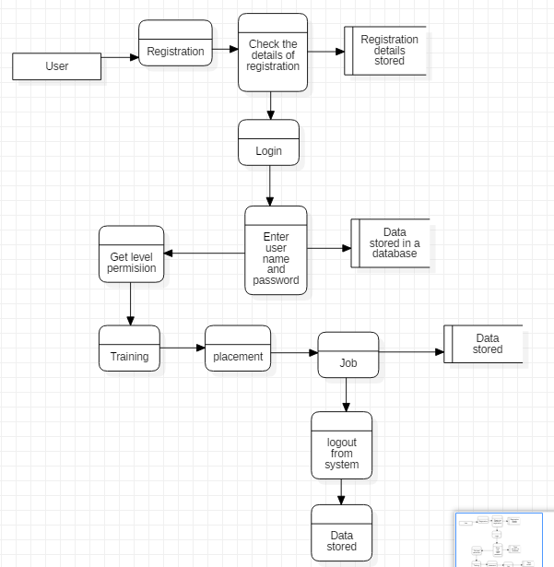

Figure 2 User Data flow diagram

## 3.2 Behavioral modelling

It represent the behavior of the system as it explains what is going to happen and describes the action of the system.

## 3.2.1 Activity diagram

Definition

Activity diagram is also the diagram in UML which presents the progress of the project. This diagram helps to illustrate how the system is working and the execution of set with the step.

Justification

* It illustrates the system working.
* Executes of set with step.
* Helps in the explanation of the system and progression of the system simultaneously.

Notation used

|  |  |  |  |
| --- | --- | --- | --- |
| S.N. | Notation Name | Notation | Description |
| 1 | Initial State |  | Starting phase of flow of the work. |
| 2 | Final State |  | End point of the flow of work |
| 3 | Decision |  | Represent decision of various path |
| 4 | Fork |  | Single concurrent flow back into multiple outgoing flow |
| 5 | Swimlane |  | Partition of the activities between classes. |
| 6 | Control flow |  | Represent the path of data passing. |
| 7 | Send Signal |  | Represent that the signal has been sent. |
|  | Joint |  | Multiple outgoing flow into single concurrent flow |

Final diagram

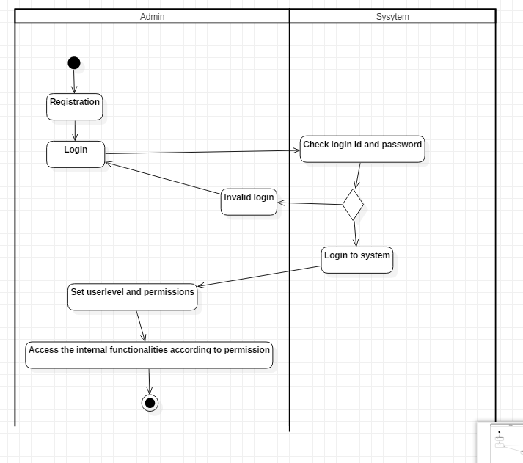

Figure3 Admin Activity Diagram

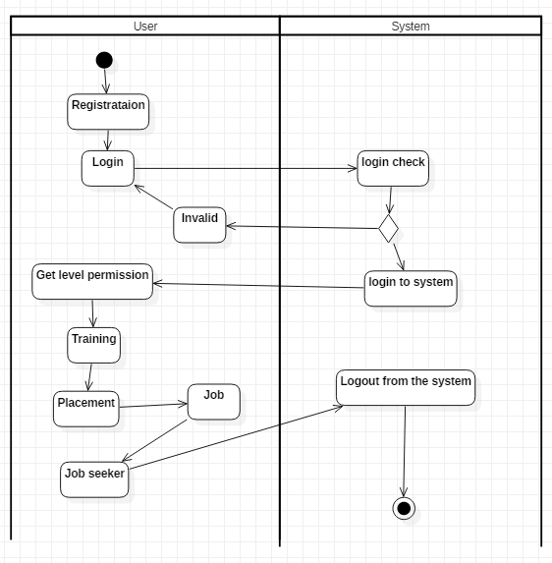

Figure4 User activity diagram

Explanation of diagram

To get into the system first of all user/admin have to get registered and get logged in so that they can access all the information of the system. But if the logged in doesn’t get success they cannot get to use the system. The diagram also shows that the in the system admin set the userlevel and permissions and user can get all the permission and get to access the overseas information.

## 3.2.2 Sequence Diagram

Definition: This diagram is all about the flow of the information/message. It is used to hold the dynamic behavior of the system. It also describes the structural organization of the objects.

Justification

* Clear explanation of use case diagram
* Clear understanding of interface with one another.

Notation used

|  |  |  |  |
| --- | --- | --- | --- |
| S.No | Notation Name | Notation | Description |
| 1 | Actor |  | It interacts with the system. |
| 2 | Object/participants |  | It only refers to roles of class but not the attributes objects. |
| 3 | Lifelines |  | It refers to the presence of object over the time/duration. |
| 4 | Activation Block |  | It illustrates the duration of task on object. |
| 5 | Messages |  | It illustrates the communication between objects and the dotted line refers to the reply of the message. |
| 6 | Self / Recursive message |  | It is mostly shown as as U shaped as it sends message to itself. |

Final diagram

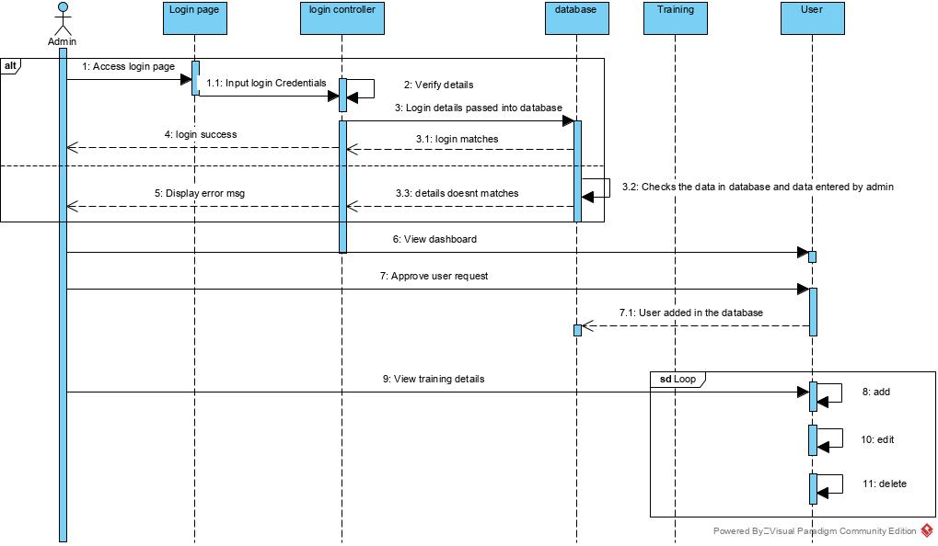

Figure5 Admin Sequence diagram

Explanation of diagram

This diagram illustrates that the the process and activity are managed by the admin. This above diagram shows that in the system admin interacts with the system and manage all the overseas management system. In the system adimn approve the user request and view all the details of users or details of trainungor job or placement.

## 3.3 Database modelling

## 3.3.1 Data dictionary

It contains the database metadata. It is also known as data Definition Matrix. Data dictionary helps to record the other objects in the database.

User registration

|  |  |  |  |
| --- | --- | --- | --- |
| Field name | Data Types | Description | Remark |
| uid | Integer(10) | Record of table-id | Primary key |
| uname | Varchar(50) | User Name | Not null |
| pwd | Varchar(50) | User authentication | Not null |
| cpwd | Varchar(50) | Password confirmation | Not null |
| User role/category | Varchar(50) | Role of user as visitor/working process | Not null |

Company details

|  |  |  |  |
| --- | --- | --- | --- |
| Field name | Data types | Description | Remark |
| companyid | Int(10) | Record of table-id | Primary key |
| name | Varchar(50) | Company Name | Not null |
| address | Varchar(50) | Location facility | Not null |
| contactno | Varchar(50) | Services to get contacted with | Not null |
| email | Varchar(50) | Company mail availability | Not null |
| Web address | Varchar(50) | Web address of company | Not null |
| City of company | Varchar(50) |  | Not null |

Placement details

|  |  |  |  |
| --- | --- | --- | --- |
| Field name | Data types | Description | Remark |
| pid | Int(10) | Record of table-id | Primary key |
| Company name | Varchar(50) | Foreign country company data | Not null |
| City of company | Varchar(50) | Company located country/city | Not null |
| Company address | Varchar(50) | Location availability | Not null |
| salary | Varchar(50) | Estimation salary | Not null |
| Company contact number | Varchar(50) | Contact details | Not null |
| email | Varchar(50) | Company sites to visit for | Not null |

## 3.3.2 ER diagram

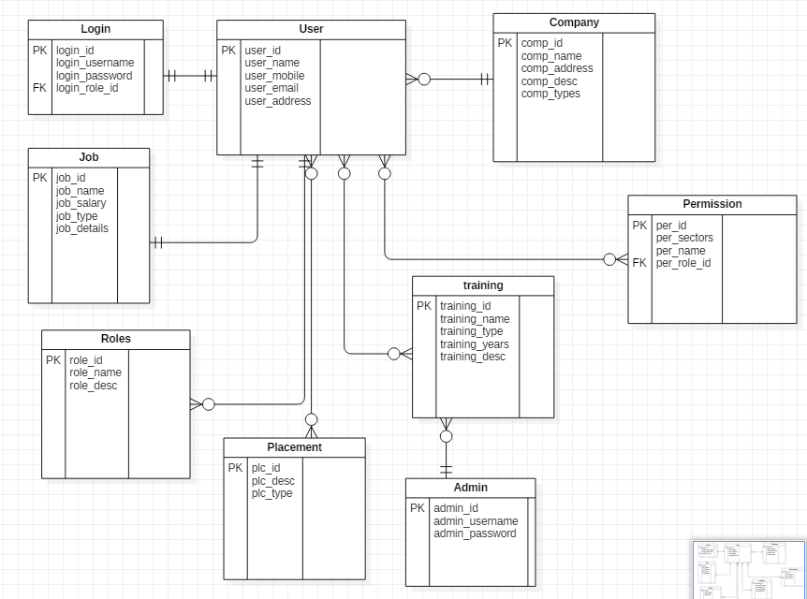

Figure 6 ER diagram

## 3.4 UI modelling

UI modelling is essential software components which helps in the usability of the system. It also represents how the end user interact with the program, device and how the system responses as UI is the line of interaction between the human and computer.

## 3.4.1 Prototyping

Before the full development of the project this phase is done to clear out the bugs and reduce the user dissatisfaction as user can get involved in this phase and give their views toward the initial phase of the development.

LOGIN FORM

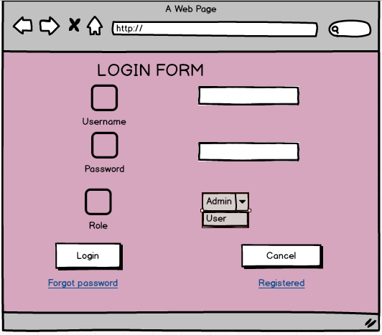

Figure 7 Login form

Registration form

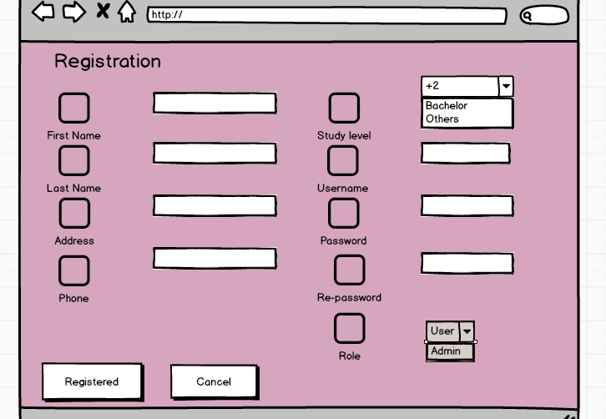

Figure 8 Registration form

Edit Profile fom

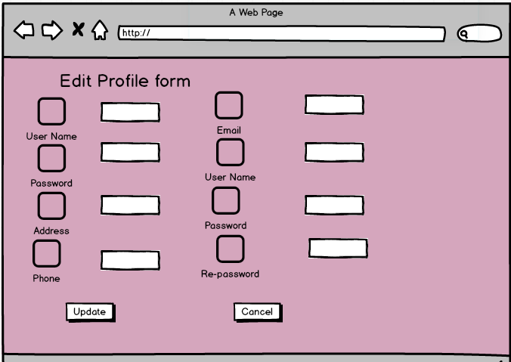

Figure 9 Edit Profile form

Dashboard

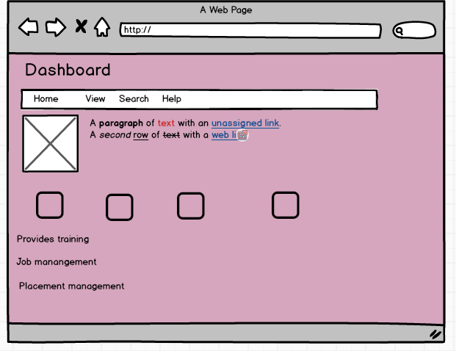

Figure 10 Dashboard form

Placement

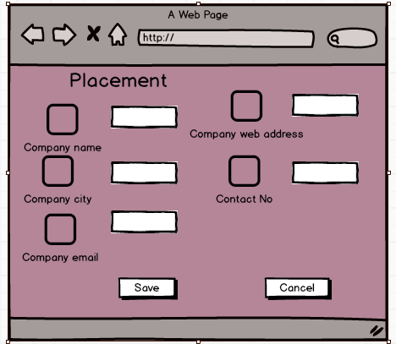

Figure11 Placement form

Training

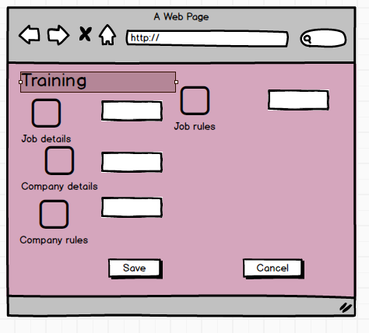

Figure 12 Training form

## 