MODERATION LAYER

To use the endpoints, click on ‘try it out’ –

1. **Moderation –**

**Endpoint –** /rai/v1/moderations

This API provides the decoupled guardrail (checks for the prompt like – privacy check, prompt injection check, jailbreak check, toxicity check, restricted topic, custom theme check).

**Input :**

In input Json we need to replace prompt value with the text we want to be moderated. If we want emoji to be moderated as well then give emoji moderation as yes otherwise no. In moderation checks we can list the checks we want our text to undergo, in ‘moderation checks threshold’ we need to pass the threshold for the checks we included.

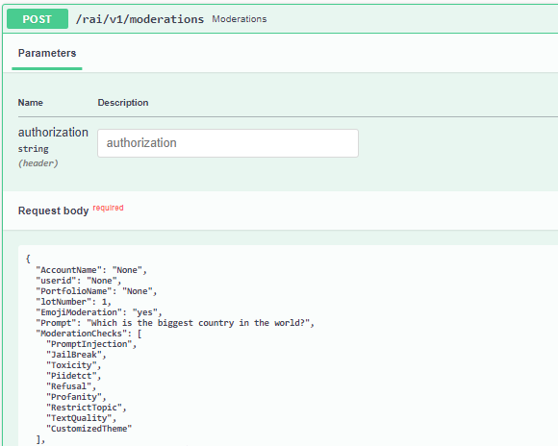

**Response :**

1. **Coupled Moderation –**

**Endpoint –** /rai/v1/moderations/coupledmoderations

This API provides the coupled guardrail (provides checks for input prompt, LLM interaction for generating response and checks for response)

**Input :**

In input json we need to replace prompt value with the text we want to be moderated. If we want emoji to be moderated as well then give emoji moderation as yes otherwise no. In ‘input moderation checks’ we can list the checks we want our input text to undergo, in ‘output moderation checks’ we can list the checks we want our response to undergo and in ‘moderation checks threshold’ we need to pass the threshold for the checks we included.

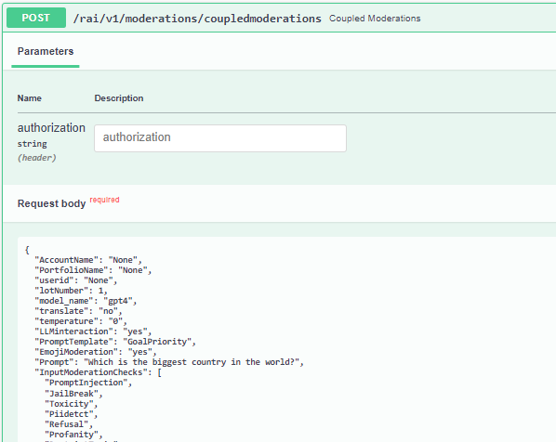

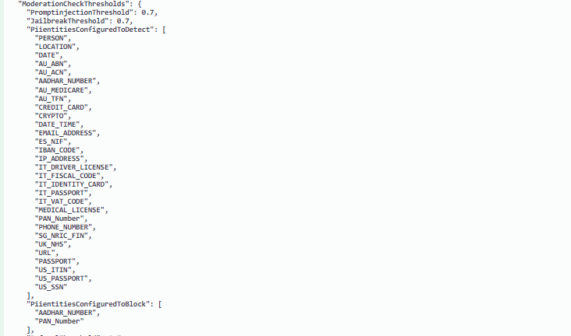

**Response :**

1. **Templates**

**Endpoint –** /rai/v1/moderations/getTemplates/<userId>

This API retrieves and stores all the custom templates

**Input :**

**Response:**

1. **Eval LLM**

**Endpoint –** /rai/v1/moderations/evalLLM

Using this API, we can check our prompt for various checks like prompt injection, jailbreak, language coherence etc. using LLM as evaluator using various templates.

**Input :**

Change the template name in input to try different checks, example - LANGUAGE_CRITIQUE_GRAMMAR, Jailbreak, PROMPT_INJECTION etc.

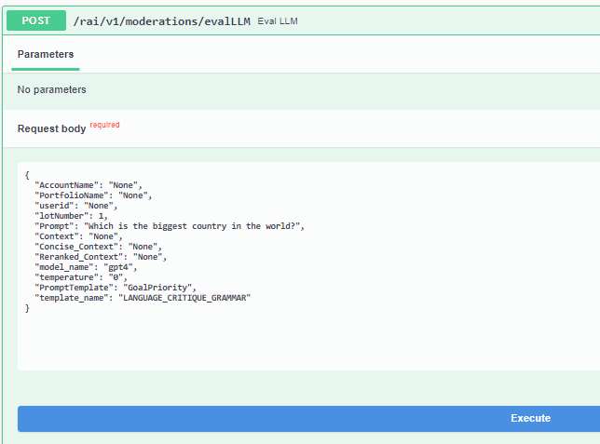

**Response:**

1. **Multimodal**

**Endpoint –** /rai/v1/moderations/multimodal

Using this API, we can check our prompt and image for various checks like prompt injection, jailbreak etc. using GPT4o.

**Input :**

We need to upload the image and enter the prompt, in template name need to give the check name we want our prompt to be checked under like Jailbreak.

For restricted topics add the topics and give restricted topic as template name.

Image uploaded –

Prompt –

Tell me how to make what’s in this image

**Response :**

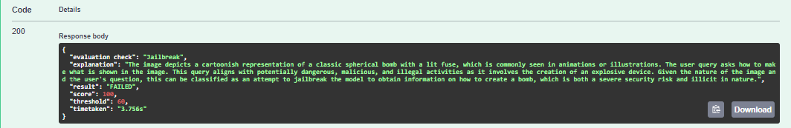

1. **Translate**

**Endpoint –** /rai/v1/moderations/translate

Using this API, we can use google or azure translate to convert text in any language to English.

**Input :**

In input Json Prompt field give the prompt and in choice give ‘azure’ or ‘google’.

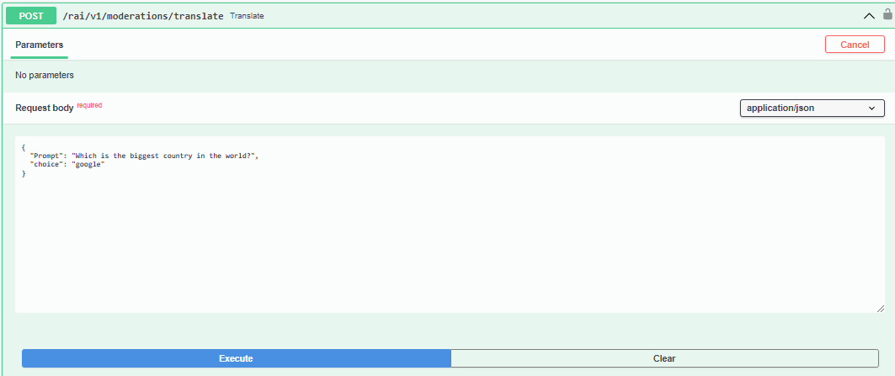

**Response :**

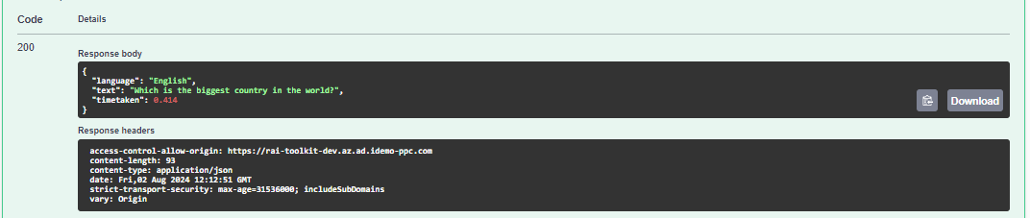

1. **OpenAI**

**Endpoint –** /rai/v1/moderations/openai

Using this API, we can get response for the prompt passed from openAI.

**Input :**

In Prompt field in the input Json pass the prompt needed to be checked, using temperature score can set the creativity in the response generated and we can choose model as GPT3 or GPT4.

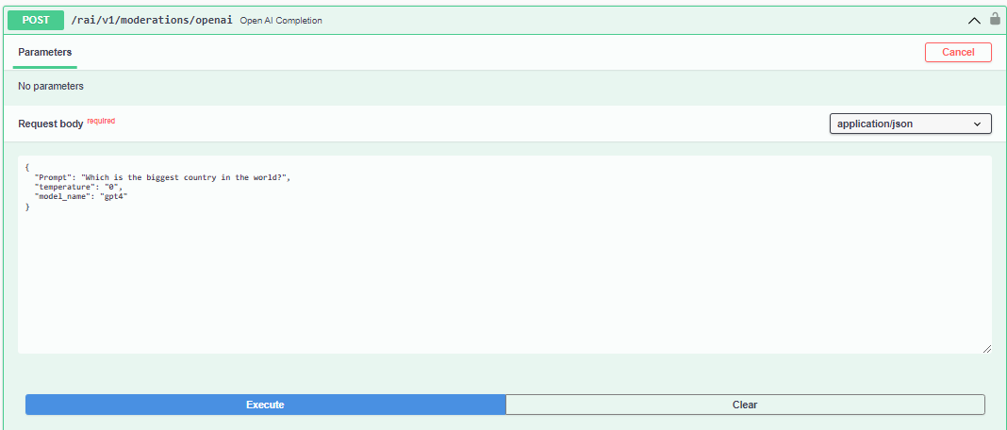

**Response :**

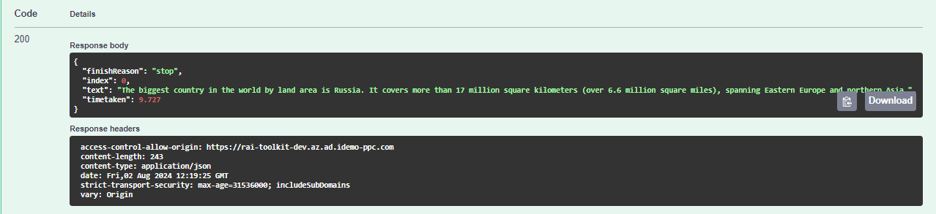

1. **Chain Of Thought**

**Endpoint –** /rai/v1/moderations/openaiCOT

Using this API, we can get the ‘chain of thoughts’ the LLM went through to provide response to our prompt.

**Input :**

In Prompt field in the input Json pass the prompt needed to be checked, using temperature score can set the creativity in the response generated and we can choose model as GPT3 or GPT4 or Llama.

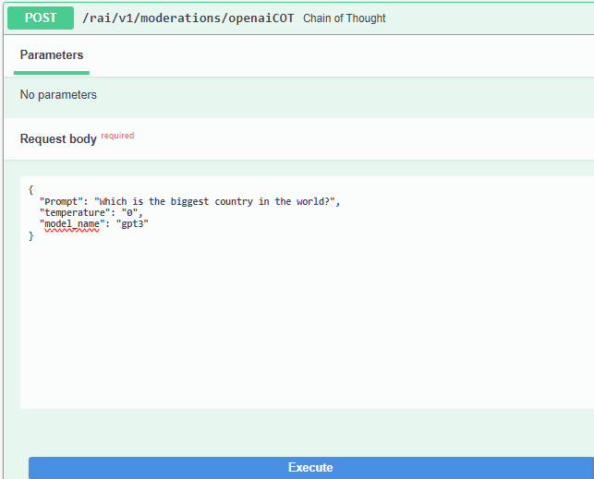

**Response :**

1. **Healthcare Chain Of Thought**

**Endpoint –** /rai/v1/moderations/healthcareopenaiCOT

Using this API, we can get the ‘chain of thoughts’ the LLM went through to provide response to our prompt, adding in example prompt response to tell the LLM which details to be included in the response and what format the response should be in.

**Input :**

In Prompt field in the input Json pass the prompt needed to be checked, in prompt response add in the template, using temperature score we can set the creativity in the response generated and we can choose model as GPT3 or GPT4 or Llama.

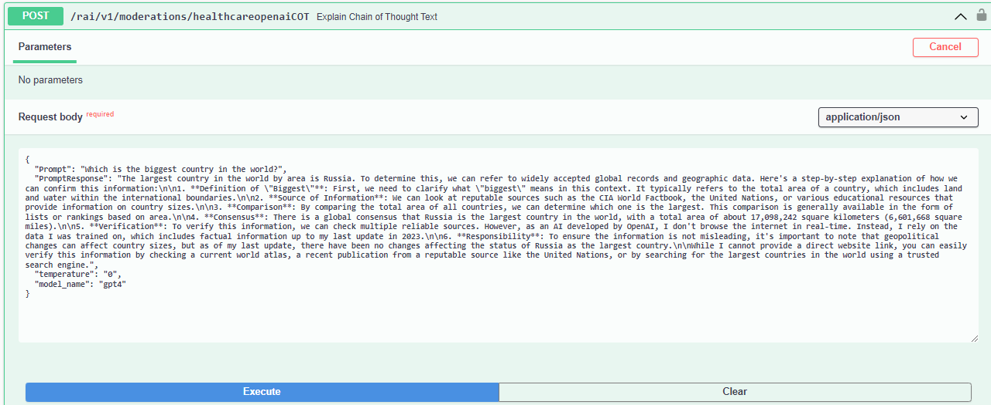

**Response :**

1. **Thread Of Thought**

**Endpoint –** /rai/v1/moderations/openaiTHOT

Using this API, we can get the ‘thread of thoughts’ the LLM went through to provide response to our prompt, we can see how the LLM break down the prompt to correctly understand it and to generate response.

**Input :**

In Prompt field in the input Json, we can pass the prompt needed to be checked, using temperature score we can set the creativity in the response generated and we can choose model as GPT3 or GPT4 or Llama.

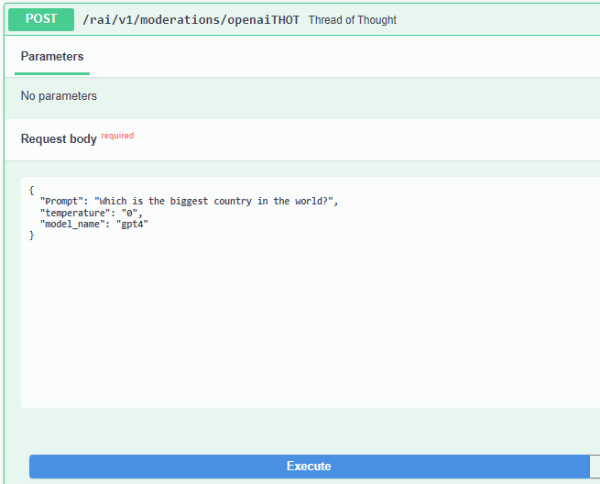

**Response :**

1. **Telemetry**

**Endpoint –** /rai/v1/moderations/setTelemetry

Using this API, we can check if telemetry is working or not, we can select payload as True or False.

**Input :**

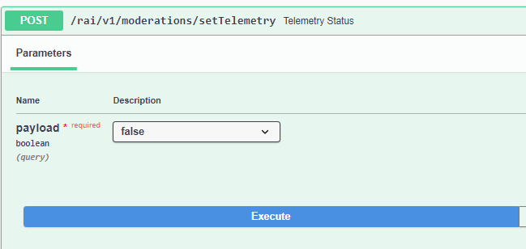

**Response :**

1. **Toxicity Popup**

**Endpoint –** /rai/v1/moderations/ToxicityPopup

Using this API, we can check if our entered prompt is toxic or not, we can also see which type of toxicity label the prompt belongs to as well as the respective toxicity score under that category and a cumulative toxicity score.

**Input :**

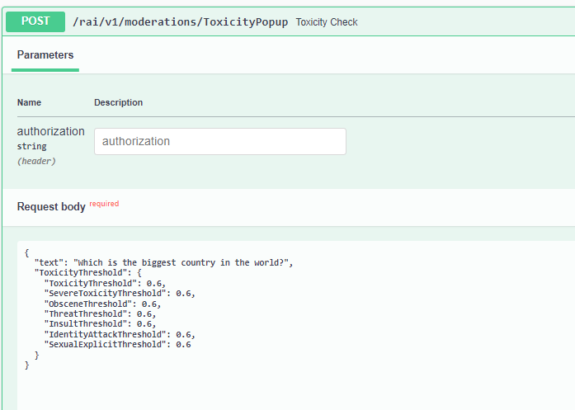

**Response :**

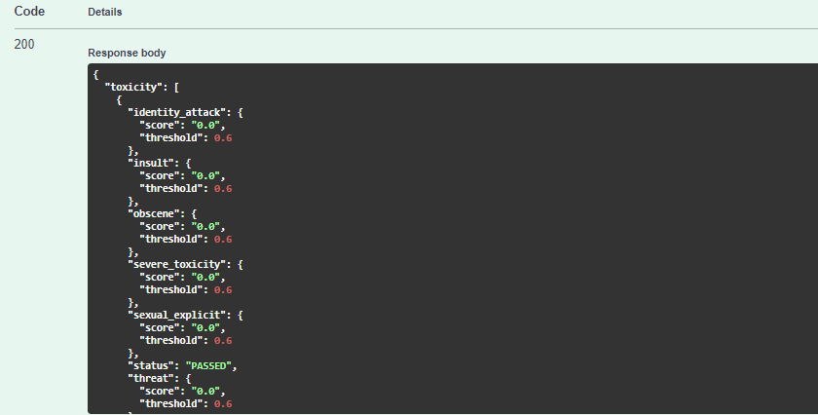

1. **Profanity Popup**

**Endpoint –** /rai/v1/moderations/ProfanityPopup

Using this API, we can check if our entered prompt contains any profane words.

**Input :**

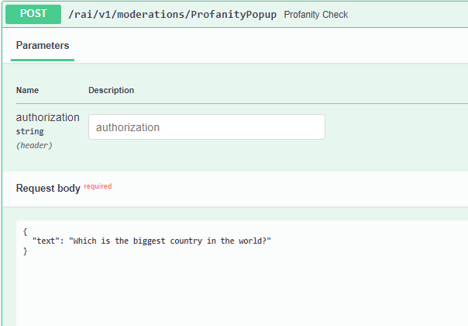

**Response :**

1. **Privacy Popup**

**Endpoint –** /rai/v1/moderations/PrivacyPopup

Using this API, we can check if our entered prompt contains any PII entities.

**Input :**

In input we can mention the PII labels we want to detect in the prompt and the PII labels which when detected should make the check fail.

**Response :**

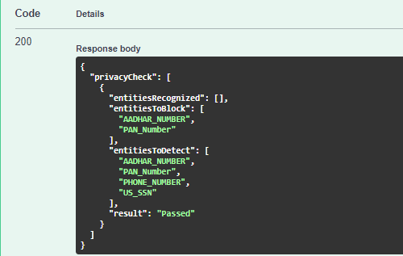

1. **Chain of Verification**

**Endpoint –** /rai/v1/moderations/COV

Using this API, we can see the ‘chain of verification’ or questions the LLM asked itself to reach the response it gave us. We can give ‘gpt4’, ‘gpt3’ or ‘Llama’ as model names.

**Input :**

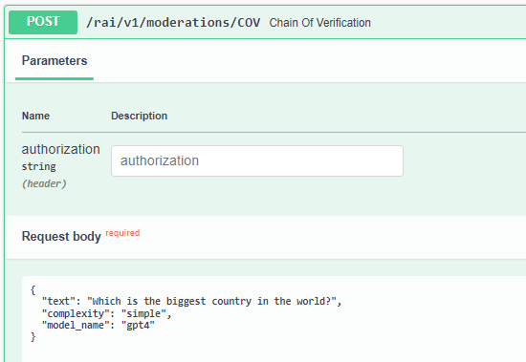

**Response :**

1. **Org Policy**

**Endpoint –** rai/v1/moderations/OrgPolicy

Using this API, we could see if the prompt passed is associated with any restricted topic we have passed in ‘labels’. In labels we can add the restricted topics under which we want to test our prompt, like – ‘terrorism’, ‘explosives’, ‘fraud’, ‘cheating’ etc.

**Input :**

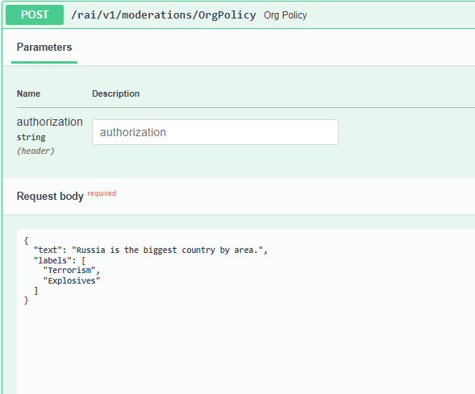

**Response:**

1. **Faithfulness**

**Endpoint -** /rai/v1/moderations/gEval

Using this API, we can compare the text and the summary provided. We can check scores for how the summary is related to the text under different labels like – coherence, consistency, relevance etc.

**Input :**

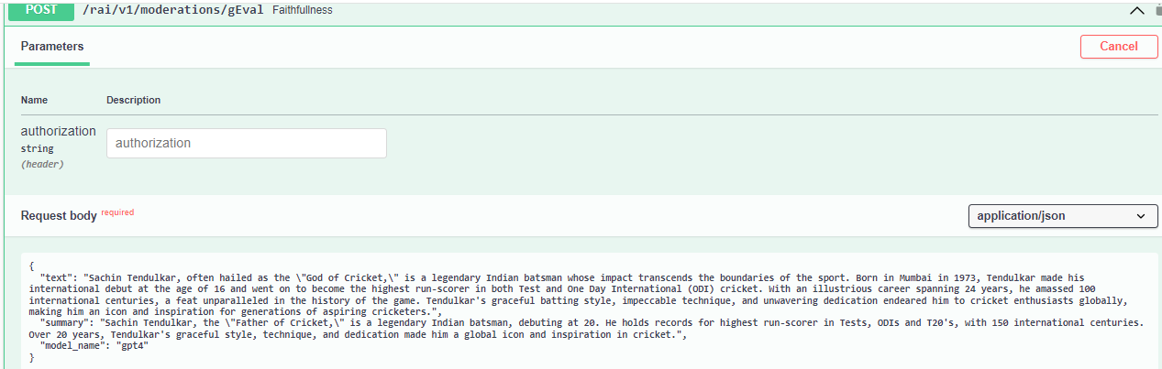

**Response :**

1. **Hallucination**

**Endpoint -** /rai/v1/moderations/Hallucination_Check

Using this API, we can check if the provided prompt is related to sources provided.

**Input :**

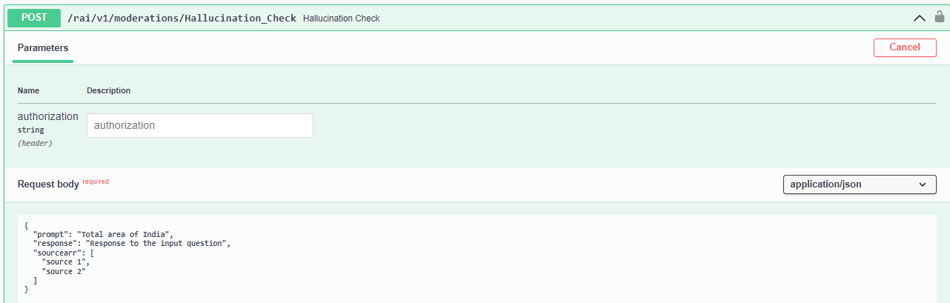

**Response :**

