**Fairness Analyze in Unstructured Text and Images**

Unstructured Text:

Endpoint: /api/v1/fairness/analysis/llm

Payload:

response: Text

evaluator: GPT_4O

Response:

Bias analysis of Text with Bias Type and Bias Score.

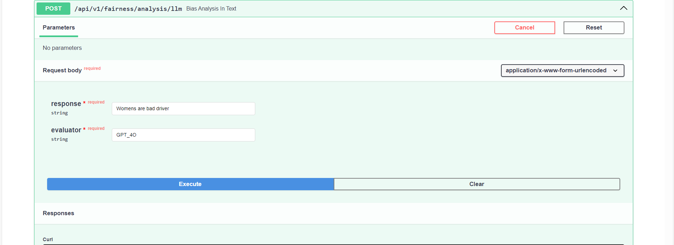

Images:

Endpoint: /api/v1/fairness/analysis/image

Payload:

prompt: Description of an image.

Image: Image for which bias needs to be analyzed

Evaluator: GPT_4O

Response: Bias analysis with the bias score and bias type.

**Fairness Analyze and Mitigation in Structured Text**

Bias Analysis in Structured Text in Both Pretrain and Posttrain Scenario.

Endpoint: /api/v1/fairness/Analyse

Payload:

**biasType**: Provide bias type based on your requirement PRETRAIN/POSTTRAIN.

**methodType**: Provided method type for metric score like disparate impact or ALL will return available metric scores.

**taskType**: As of now we have only CLASSIFICATION.

**Label**: Mention the target column name to predict.

**predLabel**: Add prediction label. Default is “labels_pred”. This is required for POSTTRAIN.

**FavourableOutcome**: Mention favorable outcome for predict column.

**ProtectedAttribute**: Mention the protected attribute column name.

**Privileged**: Mention the privileged value for protected attribute. If multiple Privileged groups are there, entered in this format [priv_1,priv_2],[priv_3,priv_4]

**File**: Upload the dataset.

Response: Response are the various metrics like **Statistical parity, Disparate Impact** which can help us identify the bias in the dataset.

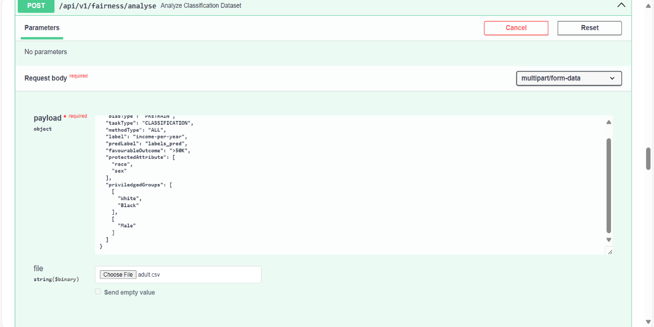

Endpoint: /api/v1/fairness/pretrainMitigate

Mitigation in Structured Text.

Payload:

**MitigationType**: Mention the mitigationType. (Curretnly supporting only preprocessing)

**MitigationTechinque**: Mention the mitigationTechinque to mitigate. (Currently supporting only reweighing)

**taskType**: As of now we have only

CLASSIFICATION.

**Label**: Mention the column name of ground truth.

**FavourableOutcome**: Mention favorable outcome for predict column.

**ProtectedAttribute**: Mention the protected attribute column name.

**Privileged**: Mention the privileged value for protected attribute. If multiple Privileged groups are there, entered in this format [priv_1,priv_2],[priv_3,priv_4]

**File**: Upload the dataset.

You will get a mitigated data which can be downloaded using the api **/api/v1/fairness/download/mitigatedData/{fileName}.**

Replace the file name with the mitigated_data_file_name from the response.

Endpoint: /api/v1/fairness/individualMetrics.

Payload: label: ground truth or prediction label

k: number of neighbors.

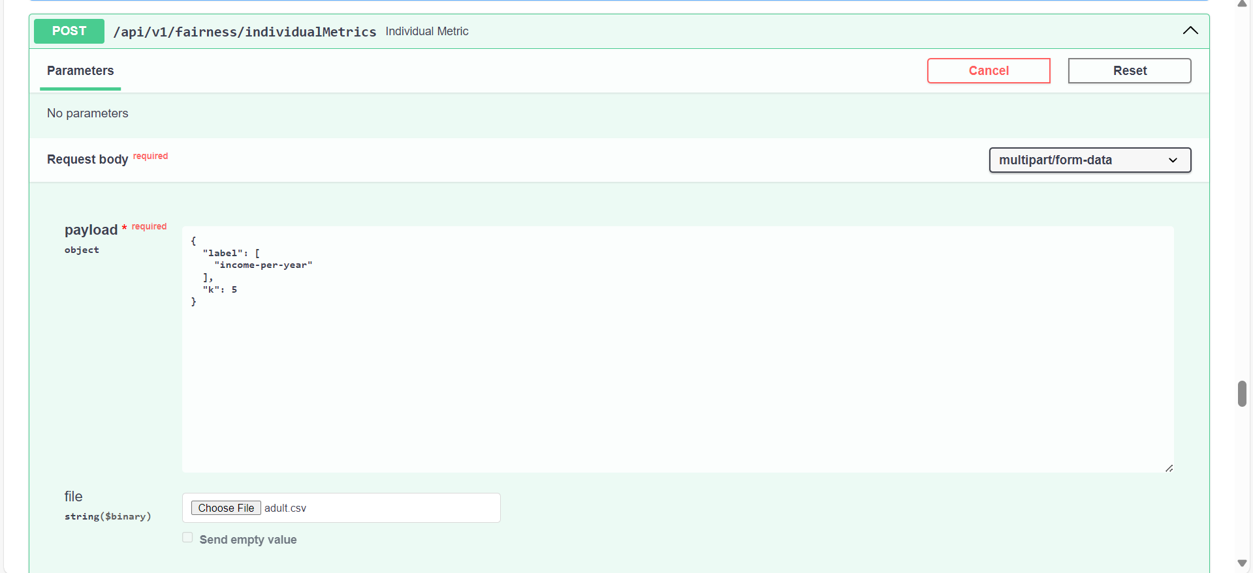

Endpoint: /api/v1/fairness/analyse/success_rate

Payload: label: ground truth or prediction column.

favourableOutcome: Mention favorable outcome for the selected label.

Categorical_attribute: Name of the categorical attribute for which success_rate needs to be calculated.

File: Structured data that needs to be monitored for the bias.

This will give you the report which can be downloaded using the endpoint /api/v1/fairness/analyse/success_rate/download/{filename}. The report will demonstrate the success_rate comparison of the categorical_attributes and its combination. This api can be used to monitor the classification task.

Endpoint: /api/v1/fairness/audit/fairness_classifier

Payload: prompt: Name of the column which contains the text

File: file containing all the text in a single column for which bias needs to be analyzed.

Response: report can be downloaded using the endpoint /api/v1/fairness/audit/fairness_classifier/download/{filename}, which will return csv and pdf. csv will contains the bias_score, bias_type, priviledge_group and pdf will have visual representation for the same.