CloudStack  
Basic Installation Guide

For CloudStack Version 3.0

Revised February 17, 2012

**A note to our readers**

This document is a draft of work in progress for a future release of CloudStack. It is not ready for publication. It may have errors, omissions, and descriptions of features that will not appear in the released software. The draft is provided for those who want an early look at work in progress for the next upcoming release of CloudStack, with the understanding that the documentation is subject to change, including major revision or removal. Distribution is not recommended.

© 2011, 2012 Citrix Systems, Inc. All rights reserved. Specifications are subject to change without notice. Citrix Systems, Inc., the Citrix logo, Citrix XenServer, Citrix XenCenter, and CloudStack are trademarks or registered trademarks of Citrix Systems, Inc. All other brands or products are trademarks or registered trademarks of their respective holders.

CloudStack software includes code redistributed under Apache Software Foundation license <http://www.apache.org/licenses/LICENSE-2.0>.

Contents

What's In This Guide 5

What Is CloudStack? 6

What Can CloudStack Do? 7

Deployment Architecture 7

Management Server Overview 8

Cloud Infrastructure Overview 9

Network 10

Overview of Basic Installation Steps 11

Minimum System Requirements 12

Machine 1: Management Server, Database, and Storage 12

​Machine 2: Host/Hypervisor 12

Management Server Installation 14

About the Management Server 14

Management Server Installation Overview 14

Prepare the Operating System 14

Install the Management Server 15

Install the MySQL Database 16

Prepare NFS Share for Secondary Storage 17

Prepare the System VM Template 17

Management Server Installation Complete! Next Steps 18

Log In to the CloudStack UI 19

Provision Your Cloud Infrastructure 20

Add a Zone 21

About Zones 21

Adding a Zone 22

Add a Pod 23

About Pods 23

Adding a Pod 23

Add a Cluster 25

About Clusters 25

Add a Cluster 25

Add a Host 27

About Hosts 27

Install XenServer Hypervisor on the Host 27

Add the Host to CloudStack 28

Add Primary Storage 29

About Primary Storage 29

Adding Primary Storage 29

Add Secondary Storage 30

About Secondary Storage 30

Adding Secondary Storage 30

Initialization and Testing 31

Troubleshooting 32

Checking the Management Server Log 32

Can't Add Host 32

Contacting Support 32

# What's In This Guide

This Basic Installation Guide describes how to install CloudStack for a basic trial setup. It includes a brief overview of CloudStack's functionality, followed by a guided walkthrough that shows how to set up the simplest possible configuration so that you can get started using CloudStack right away. We'll help you set up a cloud with the following features: a single machine that runs CloudStack software and uses NFS to provide storage; a single machine running VMs under the XenServer hypervisor; and a shared public network.

You can find out more about CloudStack's many additional features and installation options in the other CloudStack documentation available at http://docs.cloud.com:

* CloudStack Advanced Installation Guide
* CloudStack Administrator's Guide

# What Is CloudStack?

CloudStack™ is an open source software platform that pools computing resources to build public, private, and hybrid Infrastructure as a Service (IaaS) clouds. CloudStack manages the network, storage, and compute nodes that make up a cloud infrastructure. Use CloudStack to deploy, manage, and configure cloud computing environments.

**Who Should Read This**

If you are new to CloudStack or you want to learn more about concepts before installing and running CloudStack, read this overview.

If you just want to get started, you can skip to Overview of Basic Installation Steps on page 11.

Typical users are service providers and enterprises. With CloudStack, you can:

* Set up an on-demand, elastic cloud computing service. Service providers can sell self‑service virtual machine instances, storage volumes, and networking configurations over the Internet.
* Set up an on-premise private cloud for use by employees. Rather than managing virtual machines in the same way as physical machines, with CloudStack an enterprise can offer self-service virtual machines to users without involving IT departments.

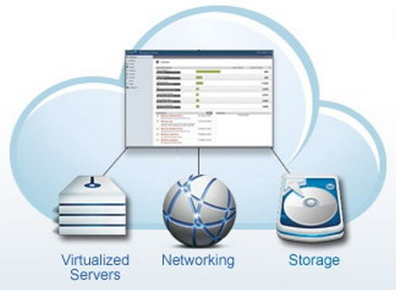

## What Can CloudStack Do?

**Multiple Hypervisor Support**

CloudStack works with a variety of hypervisors. A single cloud deployment can contain multiple hypervisor implementations. You have the complete freedom to choose the right hypervisor for your workload.

CloudStack is designed to work with open source Xen and KVM hypervisors as well as enterprise-grade hypervisors such as VMware vSphere and Citrix XenServer.

**Massively Scalable Infrastructure Management**

CloudStack can manage tens of thousands of servers installed in multiple geographically distributed datacenters. The centralized management server scales linearly, eliminating the need for intermediate cluster-level management servers. No single component failure can cause cluster- or cloud-wide outage. Periodic maintenance of the management server can be performed without affecting the functioning of virtual machines running in the cloud.

**Automatic Configuration Management**

CloudStack automatically configures each guest virtual machine’s networking and storage settings.

CloudStack internally manages a pool of virtual appliances to support the cloud itself. These appliances offer services such as firewalling, routing, DHCP, VPN access, console proxy, storage access, and storage replication. The extensive use of virtual appliances greatly simplifies the installation, configuration, and on-going management of a cloud deployment.

**Graphical User Interface**

CloudStack offers an administrator's Web interface, used for provisioning and managing the cloud, as well as an end-user's Web interface, used for running VMs and managing VM templates. The UI can be customized to reflect the desired service provider or enterprise look and feel.

**Standard API Support**

CloudStack provides an API that gives programmatic access to all the management features available in the UI. The API is maintained and documented.

## Deployment Architecture

A CloudStack installation consists of two parts: the Management Server and the cloud infrastructure that it manages. When you set up and manage a CloudStack cloud, you provision resources such as hosts, storage devices, and IP addresses into the Management Server, and the Management Server manages those resources.

The minimum installation consists of one machine running the CloudStack Management Server and another machine to act as the cloud infrastructure (in this case, a very simple infrastructure consisting of one host running hypervisor software). A more full-featured installation consists of a highly-available multi-node Management Server installation and up to thousands of hosts using any of several advanced networking setups. You can read about how to create such a setup in the CloudStack Advanced Installation Guide.

Management Server

Hypervisor

Machine 1

Machine 2

Simplified view of a basic deployment

### Management Server Overview

The Management Server:

* Provides the web user interfaces for the administrator and end users.
* Provides the APIs for the CloudStack platform.
* Manages the assignment of guest VMs to particular hosts.
* Manages the assignment of public and private IP addresses to particular accounts.
* Manages the allocation of storage to guests as virtual disks.
* Manages snapshots, templates, and ISO images, possibly replicating them across data centers.
* Provides a single point of configuration for the cloud.

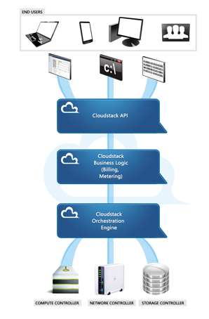

Management Server Components

For more, see Management Server Installation on page 14.

### Cloud Infrastructure Overview

As its name implies, the Management Server is there to manage something -- one or more zones (typically, datacenters) containing host computers where guest virtual machines will run. The cloud infrastructure is organized as follows:

* **Zone**: Typically, a zone is equivalent to a single datacenter. A zone consists of one or more pods and secondary storage. In the Basic Installation, the zone will be a simplified version. See About Zones on page 21.
* **Pod**: A pod is usually one rack of hardware that includes a layer-2 switch and one or more clusters. Again, in the Basic Installation, the pod is simplified. See About Pods on page 23.
* **Cluster**: A cluster consists of one or more hosts and primary storage. See About Clusters on page 25.
* **Host**: A single compute node within a cluster. The hosts are where the actual cloud services run in the form of guest virtual machines. See About Hosts on page 27.
* **Primary storage** is associated with a cluster, and it stores the disk volumes for all the VMs running on hosts in that cluster. See About Primary Storage on page 29.
* **Secondary storage** is associated with a zone, and it stores templates, ISO images, and disk volume snapshots. See About Secondary Storage on page 30.

Host

Zone

Pod

Cluster

Secondary Storage

Primary Storage

Nested organization of a zone

### Network

CloudStack offers two types of networking scenario: basic and advanced. In the Basic Installation, we use basic networking.

###### Basic Networking

Basic networking provides a single shared network. Guest isolation can be provided through layer-3 means such as security groups (IP address source filtering). All guests allocated in the zone share a single network.

###### Advanced Networking

We won't go into much detail about advanced networking here, since we're doing a Basic Installation. Advanced networking is f or more sophisticated network topologies. This network model provides the most flexibility in defining guest networks. When you are ready, you can find out more in the CloudStack Advanced Installation Guide.

# Overview of Basic Installation Steps

###### Prepare

1. Make sure you have the required hardware ready (p. 12)

###### Install the CloudStack software

1. Install the CloudStack Management Server (p. 14)
2. Log in to the CloudStack UI (p. 19)

###### Provision your cloud infrastructure

1. Add a zone (p. 21)
2. Add a pod (p. 23)
3. Add a cluster (p. 25)
4. Add a host (p. 27)
5. Set up primary storage (p. 29)
6. Set up secondary storage (p. 30)

**Try using the cloud**

1. Initialization and testing (p. 31)



# Minimum System Requirements

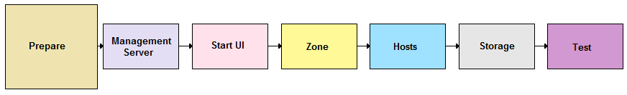

Before you can start the CloudStack trial installation, you'll need two computers that match the following requirements.

## Machine 1: Management Server, Database, and Storage

This machine will run the Management Server and MySQL database node, as well as provide primary and secondary storage. In a Basic Installation, we will use NFS on the machine with the Management Server for both types of storage. The Management Server may be placed on a virtual machine.

* Operating system: RHEL/CentOS 5.4+ 64-bit or RHEL6 64-bit
* 64-bit x86 CPU (more cores results in better performance)
* 4 GB of memory
* 250 GB of local disk (more results in better capability; 500 GB recommended)
* At least 1 NIC
* Statically allocated IP address
* Fully qualified domain name as returned by the hostname command

## ​Machine 2: Host/Hypervisor

The host is where the cloud services run in the form of guest virtual machines. For a small-scale setup, you need only one machine that meets the following requirements:

* The host must be certified as compatible with XenServer. See the Citrix Hardware Compatibility Guide: <http://hcl.xensource.com/>
* Must be 64-bit and must support HVM (Intel-VT or AMD-V enabled).
* You must re-install Citrix XenServer if you are going to re-use a host from a previous install.
* 64-bit x86 CPU (more cores results in better performance)
* Hardware virtualization support required
* 4 GB of memory
* 30 GB of local disk
* At least 1 NIC
* Statically allocated IP Address

# Management Server Installation

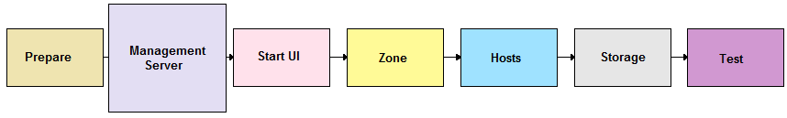

When you have the correct hardware ready, the first step of a CloudStack Basic Installation is to install the CloudStack Management Server.

## About the Management Server

The Management Server is the CloudStack software that manages cloud resources. By interacting with the Management Server through its UI or API, you can configure and manage your cloud infrastructure.

The Management Server is a dedicated server or VM. It controls allocation of virtual machines to hosts and assigns storage and IP addresses to the virtual machine instances. The CloudStack Management Server runs in a Tomcat container and requires a MySQL database for persistence.

For a Basic Installation, you will install a single instance of the CloudStack Management server and install MySQL on the same machine. The machine must meet the system requirements described in Machine 1: Management Server, Database, and Storage on page 12.

## Management Server Installation Overview

The procedure for the installation is:

1. Prepare the Operating System
2. Install the Management Server
3. Install the MySQL Database
4. Prepare NFS Share for Secondary Storage
5. Prepare the System VM Template

## Prepare the Operating System

The Management Server requires RHEL/CentOS 5.4 64 bit or later. You can download CentOS 64-bit from the following link: <http://isoredirect.centos.org/centos/5/isos/x86_64/>.

NTP is recommended.

The OS must be prepared to host the Management Server using the following steps.

1. Log in to your OS as root. All the following commands should be run as root.
2. Check for a fully qualified hostname.

# hostname --fqdn

This should return a fully qualified hostname such as "kvm1.lab.example.org". If it does not, edit /etc/hosts so that it does.

1. Disable SELinux. Set SELinux up to be permissive by default.
   1. First, set the SELINUX variable in /etc/selinux/config to “permissive”. This ensures that the CloudStack Agent can run properly on system reboot.
   2. Then set SELinux to permissive until the system is rebooted:

# setenforce permissive

1. Make sure that the Management Server can reach the Internet.

# ping www.google.com

1. (RHEL 6.x) If you do not have a Red Hat Network account, you need to prepare a local Yum repository.
   1. If you are working with a physical host, insert the RHEL 6.x installation CD. If you are using a VM, attach the RHEL6 ISO.
   2. Mount the CDROM to /media.
   3. Create a repo file at /etc/yum.repos.d/rhel6.repo. In the file, insert the following lines:

[rhel]

name=rhel6

baseurl=file:///media

enabled=1

gpgcheck=0

## Install the Management Server

Download the CloudStack Management Server at http://download.cloud.com/support/downloads.html. The download includes everything you need to get started, except MySQL.

1. Install the CloudStack packages. You should have a file in the form of “CloudStack-NNNN.tar.gz”. Untar the file and then run the install.sh script inside it. Replace the file and directory names below with those you are using:

# tar xzf CloudStack-VERSION-1-rhel6.2.tar.gz

# cd CloudStack-VERSION-1-rhel6.2

# ./install.sh

You should see a few messages as the installer prepares, followed by a list of choices.

1. Choose “M” to install the Management Server software.

>M

## Install the MySQL Database

1. On the same computer, re-run install.sh.

# ./install.sh

You should see a few messages as the installer prepares, followed by a list of choices.

1. Choose one of the following to install MySQL.

WARNING

On CentOS, it is important that you make the right choice of database version. Never choose L if it would mean downgrading your existing MySQL version. If this is not a danger, choose L to get the version that has been tested with CloudStack.

* (CentOS 5.x, no/early MySQL) If you have never installed MySQL on this machine before, or you have installed a version prior to CloudStack’s most recent tested version, 5.1.58, choose L.

L) Install MySQL 5.1.58

Q) Quit

> L

* (CentOS 5.x, newer MySQL) If you have installed a version of MySQL later than 5.1.58, choose D.

D) Install the database server (from distribution's repo)

L) Install MySQL 5.1.58

Q) Quit

> D

* (RHEL) Choose D. RHEL can use the most recent version of MySQL.

D) Install the database server (from distribution's repo)

L) Install MySQL 5.1.58

Q) Quit

> D

1. Edit the MySQL configuration (/etc/my.cnf or /etc/mysql/my.cnf, depending on your OS) and insert the following lines in the [mysqld] section. You can put these lines below the datadir line. The max_connections parameter should be set to 350 multiplied by the number of Management Servers you are deploying. This example assumes 1 Management Server, since we are doing a Basic Installation.

innodb_rollback_on_timeout=1

innodb_lock_wait_timeout=600

max_connections=350

log-bin=mysql-bin

binlog-format = 'ROW'

**NOTE:** The binlog-format variable is supported in MySQL versions 5.1 and greater. It is not supported in MySQL 5.0. In some versions of MySQL, an underscore character is used in place of the hyphen in the variable name. For the exact syntax and spelling of each variable, consult the documentation for your version of MySQL.

1. After editing my.cnf, restart the MySQL server.

# service mysqld restart

1. Best Practice: On RHEL and CentOS, MySQL does not set a root password by default. It is very strongly recommended that you set a root password as a security precaution. Run the following commands, and substitute your own desired root password for <password>.

# service mysqld start

# mysql -u root

mysql> SET PASSWORD = PASSWORD('<password>');

1. Set up the database. The following command creates the cloud user on the database.

* In dbpassword, specify the password to be assigned to the cloud user. You can choose to provide no password.
* In deploy-as, specify the username and password of the user deploying the database. In the following command, it is assumed the root user is deploying the database and creating the cloud user.

# cloud-setup-databases cloud:<dbpassword>@localhost --deploy-as=root:<password>

1. Configure the OS for the Management Server using the following command. This command will set up iptables, sudoers, and start the Management Server.

# cloud-setup-management

## Prepare NFS Share for Secondary Storage

CloudStack needs a place to keep secondary storage (see Add Secondary Storage on page 30). In a Basic Installation, we will use an NFS share that you provide from another server.

1. On the storage server, create an NFS share for secondary storage. Export it with “rw,no_root_squash.” The exact commands to use vary depending on your system.
2. On the management server, create a mountpoint. For example:

# mkdir /mnt/secondary

1. Mount the secondary storage on your Management Server. Replace the example NFS server name and NFS share paths below with your own.

# mount -t nfs nfsservername:/nfs/share/secondary /mnt/secondary

## Prepare the System VM Template

Secondary storage must be seeded with a template that is used for CloudStack system VMs.

1. On the Management Server, run the following command to retrieve and decompress the system VM template.

When copying and pasting a command, be sure the command has pasted as a single line before executing. Some document viewers may introduce unwanted line breaks in copied text.

This process will require approximately 10 GB of free space on the local file system and up to 30 minutes each time it runs.

# /usr/lib64/cloud/agent/scripts/storage/secondary/cloud-install-sys-tmplt -m /mnt/secondary -u http://download.cloud.com/templates/acton-beta1-systemvm.vhd.bz2 -h xenserver -F

1. When the script has finished, unmount secondary storage and remove the created directory.

# umount /mnt/secondary

# rmdir /mnt/secondary

## Management Server Installation Complete! Next Steps

Congratulations! You have now installed CloudStack Management Server and the database it uses to persist system data.

Management Server

MySQL cloud_db

What should you do next?

* Even without adding any cloud infrastructure, you can run the UI to get a feel for what's offered and how you will interact with CloudStack on an ongoing basis. See Log In to the CloudStack UI on page 19.
* When you're ready, use the UI to add cloud infrastructure and try running some virtual machines on it. See Provision Your Cloud Infrastructure on page 20.

# Log In to the CloudStack UI

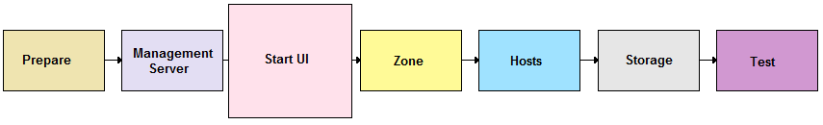

After the Management Server software is installed and running, you can run the CloudStack user interface. This UI is there to help you provision, view, and manage your cloud infrastructure.

1. Open your favorite Web browser and go to this URL. Substitute the IP address of your own machine:

http://<management-server-ip-address>:8080/client

The default username and password are "admin" and "password". Use these to login to the CloudStack UI. The first time you start the UI after a fresh Management Server installation, the Installation Wizard appears.

1. Choose Basic Setup. You're just trying CloudStack, and you want a guided walkthrough of the simplest possible configuration so that you can get started using CloudStack right away. We'll help you set up a cloud with the following features: a single machine that runs CloudStack software and uses NFS to provide storage; a single machine running VMs under the XenServer hypervisor; and a shared public network.

The Installation Wizard will remain on screen. Its prompts should give you all the information you need, but if you want just a bit more detail, you can follow along in this Guide. Continue to Provision Your Cloud Infrastructure on page 20.

1. When prompted, choose a new password.

You are logging in as the root administrator. This account manages the CloudStack deployment, including physical infrastructure. The root administrator can modify configuration settings to change basic functionality, create or delete user accounts, and take many actions that should be performed only by an authorized person. Please change the default password to a new, unique password.

# Provision Your Cloud Infrastructure

After the Management Server is installed and running, you need to add the compute resources for it to manage. This section tells how to use the CloudStack UI to describe your infrastructure to CloudStack.

**Background Concepts**

See Cloud Infrastructure Overview on page 9.

Log in to the CloudStack UI (see p. 19), then follow these procedures to provision your cloud infrastructure:

1. Add a Zone on page 21
2. Add a Pod on page 23
3. Add a Cluster on page 25
4. Add a Host on page 27
5. Add Primary Storage on page 29
6. Add Secondary Storage on page 30
7. Initialization and Testing on page 31

When you have finished with these steps, you will have a deployment with the following basic structure:

Host

Zone

Pod

Cluster

Management Server

Secondary Storage

Primary Storage

MySQL cloud_db

Conceptual view of a basic deployment

# Add a Zone

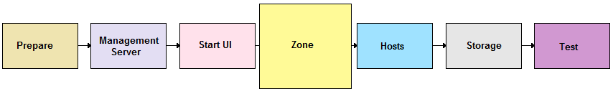

## About Zones

A zone is the largest organizational unit within a CloudStack deployment. A zone typically corresponds to a single datacenter, although it is permissible to have multiple zones in a datacenter. The benefit of organizing infrastructure into zones is to provide physical isolation and redundancy. For example, each zone can have its own power supply and network uplink, and the zones can be widely separated geographically (though this is not required).

A zone consists of:

* One or more pods. Each pod contains one or more clusters of hosts and one or more primary storage servers.
* Secondary storage, which is shared by all the pods in the zone.

Host

Zone

Pod

Cluster

Secondary Storage

Primary Storage

In the Basic Installation, you will have a single zone with one pod, a single-host cluster, one primary storage, and one secondary storage.

## Adding a Zone

These steps assume you have already logged in to the CloudStack UI and chosen Basic Installation (see p. 19). The Zone page of the Installation Wizard appears.

1. Enter the following details.

* **Name**. A name for the zone.
* **DNS 1 and DNS2**. These are DNS servers for use by guest VMs in the zone. These DNS servers will be accessed via the public network you will add later. The public IP addresses for the zone must have a route to the public DNS server named here.

CloudStack distinguishes between internal and public DNS. Internal DNS is assumed to be capable of resolving internal-only hostnames, such as your NFS server’s DNS name. Public DNS is provided to the guest VMs to resolve public IP addresses. You can enter the same DNS server for both types, but if you do so, you must make sure that both internal and public IP addresses can route to the DNS server.

* **Internal DNS 1 and Internal DNS2**. These are DNS servers for use by system VMs in the zone. These DNS servers will be accessed via the private network interface of the System VMs. The private IP address you provide for the pods must have a route to the internal DNS server named here.

1. Click Continue.

Your zone is now added.

# Add a Pod

## About Pods

A pod often represents a single rack. Hosts in the same pod are in the same subnet.

A pod is the second-largest organizational unit within a CloudStack deployment. Pods are contained within zones. Each zone can contain one or more pods; in the Basic Installation, you will have just one pod in your zone.

A pod consists of one or more clusters of hosts and one or more primary storage servers.

Host

Pod

Cluster

Primary Storage

In the Basic Installation, you will have just one cluster in your pod.

## Adding a Pod

These steps assume you have already logged in to the CloudStack UI, chosen Basic Installation, and added a zone.

1. Click Continue. The Add Pod screen appears.
2. Enter the following details.

* **Name**. A name for the pod.
* **Gateway**. The gateway for the hosts in that pod.
* **Netmask**. The netmask in use on the subnet the guests will use.
* **IP Range**: This is the reserved IP range in the private network that CloudStack uses to manage various system VMs, such as Secondary Storage VMs, Console Proxy VMs, and DHCP. These IP addresses are taken from the same subnet as computing servers. You therefore need to make sure computing servers and Management Servers use IP addresses outside of this range. These two values combine to give the system control over a certain IP address range, and leave you in control of allocation for IP addresses in the CIDR but outside of the start and end range. For example, suppose we have start=192.168.154.2 and end=192.168.154.7. CloudStack can use .2 to .7 for System VMs, leaving .8 to .254 for the Management Server and hypervisor host.
* Click Continue.

1. The Add Guest Network screen appears.
2. Enter the following details.

* **Gateway**. The gateway that the guests should use.
* **Netmask**. The netmask in use on the subnet the guests will use.
* **IP Range**. The range of IP addresses that will be available for allocation to guests in this zone.

1. Click Continue.

Your pod is now added.

# Add a Cluster

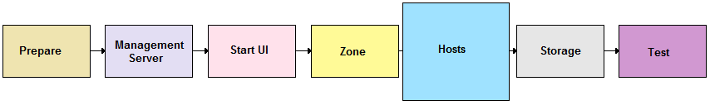

You need to tell CloudStack about the hosts that it will manage. Hosts exist inside clusters, so before you begin adding hosts to the cloud, you must add at least one cluster.

## About Clusters

A cluster provides a way to group hosts. The hosts in a cluster all have identical hardware, run the same hypervisor, are on the same subnet, and access the same shared storage. Virtual machine instances (VMs) can be live-migrated from one host to another within the same cluster, without interrupting service to the user.

A cluster is the third-largest organizational unit within a CloudStack deployment. Clusters are contained within pods, and pods are contained within zones.

A cluster consists of one or more hosts and one or more primary storage servers. CloudStack allows multiple clusters in a cloud deployment. For a Basic Installation, we only need one cluster containing a single host and primary storage.

Host

Cluster

Primary Storage

## Add a Cluster

These steps assume you have already logged in to the CloudStack UI, chosen Basic Installation, and added a zone and pod.

1. Click Continue. The Add Cluster screen appears.
2. In Hypervisor, be sure XenServer is selected.
3. Enter a name for the cluster. This can be text of your choosing and is not used by CloudStack.
4. Click Continue.

Your cluster is now added.

# Add a Host



After adding a cluster to your CloudStack configuration, you can start adding hosts. Each cluster can contain one or more hosts (see Best Practices in the Advanced Installation Guide for some hints on practical limits). In a Basic Installation, you need only one host.

## About Hosts

A host is a single computer. Hosts provide the computing resources that run the guest virtual machines. Each host has hypervisor software installed on it to manage the guest VMs (except for bare metal hosts, which are a special case discussed in the Advanced Installation Guide). For example, a Linux KVM-enabled server, a Citrix XenServer server, and an ESXi server are hosts. In a Basic Installation, we use a single host running XenServer.

The host is the smallest organizational unit within a CloudStack deployment. Hosts are contained within clusters, clusters are contained within pods, and pods are contained within zones.

Hosts in a CloudStack deployment:

* Provide the CPU, memory, storage, and networking resources needed by the virtual machines
* Interconnect using a high bandwidth TCP/IP network and connect to the Internet
* May have different capacities (different CPU speeds, different amounts of RAM, etc.), although the hosts within a cluster must all be homogeneous

For a host to function in CloudStack, you must do the following:

* Install hypervisor software on the host
* Assign an IP address to the host
* Ensure the host is connected to the CloudStack Management Server

## Install XenServer Hypervisor on the Host

1. Download XenServer from the Citrix Website (<http://www.citrix.com/lang/English/lp/lp_1688615.asp>) and install it on your second machine. Follow the Citrix XenServer Installation Guide.
2. Set the XenServer network name-label to “cloud-guest”. In a Basic Installation, all guest VMs share a single network which must have this name.

## Add the Host to CloudStack

These steps assume you have already installed XenServer on your host, logged in to the CloudStack UI, chosen Basic Installation, and added a zone, pod, and cluster.

1. Click Continue. The Add Host screen appears.
2. Provide the following details.

* **Host Name**. The DNS name or IP address of the host.
* **Username**. Usually root.
* **Password**. This is the password for the user named above (from your XenServer install).

1. Click Continue.

Your host is now added.

# Add Primary Storage

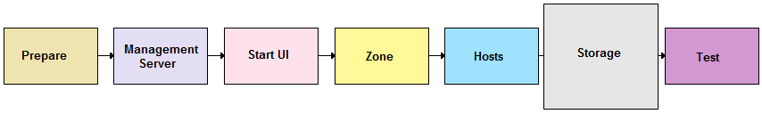

## About Primary Storage

**Primary storage** is associated with a cluster, and it stores the disk volumes for all the VMs running on hosts in that cluster.

## Adding Primary Storage

These steps assume you have already logged in to the CloudStack UI, chosen Basic Installation, and added a zone, pod, cluster, and host.

1. In the Basic Installation Wizard, click Continue. The Add Primary Storage screen appears.
2. Provide the following details.

* **Name**. The name of the storage device.
* **Server**. The IP address or DNS name of the NFS server.
* **Path.** The exported path from the server.

1. Click Continue.

The primary storage is now added.

# Add Secondary Storage



## About Secondary Storage

**Secondary storage** is associated with a zone, and it stores the following:

* Templates – OS images that can be used to boot VMs and can include additional configuration information, such as installed applications
* ISO images – disc images containing data or bootable media for operating systems
* Disk volume snapshots – saved copies of VM data which can be used for data recovery or to create new templates

The items in secondary storage are available to all hosts in the zone.

## Adding Secondary Storage

These steps assume you have already logged in to the CloudStack UI, chosen Basic Installation, and added a zone, pod, cluster, host, and primary storage. You must also prepare NFS storage as described in Prepare NFS Share on page 17.

1. In the Basic Installation Wizard, click Continue. The Add Secondary Storage screen appears.
2. Provide the following details:

* **NFS Server**. The IP address of the NFS server.
* **Path**. The exported path from the server.

1. Click Continue.

The Basic Installation's cloud infrastructure is now provisioned.

# Initialization and Testing

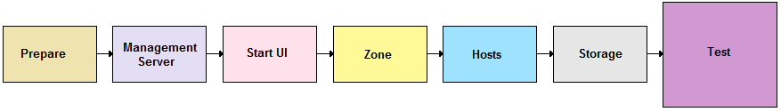

These steps assume you have already installed the Management Server, logged in to the CloudStack UI, chosen Basic Installation, and added a zone, pod, cluster, host, primary storage, and secondary storage.

1. In the Basic Installation Wizard's final screen, click Launch.

CloudStack will perform its initialization. This can take several minutes or more, depending on the speed of your network. When finished, you should see a success message.

Now use the following steps to try creating a virtual machine:

1. Log in to the CloudStack UI.
2. Go to the Instances tab, and filter by My Instances.
3. Click Add Instance and follow the steps in the wizard.
   1. Choose the zone you just added.
   2. In the template selection, likely only the provided CentOS template is available.
   3. Select a service offering. Be sure that the hardware you have allows starting the selected service offering.
   4. In data disk offering, if desired, add another data disk. This is a second volume that will be available to but not mounted in the guest. For example, in Linux on XenServer you will see /dev/xvdb in the guest after rebooting the VM. A reboot is not required if you have a PV-enabled OS kernel in use.
   5. In default network, choose the primary network for the guest. In the Basic Installation, you should have only one option here.
   6. Optionally give your VM a name and a group. Use any descriptive text you would like.
   7. Click Launch VM. Your VM will be created and started.

Congratulations! You have successfully completed a Basic CloudStack Installation.

# Troubleshooting

## Checking the Management Server Log

The command below shoes a quick way to look for errors in the management server log. When copying and pasting this command, be sure the command has pasted as a single line before executing. Some document viewers may introduce unwanted line breaks in copied text.

# grep -i -E 'exception|unable|fail|invalid|leak|invalid|warn' /var/log/cloud/management/management-server.log

## Can't Add Host

A host must have a statically allocated IP address. Host addition will error and fail if a dynamically-assigned address is present.

## Contacting ****Support****

**Open-source community**

A variety of channels are available for getting help with CloudStack, from forums to IRC chat and more. For details, see http:// <http://cloudstack.org/discuss/>.

**Commercial customers**

The CloudStack support team is available to help commercial customers plan and execute their installations. To contact the support team, log in to the support portal at <https://na6.salesforce.com/sserv/login.jsp?orgId=00D80000000LWom> using the account credentials you received when you purchased your support contract.