# File permissions in Linux

## Project description

[Describe what you accomplish through Linux commands.]

The aim of this project is to manage security on files and directories for users, groups and other

## Check file and directory details

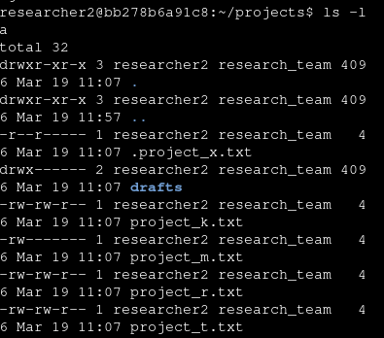[Add content here.]

## by perfoming an ls -la command on BASH it will list all the files in the current directory. On the **drafts** directory the first character **d** indicates that its a directory. preceding with **rwx** indicates that the user can read file contents and view list of directories and files within that directory. The **w** indicates they they can modify file content, within the directory they can create new files and subdirectories. **X** indicates that the user can execute files and applicaions within the directory. The preceding **------** indicates that the group and other users of the system have no access to **drafts** folder. The owner of the directory is the user **researcher2** the group that has access to the directory is **researcher_team**.

## Describe the permissions string chmod



The chmod command in this example indicates to remove write access to the others on the system on the file project_x.txt. From th previous example of the drafts folder we look at the example permissions **drwx------**

character 1 **d**  indicats that its a directory

characters 2 to 4 **rwx** indicates that the user **researcher2** has full access read write and execute on the directory.

Characters 5 to 7 **---**  indicates that the group **researcher_team** has no access to the group.

Characters 8 to 10 **---**  indicates that othr users have no access to the directory

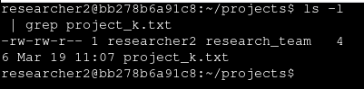

in this command we are lsiting all ffiles including hidden, using **grep** we are filtering for a specific file in this example project_k.txt. We receive confimation that other users have only read access to the file.

## Change file permissions

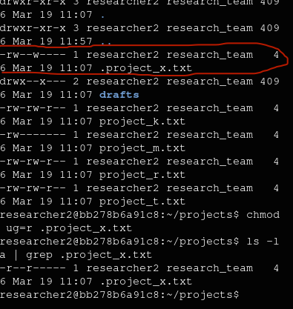

## In this example we ned to nsure that other dos not have write access to any file this would be achieved by firstly listing all file and directories in the current directory by invoking the command **ls -la.** Once we identify the fils where owner has write acess we invoke the command **chmod o-w filename.extension.** This is telling Linux to remove write access to others, on a particular file.

## For the purpos of providing an example we are going to remove write access to the group on a file called .project_x.txt note that any file starting with . Indicates that its a hidden file. We are going to remove write access for the user and group. Using the chmod command ug=r explicitly insructs Linux to provide only read access. ug=r will overwrite other permission only provide read access meaning that if user and group both have rwx it will now be r for both.

## Change file permissions on a hidden fileclear – chmod g-r

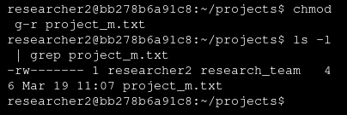

In this example we are removing read access from the group research_team combining the ls and grep commands provides a confirmation that the group has acess removed.

To remove write access on the hidden file for other on .project_x.txt we invoke the access by executing **chmod o-w .project_x.txt**  this tells the shell to rmove wite access fo others on th projet_x.txt file.

## Change directory permissions

Here we use chmod to modify access to the drafts folder **chmod g-x drafts/** this will remove execute access for the group. The / would be moved to the end of the folder name as the folder is in the current working diretory we use the relative path.

## Summary

In this projct we modified and removed permissions using **chmod,** we used **ls**  with additional switches **-la**  to list all files including hidden as well as dirctories.

We piped using the grep command to output and filter only specific information i.e. we only wan't to see a specific file.

This project was completed using qwicklabs which is provided by Google, resource to their cloud labs was provided by Coursera as part of their Cyberscurity training program.

We could have used the numeric system in granting updaing and emoving access with the chmod command here are some examples:

chmod 700 .project_x.txt = **-rwx------**

chmod 644 .project_x.txt = **-rw-r—r--**

chmod 755 .project_x.txt = **-rwxr-xr-x**

**r = 4**

**w = 2**

**x = 1**