# Apply filters to SQL queries

## Project description

You are a security professional at a large organization. Part of your job is to investigate security issues to help keep the system secure. You recently discovered some potential security issues that involve login attempts and employee machines.

Your task is to examine the organization’s data in their employees and log_in_attempts tables. You’ll need to use SQL filters to retrieve records from different datasets and investigate the potential security issues.

## Retrieve after hours failed login attempts

SELECT * FROM log_in_attempts where login_time > '18:00' AND success = FALSE;

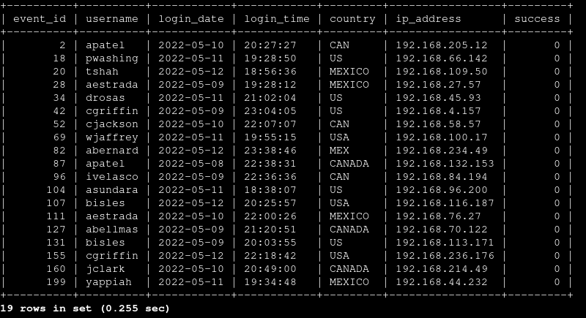

We are instructing sql to show all columns within the table log_in_attempts narowing down all failed attempts after business hours in this example 18:00, the success column outputs a Booleaan 0 = false 1= true.

## Retrieve login attempts on specific dates

SELECT * FROM log_in_attemps WHERE login_date = '2022-05-09' OR login_date = '2022-05-08';

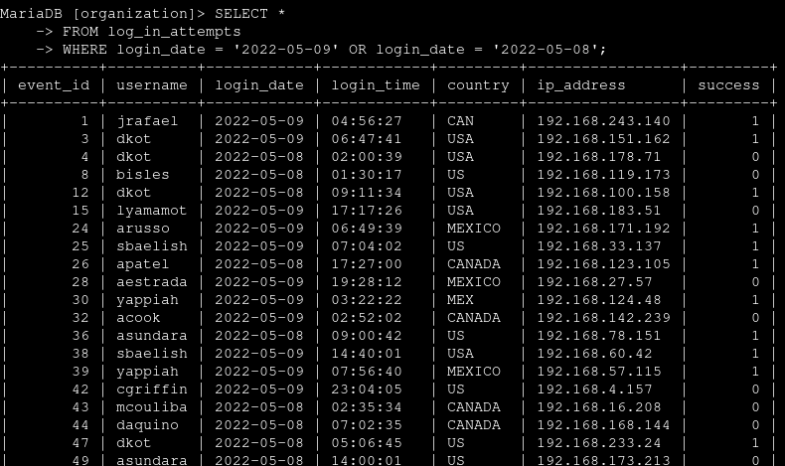here we are instructin SQL to look for logoin attempts either 2022-05-08 0r 2022-05-09 this condition will output login dates on either date.

## Retrieve login attempts outside of Mexico

SELECT * FROM log_in_attempts WHERE NOT country like 'MEX%';

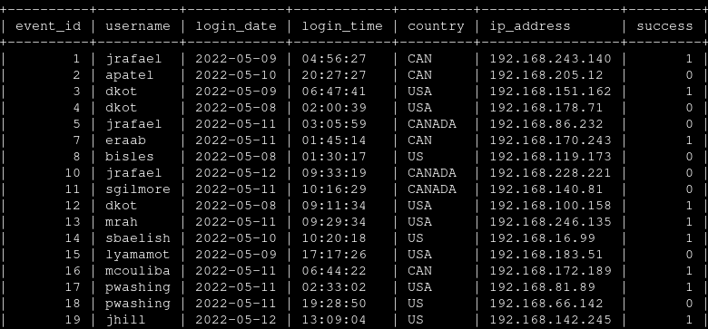

## this statement tells SQL look for entries in our table that does not contain values that start with MEX. The like keyword filters for a mathing pattern.

## Retrieve employees in Marketing

SELECT * FROM EMPLOYEES WHERE department = 'Marketing' AND Office LIKE 'East%';

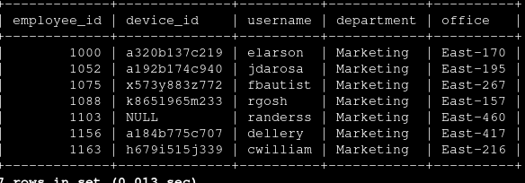

Here we are instructing SQL to return values where the department that employees belong to is in Marketing where the office locatioe starts with East. The AND clause tells SQL its both values have to be turned as output.

## Retrieve employees in Finance or Sales

SELECT * FROM employees WHERE department = 'Sales' or department = 'Finance';

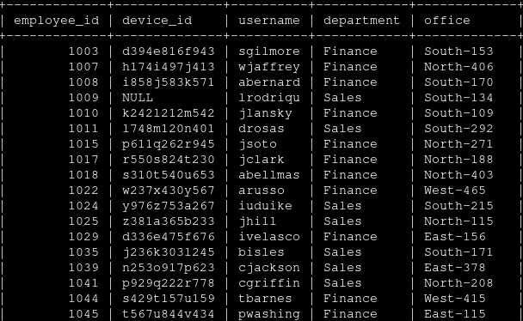

## We are instructing SQL to return all employees that are either in the Sales or Finance department

## Retrieve all employees not in IT

SELECT * FROM employees WHERE NOT department = 'Information Technology';

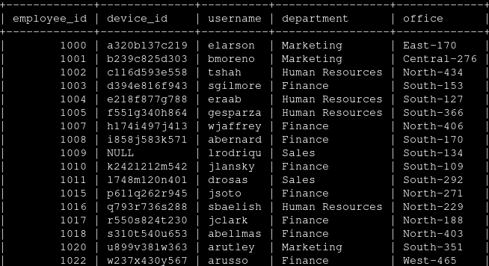

## tells sql to filter all entries where employee does not work within the Information Technology department.

## Summary

The intended project was to use the AND, OR, NOT and LIKE filters to interrogate the database in order to retrieve data from tables that match certain conditions.