Project 1: Vending Machine
Documentation, version 2.0 (Windows Forms, C#, .NET Framework 4.7.2)
Author: Serhii Berezovskyi

1. Overview
The program simulates a vending machine with three drinks (Fanta, Sprite, Cola, 3.50 PLN each) and three chocolate bars (Twix, Snickers, Mars, 2.50 PLN each). The user picks a product, chooses a payment method (cash or contactless card) and collects the product. With cash, change is returned as coins or can be donated to support Ukraine.

2. How to use the program

Step 1. Start screen
The display shows "Select a product". Payment controls are disabled until a product is selected.
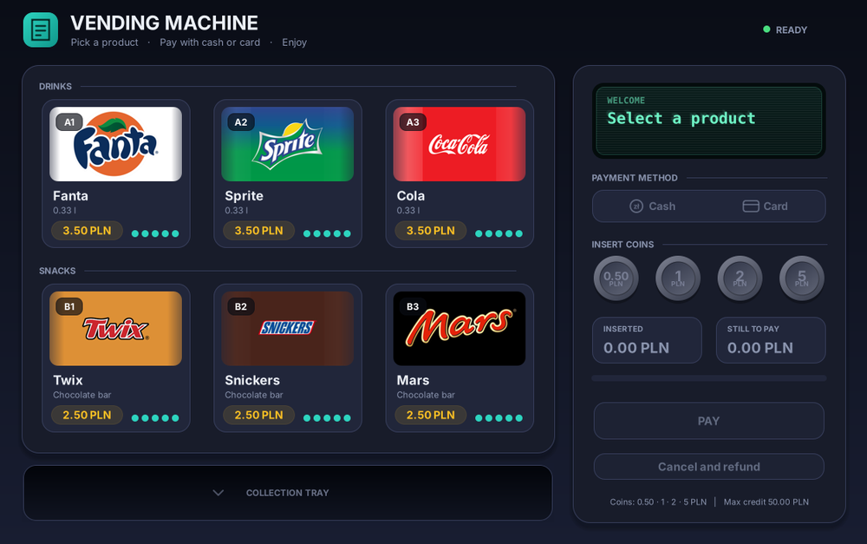
Figure 1. Start screen

Step 2. Select a product
Click a product card (or focus it with Tab and press Enter). The selected card is highlighted and the display shows its name and price. Sold-out products cannot be selected.
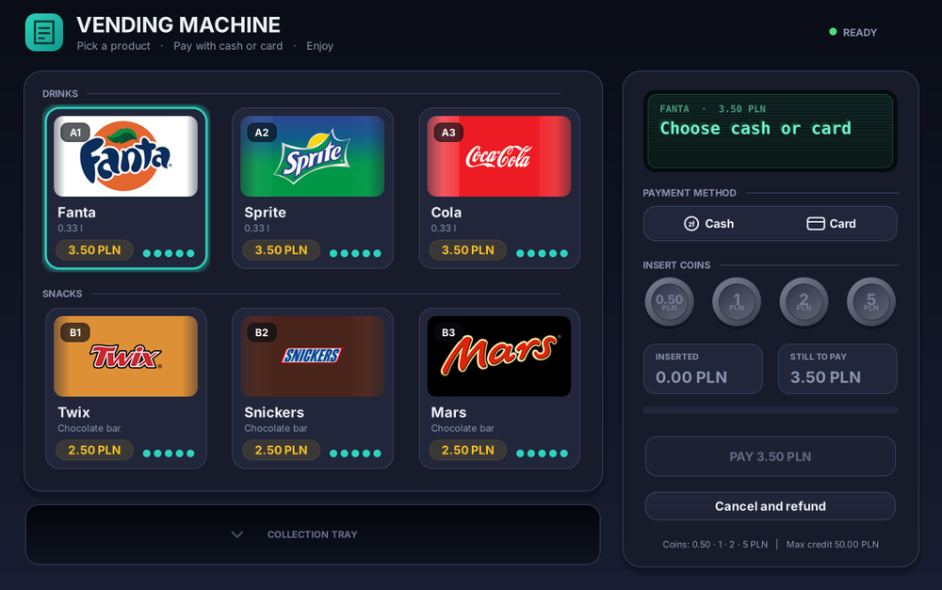
Figure 2. Fanta selected

Step 3. Choose the payment method
Use the Cash / Card toggle (also Left / Right arrow keys).

Step 4a. Paying with cash
Click the coins (0.50, 1, 2, 5 PLN). "Inserted" and "Still to pay" update, and a progress bar shows how much of the price is covered.
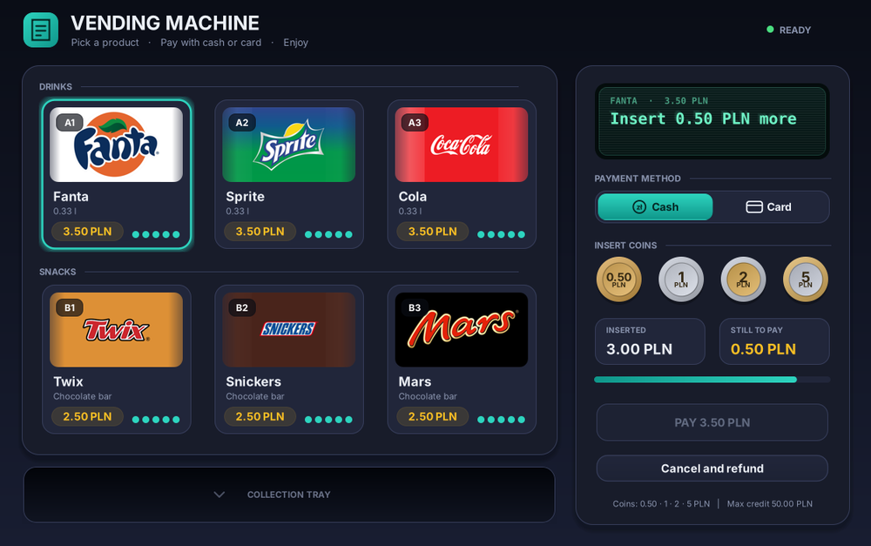
Figure 3. 3.00 PLN inserted, 0.50 PLN missing
When the price is covered the PAY button lights up.
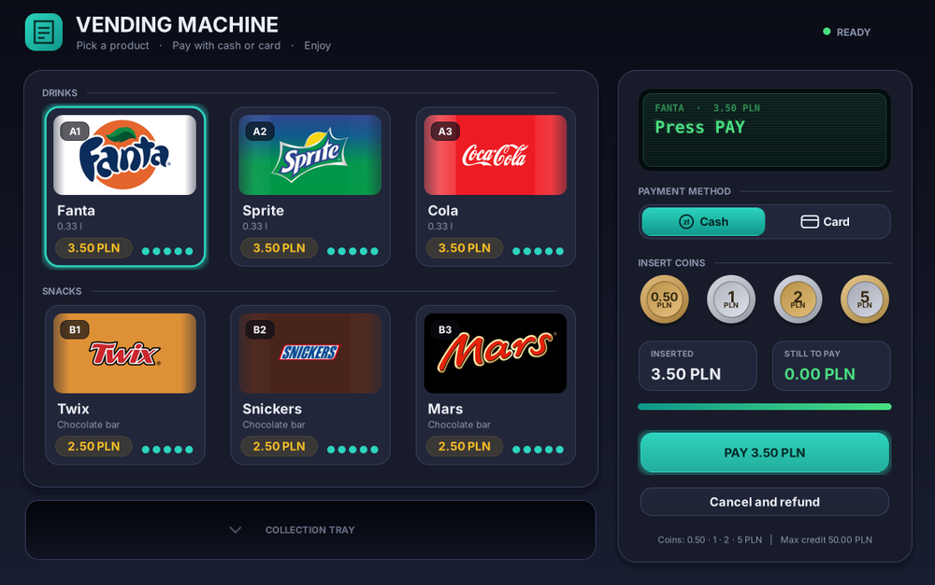
Figure 4. Price covered, ready to pay
If you inserted more than the price, a dialog asks whether to donate the change to support Ukraine or keep it.
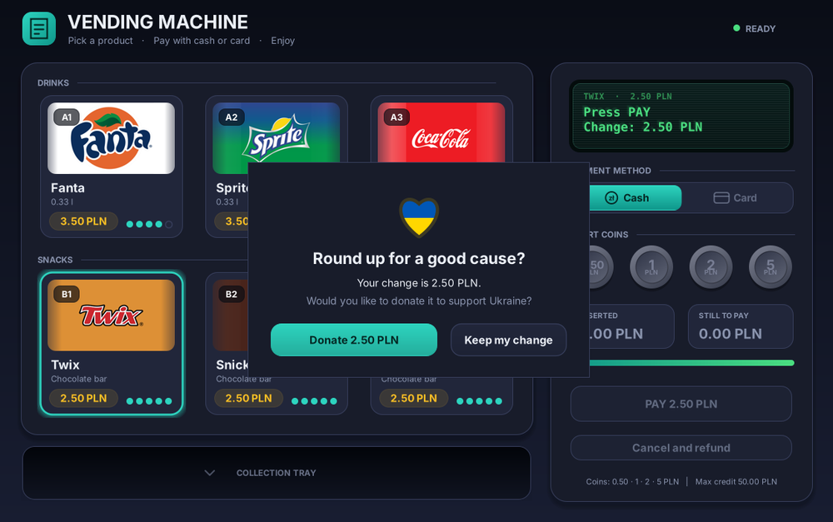
Figure 5. Change donation dialog
The product drops into the collection tray; click the tray to collect it. Change coins (if any) appear in the tray as well.
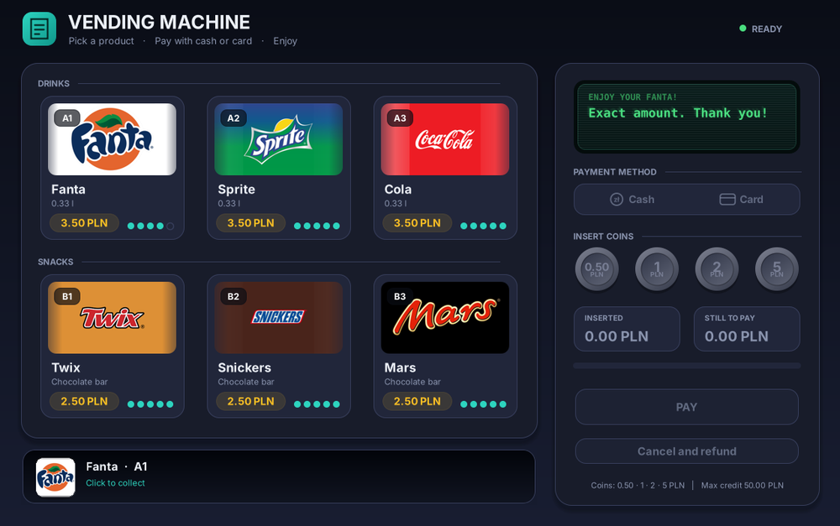
Figure 6. Exact payment, product in the tray
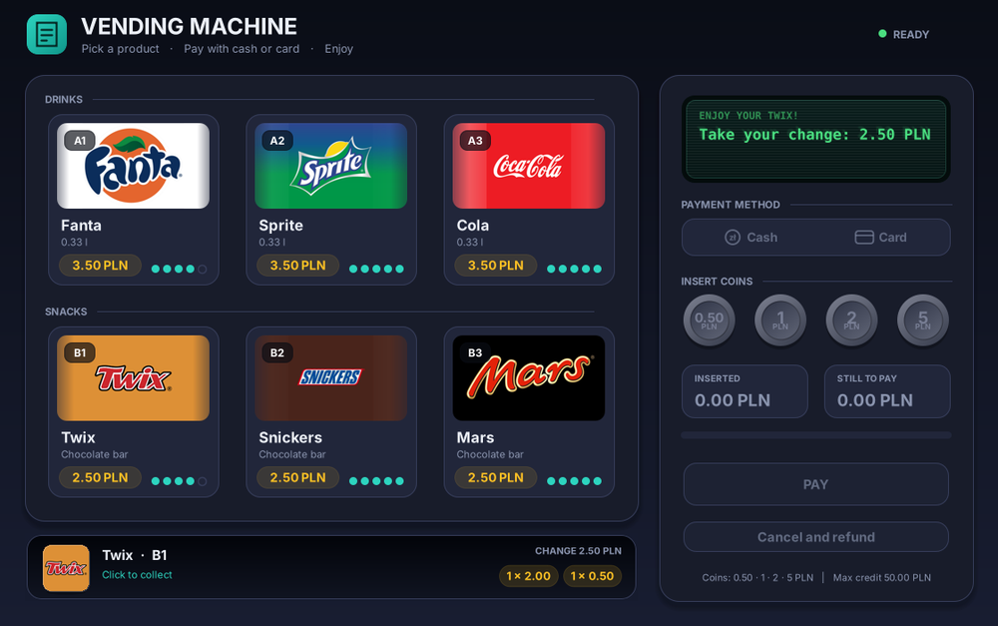
Figure 7. Change returned as coins

Step 4b. Paying with a card
After choosing Card, a contactless reader appears. Click it to simulate tapping a card.
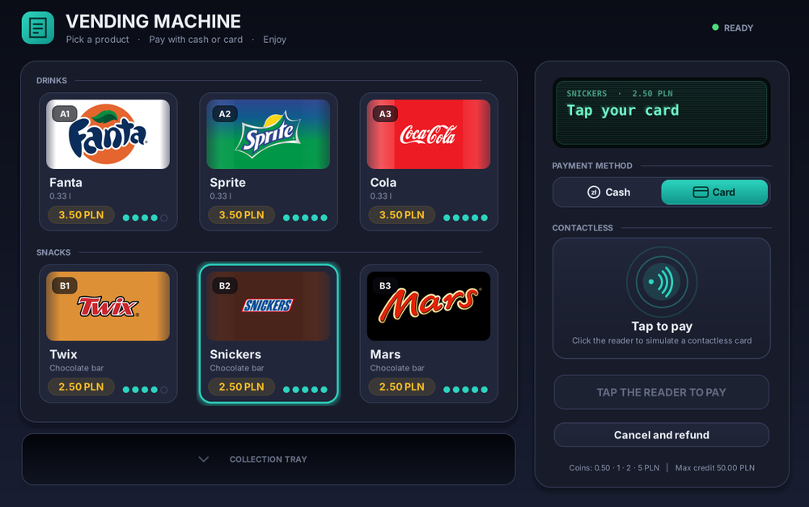
Figure 8. Card mode
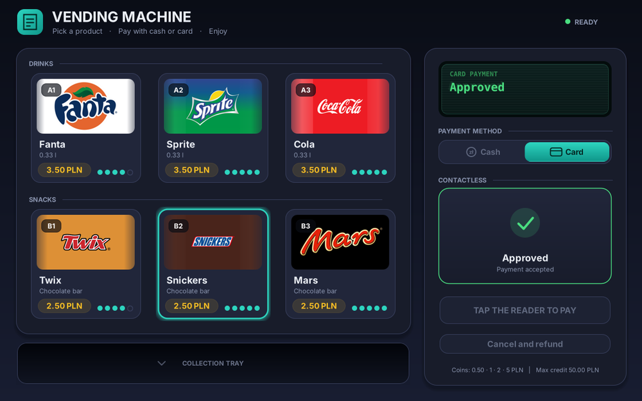
Figure 9. Card payment completed

Cancel and refund
The Cancel and refund button (or Esc) clears the selection and returns inserted coins to the tray. Switching from Cash to Card also returns the coins.
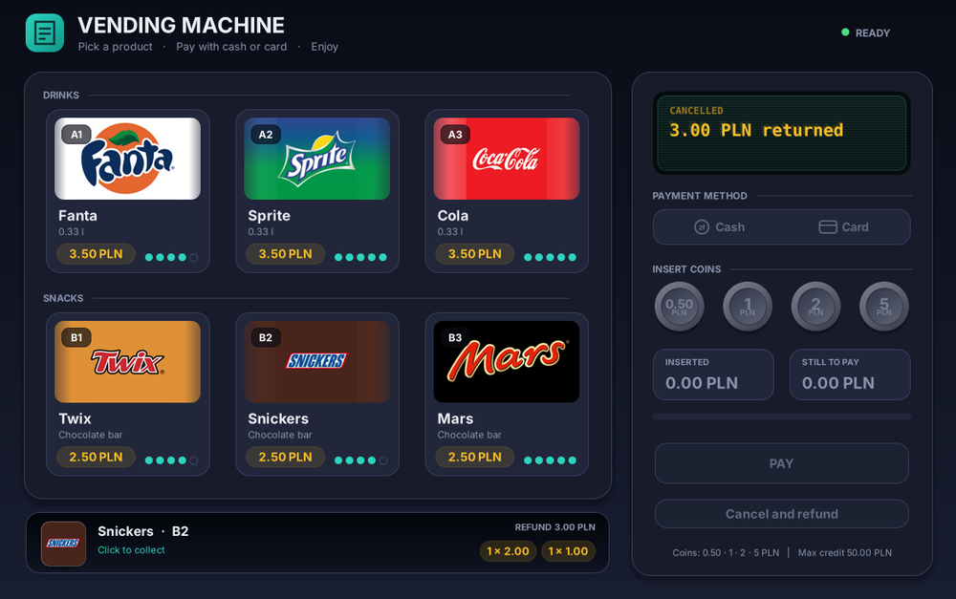
Figure 10. 3.00 PLN refunded

Sold out
Each slot holds five items. The dots on a card show the remaining stock; an empty slot shows SOLD OUT.
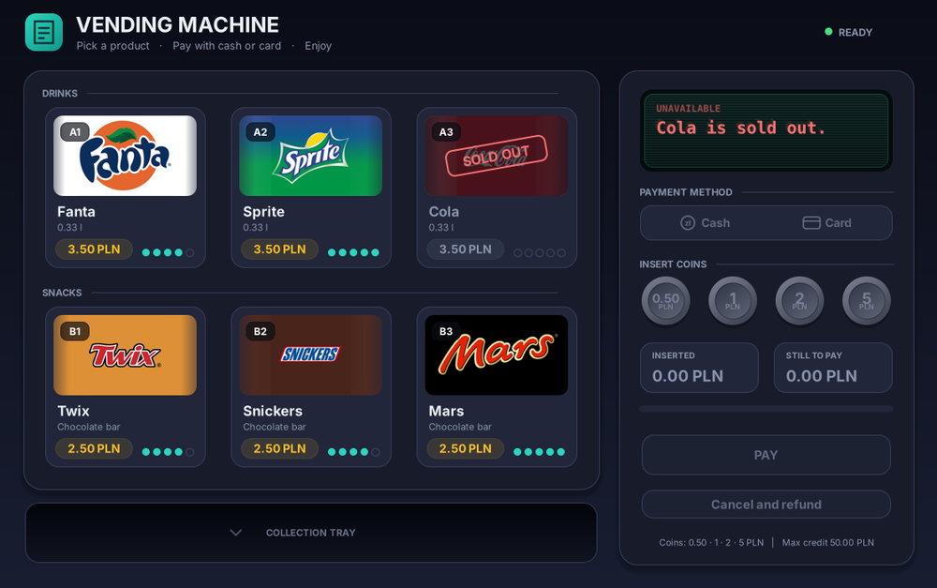
Figure 11. Cola sold out

3. Code structure
File | Responsibility
Logic/VendingMachineModel.cs | All rules: selection, payment method, credit, change, stock, limits. No UI code.
Logic/Product.cs, Catalog.cs | Product data and the single price list.
Logic/Money.cs | Money formatting and change calculation (fewest coins).
Logic/SaleResult.cs | Result of a purchase (product, change, donation flag).
UI/MainForm.cs | Translates clicks into model calls and model state into the screen.
UI/ProductCard.cs, Buttons.cs, Displays.cs, NfcPad.cs | Custom-drawn controls (cards, coins, LCD display, toggle, card reader, tray).
UI/DonationDialog.cs | Replacement for the old message box.
tests/LogicTests.cs | 28 automated tests of the business logic.

Main flow: select product, then choose method, then insert coins or tap card, then PayCash / PayCard, which reduces the stock, builds a SaleResult and resets the transaction.

4. Build
- Open VendingMachine.sln in Visual Studio 2019 or newer and press F5.
- Or from a command line with .NET Framework: msbuild VendingMachine.sln.
- The font Segoe UI is used (included in Windows). Logos are embedded in the executable.

