ArcB: A GIS tool for modeling annual diffuse infiltration on a plot scale

Salvador España, Francisco J. Alcalá, Ángela Vallejos, Antonio Pulido-Bosch
Requirement: Arcinfo 9.3

ArcB is a GIS tool for modelling annual diffuse infiltration (R_{P}) from precipitation (P) on a plot scale that uses ArcObjects as the programming language to incorporate equations and boundary conditions for the water balance consistency. Because detailed weather, soil, and vegetation data are often missing, ArcB uses well-known non-global models such as Hargreaves for daily potential evapotranspiration and Budyko for annual actual evapotranspiration (E_{A}), as well as the SCS Curve Number (CN) procedure for 24-h plot runoff (R_{O}). Annual R_{P} is quantified as the difference in annual P, E_{A}, and R_{O}.

Usage Tips
Operation of ArcB includes 6 steps, as shown in Figure 2:
(1) Daily E_{P} calculation using Hargreaves’ model (1994), by using input data for T_{d}, I_{d}, and A_{d} and other parameters
(2) Annual E_{A} calculation using Budyko’s model (1974), by using annual E_{P} data ― as the sum of the above daily E_{P} ― and the input data for annual P
(3) Correction of the above annual E_{A} by using the experimental C_{EA} value
(4) Daily R_{O} calculation for each rainy day by means of the CN procedure using the input data for 24-h P and CN_{II} values
(5) Annual R_{O} as the sum of daily R_{O}
(6) Annual R_{P} as the difference in annual P, E_{A}, and R_{O}.

The site results are saved as a table and as a point feature class in a geodatabase. With the use of the command “merge”, each water-balance term at any site is added to prepare a shapefile. The use of semi-empirical methods for EA and RO based on restricting hypothesis requires the programming of 4 boundary conditions to maintain the numerical and conceptual consistency of the soil-water balance (Fig. 3).

Using ArcE
- Open ArcCatalog and copy the ArcB folder in you hard drive.
- Add ArcB Toolbox to ArcToolbox list.
- Create 2 input tables with this format.

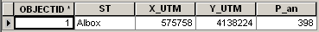

Table 1.- P

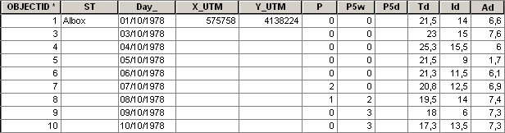

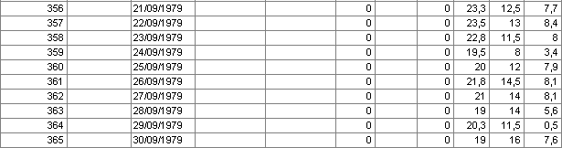

Table 2.- P_d
- Open ArcB in ArcCatalog and insert input tables (P and P_d), parameters (CNII and CEA) and geodatabases (ArcB_curr and ArcB_scra). Choose X and Y field and select the spatial reference.

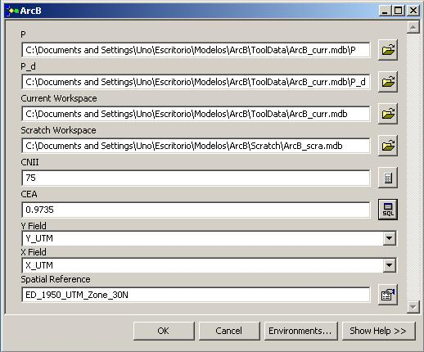
Fig. 1. The ArcB interface used to estimate E_{P}, E_{A}, R_{O,} and R_{P}.

- Run the model.
- ArcB creates 2 output files, 1 table and 1 .shp:
- RO_RP: Annual values of E_{P}, E_{A}, R_{O,} and R_{P}

RO_RP_XY: Shapefile (point) with the position of the meteorological station and annual values of E_{P}, E_{A}, R_{O,} and R_{P}.

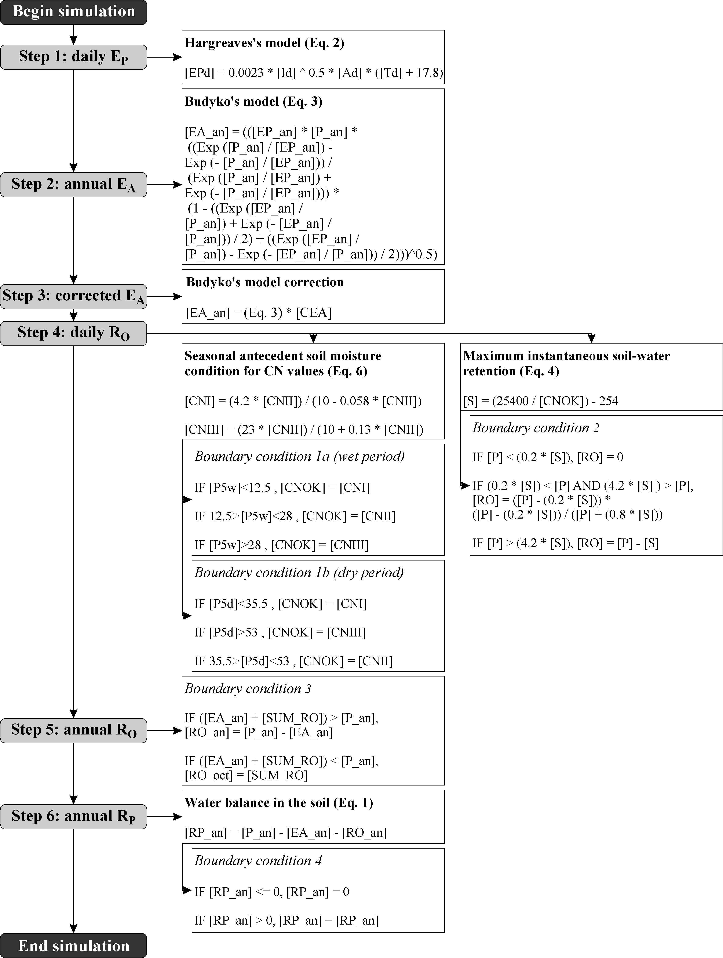

Fig. 2. Operation of ArcB

