Jim the cabin boy wants to take advantage of the stay of his boat in Port Royal to fulfill his own plans for the future. As bold as he likes, he is ready to keep the 125 pieces of treasure which are distributed by the galleon warehouses and flee as far as possible.

But the mission is not easy. The ship is full of pirates who watch the booty with strict discipline. The rats are not on our side either, and the captain's parrot usually appears at the most inopportune moments. Besides, the galleon's cellars make up a labyrinth of doors and rooms, where it is very easy to get lost or fall into the void.

HOW TO PLAY :
The galleon’s warehouses are formed by 20 screens. To advance through them and reach the pieces of the booty you have to open each numbered door with its respective key. We can only carry one key at a time. To change between screens we will use the front doors. The game ends when we get to clean all the treasure screens, in total, 125 pieces.

TIPS AND TRICKS:
- The adventurers who really want to get the treasure should make a map, or use some of the ones found on the internet, from the original game of 1984.
- To avoid leaving any piece of booty, you ideally would have to clean each screen completely before moving on to the other, although many screens require re-entering from other doors to collect all their treasures.
- A good option to take refuge from enemies in compromised situations is to be crouched in the middle of the staircase.
- Be careful when opening all the doors in a corridor. At that time, rats or the captain's parrot may appear.
- It is not advisable to jump to vertical mobile platforms when they go down. A fall from one floor above or more will make you lose your life.
GAME CONTROLS (default):

Q = up M = music ON/OFF
A = down H = pause
O = left X = cancel game
P = right
SPC = open door

* Keyboard/Joystick configurable from the start menu.

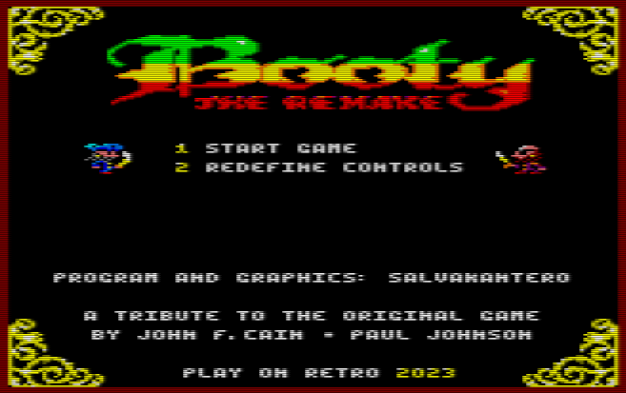

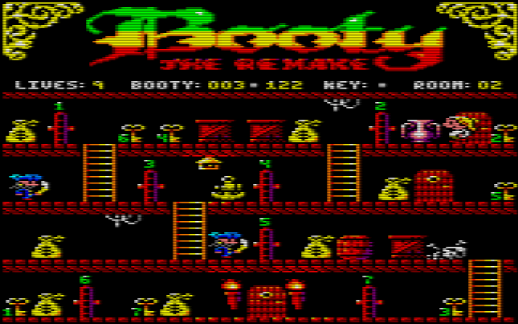

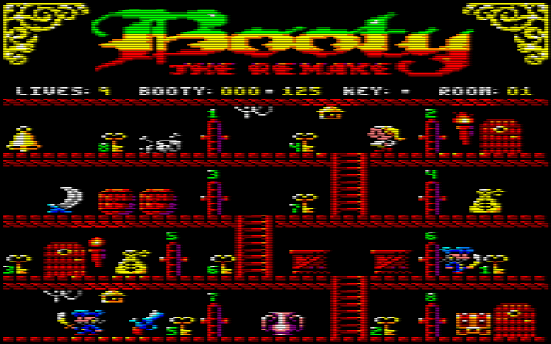

Booty. The Remake
Copyleft (C) 2023

SalvaKantero Program and graphics

A.Pérez Music
Brundij Loading screen
Masterklown Tape cover and manual pictures
Blackmores Betatesting
Felipe Monje Executive Producer

