

for ZX Spectrum 128k @salvaKantero 2016

As every year, our chief proposes a motor race with which to implement our mechanical knowledge acquired at the garage. The prize is an extra payment. This time you did your homework and you built a car in your spare time that has nothing to envy to a F1! But the stages that you have to overcome have been located and designed to try the patience of the fastest drivers.

Run over the help tiles you find on your way with your car to obtain the necessary assistance during the game. Good luck… and run!

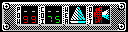
POW: Energy available. Avoid getting to 0!
COI: Coins available to collect in the stage.
WEA: Gun is available when the icon is displayed.
OBJ: Object is available when the icon is displayed.

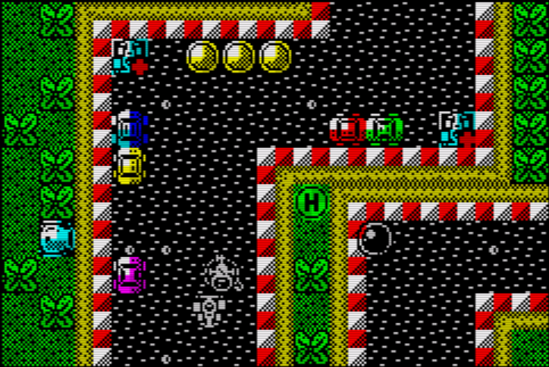
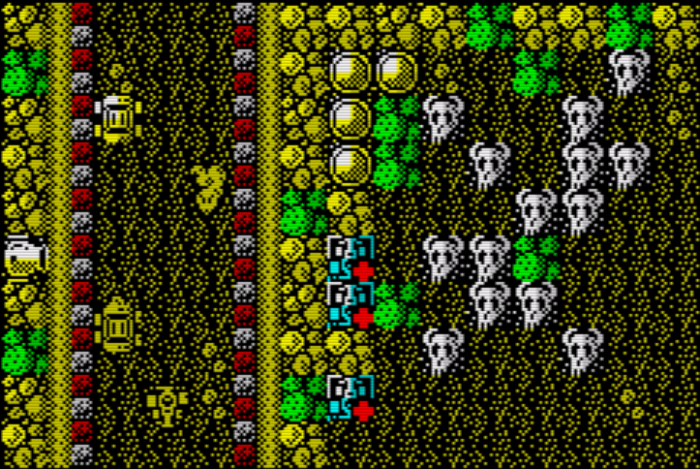
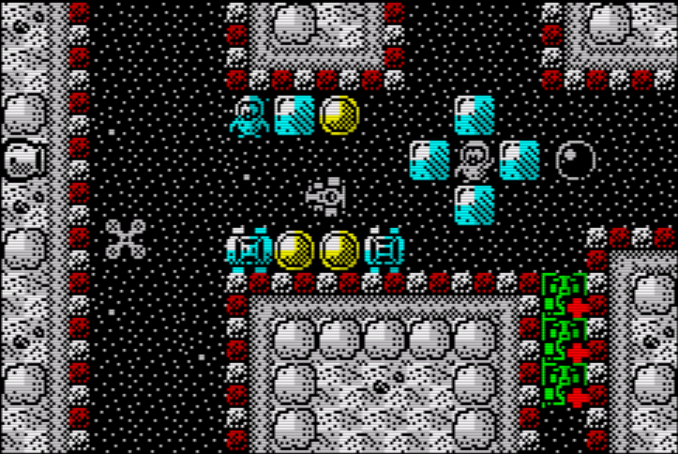

Programming & graphics by salvaKantero
Music by Davidian

Thanks to...
Dany Cantero (@dcamon) - Translations.
Na Than (@nath_mojon) – Technical support.
Felipe Monge (@vakapp) – Public relations.
elmundodelspectrum.com (@mundospectrum) – Preview & improvement proposals.
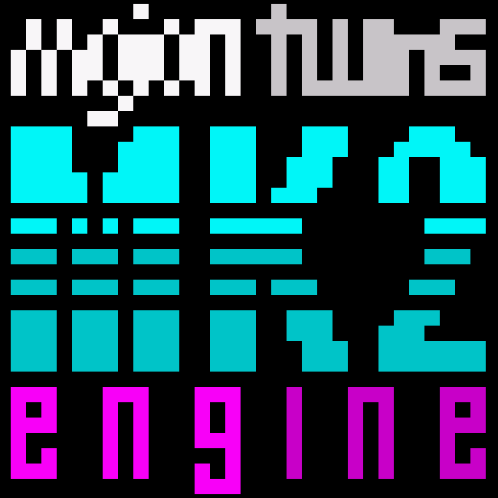
LICENSE:

MK2 is under Creative Commons license 3.0 "by-nc-ca", or "Attribution-NonCommercial-ShareAlike 3.0 Unported (CC BY-NC-SA 3.0)"

This means that you are free to:

- Copy, distribute and communicate publicly the work.
- Transform the work.
- Create products derived from the work.

Under the following conditions:

Recognition - You must recognize the credits of the work in the manner specified by the Mojon Twins; Include the text "Powered by MK2" or include the logo that we include in the file Logo.png in a visible place, as can be the loading screen or the cover of the game.

Non-commercial - you may not use this work for commercial purposes.

Share under the same license - If you alter or transform this work, or generates a derivative work, you may only distribute the work generated under a license identical to it.

Understanding that:

waiver - Any of these conditions can be waived if you get permission from the Mojon Twins.
Notice - To reuse or distribute the work must make clear the license terms of this work.

