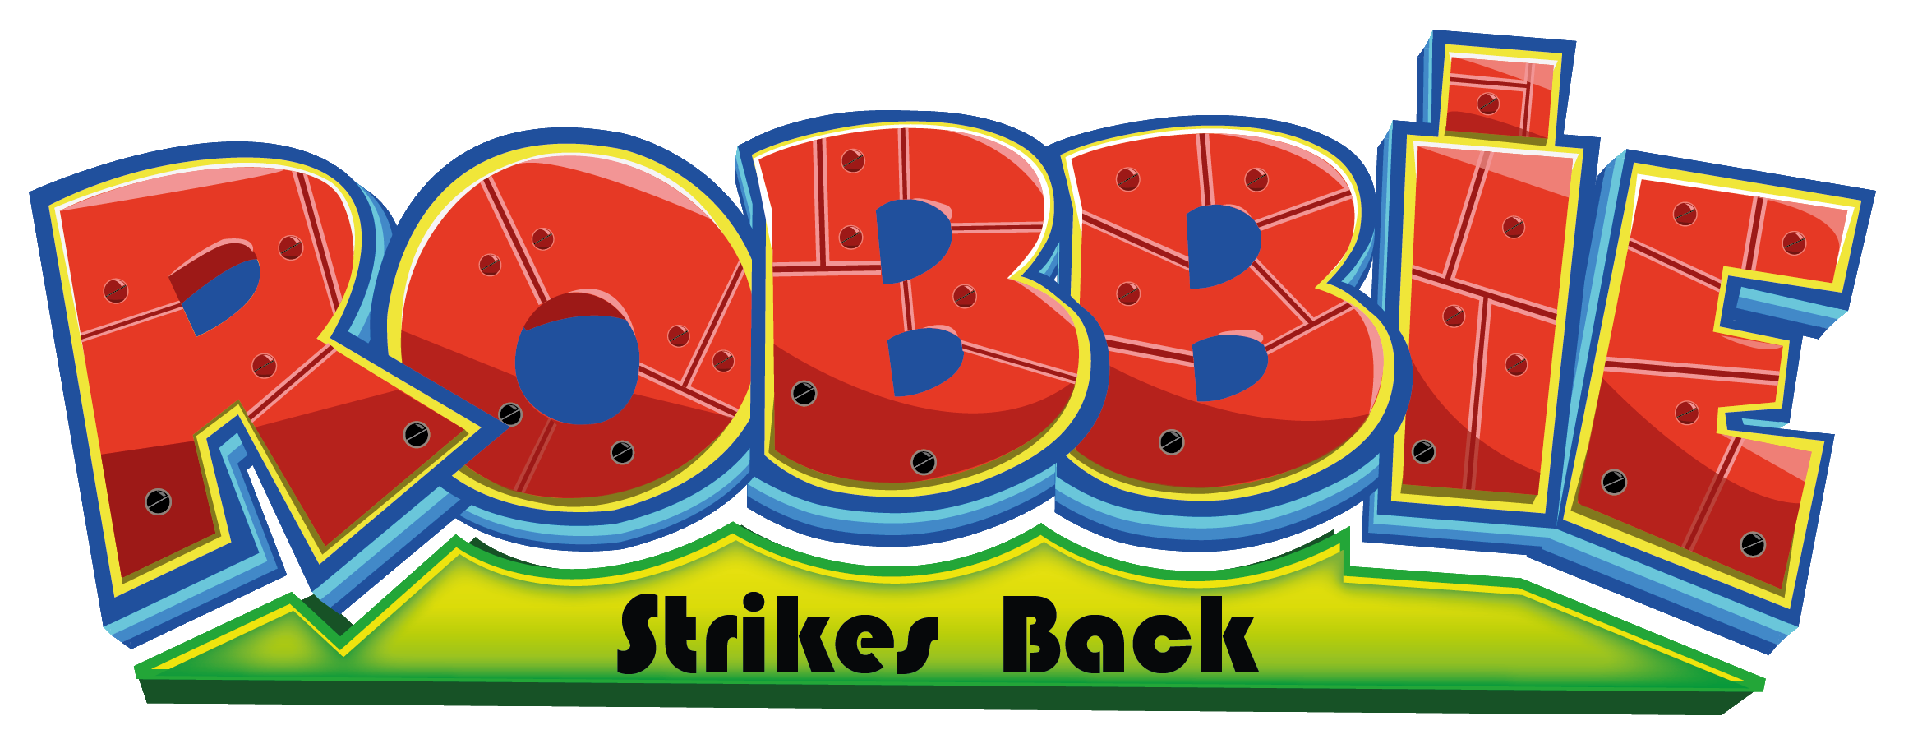
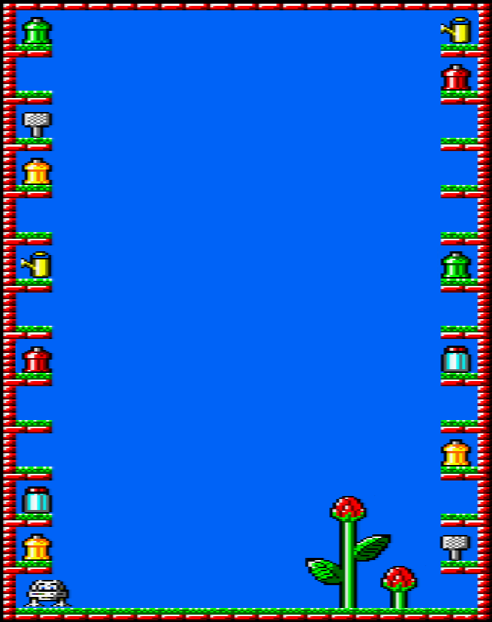

Some decades later, Robbie the robot, already retired, has come back to his garden and passes his time growing his favorite flower, the “Thyrgodian Megga Chrisanthodil”. But again the garden is invaded by evil and opportunist insects.

Now, as before, Robbie is ready to act!

Robbie has less oil in his gears nowadays, but the same decision. He has got three lethal insecticides to fight all living bugs.

So, he must sprinkle each insect that comes near his flowers with the right spray. A wrong spray will get insect momentarily paralised, or they won’t suffer at all. If Robbie leaves his flowers neglected, insect will eat them in seconds!

Note that in level five, flowering plants will reveal Robbie’s dreams!

Insects’ speed will increase each five levels.

NEW ENEMIES:
 | Greasy Worms: They move slowly in a horizontal way. They are the first to appear. [35 points]
 | Hairy Aphids: They move very fast in a diagonal way, sweeping away all the garden in seconds. [50 points]
 | Sucker Wasps: The most dangerous of all, because they will attack Robbie directly! [75 points]

ITEMS:

 | Fly Swatter: When you use it, it kills all insects in the garden. [100 points]
 | Watering Can: When you use it, it speeds up the plants’ growing. [100 points]
 | Fertilizer: When you use it, it speeds up the plants’ growing twice as much the watering can. [100 points]

GAME CONTROLS:

Setting 1 Setting 2 Setting 3
Q = up W = up Joystick
A = down S = down M = music ON/OFF
O = left A = left X = finish
P = right D = right
SPC = fire SPC = fire
M = music ON/OFF M = music ON/OFF
X = finish X = finish

LOADING INSTRUCTIONS (CPC464):

1) Reset the computer pressing down CTRL + SHIFT + SPC simultaneously and following this order.

2) Insert the tape and rewind it from the beginning.

3) Press simultaneously CTRL + ENTER (little) keys. You will see “PRESS PLAY THEN ANY KEY” on the screen. Press PLAY on the tape recorder and then press any key. The game will get 5 minutes to load completely.

ROBBIE STRIKES BACK!
Copyleft (C) 2017

SalvaKantero Program, graphics, FX sound
Beyker Music
Masterklown Tape cover
Felipe Monge Additional graphics
Dany Cantero Translations

