12.Foreign trading system

Use case diagram:

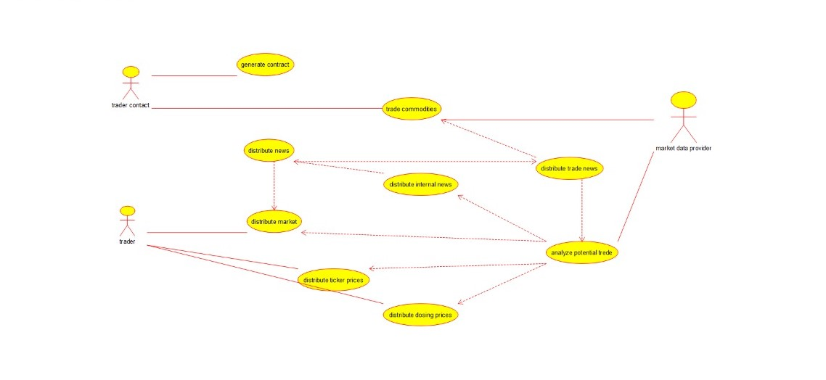

Class diagram:

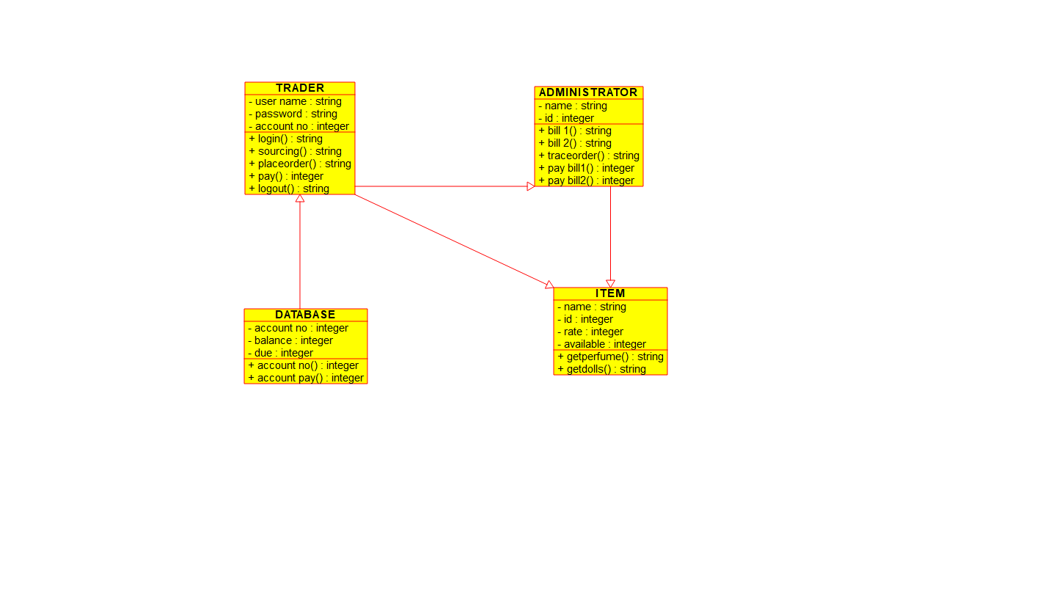

Source code:

#ifndef ADMINISTRATOR_H

#define ADMINISTRATOR_H

#include "ITEM.h"

#include <string>

/**

* class ADMINISTRATOR

*

*/

class ADMINISTRATOR : public ITEM

{

public:

// Constructors/Destructors

//

/**

* Empty Constructor

*/

ADMINISTRATOR ();

/**

* Empty Destructor

*/

virtual ~ADMINISTRATOR ();

// Static Public attributes

//

// Public attributes

//

// Public attribute accessor methods

//

// Public attribute accessor methods

//

/**

* @return string

*/

string bill_1 ()

{

}

/**

* @return string

*/

string bill_2 ()

{

}

/**

* @return string

*/

string traceorder ()

{

}

/**

* @return integer

*/

integer pay_bill1 ()

{

}

/**

* @return integer

*/

integer pay_bill2 ()

{

}

protected:

// Static Protected attributes

//

// Protected attributes

//

public:

// Protected attribute accessor methods

//

protected:

public:

// Protected attribute accessor methods

//

protected:

private:

// Static Private attributes

//

// Private attributes

//

string name;

integer id;

public:

// Private attribute accessor methods

//

private:

public:

// Private attribute accessor methods

//

/**

* Set the value of name

* @param new_var the new value of name

*/

void setName (string new_var) {

name = new_var;

}

/**

* Get the value of name

* @return the value of name

*/

string getName () {

return name;

}

/**

* Set the value of id

* @param new_var the new value of id

*/

void setId (integer new_var) {

id = new_var;

}

/**

* Get the value of id

* @return the value of id

*/

integer getId () {

return id;

}

private:

void initAttributes () ;

};

#endif // ADMINISTRATOR_H