13.BPO management system:

Use case diagram:

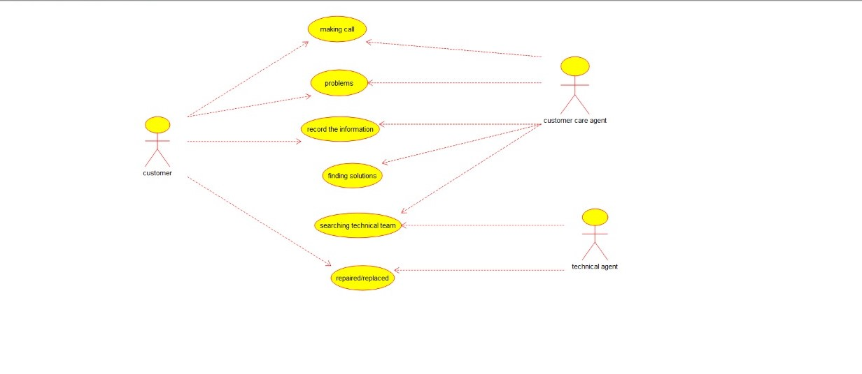

Class diagram:

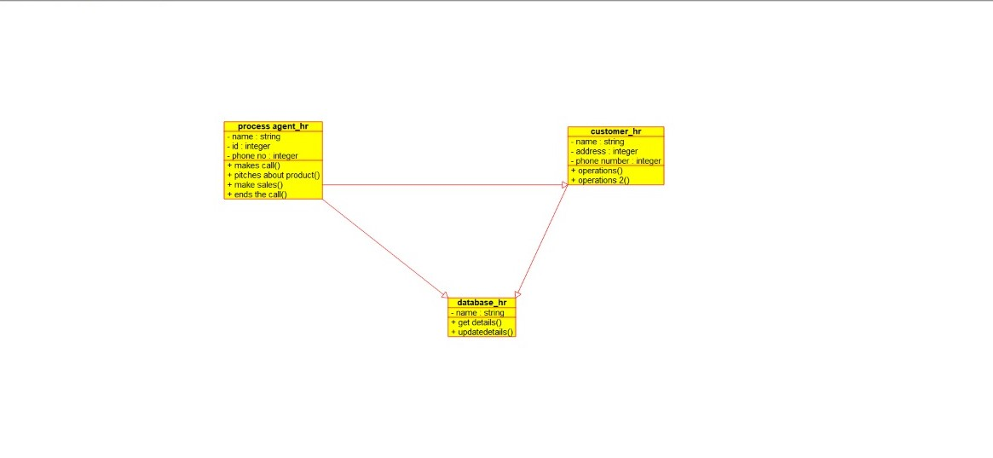

Source code:

#ifndef CUSTOMER_HR_H

#define CUSTOMER_HR_H

#include "datebase_hr.h"

#include <string>

/**

* class customer_hr

*

*/

class customer_hr : public datebase_hr

{

public:

// Constructors/Destructors

//

/**

* Empty Constructor

*/

customer_hr ();

/**

* Empty Destructor

*/

virtual ~customer_hr ();

// Static Public attributes

//

// Public attributes

//

// Public attribute accessor methods

//

// Public attribute accessor methods

//

/**

*/

void operation ()

{

}

/**

*/

void operation_2 ()

{

}

protected:

// Static Protected attributes

//

// Protected attributes

//

public:

// Protected attribute accessor methods

//

protected:

public:

// Protected attribute accessor methods

//

protected:

private:

// Static Private attribu

tes

//

// Private attributes

//

string name;

integer address;

integer phone_number;

public:

// Private attribute accessor methods

//

private:

public:

// Private attribute accessor methods

//

/**

* Set the value of name

* @param new_var the new value of name

*/

void setName (string new_var) {

name = new_var;

}

/**

* Get the value of name

* @return the value of name

*/

string getName () {

return name;

}

/**

* Set the value of address

* @param new_var the new value of address

*/

void setAddress (integer new_var) {

address = new_var;

}

/**

* Get the value of address

* @return the value of address

*/

integer getAddress () {

return address;

}

/**

* Set the value of phone_number

* @param new_var the new value of phone_number

*/

void setPhone_number (integer new_var) {

phone_number = new_var;

}

/**

* Get the value of phone_number

* @return the value of phone_number

*/

integer getPhone_number () {

return phone_number;

}

private:

void initAttributes () ;

};

#endif // CUSTOMER_H