14.E commerce registration system

Use case diagram:

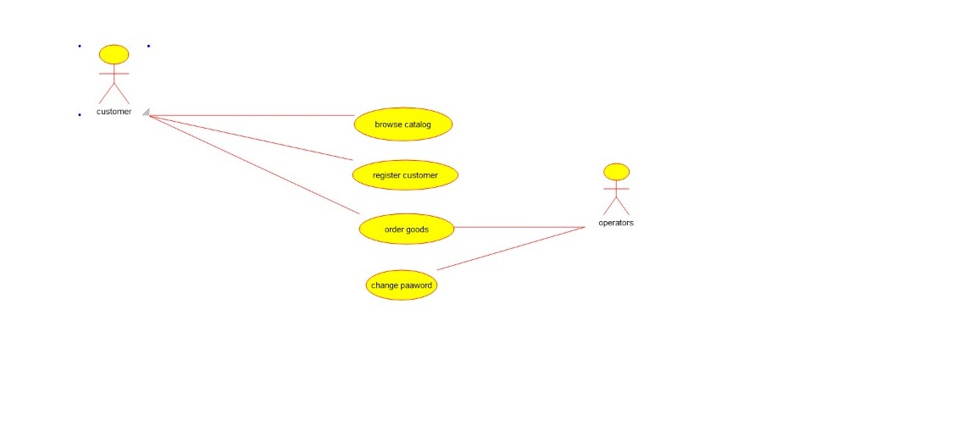

Class diagram:

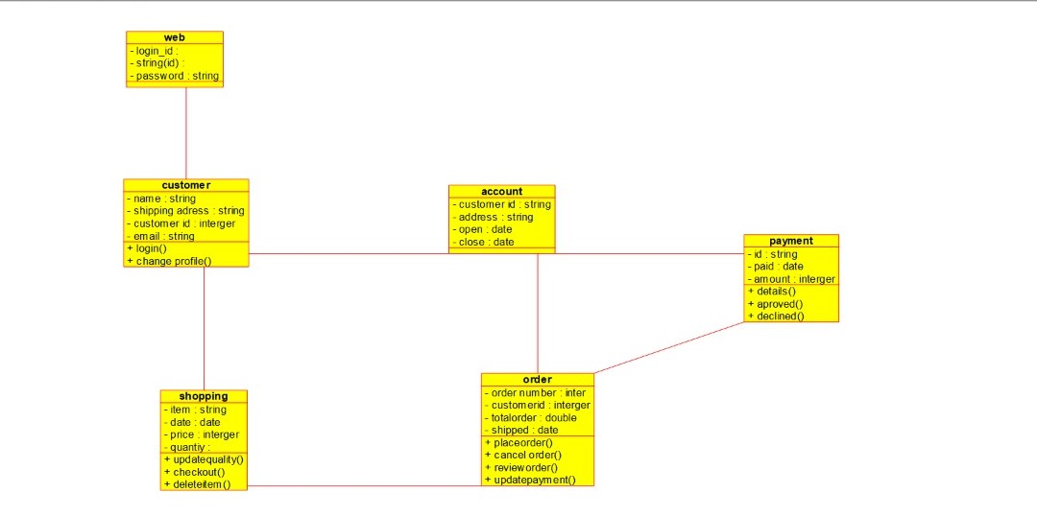

Source code:

#include "conference_info.h"

// Constructors/Destructors

//

conference_info::conference_info () {

initAttributes();

}

conference_info::~conference_info () { }

//

// Methods

//

// Accessor methods

//

// Other methods

//

void conference_info::initAttributes () {

}