15.blood bank registration

Use case diagram:

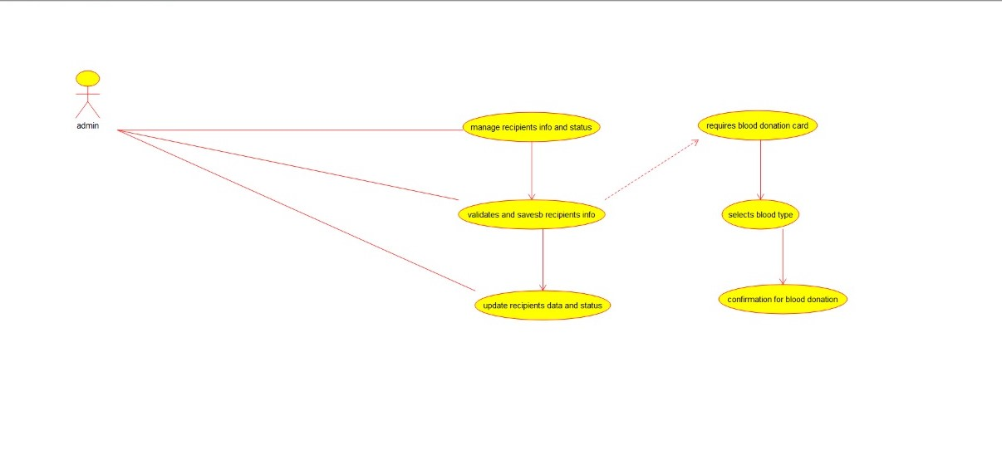

Class diagram:

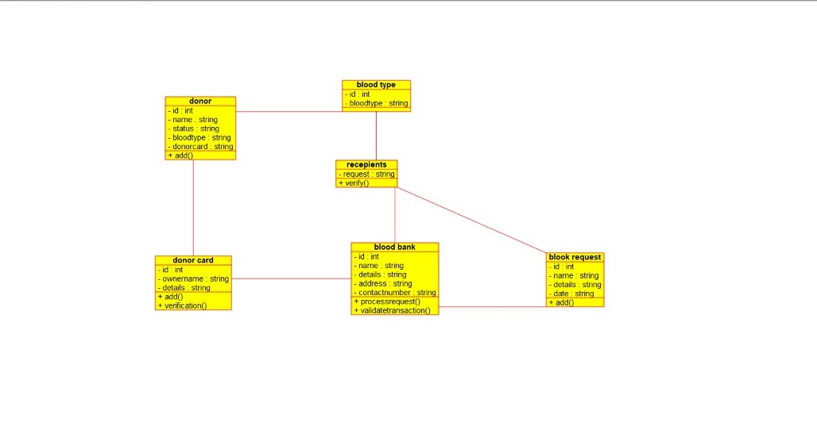

Source diagram:

#ifndef CUSTOMER_H

#define CUSTOMER_H

#include <string>

#include vector

/**

* class customer

*

*/

class customer

{

public:

// Constructors/Destructors

//

/**

* Empty Constructor

*/

customer ();

/**

* Empty Destructor

*/

virtual ~customer ();

// Static Public attributes

//

// Public attributes

//

// Public attribute accessor methods

//

// Public attribute accessor methods

//

/**

*/

void login ()

{

}

/**

*/

void change_profile ()

{

}

protected:

// Static Protected attributes

//

// Protected attributes

//

public:

// Protected attribute accessor methods

//

protected:

public:

// Protected attribute accessor methods

//

protected:

private:

// Static Private attributes

//

// Private attributes

//

string name;

string shipping_adress;

interger customer_id;

string email;

public:

// Private attribute accessor methods

//

private:

public:

// Private attribute accessor methods

//

/**

* Set the value of name

* @param new_var the new value of name

*/

void setName (string new_var) {

name = new_var;

}

/**

* Get the value of name

* @return the value of name

*/

string getName () {

return name;

}

/**

* Set the value of shipping_adress

* @param new_var the new value of shipping_adress

*/

void setShipping_adress (string new_var) {

shipping_adress = new_var;

}

/**

* Get the value of shipping_adress

* @return the value of shipping_adress

*/

string getShipping_adress () {

return shipping_adress;

}

/**

* Set the value of customer_id

* @param new_var the new value of customer_id

*/

void setCustomer_id (interger new_var) {

customer_id = new_var;

}

/**

* Get the value of customer_id

* @return the value of customer_id

*/

interger getCustomer_id () {

return customer_id;

}

/**

* Set the value of email

* @param new_var the new value of email

*/

void setEmail (string new_var) {

email = new_var;

}

/**

* Get the value of email

* @return the value of email

*/

string getEmail () {

return email;

}

private:

void initAttributes () ;

};

#endif // CUSTOMER_H