21.Hospital management

Use case diagram:

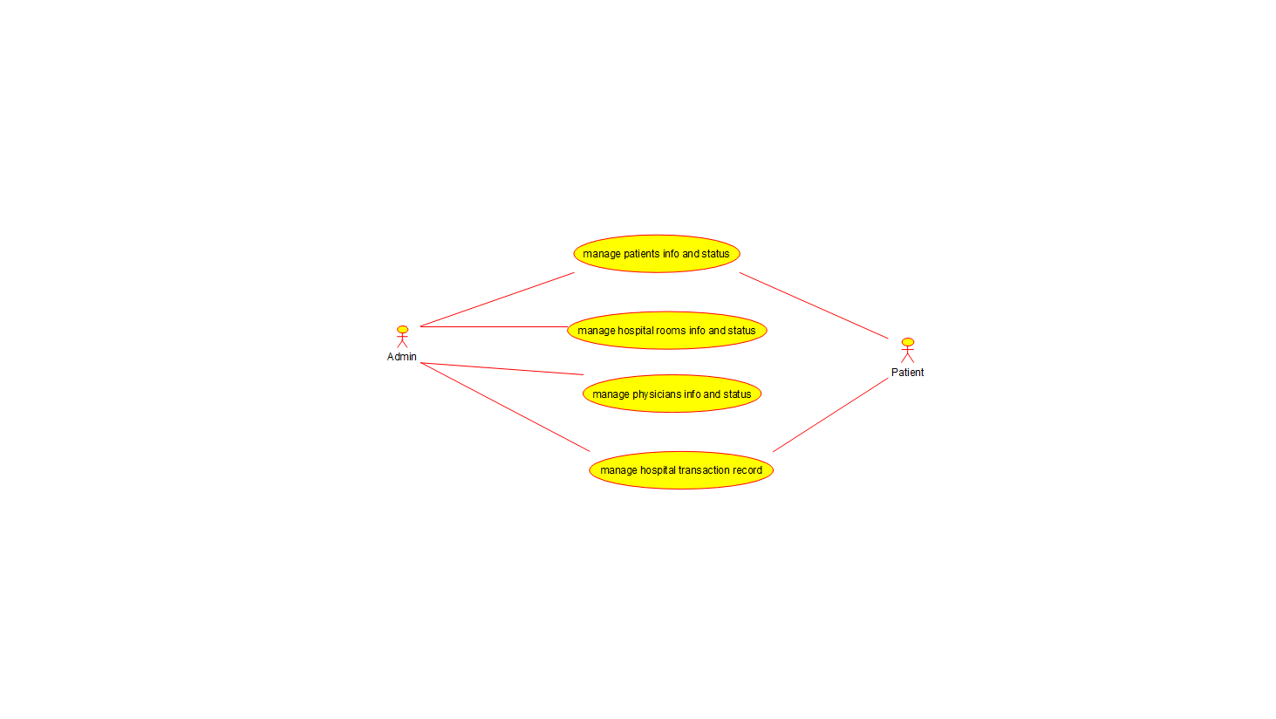

Class diagram:

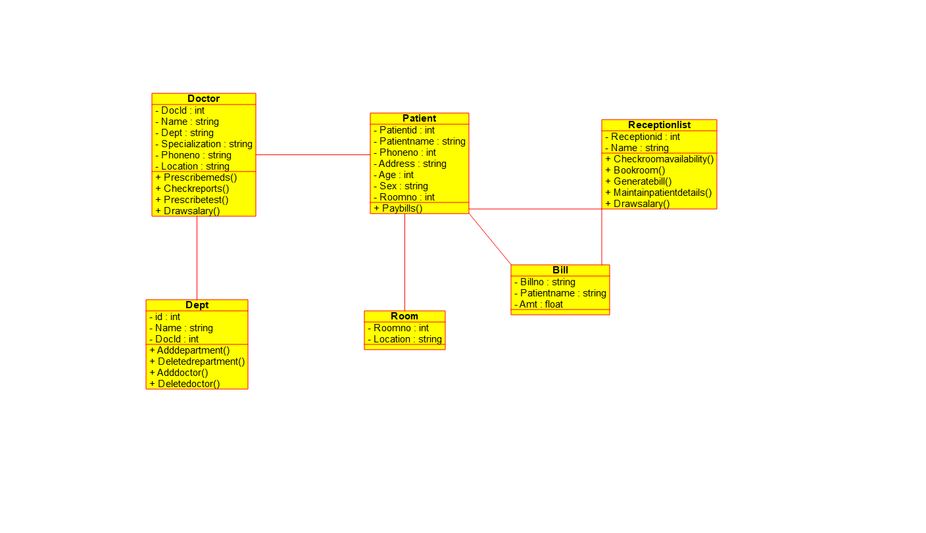

Source code:

#ifndef BILL_H

#define BILL_H

#include <string>

#include vector

/**

* class Bill

*

*/

class Bill

{

public:

// Constructors/Destructors

//

/**

* Empty Constructor

*/

Bill ();

/**

* Empty Destructor

*/

virtual ~Bill ();

// Static Public attributes

//

// Public attributes

//

// Public attribute accessor methods

//

// Public attribute accessor methods

//

protected:

// Static Protected attributes

//

// Protected attributes

//

public:

// Protected attribute accessor methods

//

protected:

public:

// Protected attribute accessor methods

//

protected:

private:

// Static Private attributes

//

// Private attributes

//

string Billno;

string Patientname;

float Amt;

public:

// Private attribute accessor methods

//

private:

public:

// Private attribute accessor methods

//

/**

* Set the value of Billno

* @param new_var the new value of Billno

*/

void setBillno (string new_var) {

Billno = new_var;

}

/**

* Get the value of Billno

* @return the value of Billno

*/

string getBillno () {

return Billno;

}

/**

* Set the value of Patientname

* @param new_var the new value of Patientname

*/

void setPatientname (string new_var) {

Patientname = new_var;

}

/**

* Get the value of Patientname

* @return the value of Patientname

*/

string getPatientname () {

return Patientname;

}

/**

* Set the value of Amt

* @param new_var the new value of Amt

*/

void setAmt (float new_var) {

Amt = new_var;

}

/**

* Get the value of Amt

* @return the value of Amt

*/

float getAmt () {

return Amt;

}

private:

void initAttributes () ;

};

#endif // BILL_H