22.online insurance processing system

Use case diagram:

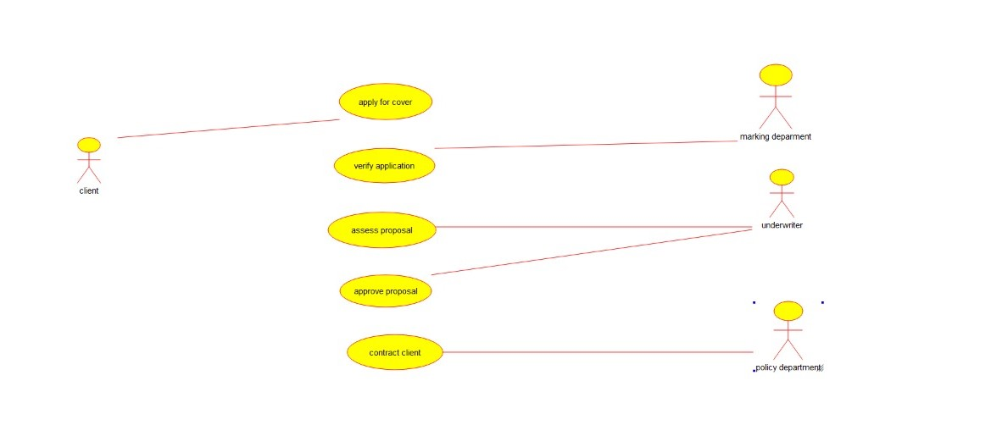

Class diagram:

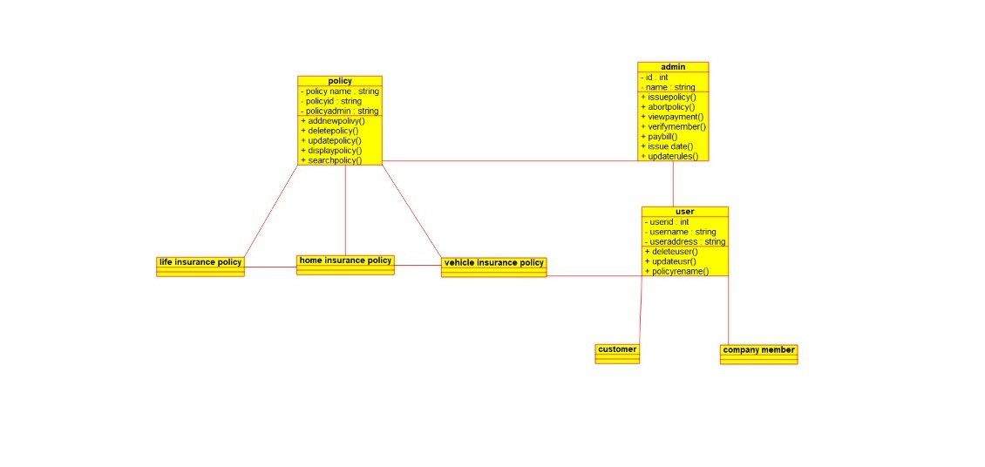

Source code:

#ifndef COMPANY_MEMBER_H

#define COMPANY_MEMBER_H

#include <string>

#include vector

/**

* class company_member

*

*/

class company_member

{

public:

// Constructors/Destructors

//

/**

* Empty Constructor

*/

company_member ();

/**

* Empty Destructor

*/

virtual ~company_member ();

// Static Public attributes

//

// Public attributes

//

// Public attribute accessor methods

//

// Public attribute accessor methods

//

protected:

// Static Protected attributes

//

// Protected attributes

//

public:

// Protected attribute accessor methods

//

protected:

public:

// Protected attribute accessor methods

//

protected:

private:

// Static Private attributes

//

// Private attributes

//

public:

// Private attribute accessor methods

//

private:

public:

// Private attribute accessor methods

//

private:

};

#endif // COMPANY_MEMBER_H