24.online stock market system

Use case diagram:

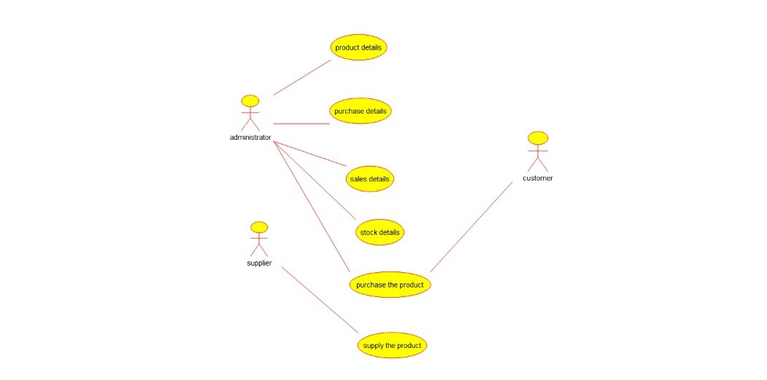

Class diagram:

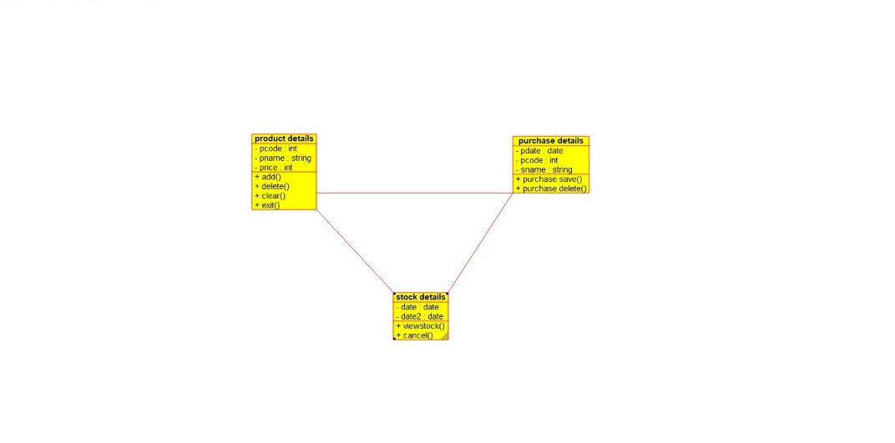

Source code:

#ifndef PURCHASE_DETAILS_H

#define PURCHASE_DETAILS_H

#include <string>

#include vector

/**

* class purchase_details

*

*/

class purchase_details

{

public:

// Constructors/Destructors

//

/**

* Empty Constructor

*/

purchase_details ();

/**

* Empty Destructor

*/

virtual ~purchase_details ();

// Static Public attributes

//

// Public attributes

//

// Public attribute accessor methods

//

// Public attribute accessor methods

//

/**

*/

void purchase_save ()

{

}

/**

*/

void purchase_delete ()

{

}

protected:

// Static Protected attributes

//

// Protected attributes

//

public:

// Protected attribute accessor methods

//

protected:

public:

// Protected attribute accessor methods

//

protected:

private:

// Static Private attributes

//

// Private attributes

//

date pdate;

int pcode;

string sname;

public:

// Private attribute accessor methods

//

private:

public:

// Private attribute accessor methods

//

/**

* Set the value of pdate

* @param new_var the new value of pdate

*/

void setPdate (date new_var) {

pdate = new_var;

}

/**

* Get the value of pdate

* @return the value of pdate

*/

date getPdate () {

return pdate;

}

/**

* Set the value of pcode

* @param new_var the new value of pcode

*/

void setPcode (int new_var) {

pcode = new_var;

}

/**

* Get the value of pcode

* @return the value of pcode

*/

int getPcode () {

return pcode;

}

/**

* Set the value of sname

* @param new_var the new value of sname

*/

void setSname (string new_var) {

sname = new_var;

}

/**

* Get the value of sname

* @return the value of sname

*/

string getSname () {

return sname;

}

private:

void initAttributes () ;

};

#endif // PURCHASE_DETAILS_H