16.online internship registration

Use case diagram:

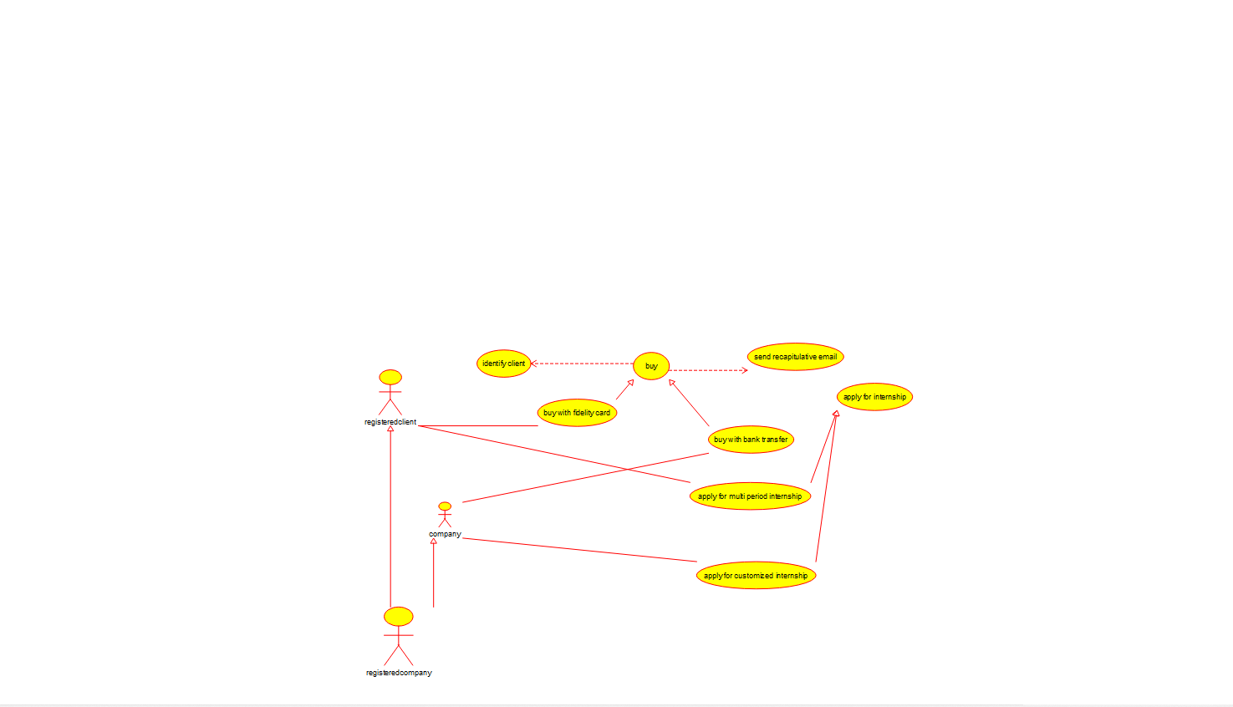

Class diagram:

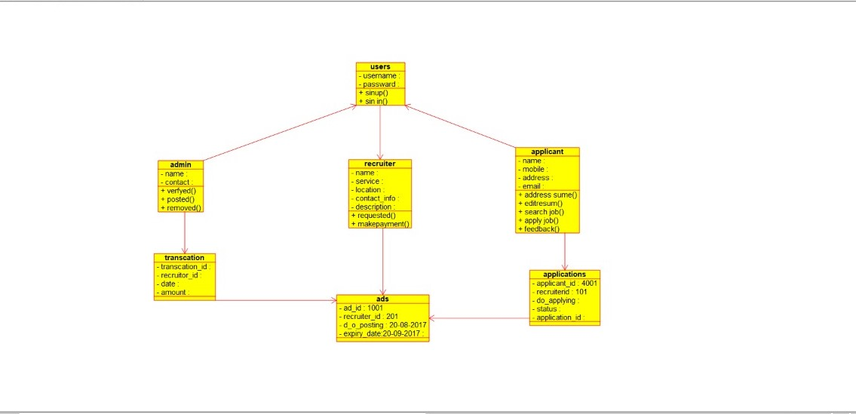

Source code:

#include "1001.h"

// Constructors/Destructors

//

1001::1001 () {

}

1001::~1001 () { }

//

// Methods

//

// Accessor methods

//

// Other methods

//

17.vechicle registration number registering system

Use case diagram:

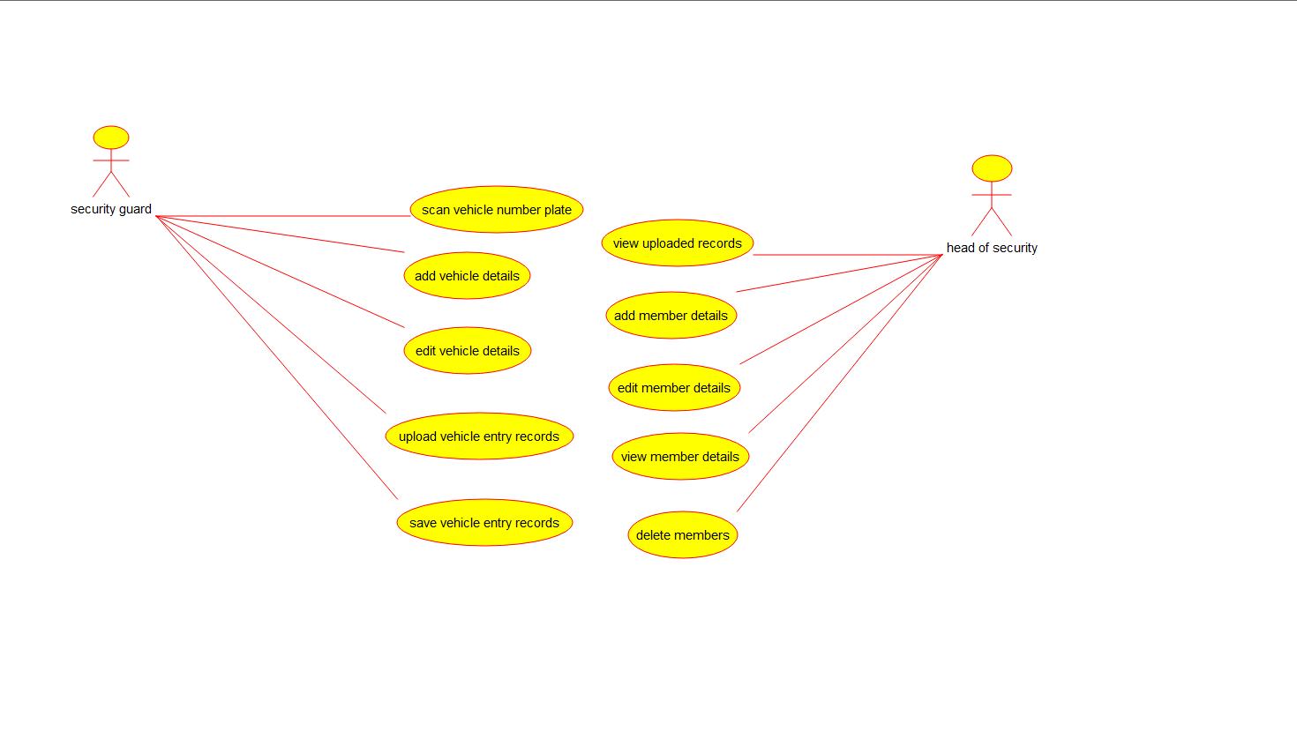

Class diagram:

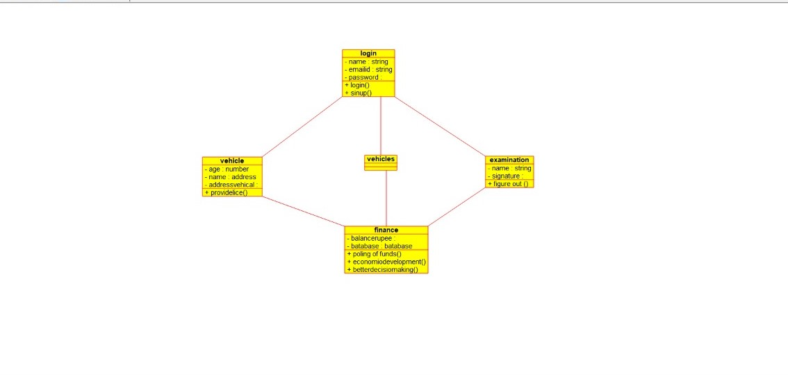

Source code:

#include "address.h"

// Constructors/Destructors

//

address::address () {

}

address::~address () { }

//

// Methods

//

// Accessor methods

//

// Other methods

//

18.food order system

Use case diagram:

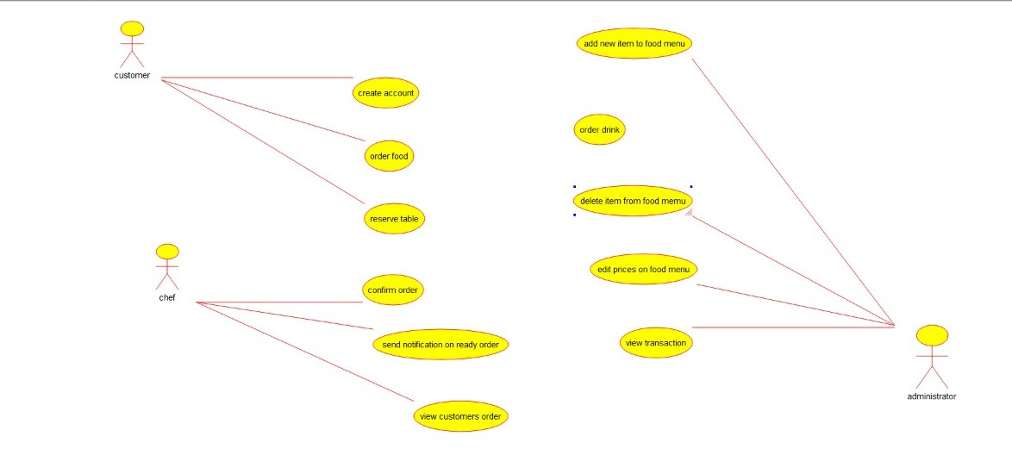

Class diagram:

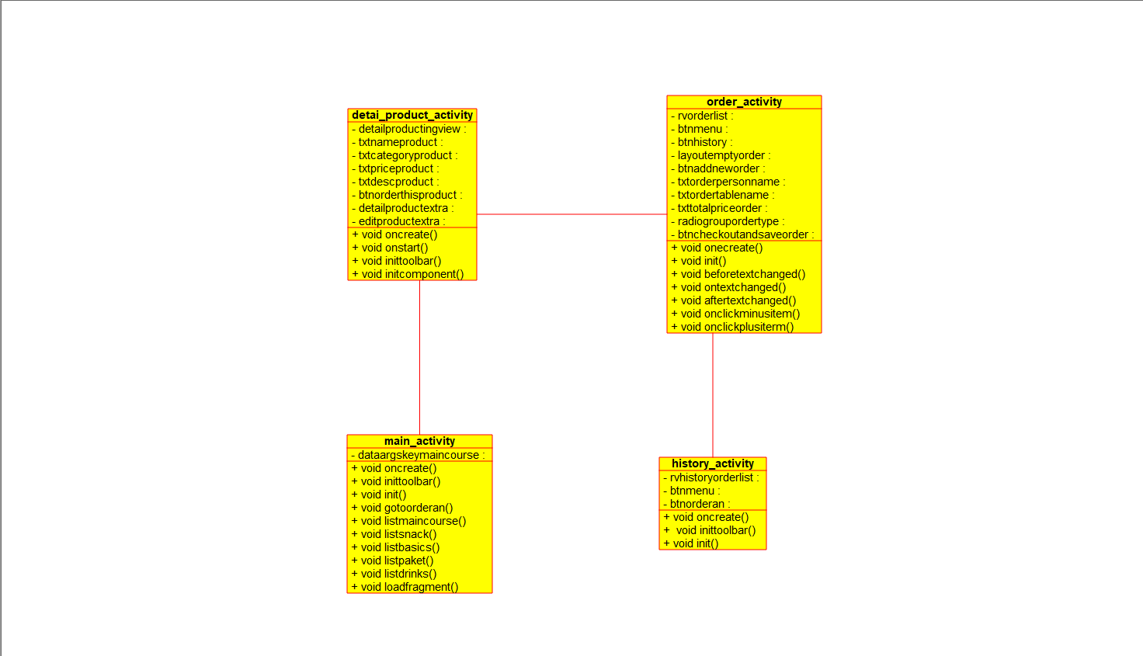

Source code:

#ifndef DETAI_PRODUCT_ACTIVITY_H

#define DETAI_PRODUCT_ACTIVITY_H

#include <string>

#include vector

/**

* class detai_product_activity

*

*/

class detai_product_activity

{

public:

// Constructors/Destructors

//

/**

* Empty Constructor

*/

detai_product_activity ();

/**

* Empty Destructor

*/

virtual ~detai_product_activity ();

// Static Public attributes

//

// Public attributes

//

// Public attribute accessor methods

//

// Public attribute accessor methods

//

/**

*/

void void_oncreate ()

{

}

/**

*/

void void_onstart ()

{

}

/**

*/

void void_inittoolbar ()

{

}

/**

*/

void void_initcomponent ()

{

}

protected:

// Static Protected attributes

//

// Protected attributes

//

public:

// Protected attribute accessor methods

//

protected:

public:

// Protected attribute accessor methods

//

protected:

private:

// Static Private attributes

//

// Private attributes

//

void detailproductingview;

void txtnameproduct;

void txtcategoryproduct;

void txtpriceproduct;

void txtdescproduct;

void btnorderthisproduct;

void detailproductextra;

void editproductextra;

public:

// Private attribute accessor methods

//

private:

public:

// Private attribute accessor methods

//

/**

* Set the value of detailproductingview

* @param new_var the new value of detailproductingview

*/

void setDetailproductingview (void new_var) {

detailproductingview = new_var;

}

/**

* Get the value of detailproductingview

* @return the value of detailproductingview

*/

void getDetailproductingview () {

return detailproductingview;

}

/**

* Set the value of txtnameproduct

* @param new_var the new value of txtnameproduct

*/

void setTxtnameproduct (void new_var) {

txtnameproduct = new_var;

}

/**

* Get the value of txtnameproduct

* @return the value of txtnameproduct

*/

void getTxtnameproduct () {

return txtnameproduct;

}

/**

* Set the value of txtcategoryproduct

* @param new_var the new value of txtcategoryproduct

*/

void setTxtcategoryproduct (void new_var) {

txtcategoryproduct = new_var;

}

/**

* Get the value of txtcategoryproduct

* @return the value of txtcategoryproduct

*/

void getTxtcategoryproduct () {

return txtcategoryproduct;

}

/**

* Set the value of txtpriceproduct

* @param new_var the new value of txtpriceproduct

*/

void setTxtpriceproduct (void new_var) {

txtpriceproduct = new_var;

}

/**

* Get the value of txtpriceproduct

* @return the value of txtpriceproduct

*/

void getTxtpriceproduct () {

return txtpriceproduct;

}

/**

* Set the value of txtdescproduct

* @param new_var the new value of txtdescproduct

*/

void setTxtdescproduct (void new_var) {

txtdescproduct = new_var;

}

/**

* Get the value of txtdescproduct

* @return the value of txtdescproduct

*/

void getTxtdescproduct () {

return txtdescproduct;

}

/**

* Set the value of btnorderthisproduct

* @param new_var the new value of btnorderthisproduct

*/

void setBtnorderthisproduct (void new_var) {

btnorderthisproduct = new_var;

}

/**

* Get the value of btnorderthisproduct

* @return the value of btnorderthisproduct

*/

void getBtnorderthisproduct () {

return btnorderthisproduct;

}

/**

* Set the value of detailproductextra

* @param new_var the new value of detailproductextra

*/

void setDetailproductextra (void new_var) {

detailproductextra = new_var;

}

/**

* Get the value of detailproductextra

* @return the value of detailproductextra

*/

void getDetailproductextra () {

return detailproductextra;

}

/**

* Set the value of editproductextra

* @param new_var the new value of editproductextra

*/

void setEditproductextra (void new_var) {

editproductextra = new_var;

}

/**

* Get the value of editproductextra

* @return the value of editproductextra

*/

void getEditproductextra () {

return editproductextra;

}

private:

void initAttributes () ;

};

#endif // DETAI_PRODUCT_ACTIVITY_H

19.home service system

Use case diagram:

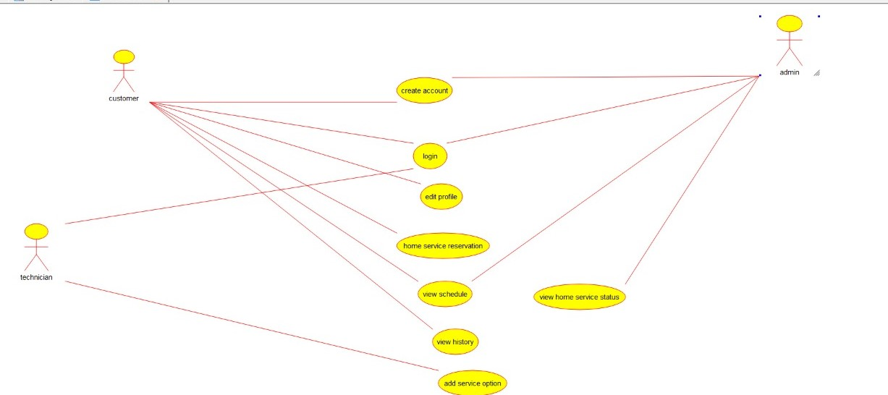

Class diagram:

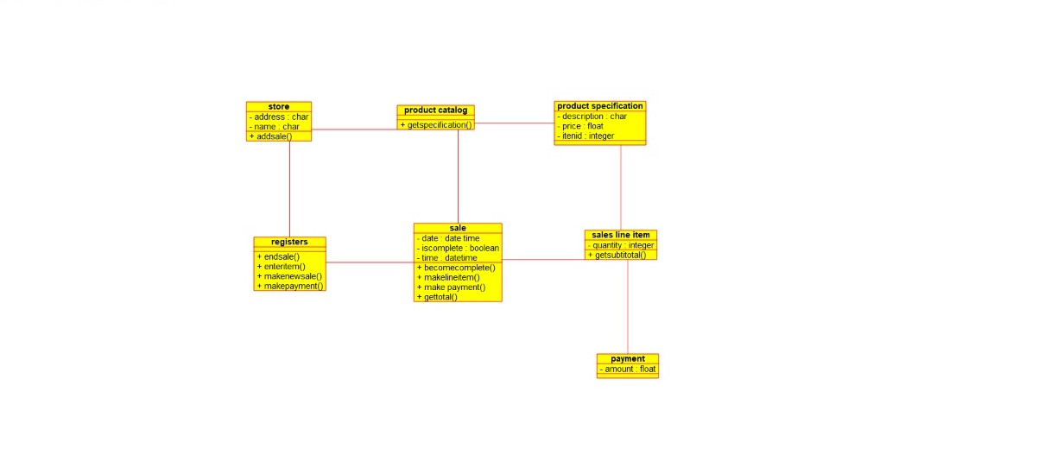

Source code:

#ifndef BOOLEAN_H

#define BOOLEAN_H

#include <string>

/**

* class boolean

*

*/

class boolean

{

public:

// Constructors/Destructors

//

/**

* Empty Constructor

*/

boolean ();

/**

* Empty Destructor

*/

virtual ~boolean ();

// Static Public attributes

//

// Public attributes

//

// Public attribute accessor methods

//

// Public attribute accessor methods

//

protected:

// Static Protected attributes

//

// Protected attributes

//

public:

// Protected attribute accessor methods

//

protected:

public:

// Protected attribute accessor methods

//

protected:

private:

// Static Private attributes

//

// Private attributes

//

public:

// Private attribute accessor methods

//

private:

public:

// Private attribute accessor methods

//

private:

};

#endif // BOOLEAN_H

20.library management system

Use case:

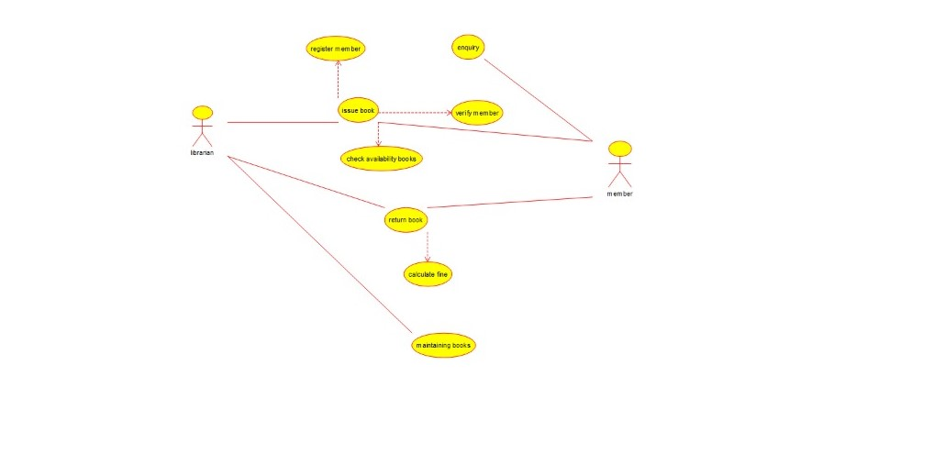

Class diagram:  
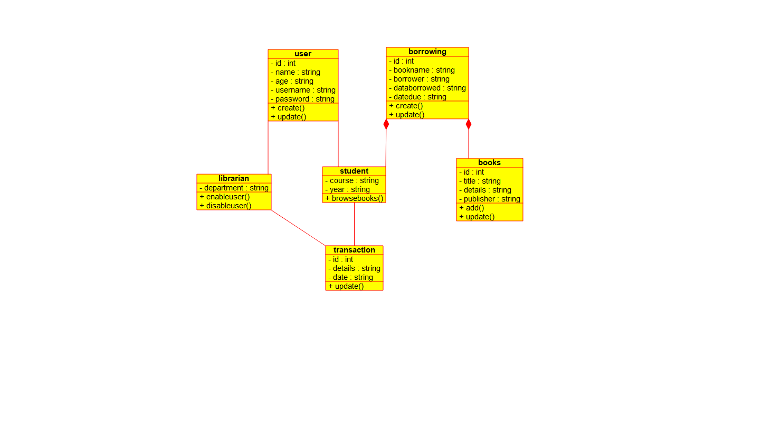

Source code:

#ifndef BOOKS_H

#define BOOKS_H

#include <string>

#include vector

/**

* class books

*

*/

class books

{

public:

// Constructors/Destructors

//

/**

* Empty Constructor

*/

books ();

/**

* Empty Destructor

*/

virtual ~books ();

// Static Public attributes

//

// Public attributes

//

// Public attribute accessor methods

//

// Public attribute accessor methods

//

/**

*/

void add ()

{

}

/**

*/

void update ()

{

}

protected:

// Static Protected attributes

//

// Protected attributes

//

public:

// Protected attribute accessor methods

//

protected:

public:

// Protected attribute accessor methods

//

protected:

private:

// Static Private attributes

//

// Private attributes

//

int id;

string title;

string details;

string publisher;

public:

// Private attribute accessor methods

//

private:

public:

// Private attribute accessor methods

//

/**

* Set the value of id

* @param new_var the new value of id

*/

void setId (int new_var) {

id = new_var;

}

/**

* Get the value of id

* @return the value of id

*/

int getId () {

return id;

}

/**

* Set the value of title

* @param new_var the new value of title

*/

void setTitle (string new_var) {

title = new_var;

}

/**

* Get the value of title

* @return the value of title

*/

string getTitle () {

return title;

}

/**

* Set the value of details

* @param new_var the new value of details

*/

void setDetails (string new_var) {

details = new_var;

}

/**

* Get the value of details

* @return the value of details

*/

string getDetails () {

return details;

}

/**

* Set the value of publisher

* @param new_var the new value of publisher

*/

void setPublisher (string new_var) {

publisher = new_var;

}

/**

* Get the value of publisher

* @return the value of publisher

*/

string getPublisher () {

return publisher;

}

private:

void initAttributes () ;

};

#endif // BOOKS_H