An Open Source (Raspberry Pi based)
Score Display System
A brief introduction
All my three daughters play volley in small teams of my city (Messina – Italy) .
The economic support for all the teams’ activities is modest and has to be carefully managed in order to maintain the teams alive. The same condition apply to many other small sport teams in our and neighborhood cities.
In all the gymnasiums they play there are different systems for displaying score and (sometimes) other related information. Often the teams have only cardboard displays (like the one in the figure) that allow to show the score only .
Since I had a powerful and inexpensive Raspberry Pi 3 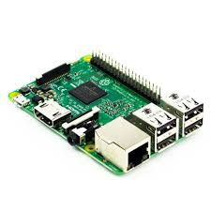 laying around my desk together with an old 32” Philips LCD TV 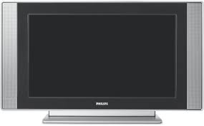, I asked myself if it could be possible to use them as a display system to show score information, as well as slide-shows and videos so as to encourage possible sponsors to give financial support to the teams.
I have then envisaged a (low cost) system that could be adapted to small gymnasiums (that will use a single LCD screen) as well as to bigger sport facilities in which many LCD’s would show, in a coordinated way, the different information.
Since I hate having messy cables laying around, I wanted to create a system that could work wireless so that it can be easily moved without too much trouble.
I ended up in realizing a system in which an Android tablet (the “game director”) controls, via WiFi, one or more “score panels”, composed by a Raspberry Pi connected to a HDMI capable monitor (or TV). Each score Panel is configurable in order to show the score information only or instead show score, slides and videos as dictated by the game director.
Each score panel can be equipped with a Raspberry Pi Camera module V2 so as to show (under control of the game director) in real time what is happening on the game field, and the camera can be mounted on a Pan-Tilt module 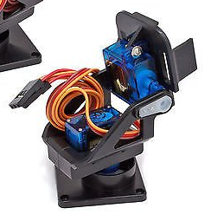 that, in turn, is controlled by the tablet.
Hardware needed
From a hardware point of view, at minimum, you need a computer (in my case an Android tablet equipped with a touch screen and endowed of WiFi capabilities but you can use a laptop if you wish) that will stay on the scorekeeper table and one or more “score panels” composed of a Raspberry Pi connected by a short HDMI cable to a LCD TV (or monitor).
One (and only one) Raspberry Pi has to be configured in such a way to realize a Wireless Local Area Network (W-LAN) acting as a sort of “access point”. The tablet plays the role of the game director and, together with all other Raspberry Pi, will connect to the W-LAN built up by the access point in order to send commands and exchange informations with all the score panels.
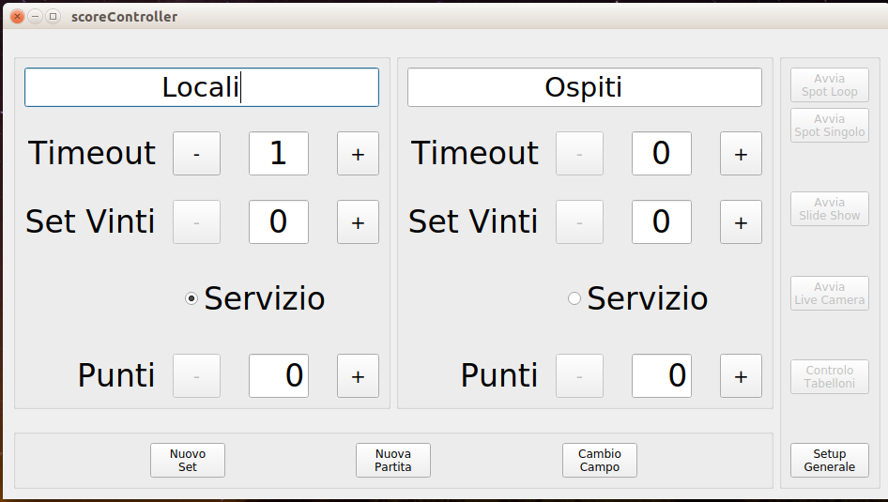
The game director GUI (italian version)
If volley is the only sport you are interested in that’s all the needed hardware. In the following we will see how to add timing capabilities to the system so to cover other sports.
The Software
In each Raspberry Pi there must be installed a (fresh) copy of the Raspbian operating system that can be downloaded from:
https://www.raspberrypi.org/downloads/
There are many tutorials that details very well how to download and install the required operating system into a micro SD and I will not go further on this argument apart that I strongly suggest to use a micro SD with a storage capacity not less than 16GB and connect your Raspberry to the Internet, trough your router, via an Ethernet cable.
Once you have installed the operating system on your Raspberry Pi, let’s be sure to have an updated version of the software by opening a terminal and issuing the following command:
$ sudo apt update && sudo apt upgrade -y
We need to modify some of the default setups of our Raspberry.
First of all, since all the informations will be exchanged via WiFi, we need to change, for security reasons, the default password of the user pi.
Click on the Raspberry icon  on your desktop and select: Preferences→Raspberry Pi Configuration.
- From the “System” tab change the password and assign a different “Hostname” to each score panel (I use panel-0, panel-1 and so on...).
- Check the “To Desktop” radio button (to boot directly into the Desktop environment) and the “Login as user ‘pi’” checkbox (to be logged automatically without having to enter the password every time).
- Depending on your display (or tv), you may need to change also the “Resolution” and “Overscan” options.
- Under the tab “Interfaces” enable “SSH” and, if you intend to use the Raspberry Camera Module and the Pan-Tilt system, enable the “Camera” and “Remote GPIO” capabilities.
- Since we will use the GPU for showing slide and videos, under the “Performance” tab increase the “GPU Memory” to 128K.
Close the configuration dialog. You will be asked to reboot: please do it now.

All the software for the Raspberry has been written in C++ by using Qt (https://www.qt.io/).
You can install Qt in the Raspberry Pi by opening a terminal and writing:

$ sudo apt install qt5-default
$ sudo apt install libqt5serialport5-dev
$ sudo apt install libqt5websockets5-dev
$ sudo apt install qtcreator

If everything has gone well you should be able to see the freshly installed Qt  environment by clicking on the raspberry icon of your desktop under the “Programming” menu.

Then you need to clone the repository in which are stored the programs that build-up the score panel system. I suggest to clone the repository by using git so you can easily update the software as a new release became available. If you don’t have it already installed, open a terminal and issue the command:

$ sudo apt install git

Then tell git who you are by writing:

$ git config –global user.email “your.email@address”
$ git config –global user.name “Your Name”

Obviously replace “your.email@address” with your actual email address and “Your Name” with your real name.

Now you are ready to clone the software repository. Open a terminal window and write:

$ mkdir ~/scoreSystem
$ cd ~/scorePanel
$ git clone https://github.com/salvato/ScorePanel.git

After the download has finished, you should have a new directory:
~/scoreSystem/ScorePanel just under your home directory.

Start Qt Creator and load the project panelChooser.pro. The first time that you open the project you have to configure Qt in order to use the right compiler, and debugger. I will not go further in configuration of Qt since there are many (?) tutorial on the net.

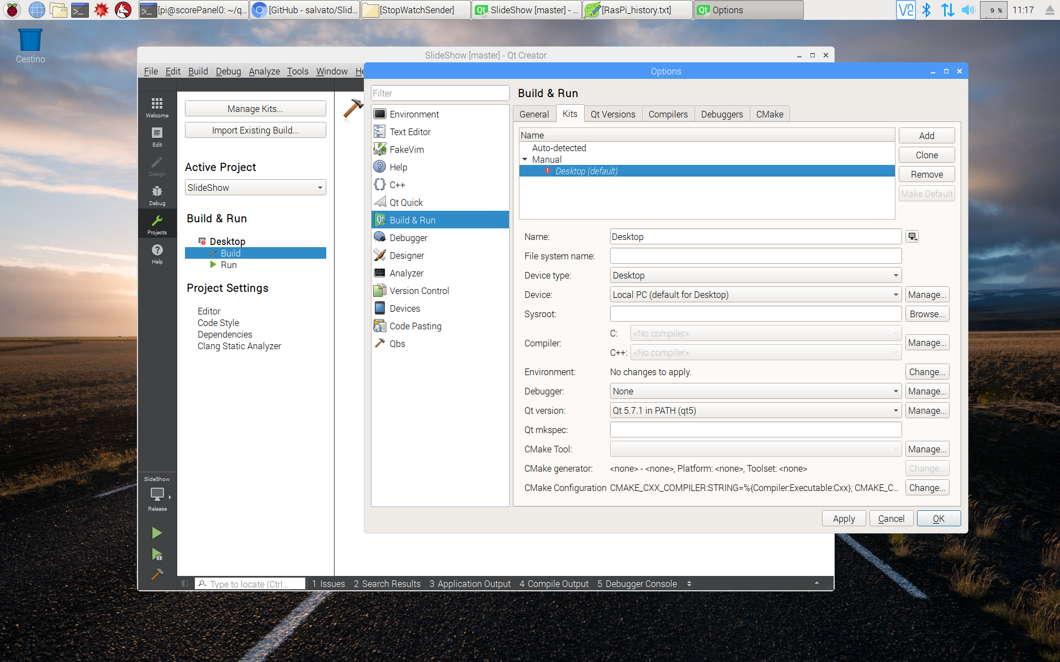

(Mettere ora le istruzioni per compilare ed eseguire il programma o farlo dopo ?)

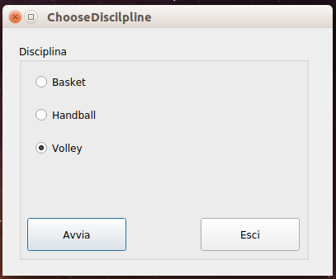

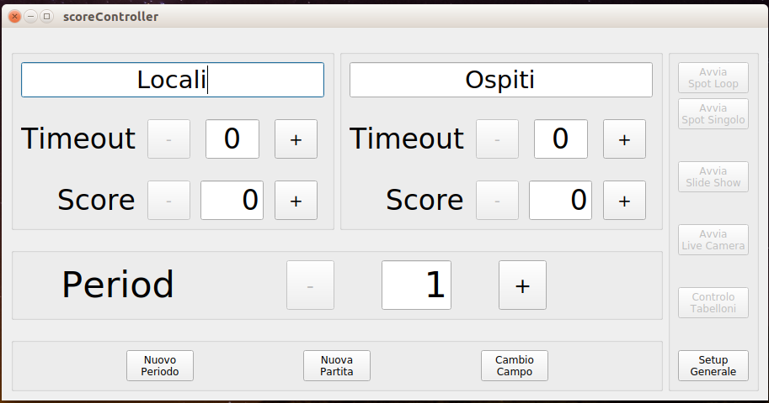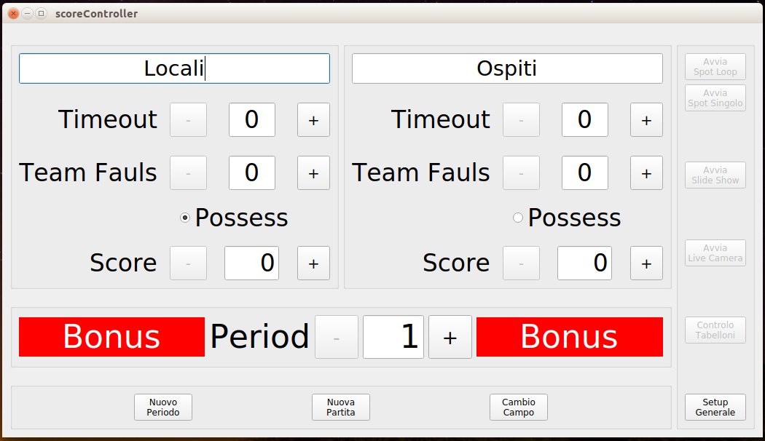

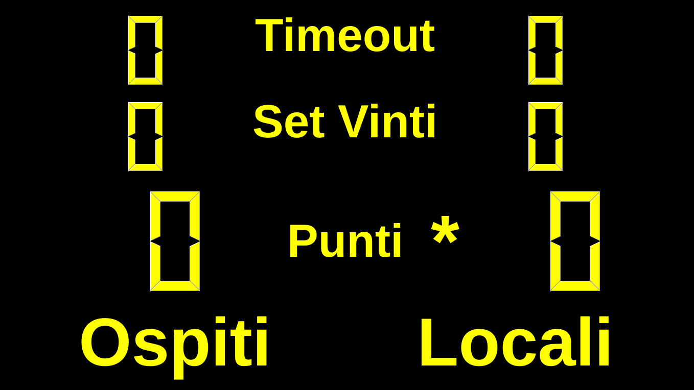
Setting your Raspberry to act as an “Access Point”
To configure your Raspberry as an access point you can follw the instructions at:
https://www.raspberrypi.org/documentation/configuration/wireless/access-point.md
stopping at the paragraph “ADD ROUTING AND MASQUERADE” since we don’t want to route any message out on internet: all the network traffic should remain inside the local network.
If everything has gone well your Raspberry has become the “router” of your own LAN.

Alternatively you can follow the instructions of Adafruit:

https://learn.adafruit.com/setting-up-a-raspberry-pi-as-a-wifi-access-point/install-software

$ sudo apt-get install hostapd isc-dhcp-server

Once you have installed the required programs, you have to configure your Raspberry as to act as a DHCP server editing the configuration file:

$ sudo nano /etc/dhcp/dhcpd.conf

Comment the lines:

option domain-name "example.org";
option domain-name-servers ns1.example.org, ns2.example.org;

by adding a # at the start of each line and uncomment the line which contains authoritative by removing the # at the beginning.
Go to the end of file and add the following lines:

subnet 192.168.4.0 netmask 255.255.255.0 {
range 192.168.4.1 192.168.42.20;
option broadcast-address 192.168.4.255;
option routers 192.168.4.1;
default-lease-time 600;
max-lease-time 7200;
option domain-name "local";
option domain-name-servers 192.168.4.1;
}

Save the changes, close the file and then edit the isc-dhcp-server configuration:
$ sudo nano /etc/default/isc-dhcp-server

go to the line containing INTERFACES and change it in INTERFACES=”wlan0”. Save the changes and close the file.

Installing Arduino IDE
If you want to use the timing capability of the score panels you need to install the Arduino IDE. In the terminal window write:

$ sudo apt install Arduino

In this way you can compile and download to your Arduino the needed software.
Once again, if everything has gone well, you should be able to see the new Arduino IDE environment by clicking on the Raspberry icon of your desktop under the “Programming” menu.
It is time now to download the “sketch” for the Arduino. In the terminal window enter the following commands:

cd ~/scoreSystem
git clone https://github.com/salvato/stopWatch.git

After a succesful download you will find a new folder : ~/scoreSystem/stopWatch containing the stopWatch.ino file. Inside this file there is the code for the timing part of the score panels. It must be compiled and loaded into the Arduino flash RAM.

(Mettere ora le istruzioni per compilare ed eseguire il programma o farlo dopo ?)

Each score panel, if needed, can be equipped with an Arduino board (I’ve used an Arduino Nano 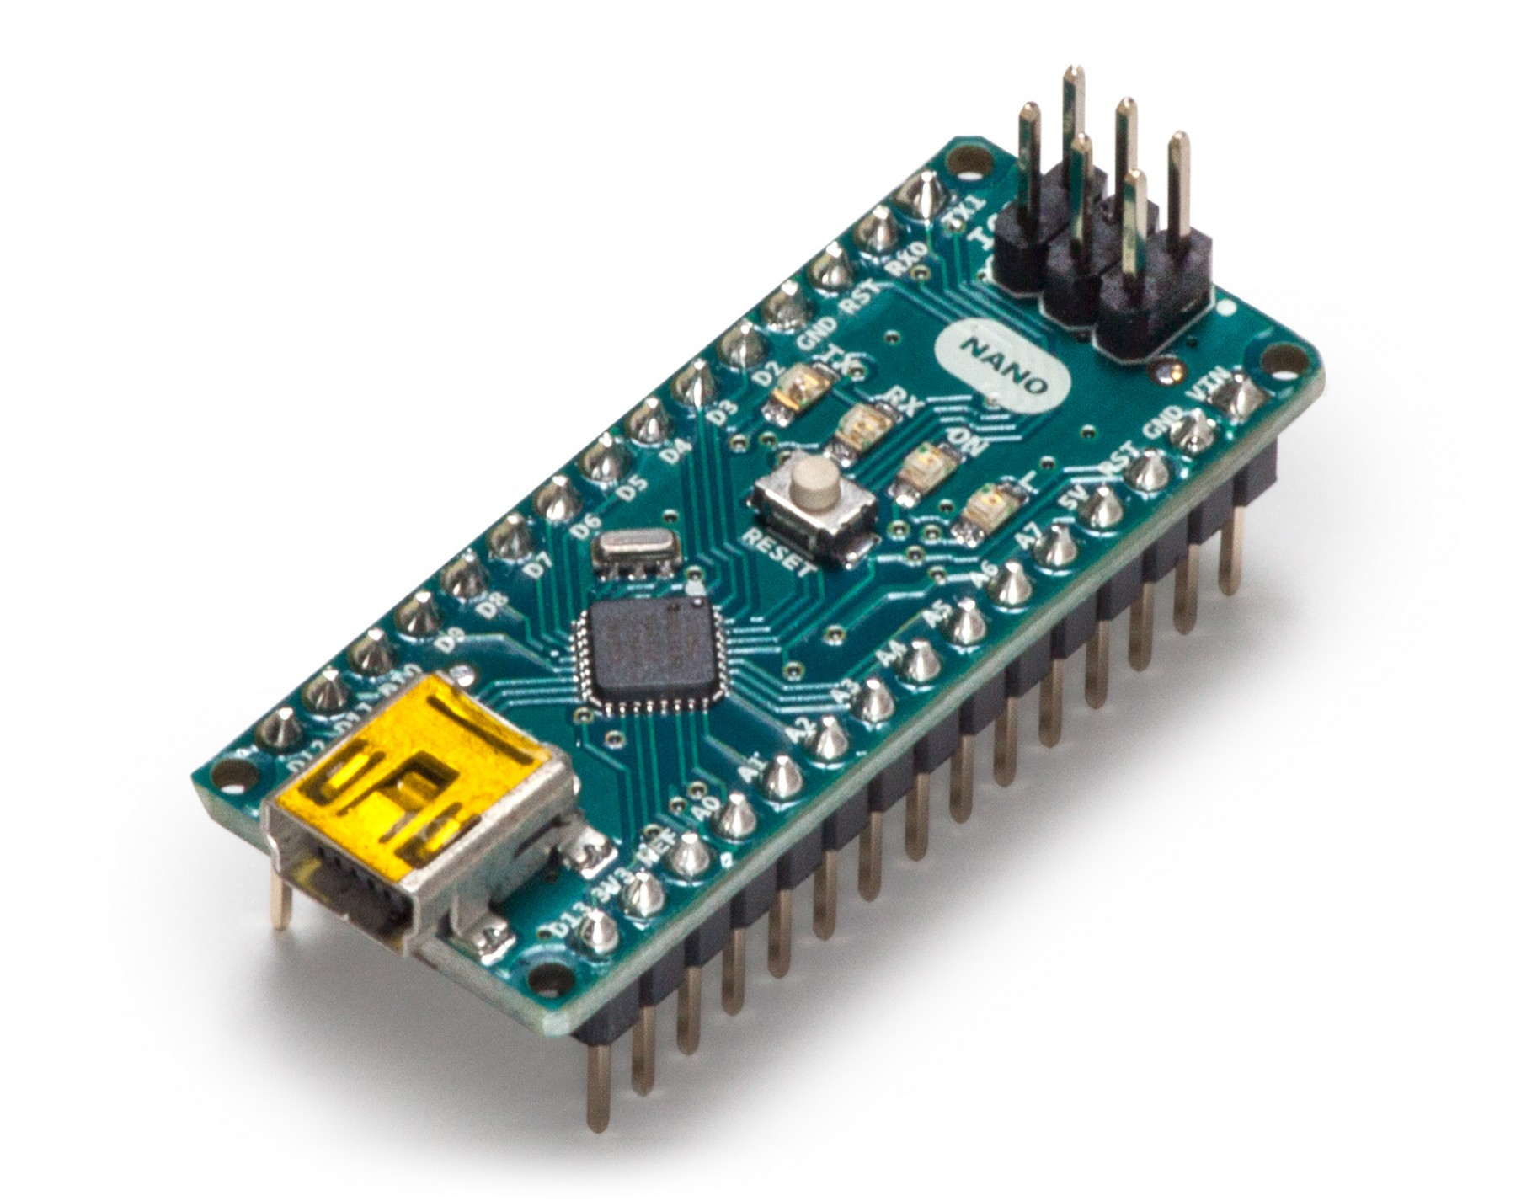), connected to the Raspberry Pi via a short USB cable, and to a nRF24 radio module 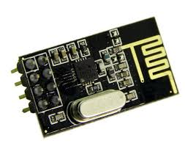, in order to receive clock information from another Arduino (plus another nRF24 and some push buttons) placed on the timekeepers table. This last configuration allow to use the score panel(s) to show information related to sport discipline in which the time plays a relevant role (e.g. basket, handball…).

