An Open Source and Raspberry Pi based
Score Display System
A brief introduction
All my three daughters play volley in small teams of my city (Messina – Italy) .
The economic support for all the teams’ activities is modest and has to be carefully managed in order to maintain the teams alive. The same condition apply to many other small sport teams in our and neighborhood cities.
In all the gymnasiums they play there are different systems for displaying score and (sometimes) other related information. Often the teams have only cardboard displays (like the one in the figure) that allow to show the score only 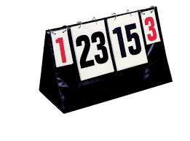.
Since I had a powerful and inexpensive Raspberry Pi 3 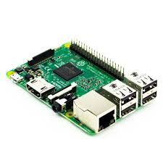 laying around my desk together with an old 32” Philips LCD TV 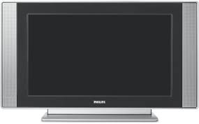, I asked myself if it could be possible to use them as a display system to show score information, as well as slide-shows and videos so as to encourage possible sponsors to give financial support to the teams.
I have then envisaged a (low cost) system that could be adapted to small gymnasiums (that will use a single LCD screen) as well as to bigger sport facilities in which many LCD’s would show, in a coordinated way, the different information.
Since I hate having messy cables laying around, I wanted to create a system that could work wireless so that it can be easily moved without too much trouble.
I ended up in realizing a system in which an Android tablet (the “game director”) controls, via WiFi, one or more “score panels”, composed by a Raspberry Pi connected to a HDMI capable monitor (or TV). Each score Panel is configurable in order to show the score information only or instead show score, slides and videos as dictated by the game director.
Each score panel can be equipped with a Raspberry Pi Camera module V2 so as to show (under control of the game director) in real time what is happening on the game field, and the camera can be mounted on a Pan-Tilt module 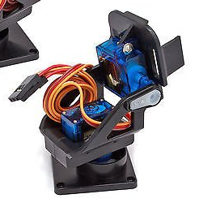 that, in turn, is controlled by the tablet.
Hardware needed
From a hardware point of view, at minimum, you need a computer (in my case an Android tablet equipped with a touch screen and endowed of WiFi capabilities but you can use a laptop if you wish) that will stay on the scorekeeper table and one or more “score panels” composed of a Raspberry Pi connected by a short HDMI cable to a LCD TV (or monitor).
One (and only one) Raspberry Pi has to be configured in such a way to realize a Wireless Local Area Network (W-LAN) acting as a sort of “access point”. The tablet plays the role of the game director and, together with all other Raspberry Pi, will connect to the W-LAN built up by the access point in order to send commands and exchange informations with all the score panels.
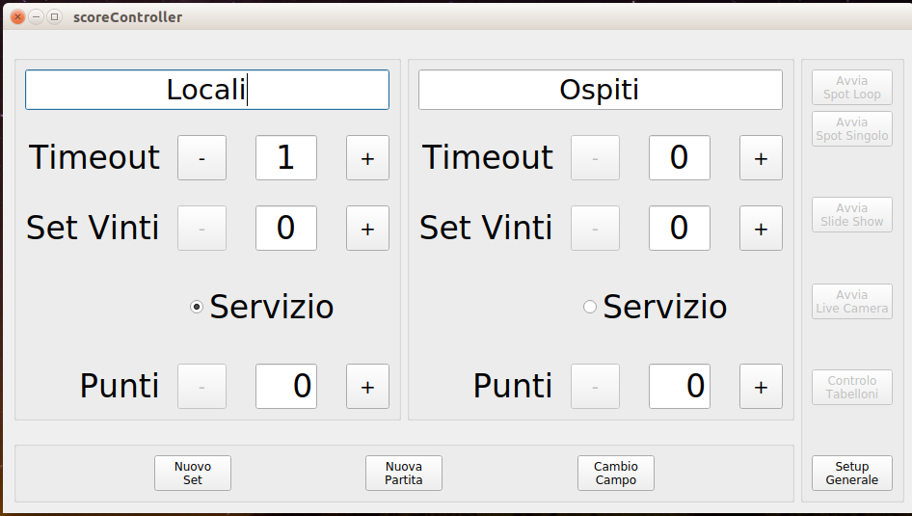The game director GUI (italian version) | 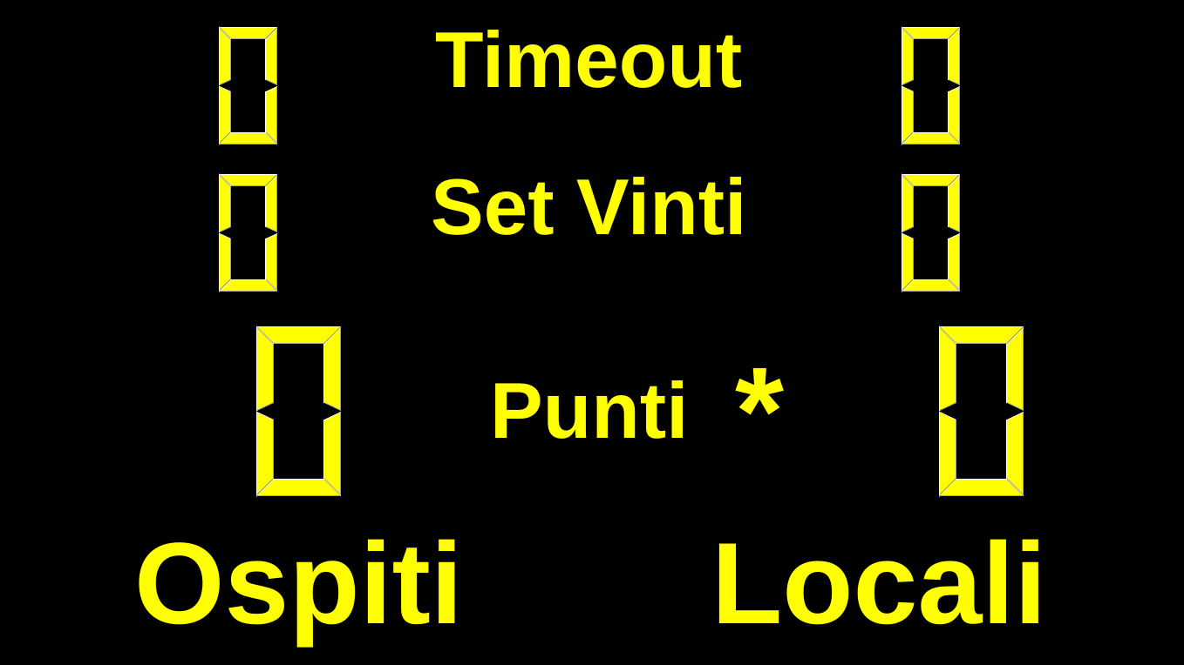The Volley score panel (italian version)
If Volley is the only sport you are interested in that’s all the needed hardware. In the following we will see how to add timing capabilities to the system so to cover other sports.
The Software
In each Raspberry Pi there must be installed a (fresh) copy of the Raspbian operating system that can be downloaded from:
https://www.raspberrypi.org/downloads/
There are many tutorials that details very well how to download and install the required operating system into a micro SD and I will not go further on this argument apart that I strongly suggest to use a micro SD with a storage capacity not less than 16GB and connect your Raspberry to the Internet, trough your router, via an Ethernet cable.
Once you have installed the operating system on your Raspberry Pi, let’s be sure to have an updated version of the software by opening a terminal and issuing the following command:
$ sudo apt update && sudo apt upgrade -y
We need to modify some of the default setups of our Raspberry.
First of all, since all the informations will be exchanged via WiFi, we need to change, for security reasons, the default password of the user pi.
Click on the Raspberry icon  on your desktop and select:
Preferences→Raspberry Pi Configuration.
- From the “System” tab change the password and assign a different “Hostname” to each score panel (I use panel-0, panel-1 and so on...).
- Check the “To Desktop” radio button (to boot directly into the Desktop environment) and the “Login as user ‘pi’” checkbox (to be logged automatically without having to enter the password every time).
- Depending on your display (or tv), you may need to change also the “Resolution” and “Overscan” options.
- Under the tab “Interfaces” enable “SSH” and, if you intend to use the Raspberry Camera Module and the Pan-Tilt system, enable the “Camera” and “Remote GPIO” capabilities.
- Since we will use the GPU for showing slide and videos, under the “Performance” tab increase the “GPU Memory” to 128K.
Close the configuration dialog. You will be asked to reboot: please do it now.
Then you need to clone the repository in which are stored the programs that build-up the score panel system. I suggest to clone the repository by using git so you can easily update the software as a new releases became available. If you don’t have it already installed, open a terminal window and issue the command:
$ sudo apt install git
Then tell git who you are by writing (this is not strictly needed):
$ git config –global user.email “your.email@address”
$ git config –global user.name “Your Name”
Obviously replace “your.email@address” with your actual email address and “Your Name” with your real name.

Now you are ready to clone the software repository. Open a terminal window and write:
$ git clone https://github.com/salvato/ScorePanel_executables.git
A new folder, ScorePanel_executables, will be created that, at present, contains three more folders:
- Android
which contains ScoreController.apk, the executable for the "game director" part of the system.
- Raspberry
which contains two executables: the panelChooser executable, responsible of realize the score panels for a few sports, and the SlideShow program, the one that take care of showing, on request, the slides. The system make use of the commonly installed program omxplayer to show short movies.
- Ubuntu
which contains the version of the programs that you can use on Ubuntu (but we will not cover the installation on Ubuntu in this document).
Copy the two programs contained in the ScorePanel_executables/Raspberry folder into the pi home directory.
The panelChooser program depends on some qt5 libraries that can be already installed and on some other that can be missing. To check which libraries are missing you may issue the following command in a terminal window:
$ ldd ~/panelChooser
In my Raspbian version (stretch) two of the needed libraries are missing:

libQt5WebSockets.so.5 => not found
libQt5SerialPort.so.5 => not found
You can install such libraries by issuing the following command:
$ sudo apt install libqt5websockets5 libqt5serialport5
You can check if everything is working by launching the panelChooser program: Open a terminal and issue:
$ ~/panelChooser
A full screen black window should appears and a message should tell that the program is waiting to be connected to a server. Hit Esc in your keyboard and the window should disappear restoring your desktop.
If your Raspberry is not connected to a network the message will instead tell you that the program is waiting for a network connection. Again hit Esc in your keyboard to close the black window.
We have to disable Screen Blanking to prevent the disappearing of the score during the match. You need to edit a configuration file:
$ sudo nano /etc/lightdm/lightdm.conf
Search the line looking:
#xserver-command=X
and change it in:
# To disable screen blanking
xserver-command=X -s 0 -dpms
If we want to control the pan and the tilt of the Raspberry camera with two servos, we need to start the gpio daemon at boot time we have to edit an other configuration file:
$ sudo nano /etc/rc.local
Insert:
/usr/bin/pigpiod &
just before the line containing:
exit(0)
If we are using the WiFi for the network connections we have to be sure that the power management does not place the WiFi interface in power save mode but, according to a post of Dougie Lawson in the Raspberry forum, in the built-in WiFi on a RPi3 the power management is always off even if the command:
$ iw dev wlan0 get power_save
will report that it is On.
Now it is time to tell our Raspberry to start automatically the program at boot so you don’t need to start it any time you switch on the system. Issue the following command on a terminal window:
$ nano ~/.config/lxsession/LXDE-pi/autostart
and, since we don’t want that a screen-saver can obscure the panel, comment the line
@xscreensaver -no-splash
changing it in:
#@xscreensaver -no-splash
Then insert a line to start at every reboot the panel control program:
/home/pi/panelChooser &
Save and reboot to check that everything has gone well.
To exit the program remember to hit Esc on your keyboard.
If you have a WiFi network up and running and don’t want to use a dedicated WiFi for your system, you are almost done with your Raspberry, but I strongly suggest that you create your own WiFi network to separate the score system from all the other network traffic.
Setting your Raspberry to act as an “Access Point”
To configure your Raspberry as an access point you can follow the instructions at:
https://www.raspberrypi.org/documentation/configuration/wireless/access-point.md
stopping at the paragraph “ADD ROUTING AND MASQUERADE” since we don’t want to route any message out on internet: all the network traffic should remain inside the local network.
If you plan to have more than one score panel in your system, only one have to be configured to act as an access point, all the other must be connected to the network created by that one.
We have done with the score panel part of the system. It is time to setup the game director part.
Installing the Android App
Connect your Android tablet to your Raspberry and copy the file:
~/ScorePanel_executables/Android/ScoreController.apk
into the SD card of your tablet. Create also two new directories into the same SD card named respectively: slides and spots.
Copy all the slides that you want to show into the slide directory (only jpeg and png formats are currently recognized) and all the movies you want to play (only mp4 files are recognized at present).
Disconnect your tablet from the Raspberry and open the file manager of your tablet. Navigate to where the ScoreController.apk file has been copied and click on its icon to install it.
It is possible that the security options on your tablet will prevent to install the program since it comes from an unknown source. You should allow to install also from unknown sources just for the time to install the program and block again once the program has been installed.
A new applet icon should appear into your tablet. Be sure to connect the tablet to the same network of the score panels and then click on the program icon: your new score system should start !
A dialog like the one depicted should appears allowing to choose the language (at present only Italiano and - a poor translation of – English) and the sport discipline you are interested in. At present only Volley can be run without further hardware. In a follow-up we will consider disciplines that requires timing information.
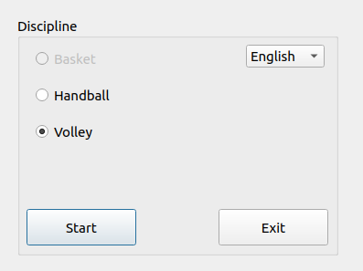
Select the discipline and click Start: the dialog will close and a new window will be shown:
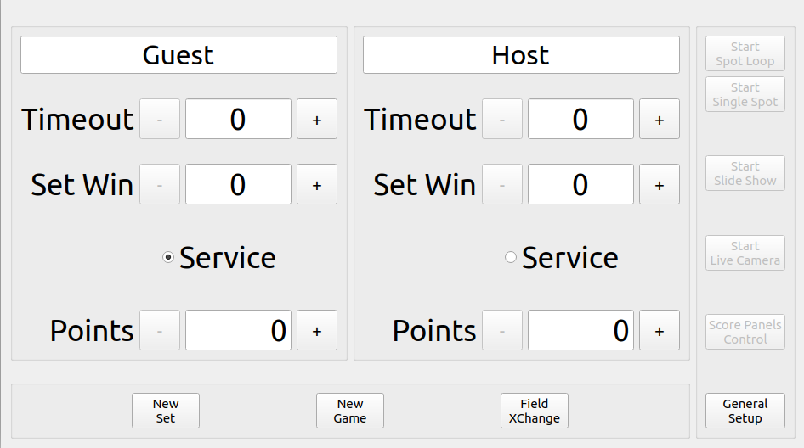
The very first time the App will run it will ask to locate the two directories containing the slides and the movies. Please select the right directories and go on.
All the controls in the window should be really intuitive so I’ll not explain their meaning. Please feel free to experiment and enjoy your new system.
The Software Sources
As said in the title all the sources are freely available and I hope to receive support for improving the system. The programs are written in c++ using Qt. You can clone the following repositories:
https://github.com/salvato/scoreController.git
https://github.com/salvato/ScorePanel.git

If everything has gone well your Raspberry has become the “router” of your own LAN.

All the software for the Raspberry has been written in C++ by using Qt (https://www.qt.io/).
You can install Qt in the Raspberry Pi by opening a terminal and writing:

$ sudo apt install qt5-default
$ sudo apt install libqt5serialport5-dev
$ sudo apt install libqt5websockets5-dev
$ sudo apt install qtcreator

If everything has gone well you should be able to see the freshly installed Qt  environment by clicking on the raspberry icon of your desktop under the “Programming” menu.

Then you need to clone the repository in which are stored the programs that build-up the score panel system. I suggest to clone the repository by using git so you can easily update the software as a new release became available. If you don’t have it already installed, open a terminal and issue the command:

$ sudo apt install git

Then tell git who you are by writing:

$ git config –global user.email “your.email@address”
$ git config –global user.name “Your Name”

Obviously replace “your.email@address” with your actual email address and “Your Name” with your real name.

Now you are ready to clone the software repository. Open a terminal window and write:

$ git clone https://github.com/salvato/ScorePanel_executables.git

$ mkdir ~/scoreSystem
$ cd ~/scorePanel
$ git clone https://github.com/salvato/ScorePanel.git

After the download has finished, you should have a new directory:
~/scoreSystem/ScorePanel just under your home directory.

Start Qt Creator and load the project panelChooser.pro. The first time that you open the project you have to configure Qt in order to use the right compiler, and debugger. I will not go further in configuration of Qt since there are many (?) tutorial on the net.

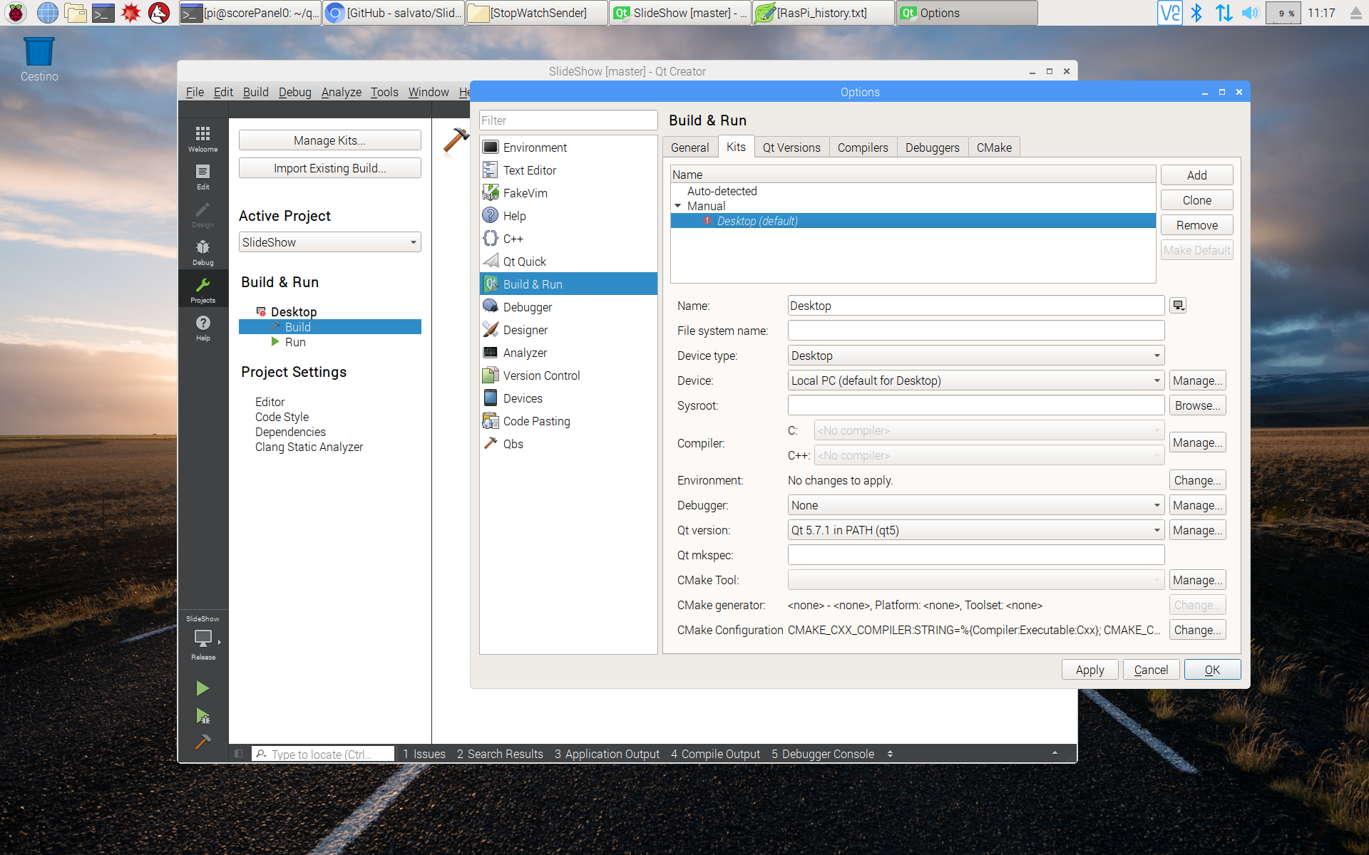

(Mettere ora le istruzioni per compilare ed eseguire il programma o farlo dopo ?)

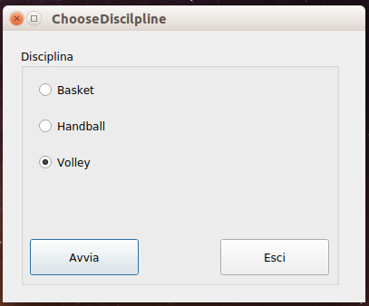

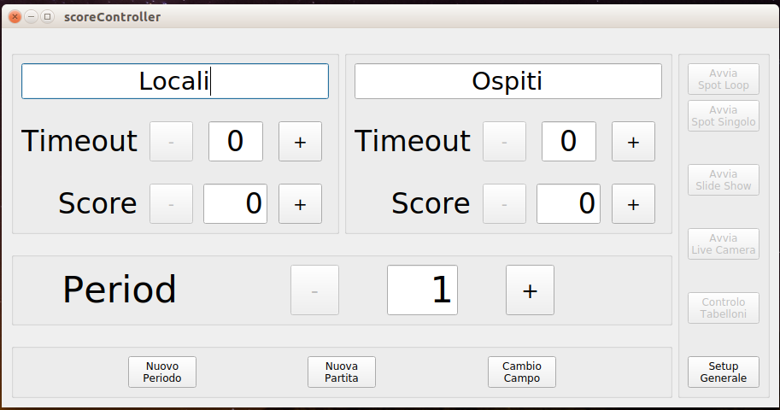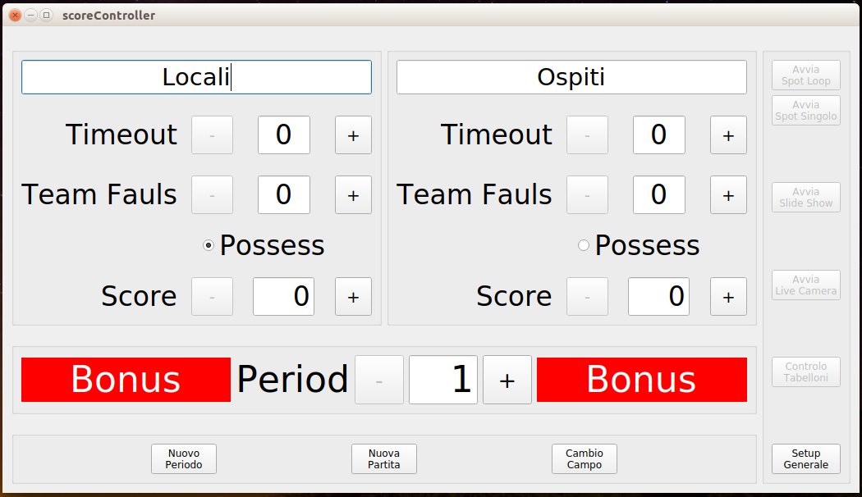

Setting your Raspberry to act as an “Access Point”
To configure your Raspberry as an access point you can follw the instructions at:
https://www.raspberrypi.org/documentation/configuration/wireless/access-point.md
stopping at the paragraph “ADD ROUTING AND MASQUERADE” since we don’t want to route any message out on internet: all the network traffic should remain inside the local network.
If everything has gone well your Raspberry has become the “router” of your own LAN.

Alternatively you can follow the instructions of Adafruit:

https://learn.adafruit.com/setting-up-a-raspberry-pi-as-a-wifi-access-point/install-software

$ sudo apt-get install hostapd isc-dhcp-server

Once you have installed the required programs, you have to configure your Raspberry as to act as a DHCP server editing the configuration file:

$ sudo nano /etc/dhcp/dhcpd.conf

Comment the lines:

option domain-name "example.org";
option domain-name-servers ns1.example.org, ns2.example.org;

by adding a # at the start of each line and uncomment the line which contains authoritative by removing the # at the beginning.
Go to the end of file and add the following lines:

subnet 192.168.4.0 netmask 255.255.255.0 {
range 192.168.4.1 192.168.42.20;
option broadcast-address 192.168.4.255;
option routers 192.168.4.1;
default-lease-time 600;
max-lease-time 7200;
option domain-name "local";
option domain-name-servers 192.168.4.1;
}

Save the changes, close the file and then edit the isc-dhcp-server configuration:
$ sudo nano /etc/default/isc-dhcp-server

go to the line containing INTERFACES and change it in INTERFACES=”wlan0”. Save the changes and close the file.

Installing Arduino IDE
If you want to use the timing capability of the score panels you need to install the Arduino IDE. In the terminal window write:

$ sudo apt install Arduino

In this way you can compile and download to your Arduino the needed software.
Once again, if everything has gone well, you should be able to see the new Arduino IDE environment by clicking on the Raspberry icon of your desktop under the “Programming” menu.
It is time now to download the “sketch” for the Arduino. In the terminal window enter the following commands:

cd ~/scoreSystem
git clone https://github.com/salvato/stopWatch.git

After a succesful download you will find a new folder : ~/scoreSystem/stopWatch containing the stopWatch.ino file. Inside this file there is the code for the timing part of the score panels. It must be compiled and loaded into the Arduino flash RAM.

(Mettere ora le istruzioni per compilare ed eseguire il programma o farlo dopo ?)

Each score panel, if needed, can be equipped with an Arduino board (I’ve used an Arduino Nano 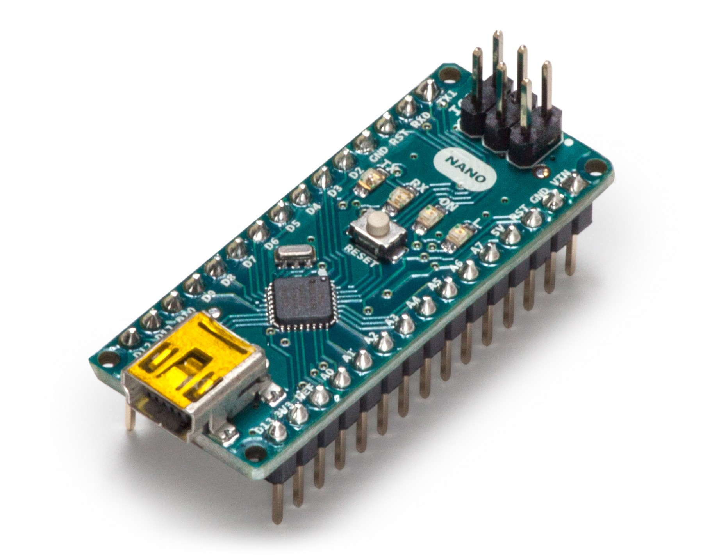), connected to the Raspberry Pi via a short USB cable, and to a nRF24 radio module 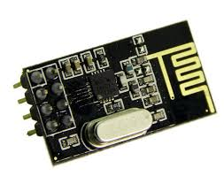, in order to receive clock information from another Arduino (plus another nRF24 and some push buttons) placed on the timekeepers table. This last configuration allow to use the score panel(s) to show information related to sport discipline in which the time plays a relevant role (e.g. basket, handball…).

