TRACQ32 v 3.1

Installing TRACQ32
- Any old versions of Tracq32 that you have installed on your system must be removed before proceeding. Run the uninstall.exe found in the directory where the previous Tracq32 was installed, or use “Add/Remove Programs” from the Windows Control Panel and select “National Instruments LabView”.

For LabView users: Tracq32 installs LabView RunTime Engine version 5.1,
this may cause problems with running Tracq32 if you have older versions of
LabView on your system.

- Install Tracq32;run setup.exe from the CD’s root directory.
3. Reboot the computer.

Note: If Raman_PL instrument is going to be controlled by Tracq32 the Computer Board (Instacal) and OPhC software must be installed first.

Launching TRACQ32 for the very first time

1.Connect your Oriel Instrument to your computer, unless you want to use the
Demo Libraries for Detector and Monochromator. Start Tracq32.
The very first time you run Tracq32 you will be prompted to go to
the Monochromator and Detector Select menus.

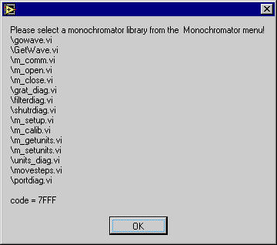

Figure1. Prompt for selecting Monochromator menu.

2.Select the Monochromator Library you wish to use
  - Select the menu item Monochromator |Select Monochromator Library Path...

- From the dialog box go to the directory containing the Virtual
Instrument files (*.vi) for the monochromator you are using.

C:\Program Files\Oriel Instruments\Tracq32\69050gpib
C:\Program Files\Oriel Instruments\Tracq32\69050rs232
C:\Program Files\Oriel Instruments\Tracq32\74000rs232
C:\Program Files\Oriel Instruments\Tracq32\74000gpib
C:\Program Files\Oriel Instruments\Tracq32\74000rs232
C:\Program Files\Oriel Instruments\Tracq32\74050gpib
C:\Program Files\Oriel Instruments\Tracq32\74050rs232
C:\Program Files\Oriel Instruments\Tracq32\74055gpib
C:\Program Files\Oriel Instruments\Tracq32\74055rs232
C:\Program Files\Oriel Instruments\Tracq32\74100gpib
C:\Program Files\Oriel Instruments\Tracq32\74100rs232
C:\Program Files\Oriel Instruments\Tracq32\77700gpib
C:\Program Files\Oriel Instruments\Tracq32\77700rs232
C:\Program Files\Oriel Instruments\Tracq32\monodemo
Use the 74050 directory for the Raman PL system.
Use monodemo directory to exercise Tracq32 without a monochromator.

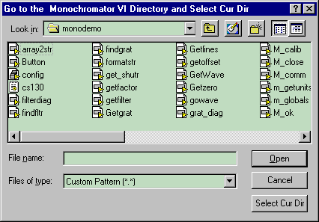

Figure 2. Dialog for selecting monochromator library.

Click the "Select Cur Dir" button.

3.Setup Monochromator Communications
  - Select the menu item Monochromator|Setup Communications..
Select the communications parameters appropriate for your
Monochromantor, ie. For the 69050 and all 74xxx set the GPIB Address
to 4 and to 6 for the 77700.

4.Select the Detector System Library you wish to use
  - Select the menu item Detector|Select Detector Library Path...

  - From the dialog box go to the directory containing the Virtual
Instrument files (*.vi) for the detection system you are using.

C:\Program Files\Oriel Instruments\Tracq32\70310gpib
C:\Program Files\Oriel Instruments\Tracq32\70310rs232
C:\Program Files\Oriel Instruments\Tracq32\70100(rs232)
C:\Program Files\Oriel Instruments\Tracq32\70103(gpib)
C:\Program Files\Oriel Instruments\Tracq32\70104(rs232)
C:\Program Files\Oriel Instruments\Tracq32\70105(gpib)
C:\Program Files\Oriel Instruments\Tracq32\76915
C:\Program Files\Oriel Instruments\Tracq32\detectordemo
C:\Program Files\Oriel Instruments\Tracq32\datafiledemo

Use the 76915 directory for the Raman PL system.
Use detectordemo or datafiledemo directories to exercise Tracq32
without a detector. Detectordemo randomly generates data;
datafiledemo uses the Y data from any scan XY data file to simulate
a detector.

Click the "Select Cur Dir" button.
5.Setup Detection System Communications
  - Select the menu item Detector|Setup Communications..
Select the communications parameters appropriate for your detection
system. For the Merlin set the GPIB Address to 1, and for OPM set
it to 2.

Note: Exiting via the close icon (x) does not save any parameter changes or mono and detector selections. If you elect to close the application using the close (x) at this point, you will need to repeat the above 5 steps the next time you start Tracq32. In order to save the selection, use File|Exit from a File menu.

If you switch monochromators and detectors via the Select library dialog you must then exit Tracq32 via the File|Exit then restart Tracq32 to load the new instruments into memory. Only the very first time you run Tracq32, will you be prompted to go to the Monochromator and Detector Select menus; you will not need to exit and restart to have this first selection loaded.

10 Minute Basics – Setting up an experiment and running a scan

1.Setting up scan parameters
Select the menu item Scan|Setup Wavelength Parameter…
Set up the Start, End and Interval wavelengths along with the Wait time.
Always update the Wavelength Parameters after changing wavelength units from
wavenumbers to nanometers or micrometers, and vice-versa.

2.Taking a reference scan.
Select the menu item Scan|Take a Simple Wavelength Scan.
After the scan is complete, save the data using File|Save Scan Data…

3.Selecting the reference scan file.
Select the menu item File|Select Reference Scan Data File… and select the
reference you wish to use.

4.Taking an Absorbance or Transmittance Scan.
Use the Scan|Take Absorbance Scan or Scan|Take Transmittance Scan after step 2
or 3.

5.Taking Radiometry Scan.
Select an Oriel Lamp Calibration file for the lamp you are using from the File
Menu – File|Select Oriel Standard Lamp File…
Run the scan by going to Scan|Take Radiometry Scan.

6.Printing data table.
Use File|Print Active Plot to print an XY data table for the “Active Plot”.

7.Averaging Plots.
Select Scan|Average Plots to plot an average of the accumulated plots.

8.Exiting Tracq32.
Select File|Exit to save setup for reloading at next startup.

Note: For more detailed information about Tracq32 please refer to Menu Bar Description paragraph.

Graph Controls

- Active Plot selects a plot for the purpose of changing properties, color, style, etc.
To change properties of the Active Plot left click on the small graph
icon to the right of the Active Plot control.
- Abort Scan aborts the running scan.
- Clear Graph clears the graph plots.
Note: You may right click in the plot area to access the graph properties, but do not use the “Clear” function from that dropdown menu. Use, the “Reinitialize to Default” menu selection, or the “Clear Graph” button on the front panel, to clear the graph.
- Cursor0, Cusor1: Indicates X, Y position of the cursor, cursor properties can be changed by left clicking on the cursor icon next to the lock icon. If cursor cannot be found, left click on cursor icon and select “Bring To Center”
- Peak indicates the maximum value between the Cursor0 and Cursor1 positions for the “Active Plot”

Menu Bar Description

File
1.File|Load Scan Data…
Loads a graph with data saved via File|Save Scan Data…
May be used to preview the data before selecting reference file for Absorbance
or Transmittance Scan.

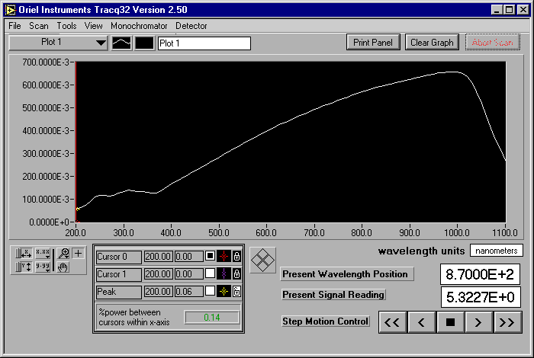

Figure 3. Tracq32 front panel.

2.File|Save Scan Data…
Saves the Scan Data of the active plot. File format is ASCII tab delimited.
Use it to save data generated by Scan|Take a Simple Wavelength Scan if you
need a reference file for Absorbance or Transmittance Scan.

3.File|Load Experiment…
Loads the Tracq32 setup which includes numeric data along with Paths
to Monochromator, Detector libraries and data files as shown below.
[Tracq32]
DetectPath="…”
MonoPath="…"
startwave
endwave
intervalwave
wait_ms
timeinterval
timepoints
refpath="…"
lampcalpath="…"
units
shift_value
shift_on=(TRUE,FALSE)

4.File|Save Experiment
Saves the current Tracq32 setup including:
DetectPath="…"
MonoPath="…"
startwave
endwave
intervalwave
wait_ms
timeinterval
timepoints
refpath="…"
lampcalpath="…"
units
shift_value
shift_on=(TRUE,FALSE)

5.File|Select Reference Scan Data File…
Select the reference file to use with Transmittance, Absorbance or Lamp
Radiometry Scan. Selection of a reference file does not load the data in a
graph form. In order to preview the data use menu Scan|Load Scan Data… then
control Clear Graph.

6.File|Select Oriel Lamp Calibration File…
Choose the lamp file for a Radiometry Scan, from the files that came with your
Oriel lamp.

7.Fiel|Select Oriel Detector Calibration File…
Choose the detector calibration file for the detector that you are using to
take the Detector Radiometry Scan.

8.File|Print Active Plot XY Data
Prints an XY data table for the “Active Plot”.

9.File|Print Graph of Active Plot…
When this menu item is selected, Tracq32 displays a preview setup. The Notes
dialog box lets you to include additional information. Use File|Printer
Setup… to change printer setup, i.e. Orientation.

10.File|Printer Setup…
Used to change the printer setup (printer, properties, orientation, paper)

11.File|Exit…
Exits Tracq32 and saves the setup (Tracq32.ini) for reloading at next startup.
You must exit Tracq32 through this menu item when you switch monochromators
and detectors via Select Library Dialog.

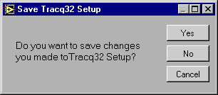

Figure 4. Exit Tracq32 dialog window.

Note on changing an Oriel Instrument:
To assure proper performance of Tracg32 when changing Monochromator or Detector:

- Click OK in the “Communication Error” dialog box
- Select new instrument(s) System library
- Click OK in a prompt dialog window
- Exit Tracq32 via File|Exit
- Restart Tracq32 to load the new instrument into memory

Scan
- Scan|Setup Scan Wavelength Parameters…
Displays a dialog window to set Scan parameters (Start, End, Interval Wavelength, and Wait time between samples)

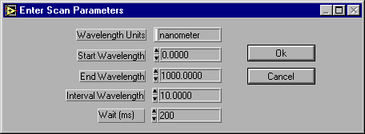

Figure 5. Setup wavelength scan parameters window.

- Scan|Take a Simple Wavelength Scan
Runs the Scan according to the wavelength scan parameters. Displays the data in a graph form.

- Scan|Setup Time Interval Scan…
Brings up the dialog window to choose parameters (Timed Interval, Points) for a Timed Interval Scan.

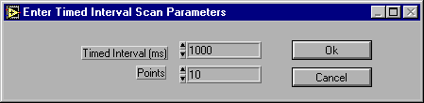

Figure 5. Dialog for setting Timed Interval Scan parameters.

- Scan|Take a Time Interval Scan
This Scan enables you to monitor detector data over a period of time(XXms = Timed Interval x Points);presents the data in a graph form.

- Scan|Take Lamp Radiometry Scan
Take a Radiometry Scan after the Oriel Standard Lamp and Reference Scan Data Files have been selected.

- Scan|Take Detector Radiometry Scan
Before running the Detector Radiometry Scan select the appropriate detector calibration file( File|Select Oriel Detector Calibration File…).
The dialog window for the scan accepts the detector gain value.
For the CURR mode on the OPM set the gain value to 1.0E+0. For OPM VOLT mode and Merlin Radiometer, enter the gain value as indicated on the transimpedance amplifier.

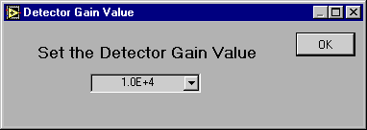

Figure 7. Detector gain value setting.

Note: It is necessary to set the Merlin calibration wavelength value (Detector|Calibrate…) to 0 before selecting Detector Radiometry Scan.

- Scan|Take Absorbance Scan
In order to run Absorbance Scan the reference data needs to be provided beforehand. Select the Reference Scan Data File or run a reference scan.

- Scan|Take Transmittance Scan
Before running the Transmittance Scan, select Reference Scan Data File or run a reference scan.

- Scan|Average Plots
This menu displays the graph, which results from averaging the current plots.

Tools
1. Tools|Spectrum Calculator
The Spectrum Calculator creates a plot by performing (*,/,+,-)calculations
on selected plots.

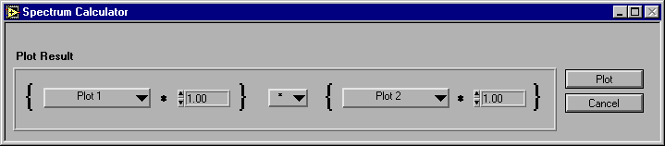

Figure 7. Spectrum Calculator dialog.

- Tools|Power Calculator
The Calculator computes the % of total Power between the X Axis Boundaries within X Axis Limits, for the selected plot.

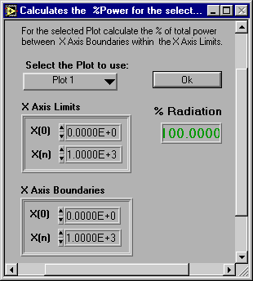

Figure 9. Power Calculator dialog window.

Note: We recommend that you exit the Tools-dialog windows by clicking “Plot” or “Cancel” for Spectrum Calculator, and “OK” for Power Calculator instead of ‘Close’ box.

View
1.View|Table
To select or unselect a table click on the word Table in the View|Table menu. If
the table is selected (check mark next to Table), a table with numeric data
for the active plot pops up, after the scanning process is completed.
Use the Scroll Bars to view all information.

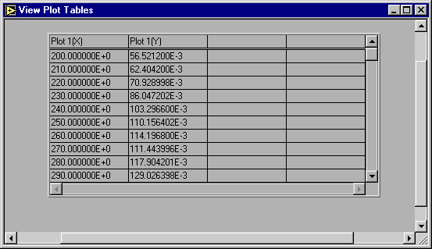

Figure 10. Plot numeric data.

Monochromator
This drop_down menu applies to Oriel Monochromators and Spectrographs. All menu items display dialog windows. For proper operation always end the selection by using OK or Cancel.

1. Monochromator|Select Monochromator Library Path…
Click the ‘Select Cur Dir’ in the dialog box after browsing the directory
containing the Virtual Instrument files (*.vi) for the monochromator you are
using (Figure 1).

2. Monochromator|Setup Communications…
Select communication parameters i.e. GPIB Board Index and Address or RS232 Port Number.

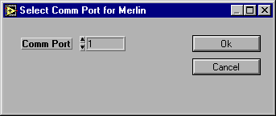

Figure 11. Communication Setup dialog.

Note:The above (2) entries don’t need to be repeated if you re-running Tracq32 with the same instrument. If a different monochromator is used follow this procedure:
- Click ‘OK’ in the ‘Communication Error” dialog box
- Select new instrument System Library
- Exit Tracq32 via File|Exit
- Restart Tracq32 to load the new instrument into memory

- Monochromator|Setup Parameters…
The dialog window is to be used to set gratings and filters parameters.
To select gratings and filters use Monochromator|Gratings…and
Monochromator|Filters… entries.

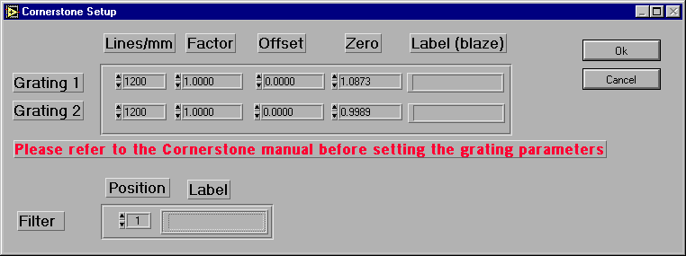

Figure 12. Monochromator (Cornerstone) setup parameters dialog.

- Monochromator|Calibrate…
Enter calibration wavelength number. The present wavelength units are displayed on the main screen below the graph panel. To change the units (nanometer, micrometer, wavenumber) go to Monochromator|Wavelength Units.

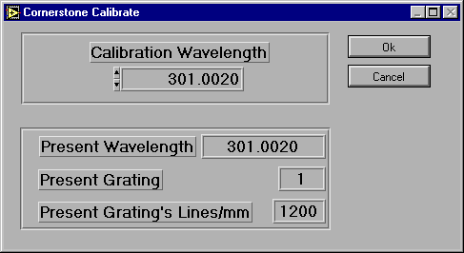
Figure 13. Dialog window for monochromator calibration.

- Monochromator|Wavelength Units…
The current wavelength units are displayed on the main screen below the graph panel. To change the units use the Monochromator|Wavelength Units… menu. The choices are : nanometer, micrometer and wavenumber.
The entry of Frequency Laser Excitation is enabled when wavenumber is selected.

Note: Always update the scan wavelength parameters before taking any scan if metric units were exchanged with wavenaumber and vice versa.

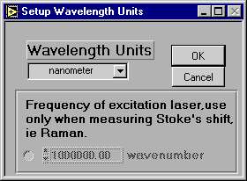

Figure 14. Dialog window for selecting monochromator units

- Monochromator|Go to Wavelength…
Enter the wavelength number to move the gratings to the position corresponding to the new wavelength. The present wavelength units are displayed on the front panel.

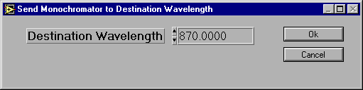

Figure 15. Go to Wavelength… dialog window.

- Monochromator|Gratings…

The setup gratings dialog allows remote grating control.
Grating is initialized to the last grating selection. The in use indicator informs you of which grating is presently used. The two fields next to Grating and in use display grating label which can be updated via Monochromator|Setup Parameters…
To set Grating, select either grating number or auto, for automatic grating selection. When in auto mode the grating label will change to use wavelength table. To fill the Automatic Change-Over Table enter the appropriate wavelength values (ascending order) in the to column. The first column, from, is updated automatically. The last column, use Grating, is for setting gratings order.
The real wavelength range for any grating in auto mod begins with from wavelength value and ends with to wavelength value minus Interval Wavelength (Scan|Setup Scan Wavelength Parameters…).
For the last grating enter, Inf, as the last wavelength value.

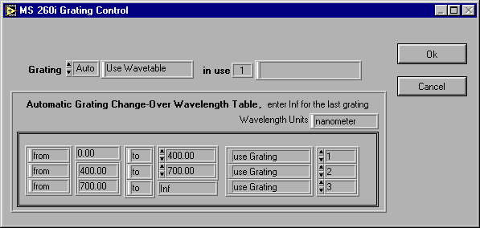

Figure 16. Grating control dialog window.

- Monochromator|Filter…

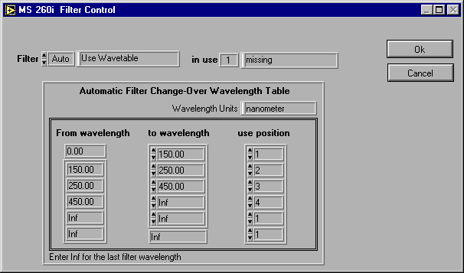

Figure 17. Filters setup dialog window.

The setup filters dialog allows remote filters control.
Filter is initialized to the last filter selection. The in use indicator informs you of which filter is presently used. The two fields next to Filter and in use display filter label which can be updated via Monochromator|Setup Parameters…
To set Filter, select either filter number or auto, for automatic filter selection. When in auto mode the filter label will change to use wavelength table. To fill the Automatic Change-Over Table enter the appropriate wavelength values (ascending order) in the to wavelength column. The first column, from wavelength, is updated automatically. The last column, use Filter, is for setting filters order.

The real wavelength range for any filter in auto mod begins with from wavelength value and ends with to wavelength value minus Interval Wavelength (Scan|Setup Scan Wavelength Parameters…).
For the last filter enter, Inf, as the last wavelength value.

- Monochromator|Shutter…
Choose between two positions: Open, Close.

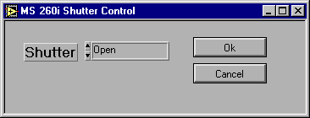

Figure 18. Controlling shutter dialog window.

- Monochromator|Port…
Select one of two outports (Axial, Lateral) or Auto for automatic ports changeover if the instrument you are using has two outports. For Auto set the changeover wavelength by filling in the Automatic Port Change-Over Wavelength Table.
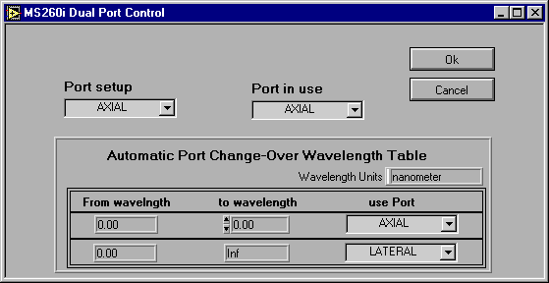
Figure 19. Outport setup dialog window.

Detectors
This drop-down menu applies to Oriel Detectors (OPM, Merlin, Photon Counter). All menu items display dialog windows. For proper operation always end the selection by using OK or Cancel. When setting up the parameters always refer to the detector manual.

1. Detector|Select Detector Library Path…
Click the Select Cur Dir in a dialog box after browsing to the directory
containing the Virtual Instrument files (*.vi) for the detector you are
using (Fig 1).

2. Detector|Setup Communications…
Select communication parameters i.e. GPIB Board Index and Address or RS232 Port Number.

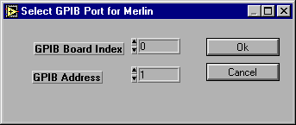

Figure 20. Detector setup communication.

Note:The above (2) entries don’t need to be repeated if you are re-running Tracq32 with the same instrument. If a different detector is used, follow this procedure:
- Click ‘OK’ in the ‘Communication Error” dialog box
- Select new instrument System Library
- Exit Tracq32 via File|Exit
- Restart Tracq32 to load the new instrument into memory

3. Detector|Setup Parameters…
Please refer to the detector manual for parameters definition. For information
on a specific instrument window operation, look in the appendix of this manual.

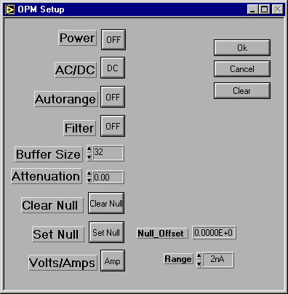

Figure 21. Detector (OPM) setup parameters dialog.

4. Detector|Calibrate…

This menu calibrates the detector readout for a specific wavelength. To
run calibrated scan use Scan|Take Detector Radiometry Scan.

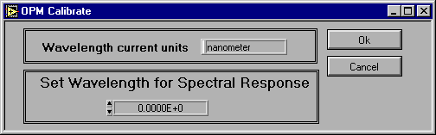

Figure 22. Detector calibration (OPM) dialog window.

Appendix

This appendix describes the Tracq32 dialog windows for the following Oriel monochromators and detectors(radiometers). It basically includes dialog windows for instruments which have different set of entries for the same menu.

- Spectral Luminator (69050).
- Cornerstone 130 1/8m (74000).
- Cornerstone 260 1/4m – CS260(74100).
- Imaging Spectrograph – MS260i (74050, 74055).
- 1/4 Monochromator and Spectrograph – MS257 (77700).
- Merlin Radiometer - single detector channel(70100,70103).
- Merlin Radiometer - dual detector channel (70104,70105).
- Multifunction Optical Power Meter – OPM 70310.
- Optical Photon Counter – 69015.

Ad1. Spectral Luminator
  - Spectral Luminator - Monochromator|Setup Parameters…

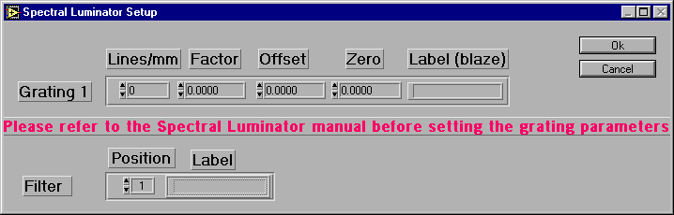

Figure 23. Parameters setup dialog window for Spectral Luminator.

The Spectral Luminator is furnished with one grating only. Enter the grating parameters according the Spectral Luminator instrument manual. To enter filter label, select the desired filter number, then proceed with writing filter label.

Ad2. Cornerstone CS130 1/8m
1. Cornerstone – Monochromator|Setup Parameters…
The Cornerstone can have up to two gratings. To set the gratings parameters and
filters label use the dialog window below.

Figure 25. Monochromator (Cornerstone) setup parameters dialog.

Ad3.Cornerstone 260 – CS260
Ad4.Imaging Spectrograph – MS260i

- … - Mochromator|Setup Parameters…
The dialog windows for both of these instruments look alike. Both instruments can use up to three gratings.

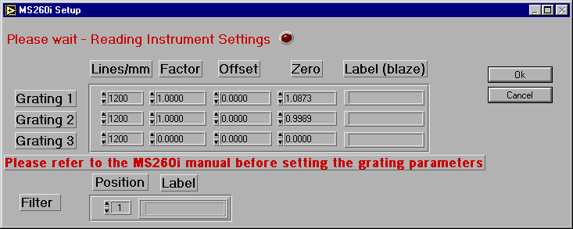

Figure 26. Setup parameters dialog window for MS260i and CS260.

Ad5. ¼ Monochromator and Spectrograph

1. Monochromator|Filter…
The MS257 can use two Motorized Filter Wheels for the same measurement. If this
is the case execute setup for both wheels separately, by calling the
Monchromator|Filter… menu twice and selecting Wheel 1 and Wheel 2.

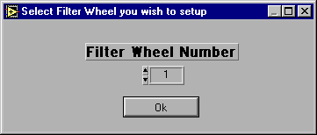

Figure 27. Filter wheel selection.

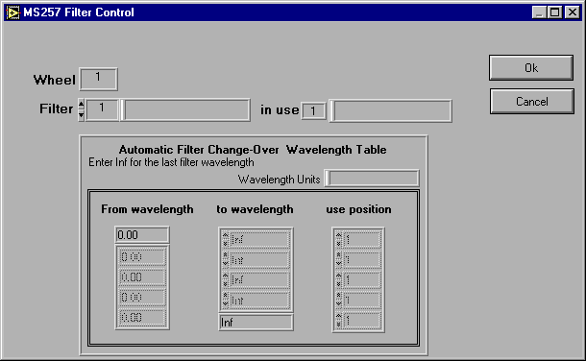

Figure 28. Filter setup dialog window for MS257.

2. MS257 – Monochromator|Setup Parameters…

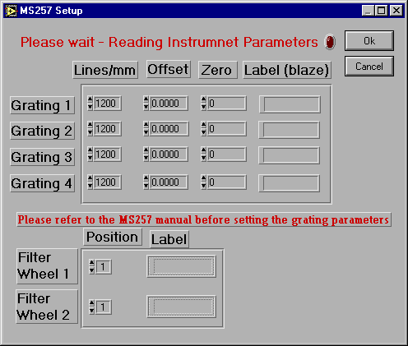

Figure 29. Setup dialog window for MS257.
The setup parameters dialog for MS257 accepts parameters for four gratings and
filter labels for two motorized filter wheels.

Ad 6. Merlin Radiometer – single detector channel.
- Merlin – Detector|Setup Parameters…
The Merlin setup parameters dialog window includes two different instrument configurations referred to as Setup1 and Setup2. For best measurement setup, please refer to the Merlin instrument manual.
The reference gain cannot be selected remotely, set reference gain from the Merlin’s front panel.
Merlin’s seamless autoranging is the optimal way to use the unit. Turn it off only if you are using the numerical display on the front panel, for signal picking.
The Reference Level Setup push button will popup window for advanced measurement settings.

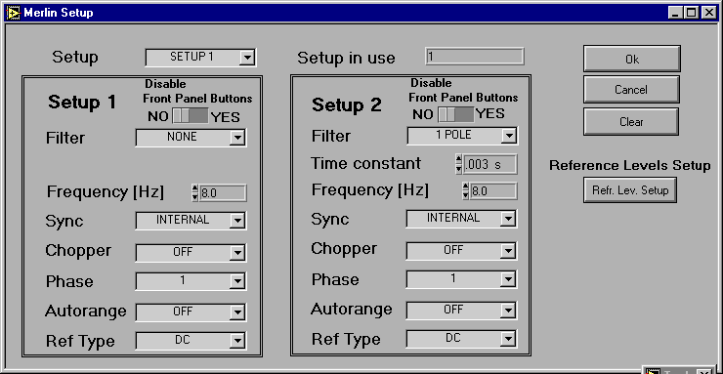

Figure 30. Setup parameters dialog window for Merlin – single detector channel.

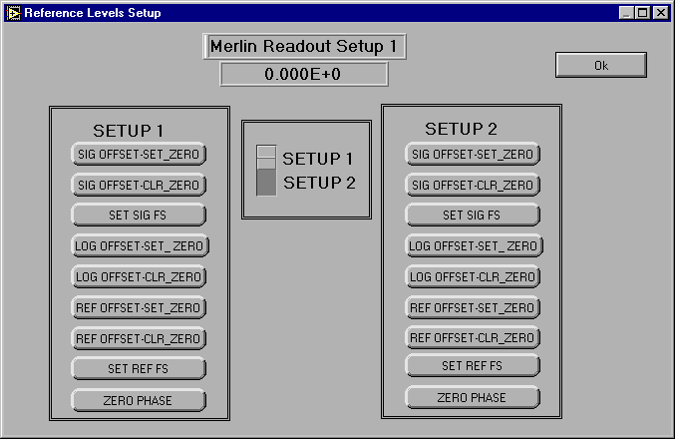

Figure 31. Reference Levels Setup dialog window for Merlin.

- Merlin – Detector|Calibrate…

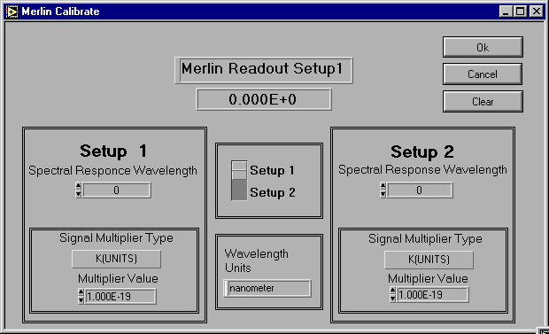

Figure 32. Detector calibration dialog window.

Wavelength specifications must range between the minimum and maximum values defined in the active wavelength table. Merlin will sound a “beep” if the setting is outside this range, indicating that the request was denied.
Specifying a wavelength of 0nm will disable the table and result in a table value of 1.oooo.
The Multiplier Value (calibration scale number) selection is enabled only when Signal Multiplier Type is set to K(UNITS).

Ad7. Merlin – dual detector channel.
- Merlin – Detector|Setup Parameters…
The setup parameters dialog window includes two different instrument configurations referred to as Channel1 and Channel2. For best measurement setup please refer to the Merlin instrument manual.
For single channel operation select either Channel1 or Channel2; for the dual channel operation use Auto mode.
When running an experiment in Auto mode enter the changeover wavelength value in the Channels Automatic Change-Over Wavelength Table.
The reference gain cannot be selected remotely, set reference gain from the instrument front panel.
Merlin’s seamless autoranging is the optimal way to use the unit. Turn it off only if you are using the numerical display on the front panel, for signal picking.
The Reference Level Setup push button will pop-up a window for advanced measurement settings.

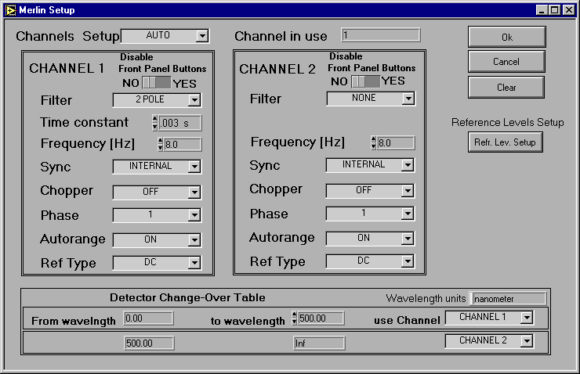

Figure 34. Setup parameters dialog window for dual channel Merlin.

Ad8. Multifunctional Optical Power Meter – OPM.
- OPM – Detector|Setup Parameters…
The following OPM setup parameters dialog box lets you configure your Oriel OPM. This user friendly environment prevents out of range settings; however, for best performance please refer to the OPM instrument manual.
When Autorange is set to OFF, the Set NULL and Clear NULL buttons are enabled; also the Range for VOLT mode or CURR mode are accessible.

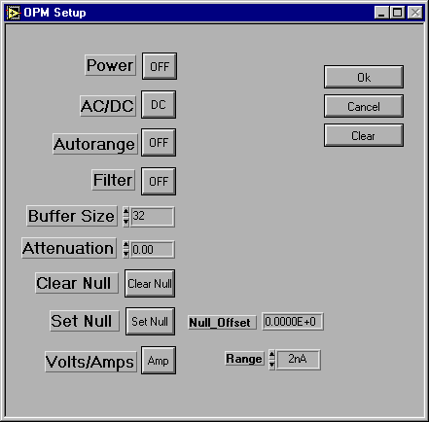

Figure 34. OPM setup parameters dialog box.

Ad9. Optical Photon Counter.
- OPhC – Detector|Setup Parameters…

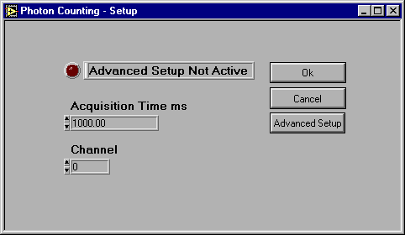

Figure 35. Optical Photon Counter setup dialog box.
The basic setup for the OPhC includes Acquisition Time (duration of each measuring period) and Channel. To activate the advanced setup select Advanced Setup. The advanced setup lets you receive corrected measurement counts with respect to the Dead Time and Dark Counts parameters.
Please refer to the OPhC instrument manual when setting up parameters.

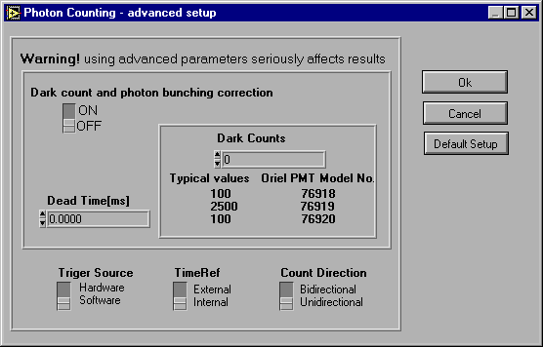

Figure 36. Advanced setup dialog box for OPhC.

