An Event Database for Rotational Seismology
Salvermoser, J., B. Chow, C. Hadziioannou, S. Hable, C.-M. Ramos Domke, J. Wassermann, U. Schreiber, A. Gebauer and H. Igel

Introduction/Motivation:
- Why rotational measurements?
- Summary of related previous studies: Igel et al. (2005 & 2007), Hadziioannou et al. (2012), …
- Intention of the project:
  - make processed data publicly available → browse waveforms and parameters by events
  - present guides and python (open access) source-code examples to download ring laser waveforms → teaching by ipython notebooks!?
  - Provide meta-data (peak-values, SNRs, ...) to public which can be processed by openly

Database:
- Currently running data of one station: Wettzell
→ short station description (not too specific!): G-Ring, Broadband seismometer
→ Aim: include waveforms from PFO, Christchurch, Gran Sasso?, FFB
- Features:
  - GCMT catalog
  - Download example code
  - Search parameters
  - Map
  - Popup-Menue
  - Event availability notes (Which events are available?)

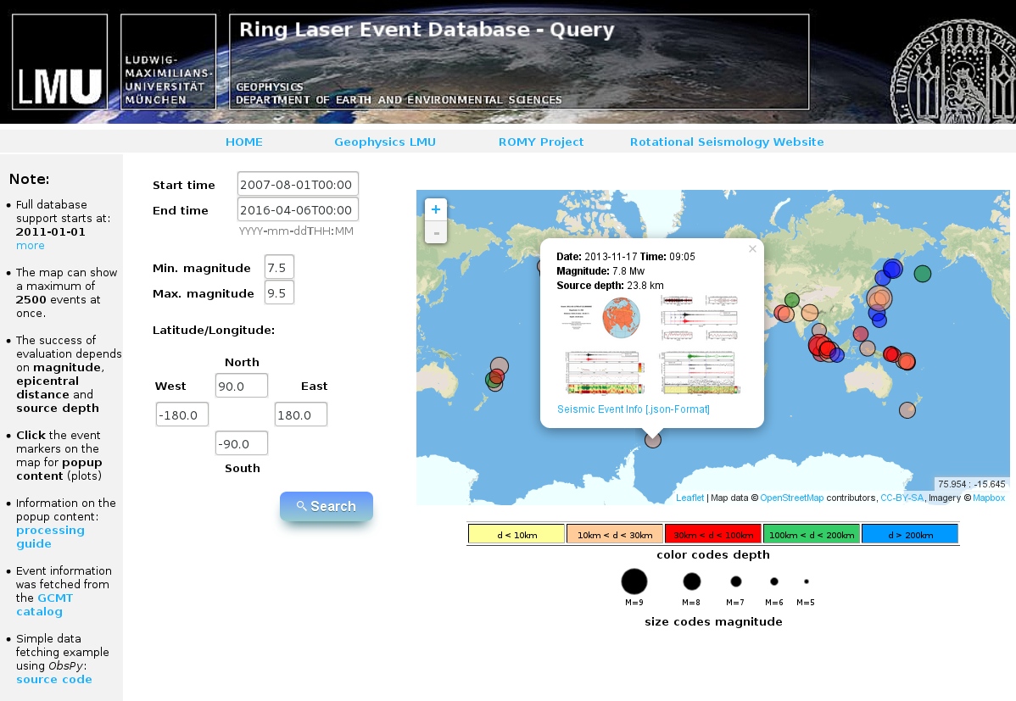
Processing (Using Obspy mainly)
- Check for new events: (daily automatic updates)
→ Checks GCMT-catalog for new events (Moment magnitude catalog): usually Mw >4.5

- Download raw Ring laser and broadband seismometer waveforms according to fetched event origin time (from event-xml)

- Preprocessing split in 3 categories according to epicentral distance:
Table 1:
 | Distance  range | Lowpass  cutoff | Resampling decimation factor | Cross-correlation  window lenght
close | 0 <= d <= 3° | 4 Hz | 2 | 3 s
local | 3° < d <= 10° | 2 Hz | 2 | 5 s
tele | d > 10° | 1 Hz | 4 | 120 s

- Remove instrument response of seismometer recordings (velocity) → [nm/s] and adjust sensitivity of ring laser to [nrad/s], deviate acceleration [nm/s²] from seismometer velocity

- Filter according to table 1

- Phase velocity and Backazimuth estimation:

  - Love wave phase velocities:
    - Rotate seismometer’s accelerations from North-East to Radial-Transverse to match the ring laser rotation rate phase. Use theoretical Baz from source receiver geometry!
    - Split the signal traces into subwindows (length according to table 1) and for each subwindow apply cross-correlation between vertical rotation rate and transverse acceleration → check the coherence of the two recorded waveforms
    - For threshold of 75% correlation between the vert. rot. rate and transv. acc. determine phase velocity for the particular time windows that pass this requirement:

using peak values of a_{t} and Ω_{z} in the time windows.
    - Ideally obtain an impression of the dispersive character of Love waves right away, by looking at the temporal evolution of the phase velocity

  - Backazimuth estimation:
    - Analogous to before: split traces into subwindows.
    - For each window estimate the direction of the rotational signal by a grid search optimization algorith:
    - The algorithm checks the correlation between horizontal acceleration and vert. rotation rate by rotating the N-E components in 1°-steps
→ the correlation ismaximum when the rotation angle is equal to best-fitting backazimuth, which is naturally the theoretical Baz
    - For the final estimated BAz value only subwindows that reach 90% max. correlation are considered. The corresponding BAz values is an average over these windows.
    - The conformity of theoretical and estimated BAz is a measure for the conformity of the two recorded measurands (rotation rate, transv. acc.) and thus for the resolution quality of the two instruments.

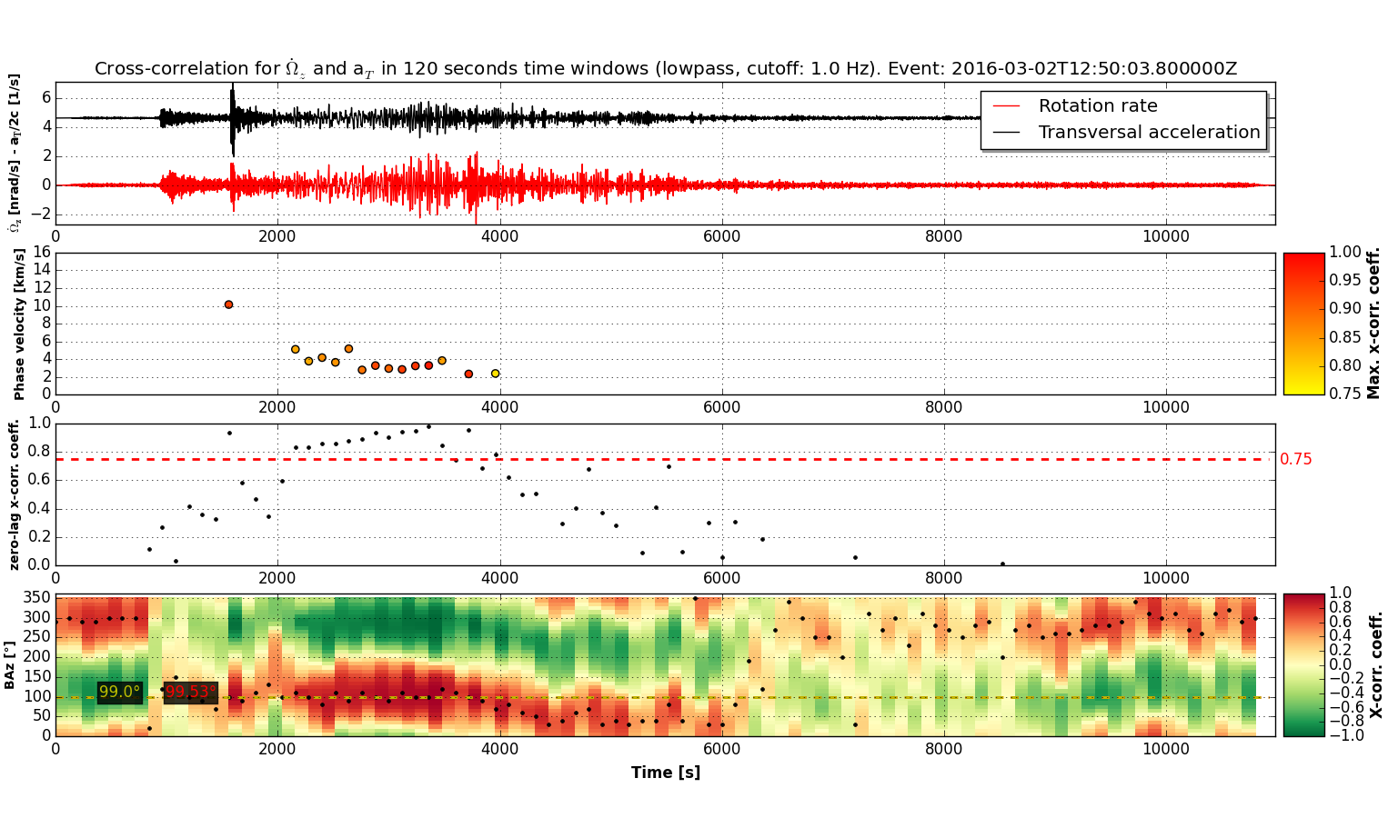
Conclusions
- Inclusion of other ring lasers (PFO, Christchurch, FFB, Gan Sasso?) in future
- Statistical evaluations:
  - Magnitude scale based on rotational ground motions (Love waves)
  - Local, one-station tomography
  - Analysis of azimuthal effects
- …

References
- Igel et al. (2005): “Rotational motions induced by …”
- Igel et al. (2007): “Broad band observations of earth …”
- Hadziioannou et al. (2012): “Examining ambient noise using co-located …”
- Schreiber et al. (2003): “New applications of very large ring lasers”
- Kurrle et al. (2010): “Can we estimate local Love wave dispersion properties ...”
- Krischer et al. (2015): “Obspy: a bridge for seismology ...”
- Megies et al. (2011): “Obspy – What can it do for data centers ...”
- …

- Title page with all authors’ names and affiliations, and complete contact information for the corresponding author.
- Abstracts required for all Regular and Eastern Section articles
- Text (Introduction, Body, Conclusion)
- Data & Resources - this section will be required for all SRL articles published in January 2016 and later; requirements are the same as for D&R in BSSA -- see D&R guidelines below.
- Acknowledgments
- References
- Tables
- Figures for information and fees, see below.
- Appendixes (optional)
- Captions for tables and figures
- Electronic Supplement (optional) - for instructions and fees, see SSA's guidelines for electronic supplements, linked at the bottom of this page.

