Protocol for the BI-VWM Semestral work
authored by Nikita Mortuzaiev (mortunik) and Roman Zhuravskyi (zhurarom)

- Task specification
As the semestral project for the BI-VWM subject at FIT CTU we decided to implement the Extended Boolean model (EBM) for information retrieval. The goal of this task is to observe differences in efficiency between the EBM and the Sequential search of boolean queries.

Application input: a boolean query.
Application output: the set of names of documents from the collection along with their relevancy according to the input query.

Boolean query is the query accepted from the user input that consists of the words to be found in the collection of documents and the boolean operators as “and”, “or” and “not”. The query can also contain brackets to handle the priority of evaluation.

The relevancy of the document for the given query is evaluated using the formulas for the Extended Boolean model described in the lecture.

- The method of solving
In brief, at the beginning of the execution the application prepares the collection of documents for further processing. It parses every document in the collection to get the lists of words. Then it filters them from the words that contain numbers, punctuation or HTML tags. That faze of preprocessing continues with the lemmatization (converting the word to its infinitive state) and the stemming (cutting out the word endings) and finishes with the creating and saving the matrix of weights of the words in the vocabulary and preparing the set of inverted lists of the terms.

Now, the application is ready to accept the input from the user. It parses the queries using the Top-Dow parser and recursively evaluates them using the matrix of weights and the set of inverted lists prepared before. For every document that has the relevance greater than zero, it displays the result on the screen.

- Implementation
The application is written in Python 3.6 and uses four third-party libraries. The NLTK 3.5 library is used in the faze of preprocessing. It provides the useful functions and classes for the spelling, lemmatization and stemming. The GUI part of the application is written with the help of Django 3 package and the styles for the website are provided by the Bootstrap 4 classes. The Numpy and Pandas libraries are also used as the packages containing useful containers for the data from the collection.

The project was developed on Ubuntu 18.04 and Endless 3.8 machines within the JetBrains PyCharm IDE. The web application was tested with the help of Chromium web browser.

The requirements for the successful execution are listed in the “requirements.txt” file and can be installed with running this code:
$ pip3 install -r requirements.txt
There are two ways of running the application. The application executed by this code:
$ python3 main.py
uses the matrix of weights already saved in the “dataset.csv” file while not creating it by running the preprocessing faze. The application executed by this:
$ python3 main.py --new
starts the preprocessing faze (parses the whole dataset, which is more than 2,000 files) and only after the saving the computed matrix starts the web server for the communication with the user.

After the web server is started, use your web browser to connect to the address “localhost:8000” or “127.0.0.1:8000”. Then the application is ready to be used.

- Experiments
The program was tested and showed the difference in time of searching the queries with the EBM and the Sequential search. The user can also experiment the the queries and the methods of searching using the web interface.
Experimentally was found that for the given dataset (that can be found in the “bbc” directory) the result depends on the number of documents the words from the query appears in.
The first output takes a lot more time to be found due to the setup of the Python cache. But the difference between these tho methods and the average searching time remain the same.

- Examples
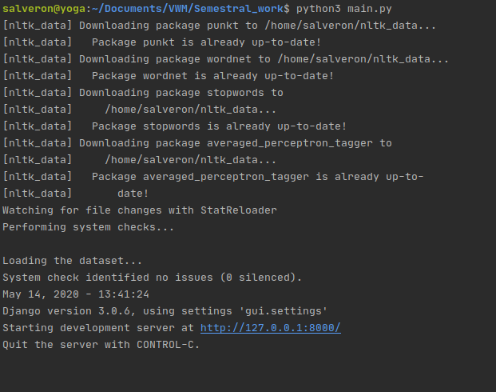
The example of executing the program that uses the prepared matrix of weights:
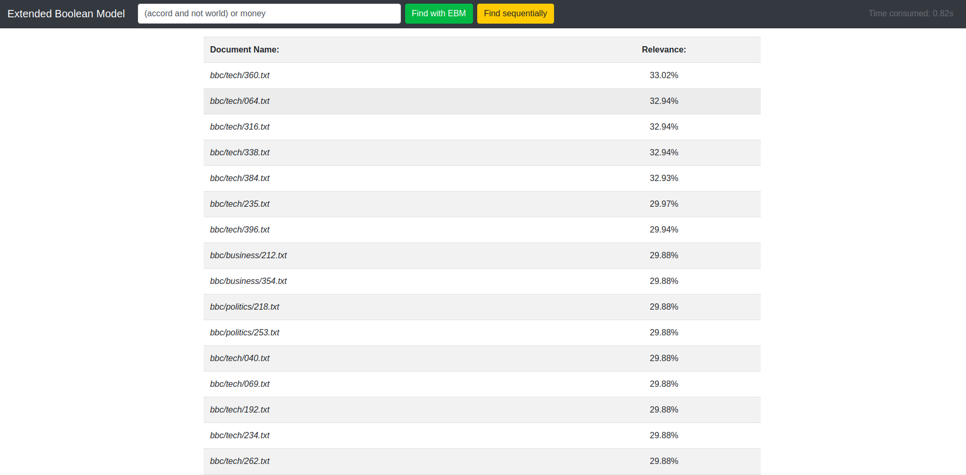
The example of finding the query “(accord and not world) or money”:
- Discussion
The project requires more time for better implementation and improvements of code. Its main disadvantage is the enormous amount of time consumed by the preprocessing of the whole dataset. Currently there are more than 2,000 files in it, and the preprocessing faze executed with the “--new” flag lasts about half an hour. The obvious improvement is to add multiple threads for the preprocessor to parse those files a lot faster.
Another good feature to be implemented is a possibility for the user to upload his own collection of files and then search it for queries. This feature, however, requires a better knowledge of Django library and more work with the web interface.
The complexity of the code and overall required execution time are also to be optimized.

- Conclusion
Again, the project requires a lot more time to be well implemented and released. However, it was a great experience to work with the Extended Boolean model and experimenting with it. EBM remains a very interesting choice as for the algorithms for information retrieval and can quickly and easily search in the large collections of files.

