Structural Diagram:

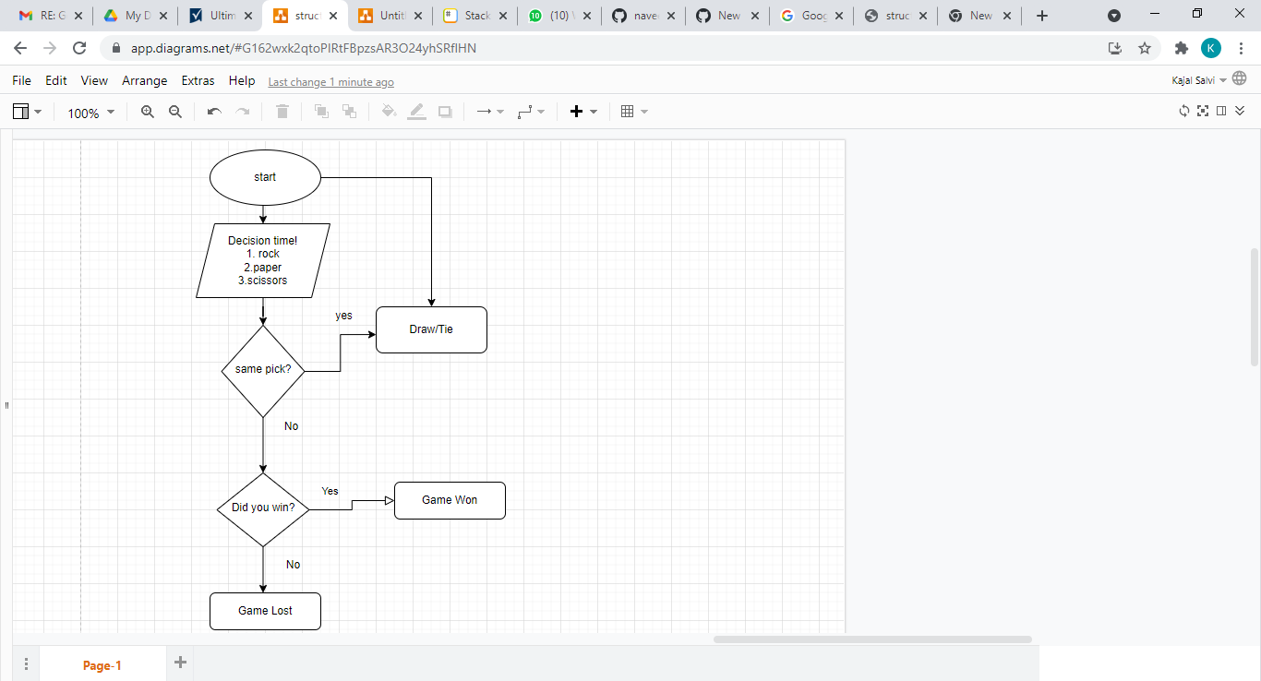

Flow chart: