**About Salvador Villalon**

I am currently a rising senior at the University of California, Irvine studying Computer Science.

This summer I was a Software Engineer Intern at JPMorgan Chase & Co. This was a great internship. I like to say that this internship gave me real challenges that happen in industry and it is up to me to learn how to overcome them.

This website will talk about my experiences here.

**The Project**

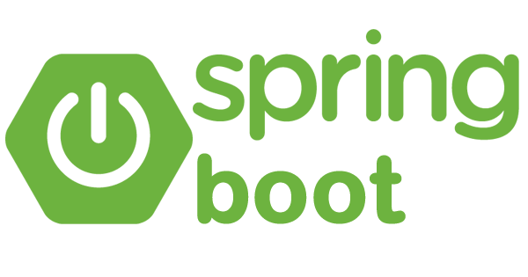 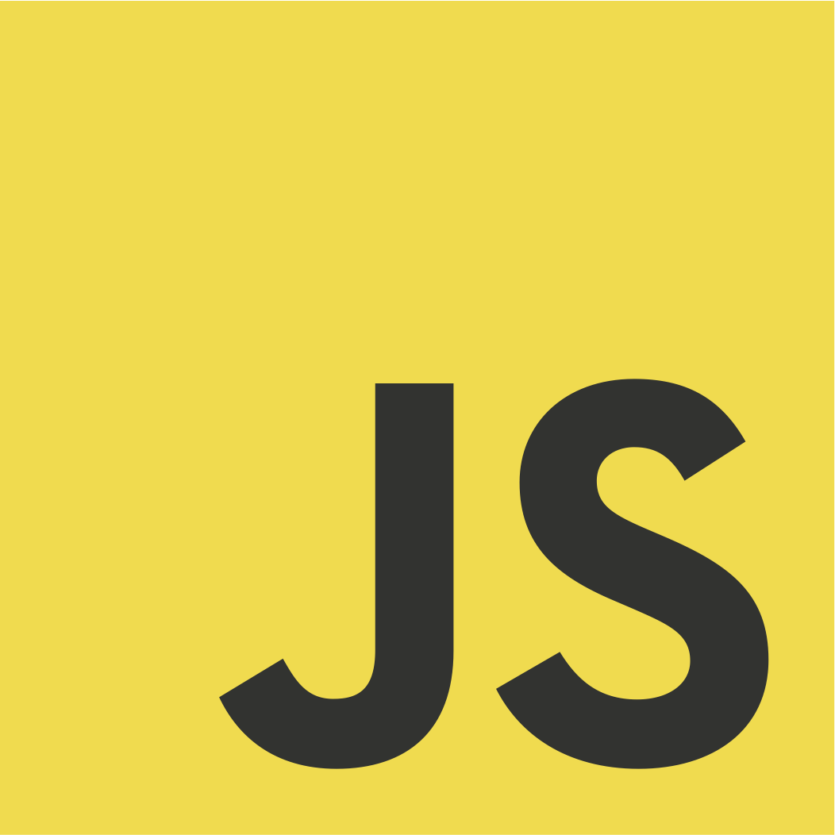 

Throughout the internship, we worked on implementing from scratch a full-stack web application using Groovy, React, and Spring Boot.

Let me give you some background on why we were working on this. Our team worked on a system that clients who are companies depend on for their transactions (so if this system was down, then the companies could not do their transactions). There was a product team that worked with my team and they worked with companies and their invoices. **Here is the interesting part.** The product team will send a file with company’s invoice information and my team had to get this file and manually copy and paste the information into a system they had.

Our task was to remove this manual task and improve it through the web application we were going to implement.

**Challenges from Project**

The team has never worked on frontend applications. They were not able to give us direct guidance on this. This meant that the team has never used frontend technologies based on the standards of the firm.

They also wanted authentication and authorization, but the team has never done this before. I had to research how JPMC implements OAuth and implemented in the application.

They also wanted this application to go to the Production Environment, but they have never deployed a frontend application in JPMC environment before.

**Lessons Learned**

**Introduction to What Happened to Me**

With the nature of this project we divided tasks throughout the intern team of 3. There were 3 parts to work on frontend, backend, and continuous integration & continuous deployment (CI/CD). I was in charge of Backend. As I previously mentioned the team has never done frontend or deployment of a frontend application. There expertise is on backend. So, throughout the internship, all of the attention was giving to the other interns and their part of the project. This attention was given since the other interns would encounter problems that they could not fix so attention was given to help fix these issues. This team’s expertise was on backend so they had more code examples for me to reference and see how I can apply it to my backend.

I noticed how they were mostly checking to see how the others were doing, but they would not check on me. In my thoughts I said, “it is okay I do not mind it”, but in reality, I kind of did. Also, I had no experience using React and JavaScript, so it made me feel even more useless and not important. Little by little it made me feel less and less happy about the internship.

All of this contributed to me being quiet throughout the internship. I remember we would have intern meetings and they would talk on sections of the project that I was not aware of, so I felt I was not able to help as much…

You could say “But Sal you should have spoken up and said something” and I did. I told them that I felt I was not understanding what was going and I told them to explain it so that I was up to date, but this was not enough. Due to my lack of understanding and how I felt, I grew even more quiet.

As the weeks went by, I knew there was something wrong as I was not feeling my best, but I could not figure out why. It was until the last day of the internship where I had a conversation with a teammate, and she helped me figure out why I was feeling like this. The feeling was that I felt I was not contributing. I felt that my part was not important. I felt like this because no one was checking on me. I felt I was just by myself.

People can say “But Sal you should have spoken up about it earlier in your internship.” You are definitely right; I will talk about that in the next section: A Deeper Analysis of What Happened to Me

**A Deeper Analysis of What Happened to Me**

The lesson learned was that I should have spoken up earlier. I should have spoken up about how I felt to my manager or someone else on the team. I need to speak up since no one will know how I felt.

I felt that I did not speak up, because

* I knew that there was something wrong, but I said to myself “maybe the other interns will notice how I feel and do something about it”
* I knew there was something wrong and I let time do the work of fixing my problems. For example, someone asked me how the internship was going, and I told her that “it will get better.” This statement said that I was going to let time fix what is going wrong and that I was not going to act upon it
* Also, I did not speak up because I did not know what was wrong with me so I could not describe it.

Obviously, it was bad that I finally figured out what was wrong with me at the last day of the internship, but honestly it is okay. All of this was a learning experience.

**What Did I learn from this and How am I going to Approach It Next Time**

Next time when I start feeling and identifying that I am not feeling happy or comfortable, I will remember to the following:

* I need to seek someone to speak about it. It does not always have to be your manager. It can be someone outside your team.
* Do not let time fix your problems. You have to act upon it and take the initiative. If you are not trying, then no one is going to help you.
* Speak up. Nobody is going to know how you feel if you do not speak up about it, all you will do is bottle up your feelings and not feel happy.
* If you are going to speak up about your feelings, remember to back it up with facts. For example: “I feel excluded from the meeting because ….”
* There will always be something that you don’t know but remember that it will take time to learn it. You won’t be able to learn everything in 10 weeks so don’t beat yourself over it if you don’t learn everything.

Most important of all:

* I was learning, it is not always going to be perfect. Nothing is going to be perfect. There will be many challenges and it is up to us to learn how to react towards it.

**What Did I learn About Myself?**

This internship thought me more about myself and the person that I am.

I learned that:

* I like that a manager or teammate comes in and checks in on how I am doing in my work. This gives me a chance to show what I am working on and ask questions if I am stuck on something
* I feel at times I want to learn a lot which is good! But sometimes I have to calm down because if not I feel like I am behind on my learning (I sometimes feel that I need to catch up with all the technologies since there are other students that already know this. This stresses me out.
* Sometimes I feel that when I am given a problem. It is my responsibility to solve it and only mine. This is not true. I have a team to work with. It is not just me who is working on it.
* I learned that I really enjoy doing this type of trips where I go to a place I never been before and stay for months working. But this will be different when I start looking for entry level positions since I will be working there for more than 10 weeks. I feel that I want something closer to home.

**Conclusion**

Honestly it sucked that everything became clear at the last day of the internship, but it is okay. An internship is a learning experience. All of this was a learning experience now I have a better understanding of what it is like working as Software Engineer, what it is like working at a firm, and I got to meet a lot of people. I also got to work with technologies that I never worked before! Overall, I am still grateful for the opportunity of working at JPMC, it taught me a lot of myself and working as a Software Engineer.

If you have any questions, feel free to contact me.

Thank you for reading this and keep up the good work.

**Pictures**

Here are some pictures of my adventures in Chicago! (This was my first time in Chicago)