Question 1.a

Total number of parameters: 7682826

Validation accuracy is: 81.2 %

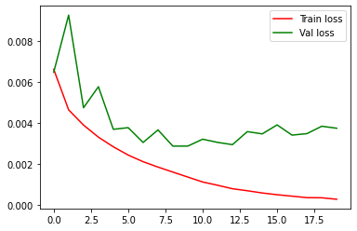

Accuracy of the network on the 1000 test images: 79.8 %

Question 1.b

Total number of parameters: 7682826

Question 1.c

Before .

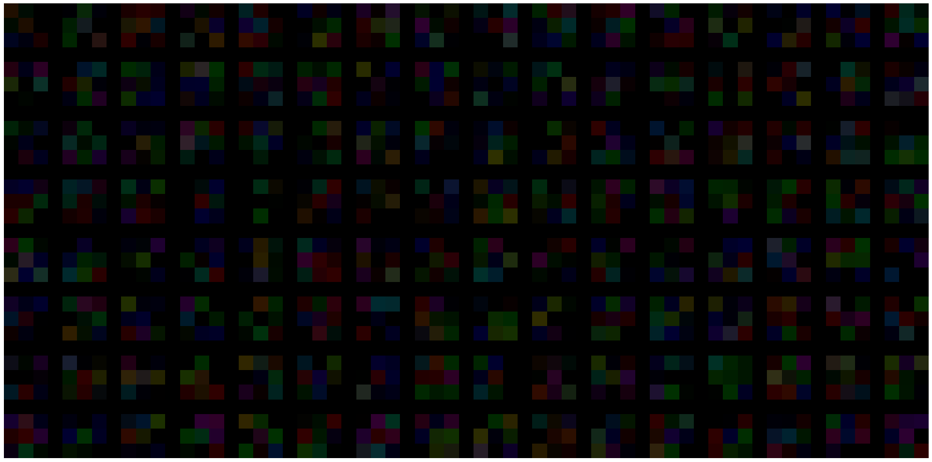

After

**Question 2.a**

In the following graph we find the accuracy and loss curves of our convolutional neural net with batch normalization and 20 epochs. The final training accuracy was 97.95% and the final validation accuracy was 81.00%.

Comparing the loss curves of 1a) sees many similarities, but comparing the accuracy curves, we see that the validation accuracy is less jagged and rises much faster in the beginning compared to the graph without batch normalization.

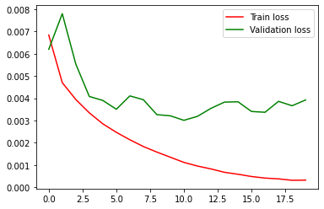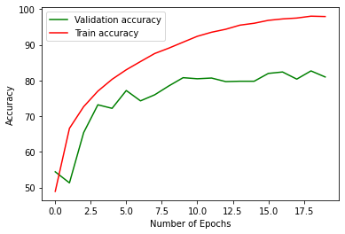

**Question 2.b**

We used early stopping to save the model with the highest validation accuracy, instead of using the last model made in the last epoch. In these graphs you can see the same data for the batch normalization with 50 epochs.

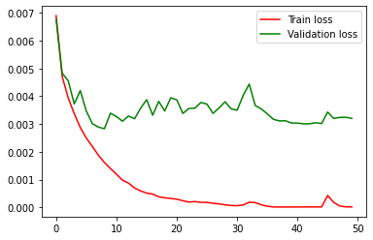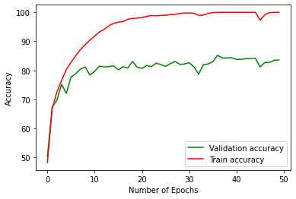

The accuracy on the test images was 83.7% on 50 epochs with early stopping which is above the last validation accuracy of the data (which is not the most ideal weights) of 83.6%.

The reported validation accuracy for early stopping with 50 epochs but without batch normalization was 79.7% and a training accuracy of 99.9%. The total accuracy on the test images was 80.5%. We see that here the early stopping also found a better model than the last one generated in the last epoch. However, since we did not normalize the batches, the rate is somewhat lower, but still higher than in 1.a, which can both be attributed to the number of epochs as well as the early stopping.

Question 3:

3.1.Data augmentation is known for preventing overfitting and make the model more general by creating more training data.

We used different techniques like Geometric Transformation and Color Transform. And the best validation accuracy lead by Random Horizontal Flip(p=0.5).

1. **Geometric transformation**

|  |  |
| --- | --- |
| **Augmentation technique** | **Validation Accuracy** |
| ﻿RandomAffine(translate=(0.1,0.3)) | 80.6 % |
| ﻿RandomRotation(degrees=(-45,45) | 73.5 % |
| ﻿RandomAffine(scale=(0.5, 0.75) | 74.1 % |
| RandomCrop(size=(32,32)) | 76.8 % |
| **transforms.RandomHorizontalFlip(p=0.5)** | **82.6 %** |

1. **Color Transformation:**

|  |  |
| --- | --- |
| **Augmentation technique** | **Validation Accuracy** |
| RandomGrayscale | 74.5 % |
| ColorJitter (﻿brightness=0, contrast=0, saturation=0, hue=0.5) | 69.9% |

**3.2.Dropout:**

Dropout is another approach to prevent over fitting and improve model generalization**.**

Here we experimented with different dropout values ranging from (0.1 to 0.9) And the best validation accuracy lead by Dropout(p=0.3).

|  |  |
| --- | --- |
| **Dropout value** | **Validation Accuracy** |
| 0.1 | 82.3 % |
| 0.2 | 80.1 % |
| **0.3** | **82.5 %** |
| 0.4 | 79.3 % |
| 0.5 | 75.4 % |
| 0.6 | 65.7 % |
| 0.7 | 58.4 % |
| 0.8 | 42.7 % |
| 0.9 | 10.2 % |

Dropout(p=0.1)

Dropout(p=0.2)

Dropout(p=0.3)

Dropout(p=0.4)

Dropout(p=0.5)

Dropout(p=0.6)

Dropout(p=0.7)

Dropout(p=0.8)

Dropout(p=0.9)