LAPORAN PENGERJAAN UJI KOMPETENSI KEJURUAN SMK MAHARDHIKA BATUJAJAR

TAHUN PELAJARAN 2022-2023

KOMPETENSI KEAHLIAN : Rekayasa Perangkat Lunak KELAS :XII RPL 1

NAMA LENGKAP :Salwa Kalista Dewi

NIS :0063689182

PAKET SOAL :3 (Tiga)

JENIS APLIKASI : Web Galerry Fhoto

ALOKASI WAKTU : 24 jam

# PENJADWALAN KEGIATAN

Silahkan buat form penjadwalan dengan excel seperti yang pernah dicontohkan

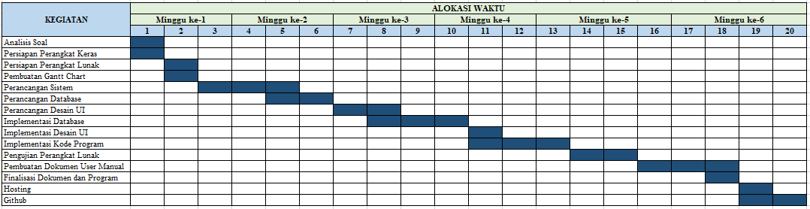

# PERSIAPAN PERANGKAT KERAS

Silahkan isikan deskripsi/spesifikasi dari komputer/laptop yang kamu gunakan

|  |
| --- |
| Device name DESKTOP-7LLKFN8  Processor Intel(R) Core(TM) i3-10105F CPU @ 3.70GHz 3.70 GHz  Installed RAM 8,00 GB  Device ID 1F4726BD-D888-4288-907B-439CB779D116  Product ID 00330-80000-00000-AA809  System type 64-bit operating system, x64-based processor  Pen and touch No pen or touch input is available for this display |
| Edition Windows 10 Pro  Version 22H2  Installed on ‎29/‎08/‎2023  OS build 19045.3930  Experience Windows Feature Experience Pack 120.2212.3920.0 |

# PERSIAPAN PERANGKAT LUNAK

Silahkan isikan perangkat lunak yang terlibat dalam pembuatan project ini

-Visual Studio Code

-XAMPP

-Chrome

- Microsoft Excel

- Microsoft Word

-Balsamiq

-Astah Pro

# PERANCANGAN ALGORITMA APLIKASI

Silahkan gambarkan activity diagram aplikasi yang kamu buat

**Register**

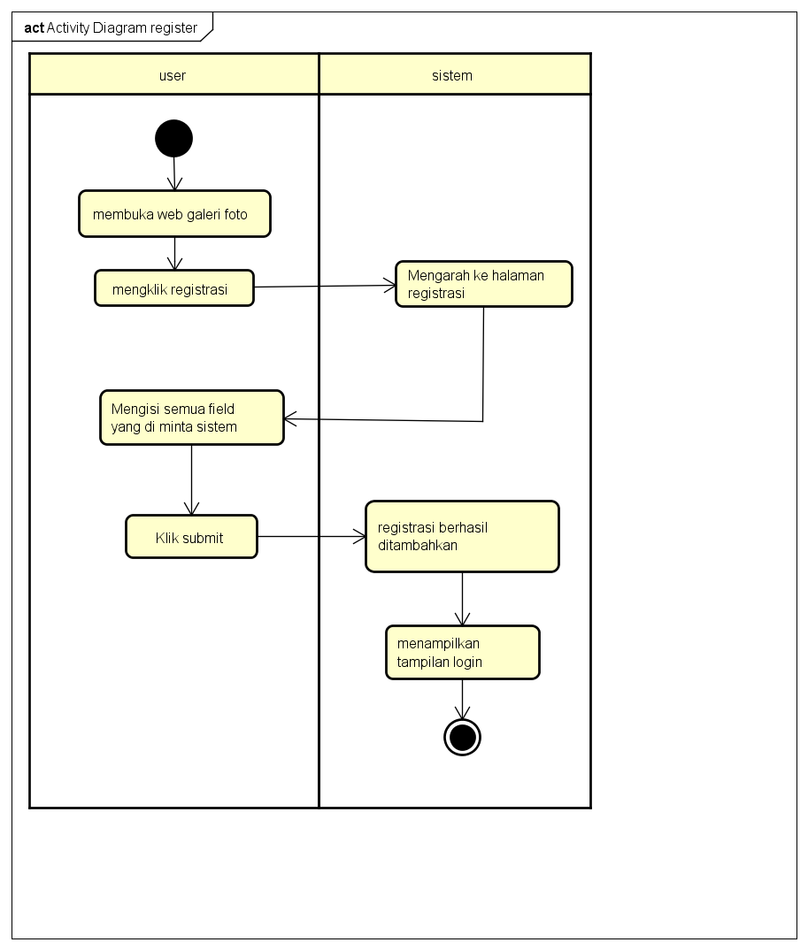

**Login**

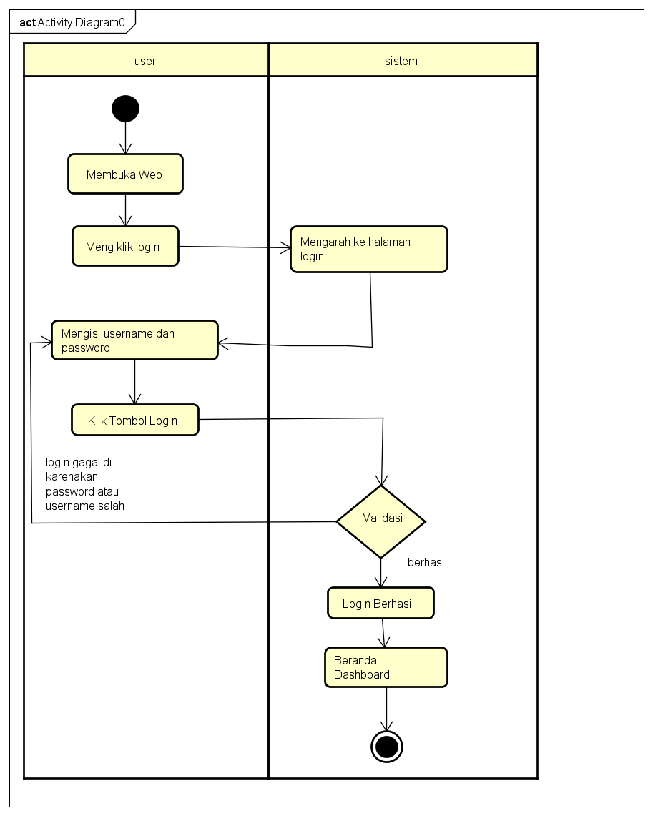

**Tambah Data Foto**

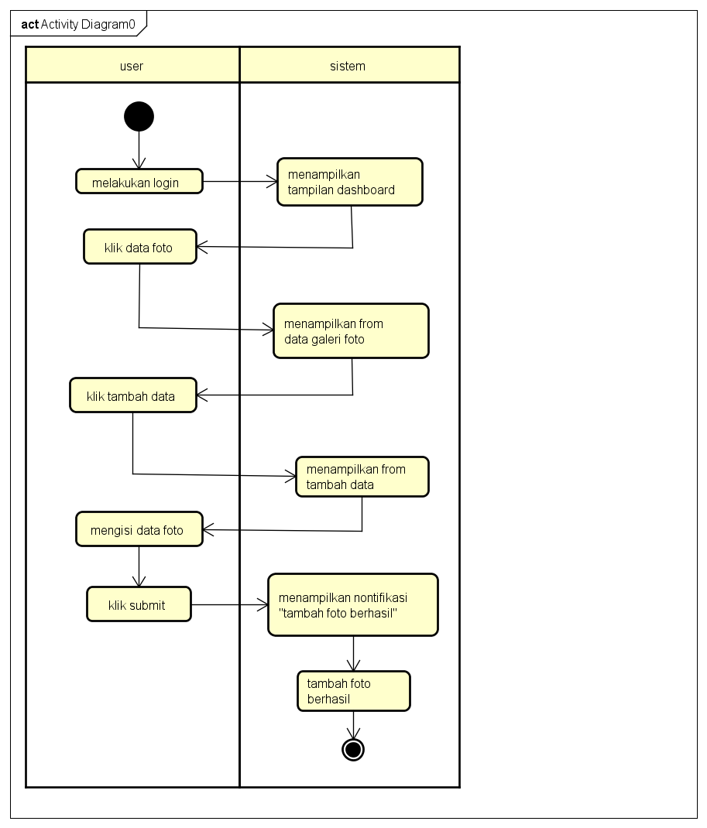

**Hapus Foto**

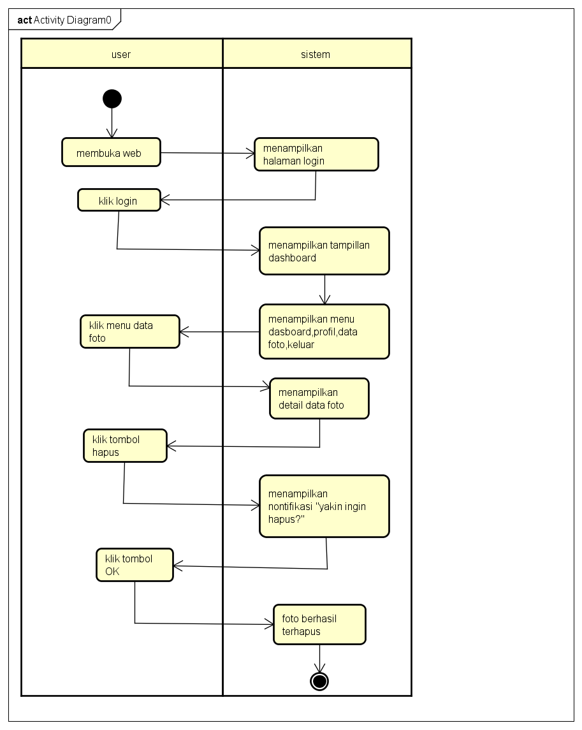

**Edit Foto**

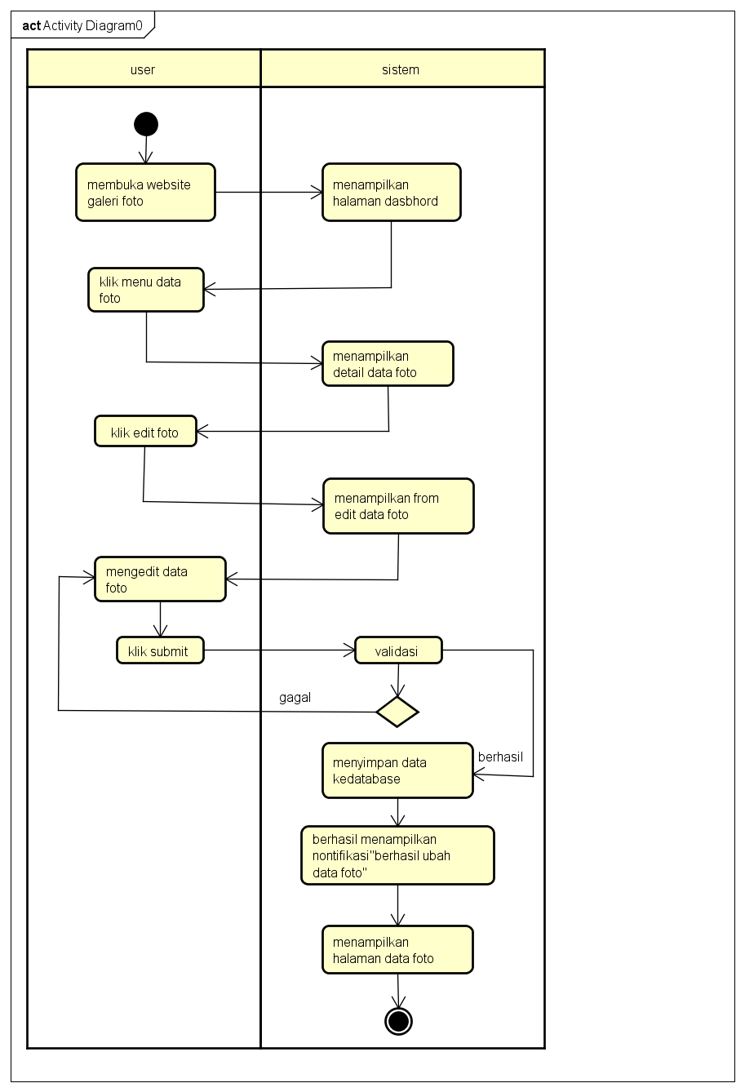

**Lihat Foto**

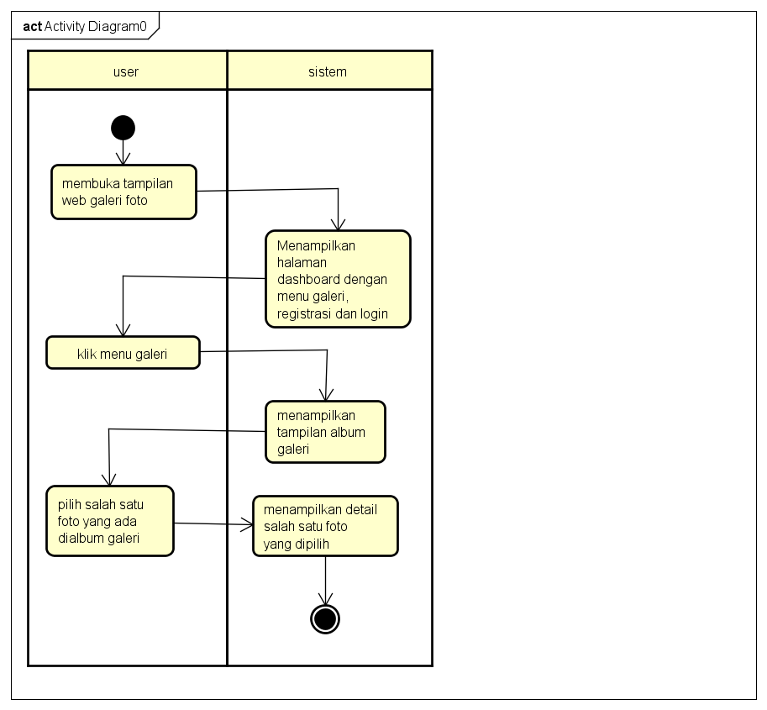

# PERANCANGAN DESAIN BASIS DATA

Silahkan gambarkan ERD/DFD/class diagram atau desain basis data pada phpMyAdmin beserta relasinya

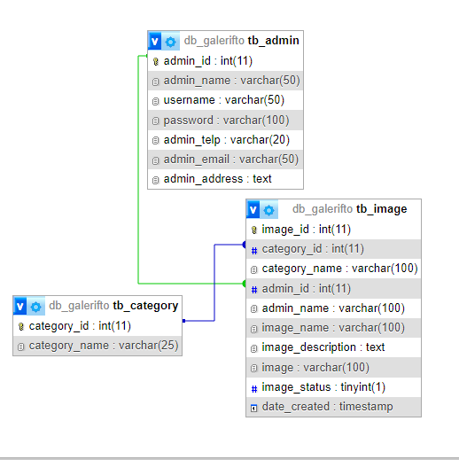

**ERD**

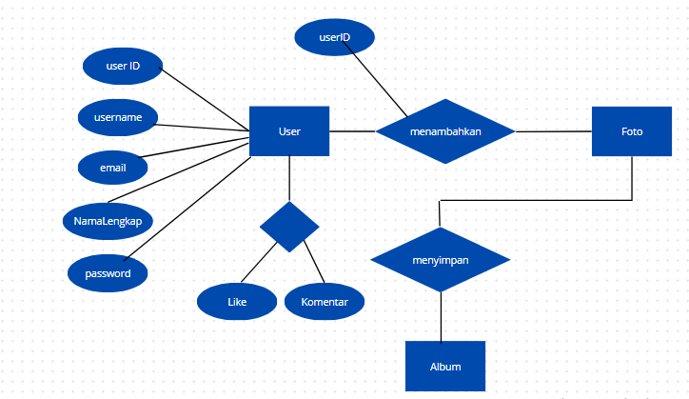

**CLAS DIAGRAM**

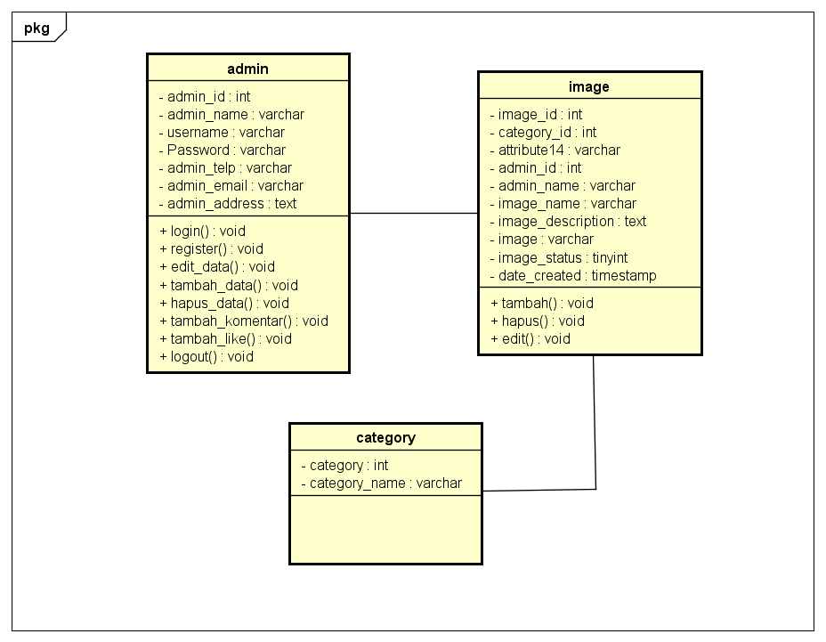

# DUMMY DATA

Buat data dummy/bohongan yang dipersiapkan untuk nanti dimasukkan

**tb_admin**

|  |  |  |  |  |  |  |
| --- | --- | --- | --- | --- | --- | --- |
| Admin_ID | Admin_Name | Username | Password | Admin_telp | Admin_email | Admin_address |
| 1 | irwan | irwan | adminirwan | 085774137284 | irwan@gmail.com | Jl.Raya Kadu Seungit |
| 2 | diana | diana | 1234 | 085788992919 | [diana@gmail.com](mailto:diana@gmail.com) | Suka Seneng Cikeusik |
| 3 | hazwan | hajwan | 123 | 085787778811 | hazwan@gmail.com | Cukeusik Pandeglang |
| 4 | salwa | jeje | salwacantik | 0897654321 | Salwakalista_40@gmail.com | Batujajar |

**Tb_category**

|  |  |
| --- | --- |
| Category_id | Category_Name |
| 16 | Hewan peliharaan |
| 18 | Fashion |
| 21 | Tumbuhan |
| 22 | Dokumenter |
| 23 | Arsitektur |

**Tb_Image**

|  |  |  |  |  |  |  |  |  |  |
| --- | --- | --- | --- | --- | --- | --- | --- | --- | --- |
| Image_id | Category_id | Category_name | Admin_id | Admin_name | Image_name | Image_dscription | image | Image_status | Date_created |
| 61 | 22 | dokumenter | 5 | salwa | cute | kurupuk | Foto1705973240.gif | 1 | 2024-01-23  08:27:20 |
| 62 | 22 | dokumenter | 5 | salwa | dino | dinobuncit | Foto1706497797.jpg | 1 | 2024-01-29  10:09:57 |
| 63 | 16 | Hewan peliharaan | 5 | salwa | yaya | dinosooo | Foto1707813668.jpg | 1 | 2024-02-19  15:5644 |

## PEMBUATAN BASIS DATA (MySQL Code)

Silahkan buat basis data di PHPMyAdmin, jika sudah selesai bisa di copykan filenya di sini sebagai lampiran (*screenshot struktur tabel pada basis data yg dibuat)

**Tb_admin**

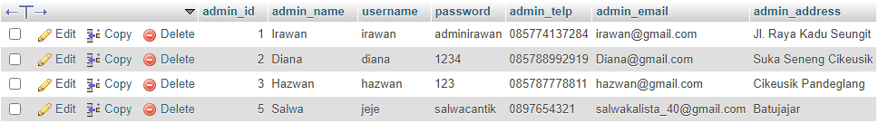

**Tb_category**

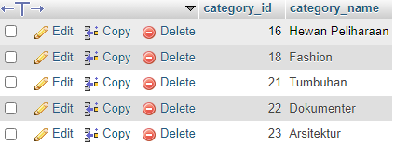

**Tb_Image**

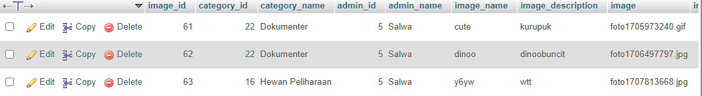

# PERANCANGAN TAMPILAN ANTARMUKA (UI) WEB

1. Use case

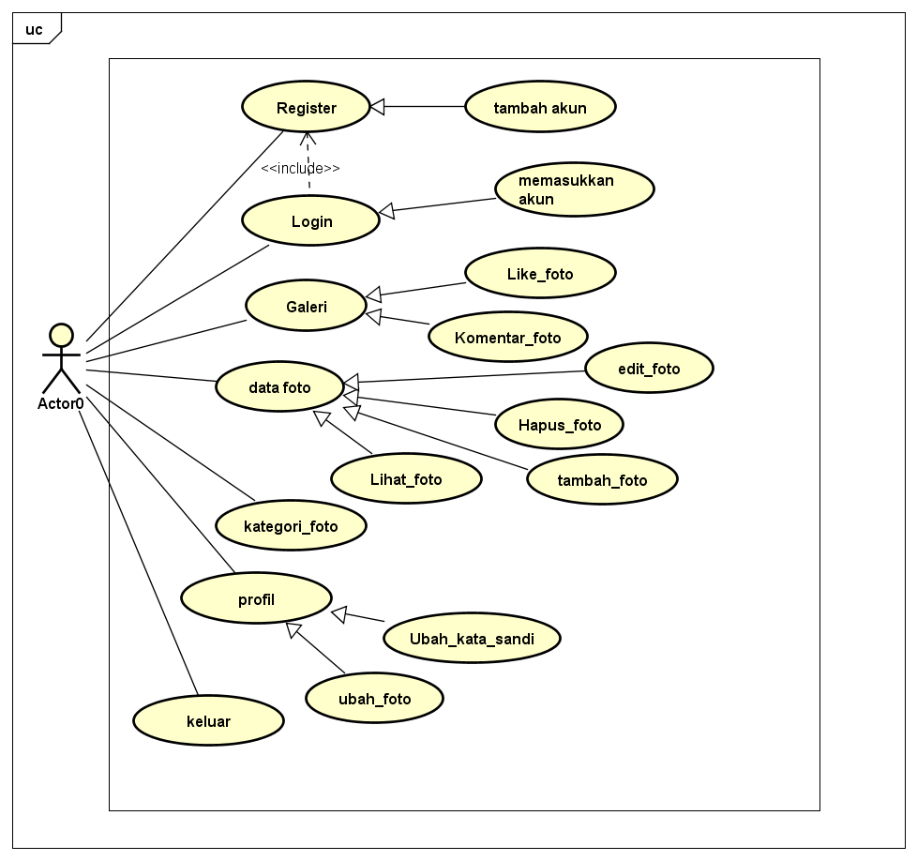

Skanario Use Case

Nama : Login

ID :UC01

Deskripsi : User mengakses Login

Aktor :User

**Skenario Use Case**

|  |  |
| --- | --- |
| Aksi Aktor | Reaksi Sistem |
| 1. Membuka web dengan menggunakan domain localhost/galeri foto/index.php |  |
|  | 1. Menampilkan tampilan login |
| 1. Menambahkan username dan password dengan benar |  |
| 1. Klik tombol login |  |
|  | 1. Berhasil login |
|  | 1. Menampilkan halaman dashboard |
| Skenario Alternatif |  |
|  |  |

Skanario Use Case

Nama : Login

ID :UC02

Deskripsi : User menambahkan foto

Aktor :User

**Skenario Utama**

|  |  |
| --- | --- |
| Aksi Aktor | Reaksi Sistem |
| 1. Melakukan login |  |
|  | 1. Menampilkan halaman dashboard dengan menu data foto |
| 1. Klik menu data foto |  |
|  | 1. Menampilkan detail foto |
| 1. Klik tambah foto |  |
|  | 1. Menampilkan from tambah foto |
| 1. Mengisi data foto |  |
| 1. Klik submit |  |
|  | 1. Behasilmenampikan nontifikasi “tambah foto berhasil” |
| Skenario Alternatif |  |

Skanario Use Case

Nama : Login

ID :UC03

Deskripsi : User edit foto

Aktor :User

**Skenario Utama**

|  |  |
| --- | --- |
| Aksi Aktor | Reaksi Sistem |
| 1. Melakukan login |  |
|  | 1. Menampilkan halaman dashboard dengan menu data foto |
| 1. Klik menu data foto |  |
|  | 1. Menampilkan detail foto |
| 1. Klik edit foto |  |
|  | 1. Menampilkan from edit foto |
| 1. Mengisi edit foto |  |
| 1. Klik submit |  |
|  | 1. Behasilmenampikan nontifikasi “berhasil ubah data foto” |
| Skenario Alternatif |  |

Skanario Use Case

Nama : Login

ID :UC04

Deskripsi : User menghapus foto

Aktor :User

**Skenario Utama**

|  |  |
| --- | --- |
| Aksi Aktor | Reaksi Sistem |
| 1. Melakukan login |  |
|  | 1. Menampilkan halaman dashboard dengan menu data foto |
| 1. Klik menu data foto |  |
|  | 1. Menampilkan detail foto |
| 1. Klik tombol hapus |  |
|  | 1. Menampilkan nontifikasi”yakin Ingin hapus?” |
| 1. Klik Tombol OK |  |
|  | 1. Foto berhasil terhapus |
| Skenario Alternatif |  |

Skanario Use Case

Nama : Login

ID :UC05

Deskripsi : User melihat foto

Aktor :User

**Skenario Utama**

|  |  |
| --- | --- |
| Aksi Aktor | Reaksi Sistem |
| 1. Membuka web galeri foto |  |
|  | 1. Menampilkan halaman dashboard dengan menu galeri,registrasi,login |
| 1. Klik menu galeri |  |
|  | 1. Menampilkan detail album foto |
| 1. Pilih salah satu foto yang ada di album galeri |  |
|  | 1. Menampilkan detail foto yang sudah dipilih |
| Skenario Alternatif |  |

2.From Register

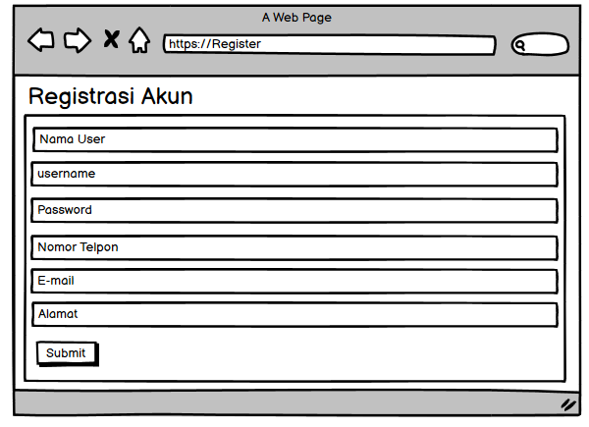

3.Tampilan Login

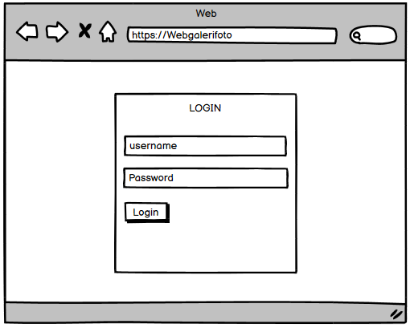

1. Admin dashboard

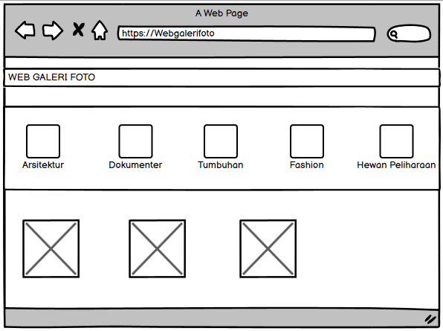

1. Tampilan tambah foto

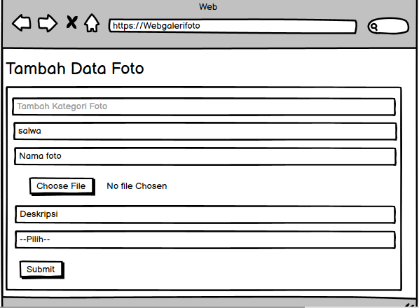

1. Tampilan edit foto

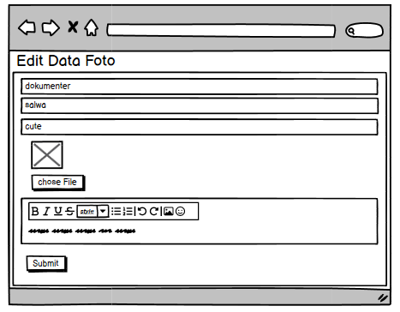

7.Tampilan Hapus Foto

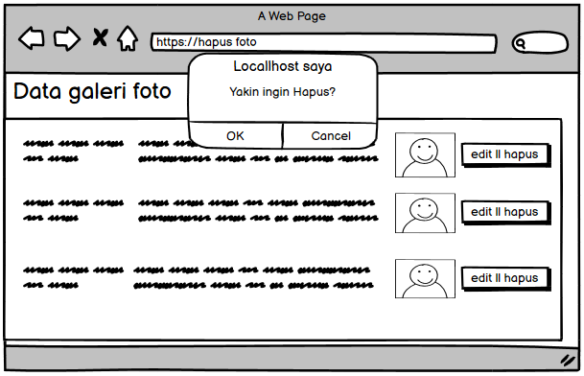

8.Tampilan komentar dan like Foto

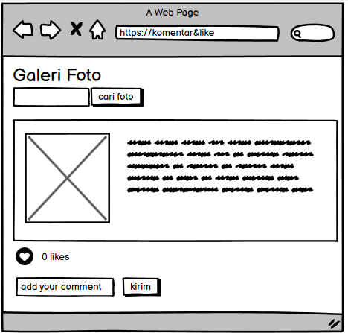

1. *Silahkan gambarkan use case diagram aplikasi yang kamu buat*
2. Admin dashboard

Tampilan untuk full manage semua data, buatkan sketsa/mockup-nya

1. Tampilan Kasir

Setiap menu buatkan sketsa/mockup-nya

1. Tampilan owner

Setiap menu buatkan sketsa/mockup-nya

# PEMBUATAN STRUKTUR WEB (HTML)

|  |
| --- |
| <!DOCTYPE html PUBLIC "-//W3C//DTD XHTML 1.0 Transitional//EN" "http://www.w3.org/TR/xhtml1/DTD/xhtml1-transitional.dtd">  <html xmlns="http://www.w3.org/1999/xhtml">  <head>  <meta charset="utf-8">  <meta name="viewport" content="width=device-width, initial-scale=1">  <title>WEB Galeri Foto</title>  <link rel="stylesheet" type="text/css" href="style.css">  </head>  <body>  <!-- header -->  <header>  <div class="container">  <h1><a href="dashboard.php">WEB GALERI FOTO</a></h1>  <ul>  <li><a href="dashboard.php">Dashboard</a></li>  <li><a href="profil.php">Profil</a></li>  <li><a href="data-image.php">Data Foto</a></li>  <li><a href="Keluar.php">Keluar</a></li>  </ul>  </div>  </header>    <!-- content -->  <div class="section">  <div class="container">  <h3>Dashboard</h3>  <div class="box">  <h4>Selamat Datang <?php echo $_SESSION['a_global']->admin_name ?> di Website Galeri Foto</h4>  </div>  </div>  </div>  <!-- category -->  <div class="section">  <div class="container">  <h3>Kategori</h3>  <div class="box">  <?php  include 'db.php';  $kategori = mysqli_query($db, "SELECT * FROM tb_category ORDER BY category_id DESC");  if(mysqli_num_rows($kategori) > 0){  while($k = mysqli_fetch_array($kategori)){  ?>  <a href="galeri.php?kat=<?php echo $k['category_id'] ?>">  <div class="col-5">  <img src="img/gogo.png" width="50px" style="margin-bottom:5px;" />  <p><?php echo $k['category_name'] ?></p>  </div>  </a>  <?php }}else{ ?>  <p>Kategori tidak ada</p>  <?php } ?>  </div>  </div>  </div>    <!-- new product -->  <div class="container">  <h3>Foto Terbaru</h3>  <div class="box">  <?php  $foto = mysqli_query($db, "SELECT * FROM tb_image WHERE image_status = 1 ORDER BY image_id DESC LIMIT 8");  if(mysqli_num_rows($foto) > 0){  while($p = mysqli_fetch_array($foto)){  ?>  <a href="detail-image.php?id=<?php echo $p['image_id'] ?>">  <div class="col-4">  <img src="foto/<?php echo $p['image'] ?>" height="150px" />  <p class="nama"><?php echo substr($p['image_name'], 0, 30) ?></p>  <p class="admin">Nama User : <?php echo $p['admin_name'] ?></p>  <p class="nama"><?php echo $p['date_created'] ?></p>  </div>  </a>  <?php }}else{ ?>  <p>Foto tidak ada</p>  <?php } ?>  </div>  </div>    <!-- footer -->  <footer>  <div class="container">  <small>By: Salwaclsta</small>  </div>  </footer>  </body>  </html> |

1. PEMBUATAN STYLE WEB (CSS)

File style.css

|  |
| --- |
| @charset "utf-8";  /* CSS Document */  * {  padding:0;  margin:0;  font-family:'Quicksand', sans-serif;  }  body {  background-color:#f8f8f8;  }  a {  color: inherit;  text-decoration:none;  }  #bg-login {  display: flex;  height: 100vh;  justify-content: center;  align-items: center;  }  .box-login {  width: 300px;  min-height: 200px;  border:1px solid #ccc;  background-color: #fff;  padding:15px;  box-sizing:border-box;  }  .box-login h2 {  text-align:center;  margin-bottom:15px;  }  .input-control {  width:100%;  padding:10px;  margin-bottom:15px;  box-sizing:border-box;  }  .btn {  padding:8px 15px;  background-color: #0088c7;  color: #fff;  border:none;  cursor: pointer;  }  header {  background-color: #006dc7;  color: #fff;  }  header h1 {  float:left;  padding:10px 0;  }  header ul {  float:right;  }  header ul li {  display:inline-block;  }  header ul li a {  padding:20px 0 20px 15px;  display: inline-block;  }  footer {  padding:25px 0;  }  .container {  width: 80%;  margin: 0 auto;  }  .container:after {  content:'';  display: block;  clear:both;  }  .section {  padding:25px 0;  }  .box {  background-color: #fff;  border:1px solid #ccc;  padding:15px;  box-sizing: border-box;  margin:10px 0 25px 0;  }  .box:after {  content: '';  display: block;  clear: both;  }  .table {  width: 100%;  border-collapse: collapse;  }  .table tr {  height: 30px;  }  .table tr td {  padding:5px 10px;  }  .search {  padding:15px 0;  background-color: #fff;  border:1px solid #ccc;  text-align: left;  }  .search input[type=text] {  width: 20%;  padding:5px;  }  .search input[type=submit] {  padding:10px 12px;  background-color: #007ec7;  color: #fff;  border:none;  cursor:pointer;  }  .col-5 {  width:20%;  height:100px;  text-align: center;  float: left;  padding:10px;  box-sizing: border-box;  }  .col-4 {  width:25%;  height: 230px;  border:1px solid #ccc;  float: left;  padding:10px;  box-sizing: border-box;  margin-bottom: 10px;  }  .col-4:hover {  box-shadow: 0 0 3px #999;  }  .col-4 img {  width: 100%;  }  .col-4 .nama {  font-weight: bold;  color: #666;  margin-bottom: 5px;  }  .col-4 .admin {  font-weight: bold;  color: #3fc6fc;  }  .footer {  padding:25px 0;  background-color: #333;  color: #fff;  text-align: center;  }  .footer p {  margin-bottom: 10px;  }  .footer small {  margin-top: 25px;  display: inline-block;  }  .col-2 {  width: 50%;  min-height: 200px;  padding:10px;  box-sizing: border-box;  float: left;  }  .col-2 img {  border:1px solid #f9f9f9;  padding:5px;  box-sizing: border-box;  }  .col-2 h3 {  margin-bottom: 10px;  }  .col-2 h4 {  color: #009fc7;  }  .col-2 p {  margin:15px 0;  text-align: justify;  line-height: 25px;  font-size: 14px;  }  @media screen and (max-width: 768px) {  .container {  width: 90%;  }  .col-5 {  width:50%;  margin-bottom: 10px;  }  .col-4 {  width:50%;  height: 300px;  }  .col-2 {  width:100%;  }  } |

1. PEMBUATAN KODE WEB (PHP/JS)

File index.php

|  |
| --- |
| <?php  include 'db.php';  $kontak = mysqli_query($db, "SELECT admin_telp, admin_email, admin_address FROM tb_admin WHERE admin_id = 2");  $a = mysqli_fetch_object($kontak);  ?>  <!DOCTYPE html PUBLIC "-//W3C//DTD XHTML 1.0 Transitional//EN" "http://www.w3.org/TR/xhtml1/DTD/xhtml1-transitional.dtd">  <html xmlns="http://www.w3.org/1999/xhtml">  <head>  <meta charset="utf-8">  <meta name="viewport" content="width=device-width, initial-scale=1">  <title>WEB Galeri Foto</title>  <link rel="stylesheet" type="text/css" href="style.css">  </head>  <body>  <!-- header -->  <header>  <div class="container">  <h1><a href="index.php">GALERI FOTO</a></h1>  <ul>  <li><a href="galeri.php">Galeri</a></li>  <li><a href="registrasi.php">Registrasi</a></li>  <li><a href="login.php">Login</a></li>  </ul>  </div>  </header>    <!-- search -->  </div>  </div>  <div class="search">  <div class="container">  <form action="galeri.php">  <input type="text" name="search" placeholder="Cari Foto" />  <input type="submit" name="cari" value="Cari Foto" />  </form>  </div>  </div>  <?php  // galeri.php  include 'db.php';  if (isset($_GET['search'])) {  $search_query = $_GET['search'];  // Use $search_query in your SQL query to filter results  $foto = mysqli_query($db, "SELECT * FROM tb_image WHERE image_status = 1 AND image_name LIKE '%$search_query%' ORDER BY image_id DESC LIMIT 8");  } else {  $foto = mysqli_query($db, "SELECT * FROM tb_image WHERE image_status = 1 ORDER BY image_id DESC LIMIT 8");  }  // Rest of your code...  ?>  <!-- category -->  <div class="section">  <div class="container">  <h3>Kategori</h3>  <div class="box">  <?php  $kategori = mysqli_query($db, "SELECT * FROM tb_category ORDER BY category_id DESC");  if(mysqli_num_rows($kategori) > 0){  while($k = mysqli_fetch_array($kategori)){  ?>  <a href="galeri.php?kat=<?php echo $k['category_id'] ?>">  <div class="col-5">  <img src="img/gogo.png" width="50px" style="margin-bottom:5px;" />  <p><?php echo $k['category_name'] ?></p>  </div>  </a>  <?php }}else{ ?>  <p>Kategori tidak ada</p>  <?php } ?>  </div>  </div>  </div>    <!-- new product -->  <div class="container">  <h3>Foto Terbaru</h3>  <div class="box">  <?php  $foto = mysqli_query($db, "SELECT * FROM tb_image WHERE image_status = 1 ORDER BY image_id DESC LIMIT 8");  if(mysqli_num_rows($foto) > 0){  while($p = mysqli_fetch_array($foto)){  ?>  <a href="detail-image.php?id=<?php echo $p['image_id'] ?>">  <div class="col-4">  <img src="foto/<?php echo $p['image'] ?>" height="150px" />  <p class="nama"><?php echo substr($p['image_name'], 0, 30) ?></p>  <p class="admin">Nama User : <?php echo $p['admin_name'] ?></p>  <p class="nama"><?php echo $p['date_created'] ?></p>  </div>  </a>  <?php }}else{ ?>  <p>Foto tidak ada</p>  <?php } ?>  </div>  </div>    <!-- footer -->  <footer>  <div class="container">  <small>By: Salwaclsta</small>  </div>  </footer>  </body>  </html> |

File koneksi.php

|  |
| --- |
| <?php  $hostname = 'localhost';  $username = 'root';  $password = '';  $dbname = 'db_galerifto';    $db= mysqli_connect($hostname, $username, $password, $dbname) or die ('gagal terhubung ke database');  ?> |

CRUD file

**Inex.php**

|  |
| --- |
| <?php  include 'db.php';  $kontak = mysqli_query($db, "SELECT admin_telp, admin_email, admin_address FROM tb_admin WHERE admin_id = 2");  $a = mysqli_fetch_object($kontak);  ?> |

1. UJI COBA
2. REVISI
3. PENENTUAN DOMAIN DAN HOSTING
4. UPLOAD WEB KE HOSTING
5. UPLOAD WEB KE GITHUB
6. PEMBUATAN USER GUIDANCE