PENETRATION TESTING REPORT
Mediroza General Hospital — Web Application Security Assessment
Networkwalks — Batch B082 | Week 4 Capstone Project
Prepared by | Salwa
Organisation | Networkwalks — Cyber IT Diploma
Batch | B082 | Week 4 Capstone Project
Target | https://medirozahospital.com
Engagement Type | Full Black-box Penetration Test
Classification | Confidential
Authorization | Written authorisation granted by client via Networkwalks (confirmed in engagement brief)

1. Executive Summary
I was assigned to carry out a black-box penetration test against Mediroza General Hospital's website, https://medirozahospital.com, as my Week 4 capstone project. The client had already given written authorisation for this test through Networkwalks, so everything below was done within an agreed, legal scope.
My goal was to see how far I could get into the system starting with zero knowledge of it, exactly the way a real outside attacker would, and then document exactly what I found and how I found it.
I ended up finding a chain of vulnerabilities that all connected to each other. It started with a weakness in the login page that let me figure out a valid username, which led to a SQL injection bug that let me log in without ever knowing the real password. That got me into a restricted area with three confidential patient lab reports. After cracking the passwords on those PDFs, I noticed one of them had a hidden note left inside its metadata by an IT staff member, and that note pointed me straight to an old, forgotten database backup sitting in a public folder on the server. That backup had the salaries of all 30 hospital staff and the ownership details of all 10 shareholders, sitting in plain, unprotected text.
Overall, I'd rate this site's security as poor. None of what I did required advanced skills or special tools — just patience and knowing what to look for. I've laid out every step below in the order I actually did them, along with what I used and what I found at each stage.
Overall Risk Rating: CRITICAL — I'd recommend this gets fixed immediately.

2. Scope and Methodology

2.1 Scope
I was only allowed to test https://medirozahospital.com itself. I was not allowed to try social engineering (tricking staff), denial-of-service attacks (trying to crash the site), or anything outside that one domain.

2.2 My Approach
I worked through this in four rough phases, the same way I've approached the earlier weekly projects:
- Reconnaissance — getting to know the target before touching anything sensitive
- Finding weaknesses — testing how the login page actually behaved
- Exploiting what I found — proving the weaknesses were real and seeing how far they let me go
- Writing it all down — this report, with evidence for every step

2.3 Tools I Used
- Web browser — for manually testing the login form and browsing the site
- Networkwalks Hash Calculator — to extract a crackable hash from each password-protected PDF
- Networkwalks Password Cracker — to run a dictionary attack against each hash and recover the real password
- qpdf — to decrypt each PDF once I had its cracked password
- exiftool — to read hidden metadata inside the decrypted PDF files
- Claude (AI assistant) — to convert the raw SQL data from the backup into a clean, readable spreadsheet

3. Findings and Proof of Exploitation

3.1 Finding 1 — Username Enumeration on the Login Page
Severity: Medium
What this means: a login page has a username enumeration problem when it gives you a different error message depending on whether the username you typed actually exists in the system or not. A properly secured login should always say the same generic thing no matter what — otherwise it's handing out free information.
What I did: I opened the login page and tried a username first, just to see how it would react. When I typed "admin" with a random password, it told me "password not correct." When I tried other made-up usernames, it told me "user not found" instead.
What that told me: the only way the site can tell me "password not correct" is if it first checked and found that the username "admin" actually exists in its database. That confirmed there really is an account called admin, without me needing to guess the password yet.

3.2 Finding 2 — SQL Injection Login Bypass
Severity: Critical
What this means: SQL injection happens when a website takes what you type into a form and drops it straight into a database command without checking it first. If you're clever about what you type, you can change what that command actually does.
What I did: knowing "admin" was a real account from Finding 1, I typed the following into the username field, with anything at all in the password field:
Username: admin'--
Password: (anything)
This logged me straight in as admin — no real password needed at all.
Why this worked: the login page almost certainly runs a database check that looks something like this behind the scenes:
SELECT * FROM users WHERE username = '$username' AND password = '$password'
When I typed admin'--, the apostrophe closes off the username text early, and the two dashes (--) tell the database to ignore everything written after them. So the real command the database actually ran was just:
SELECT * FROM users WHERE username = 'admin'
There's no password check left in that at all — the database just finds the admin row and lets me in.

3.3 Finding 3 — Confidential Patient PDFs Accessible After Bypass
Severity: Critical
What I did: once I was logged in through the SQL injection, I looked around the area I now had access to and found three patient lab report PDFs sitting there, downloadable by anyone who could get past that login:
- patient_report_1.pdf
- patient_report_2.pdf
- patient_report_3.pdf
I downloaded all three to my machine.

3.4 Finding 4 — Weak, Crackable PDF Passwords
Severity: High
What I did: each of the three PDFs was individually password-protected. For each file, I used the Networkwalks Hash Calculator to extract a crackable hash straight from the PDF's encryption, then ran that hash through the Networkwalks Password Cracker to recover the real password via a dictionary attack. Once I had each password, I used qpdf to actually decrypt the file.
Here's exactly what I ran to decrypt each file once the Password Cracker gave me its result:
cd /home/kali/Downloads/
qpdf --password='123456' --decrypt patient_report_1.pdf report1_open.pdf
qpdf --password='password' --decrypt patient_report_2.pdf report2_open.pdf
qpdf --password='!@#$%^&' --decrypt patient_report_3.pdf report3_open.pdf
Cracked passwords:
- patient_report_1.pdf → 123456
- patient_report_2.pdf → password
- patient_report_3.pdf → !@#$%^&
All three cracked almost instantly through the Password Cracker's dictionary attack, which tells you these passwords weren't providing any real protection at all — they're some of the most common passwords in existence.
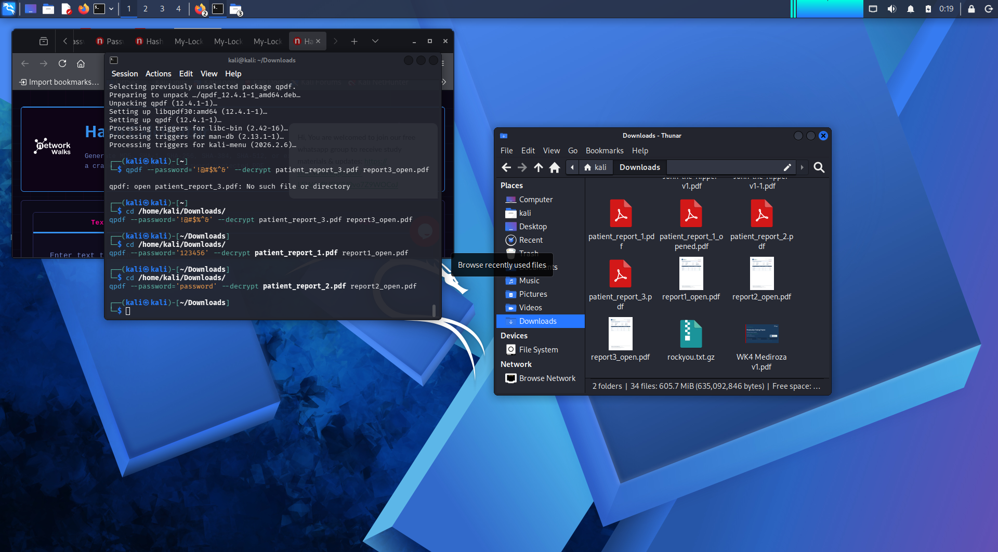
Terminal output showing qpdf decrypting all three patient reports using the passwords recovered from the Networkwalks Password Cracker.

3.5 Finding 5 — Hidden Metadata Pointing to a Backup File
Severity: Medium
What this means: PDF files carry hidden information behind the scenes — things like who created the file, what software made it, and sometimes internal notes or comments that were never meant to be seen by an outside reader. Regular PDF viewers don't show this, but a tool like exiftool can pull it straight out.
What I did: once each PDF was decrypted, I ran exiftool on all three to see what was hiding underneath.
Reports 1 and 2 came back completely normal — just standard lab report info, nothing unusual:
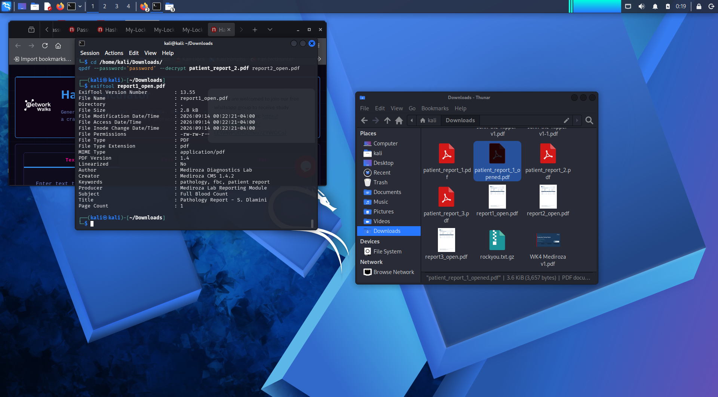
exiftool output for patient_report_1 (report1_open.pdf) — Subject: Full Blood Count, Title: Pathology Report - S. Dlamini. Nothing unusual.
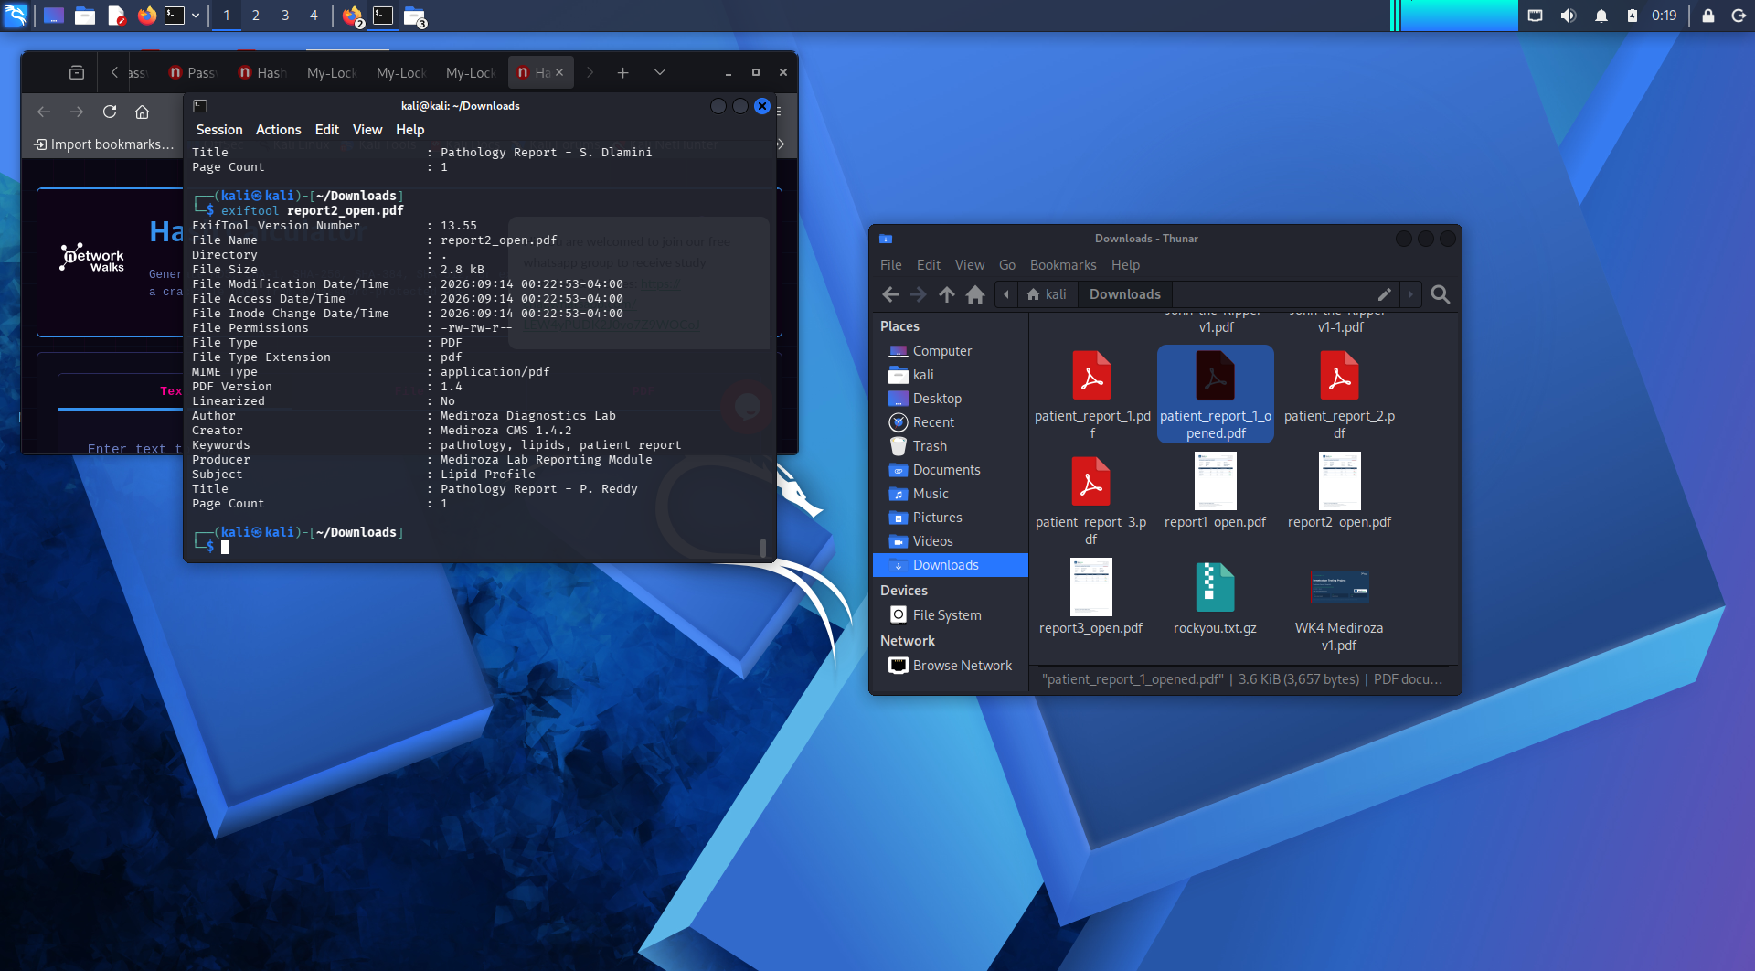
exiftool output for patient_report_2 (report2_open.pdf) — Subject: Lipid Profile, Title: Pathology Report - P. Reddy. Nothing unusual.
Report 3 was different. Its metadata contained a leftover internal comment:
Author : j.malik
Comments : DB backup moved to /old before site migration, do not delete
This was clearly a note left behind by an IT staff member (initials j.malik) meant for internal use only, never intended to leave the organisation. It directly told me where to find something sensitive on the server.
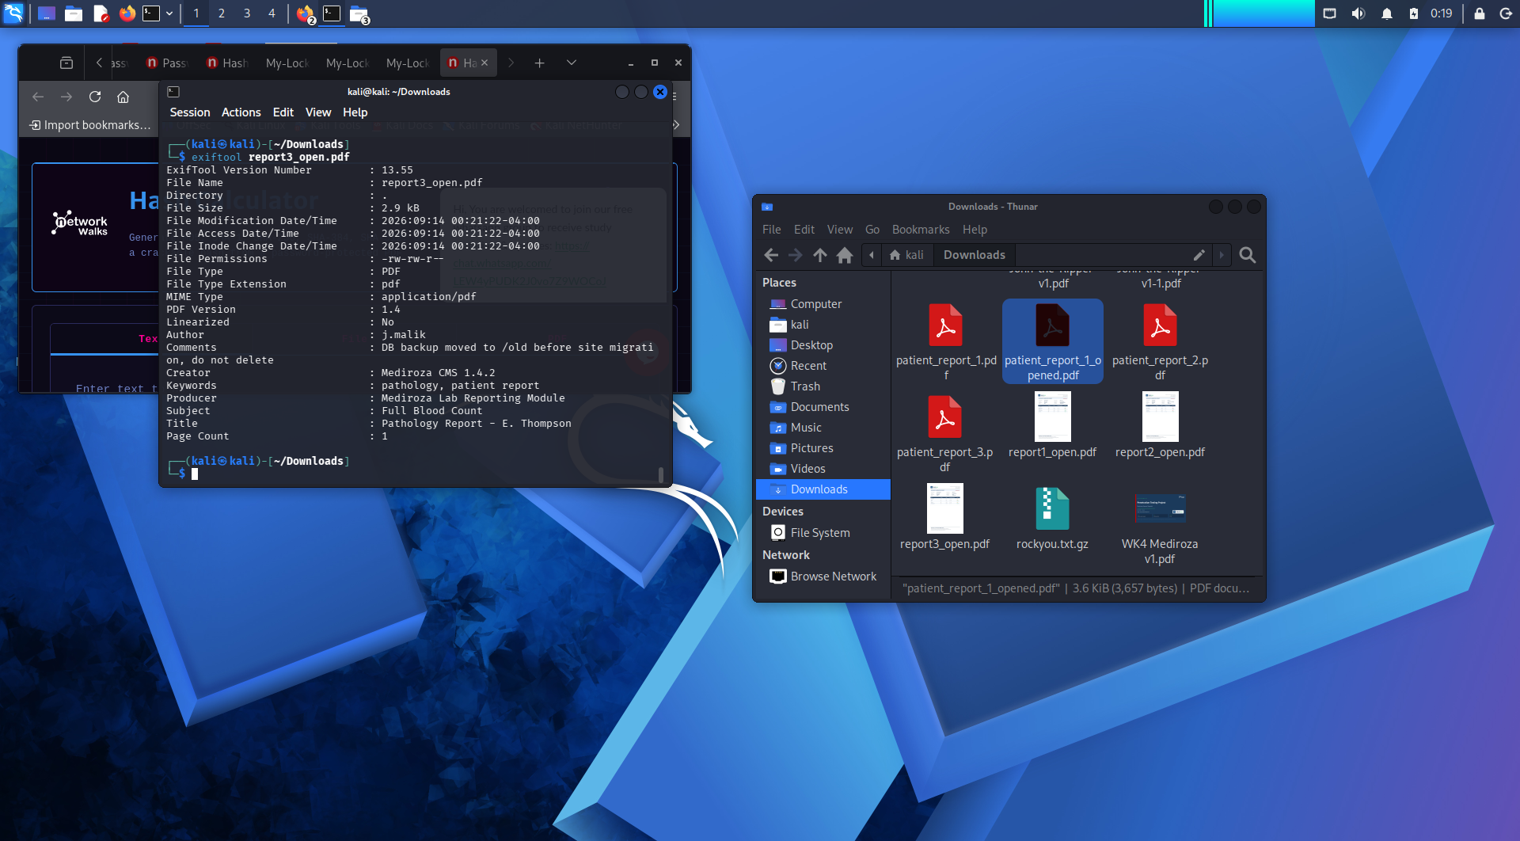
exiftool output for patient_report_3 (report3_open.pdf) — Author: j.malik, Comments field revealing the /old backup location.

3.6 Finding 6 — Exposed Database Backup File
Severity: Critical
What I did: following the exact clue from the metadata, I navigated to:
https://medirozahospital.com/old/mediroza_db_backup_2019.sql
The file was sitting there completely publicly accessible — no login, no password, nothing standing between me and it. It's a full MySQL database dump from the "mediroza_hr" database, generated by the Mediroza CMS's own backup module and dated 2019-08-27, containing two tables: staff and shareholders.
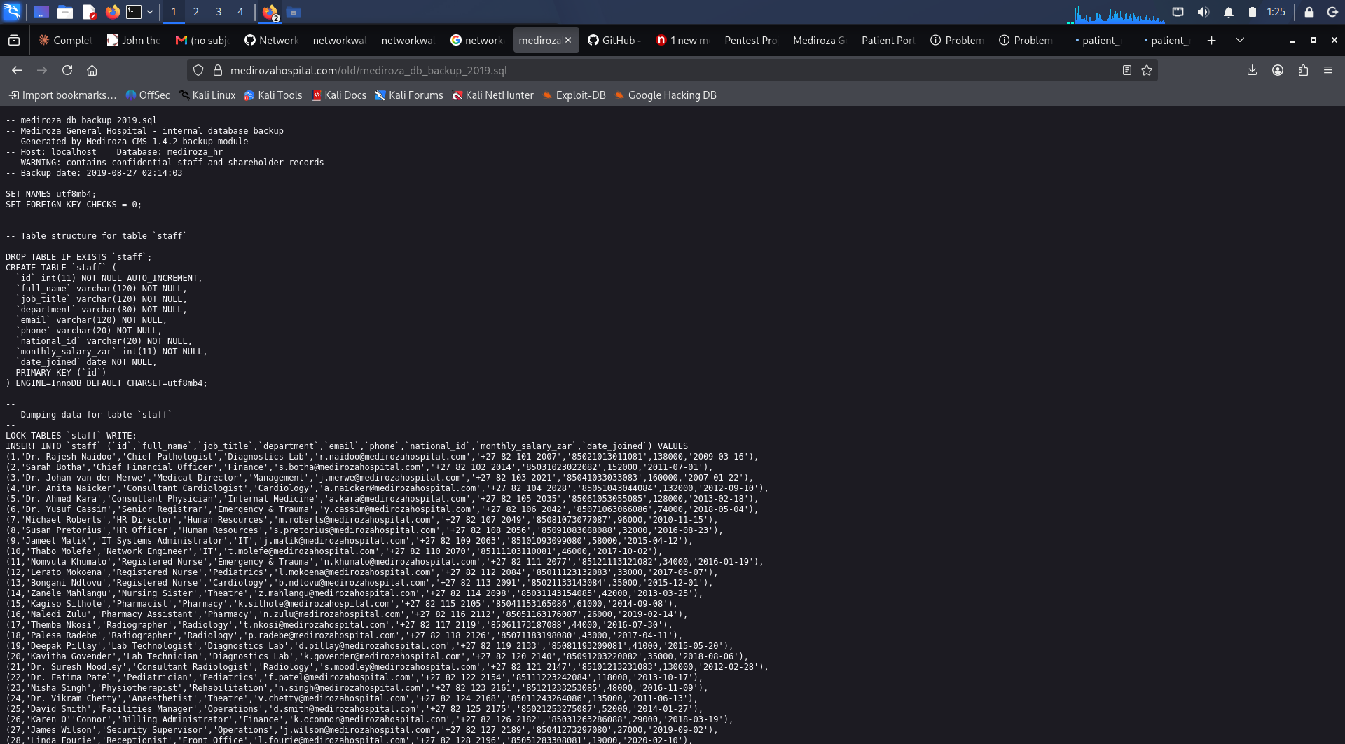
The exposed backup file loading directly in the browser at /old/mediroza_db_backup_2019.sql — no authentication required. Shows the file header warning and the start of the staff table.
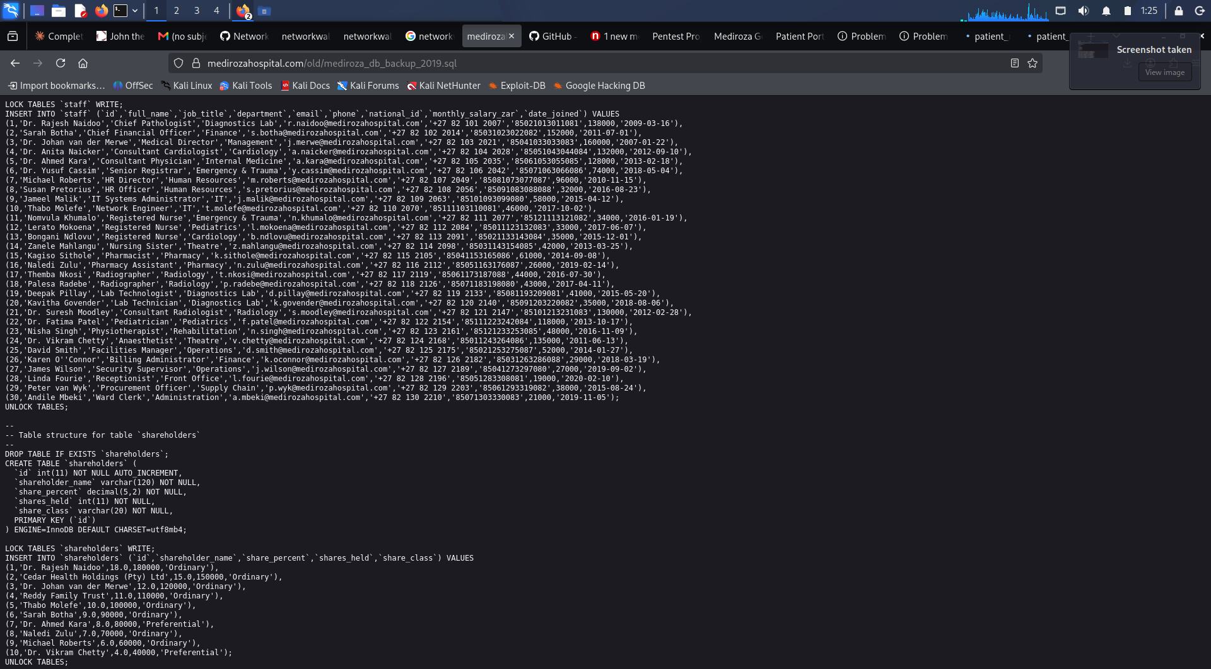
Continuation of the same file, showing the rest of the staff records and the full shareholders table, all in plain, unprotected text.

3.7 Finding 7 — Confidential Staff Salaries and Shareholder Data Exposed
Severity: Critical
What was inside: the staff table held the full name, job title, department, email, phone number, national ID number, monthly salary (in ZAR), and start date for all 30 hospital employees. The shareholders table held the name, ownership percentage, number of shares, and share class for all 10 people/entities who own a stake in the hospital.
I opened the SQL file and copied the raw staff and shareholder INSERT INTO rows, then asked Claude (an AI assistant) to convert them into clean, readable tables — one for staff, one for shareholders.
This connects the whole attack chain together: the j.malik who left the note in Finding 5 is literally the IT Systems Administrator listed in this same staff table — the same person's own internal note led me to the exposure of their own company's most sensitive financial data.
Below is the full staff table, with national ID numbers, emails, and phone numbers left out of this written report for privacy reasons — the complete unredacted data is included in the accompanying spreadsheet.
Full Name | Job Title | Department | Monthly Salary (ZAR)
Dr. Rajesh Naidoo | Chief Pathologist | Diagnostics Lab | 138,000
Sarah Botha | Chief Financial Officer | Finance | 152,000
Dr. Johan van der Merwe | Medical Director | Management | 160,000
Dr. Anita Naicker | Consultant Cardiologist | Cardiology | 132,000
Dr. Ahmed Kara | Consultant Physician | Internal Medicine | 128,000
Dr. Yusuf Cassim | Senior Registrar | Emergency & Trauma | 74,000
Michael Roberts | HR Director | Human Resources | 96,000
Susan Pretorius | HR Officer | Human Resources | 32,000
Jameel Malik | IT Systems Administrator | IT | 58,000
Thabo Molefe | Network Engineer | IT | 46,000
Nomvula Khumalo | Registered Nurse | Emergency & Trauma | 34,000
Lerato Mokoena | Registered Nurse | Pediatrics | 33,000
Bongani Ndlovu | Registered Nurse | Cardiology | 35,000
Zanele Mahlangu | Nursing Sister | Theatre | 42,000
Kagiso Sithole | Pharmacist | Pharmacy | 61,000
Naledi Zulu | Pharmacy Assistant | Pharmacy | 26,000
Themba Nkosi | Radiographer | Radiology | 44,000
Palesa Radebe | Radiographer | Radiology | 43,000
Deepak Pillay | Lab Technologist | Diagnostics Lab | 41,000
Kavitha Govender | Lab Technician | Diagnostics Lab | 35,000
Dr. Suresh Moodley | Consultant Radiologist | Radiology | 130,000
Dr. Fatima Patel | Pediatrician | Pediatrics | 118,000
Nisha Singh | Physiotherapist | Rehabilitation | 48,000
Dr. Vikram Chetty | Anaesthetist | Theatre | 135,000
David Smith | Facilities Manager | Operations | 52,000
Karen O'Connor | Billing Administrator | Finance | 29,000
James Wilson | Security Supervisor | Operations | 27,000
Linda Fourie | Receptionist | Front Office | 19,000
Peter van Wyk | Procurement Officer | Supply Chain | 38,000
Andile Mbeki | Ward Clerk | Administration | 21,000

And the full shareholders table:
Shareholder Name | Share % | Shares Held | Share Class
Dr. Rajesh Naidoo | 18.0% | 180,000 | Ordinary
Cedar Health Holdings (Pty) Ltd | 15.0% | 150,000 | Ordinary
Dr. Johan van der Merwe | 12.0% | 120,000 | Ordinary
Reddy Family Trust | 11.0% | 110,000 | Ordinary
Thabo Molefe | 10.0% | 100,000 | Ordinary
Sarah Botha | 9.0% | 90,000 | Ordinary
Dr. Ahmed Kara | 8.0% | 80,000 | Preferential
Naledi Zulu | 7.0% | 70,000 | Ordinary
Michael Roberts | 6.0% | 60,000 | Ordinary
Dr. Vikram Chetty | 4.0% | 40,000 | Preferential

4. Full Attack Chain — Step by Step
Putting it all together, here's the complete path from knowing nothing about the site to full data exposure:
- Step 1: Tested the login page's error messages and found that "admin" is a real, valid username (Finding 1)
- Step 2: Used the payload admin'-- to bypass the login completely with no real password (Finding 2)
- Step 3: Found and downloaded 3 confidential patient PDF reports from the now-accessible area (Finding 3)
- Step 4: Cracked all three PDF passwords — 123456, password, and !@#$%^& (Finding 4)
- Step 5: Found a hidden note in report 3's metadata, left by j.malik, pointing to /old (Finding 5)
- Step 6: Found the exposed database backup sitting publicly at that exact path (Finding 6)
- Step 7: Read the full staff salary and shareholder ownership data straight out of the backup (Finding 7)

5. Risk Rating Summary
Finding | Severity | Why
1. Username Enumeration | Medium | Confirms valid accounts exist, setting up further attacks
2. SQL Injection Login Bypass | Critical | Full authentication bypass with zero valid credentials
3. Patient PDFs Accessible | Critical | Direct exposure of confidential patient health records
4. Weak PDF Passwords | High | Trivial to crack, so encryption gave almost no real protection
5. Metadata Leak | Medium | Internal note leaked the location of a bigger exposure
6. Exposed DB Backup | Critical | Sensitive backup file publicly reachable with no authentication
7. Staff/Shareholder Data Exposed | Critical | Full salary and ownership data exposed in plain text

6. Recommendations and Remediation

6.1 Fix the Username Enumeration
Make the login page return the exact same generic message no matter what — something like "Invalid username or password" — regardless of whether the username or the password was the wrong part.

6.2 Fix the SQL Injection
This is the most important fix in this whole report. The login query needs to be rewritten using parameterised/prepared statements so user input can never change the structure of the query, no matter what someone types in.

6.3 Fix PDF Access and Password Strength
Patient PDFs shouldn't be reachable just because someone gets past a login page — they should be served through a script that separately checks permissions every time. Passwords protecting sensitive files should be long and complex, not simple words or number strings.

6.4 Strip Metadata Before Files Leave the Organisation
Internal staff comments and notes should never end up inside a file that a patient or outsider could ever get their hands on. Metadata should be stripped from any document before it's distributed.

6.5 Remove the Exposed Backup Immediately
The backup file needs to be deleted from the public web folder right away, and backups in general should never be stored anywhere inside the website's public folder structure — they belong in a separate, access-controlled location.

7. Conclusion
This project showed me just how far a handful of small, individually simple mistakes can chain together into something serious. None of the steps I took required advanced tools or deep technical skill — mostly just patience, curiosity, and knowing what to look for at each stage. I'd recommend Mediroza General Hospital treat every Critical-rated finding here as urgent, especially the SQL injection and the exposed backup file, before this system is ever used to hold real patient data.

Appendix A — Full Data Tables
The complete staff table (including national ID numbers, emails, and phone numbers) and the full shareholder table are provided in the accompanying spreadsheet: Mediroza_M3_Exposed_Data_Summary.xlsx, submitted alongside this report.

Submitted by: Salwa | Networkwalks | Batch B082 | Week 4 Capstone Project

