Week 2 Project — Footprinting & Network Scanning
Salwa | Networkwalks Cyber IT Diploma | 23 August 2026

Introduction
For this project I practiced footprinting and reconnaissance, which is the first step of any penetration test. The goal is to gather as much information as possible about a target before doing any active testing. I used a mix of Kali Linux command line tools, Maltego, and Zenmap, and I ran all of this against networkwalks.com (a target the course gave us permission to test) and my own local network.
Below I've gone through each part of the assignment, what I did, what I found, and a screenshot showing my actual results.

Part 1 — Footprinting with Kali Tools
For this part I picked six different Kali tools and ran them all against networkwalks.com to see what kind of information each one could dig up.
The first tool I used was whois. This tells you who owns a domain and when it was registered. Running it against networkwalks.com showed me it's registered through GoDaddy, was created back in November 2019, and doesn't expire until 2027. The actual owner's info is hidden behind a privacy service called Domains By Proxy, so I couldn't see personal contact details — which is pretty normal for most domains these days.
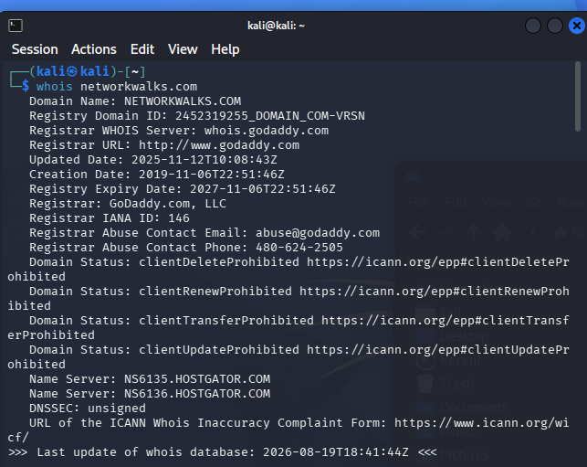
whois networkwalks.com — registration details
Next I ran nslookup, which just resolves the domain name to its actual IP address. That gave me 192.232.216.135.
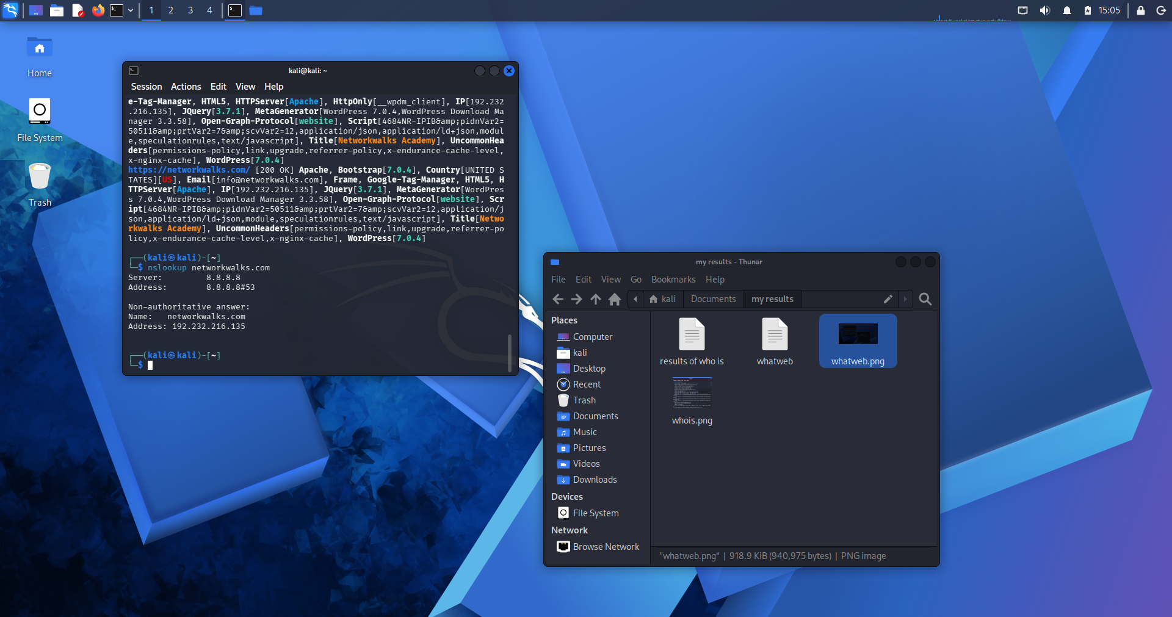
nslookup networkwalks.com — resolved IP address
After that I used dnsrecon to pull a full list of DNS records. This one gave me a lot more detail — it showed the mail server (mail.networkwalks.com), the name servers, an SPF record for email security, and a bunch of SRV records related to autodiscover/email setup through cPanel.
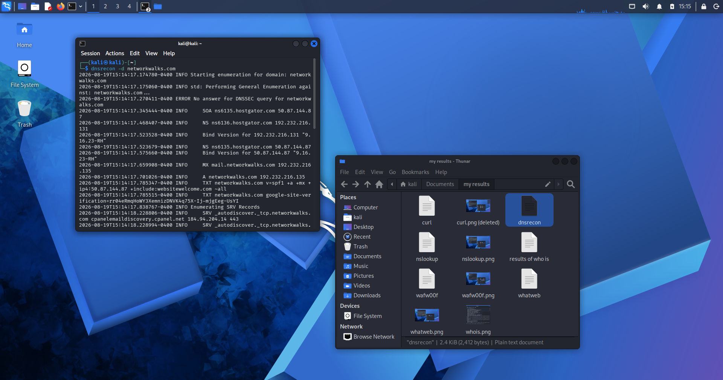
dnsrecon -d networkwalks.com — DNS record enumeration
Then I ran whatweb to fingerprint what the website is actually built with. It found the site runs WordPress 7.0.4 on an Apache server, hosted in the US, and even picked up the contact email listed in the site's metadata (info@networkwalks.com).
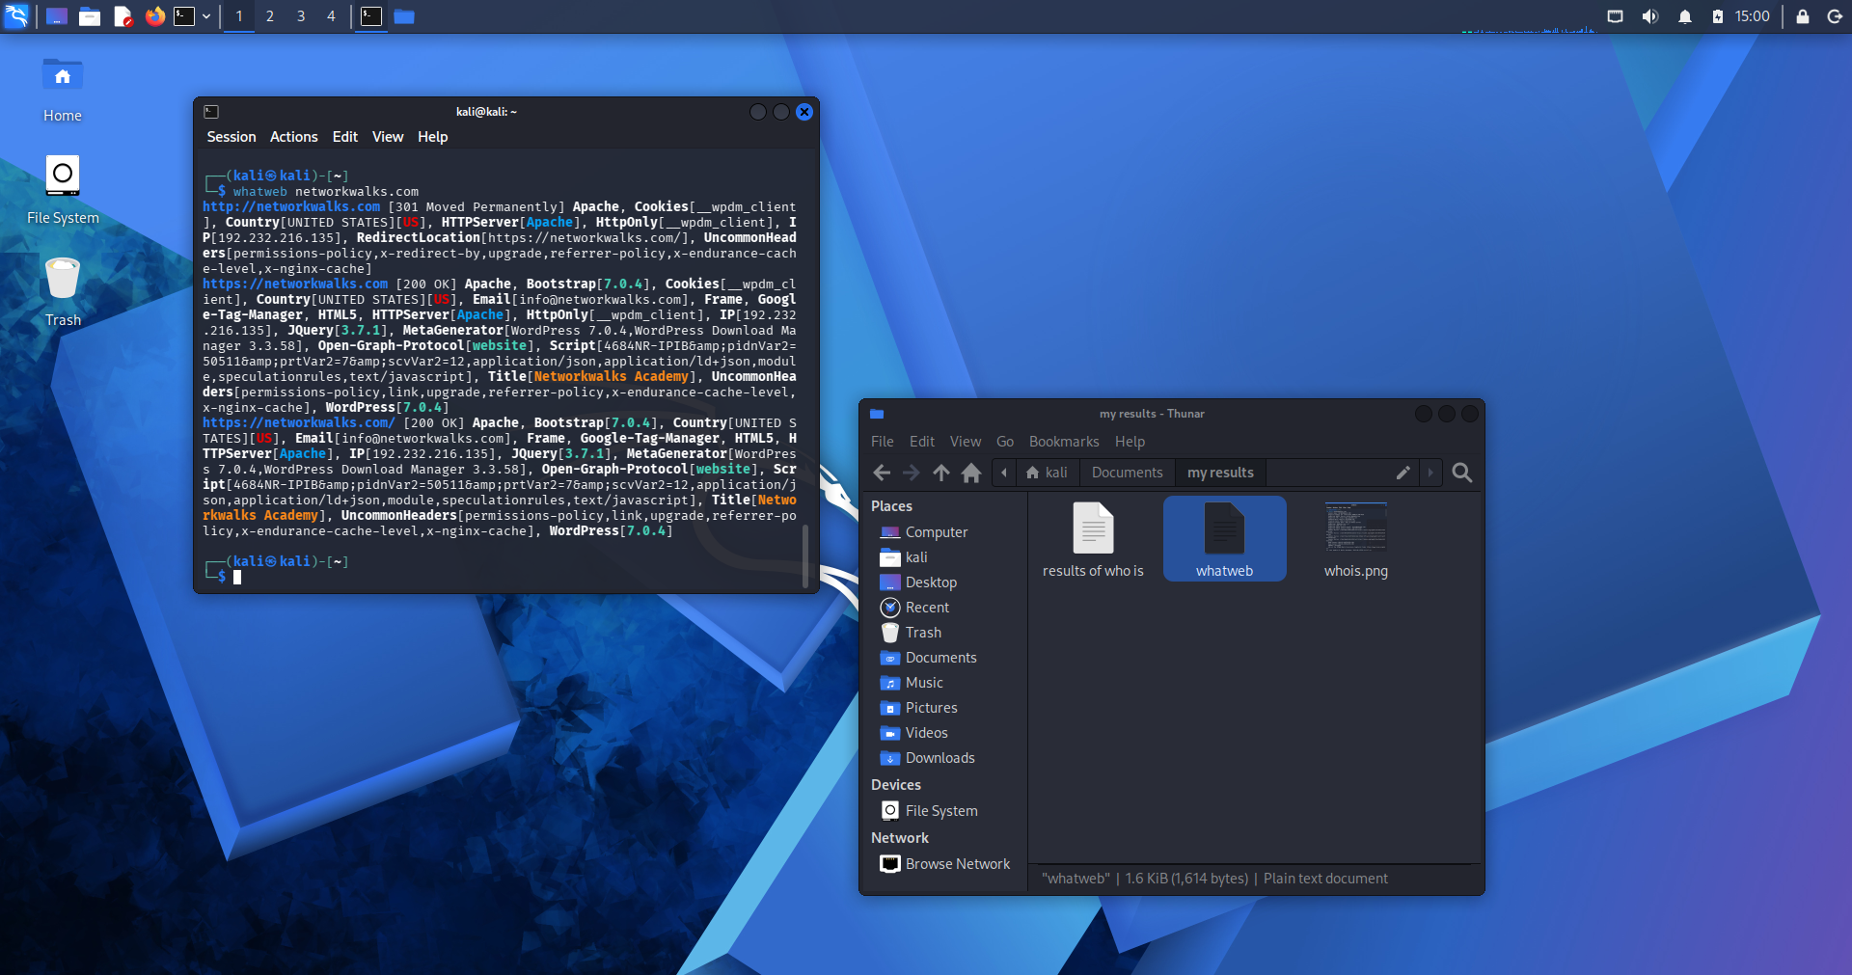
whatweb networkwalks.com — technology fingerprinting
I also ran wafw00f to check if the site has a firewall protecting it. Turns out it's sitting behind a ModSecurity WAF, which is a common security layer that filters out malicious requests before they reach the actual server.
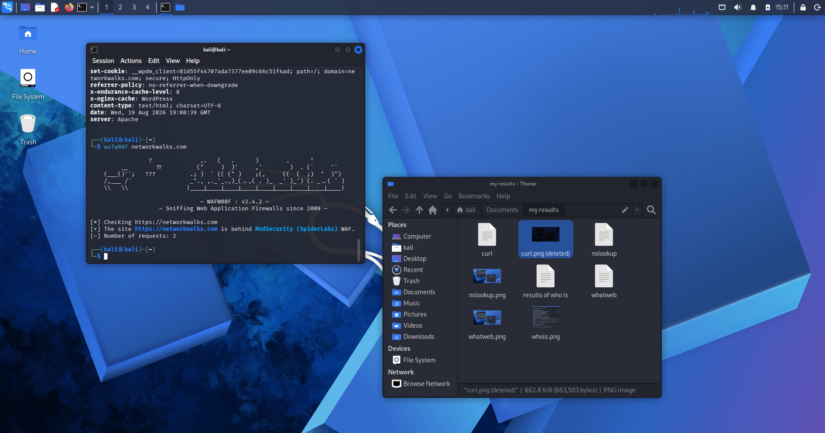
wafw00f networkwalks.com — WAF detection
Last, I used curl to look at the raw HTTP headers the server sends back. This confirmed it's running Apache and showed some WordPress-specific caching headers.
(I lost the screenshot for this one before I could save it, so here's the actual terminal output instead:)
$ curl -I https://networkwalks.com HTTP/2 200 content-type: text/html; charset=UTF-8 server: Apache x-nginx-cache: WordPress
Overall, these six tools painted a pretty clear picture of networkwalks.com's setup: it's a WordPress site on Apache, hosted through HostGator, registered via GoDaddy, and protected by a WAF. Nothing too surprising, but it's a good example of how much information is just sitting out there publicly on any website.

Part 3 — Maltego
For the Maltego part, I installed it through apt (it's not preinstalled on Kali) and created a Domain entity for networkwalks.com to start building out a graph.
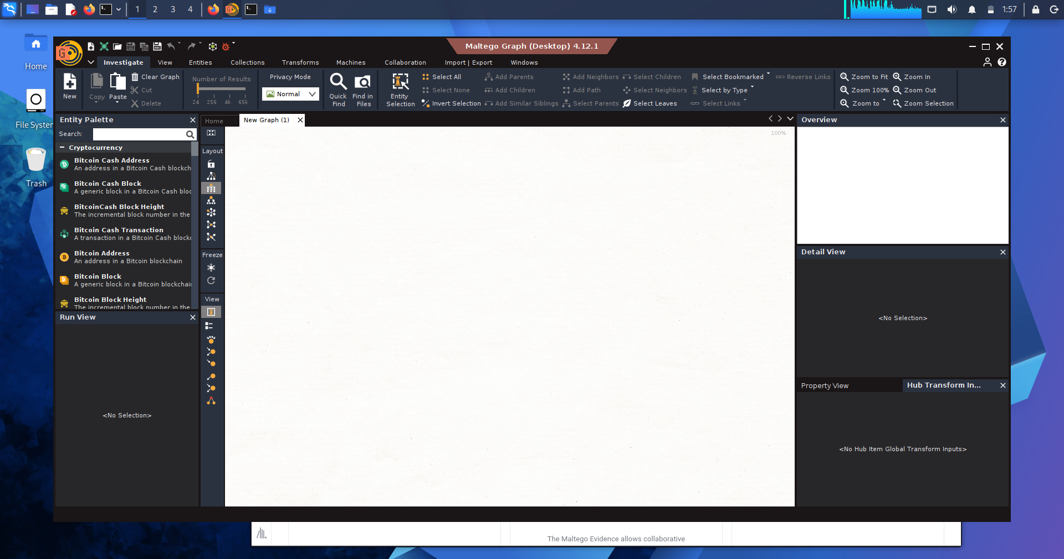
Maltego open, ready to start
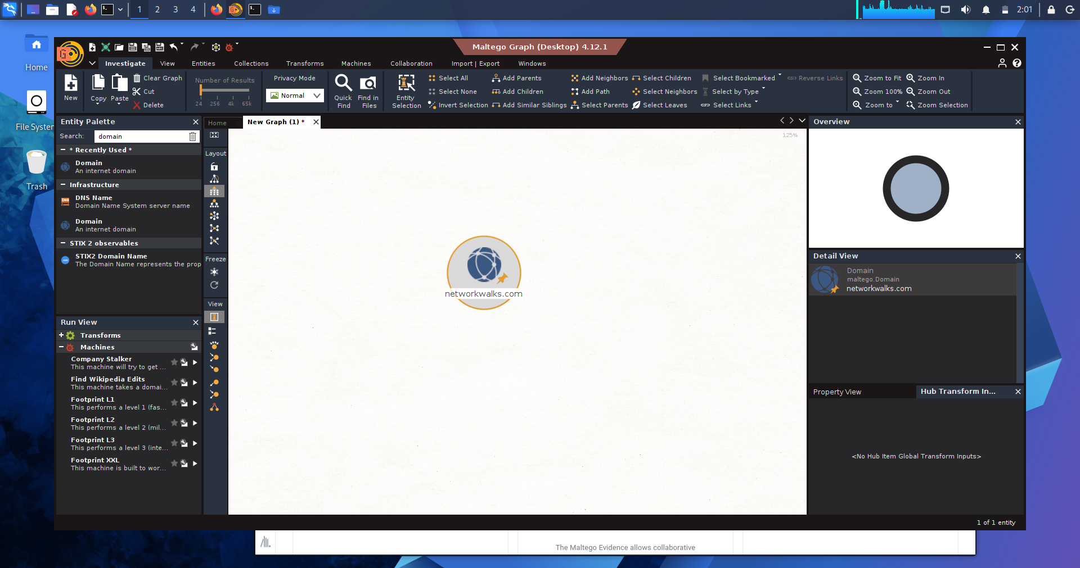
Domain entity created for networkwalks.com
First I ran a simple transform called "To Email Addresses" which searches for emails linked to the domain. It found one email entity.
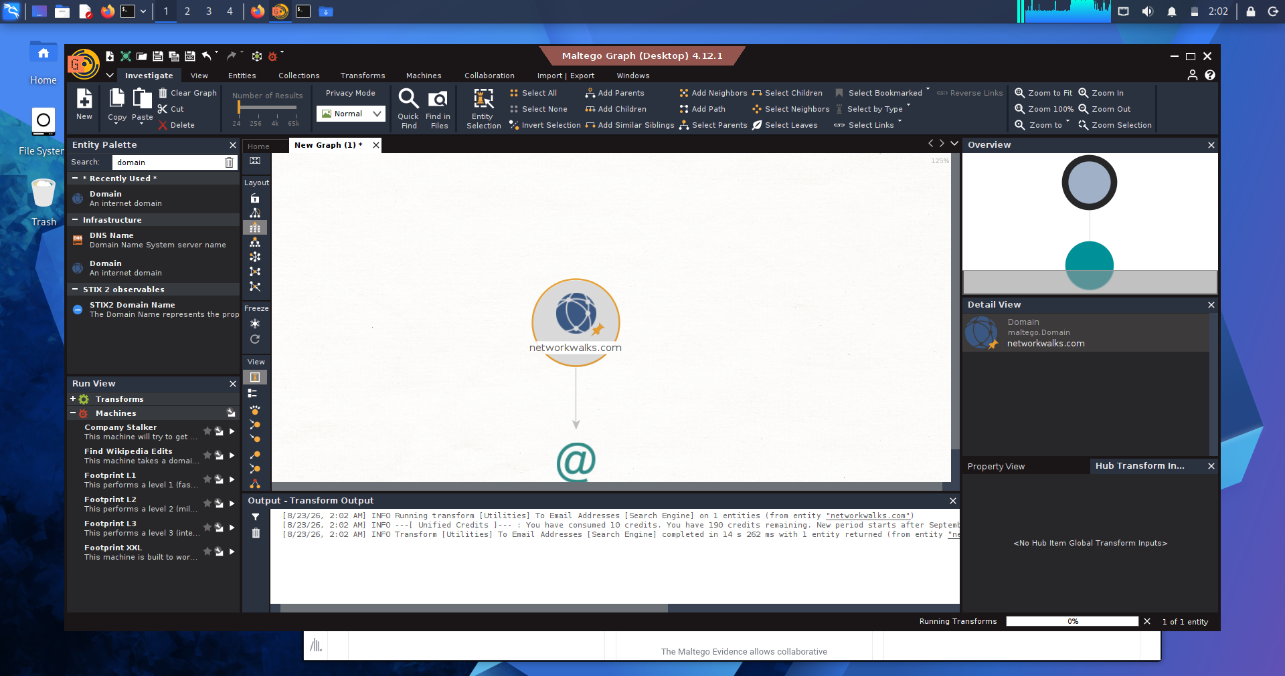
To Email Addresses transform result
Then I ran the Footprint L1 Machine, which does a bunch of transforms automatically to map out a domain's infrastructure. This is where I actually found the mail server — mail.networkwalks.com — along with several other subdomains like webdisk, webmail, autodiscover, and cpanel. Seeing those subdomains together basically confirms it's hosted using cPanel/WHM, which matches what dnsrecon found back in Part 1.
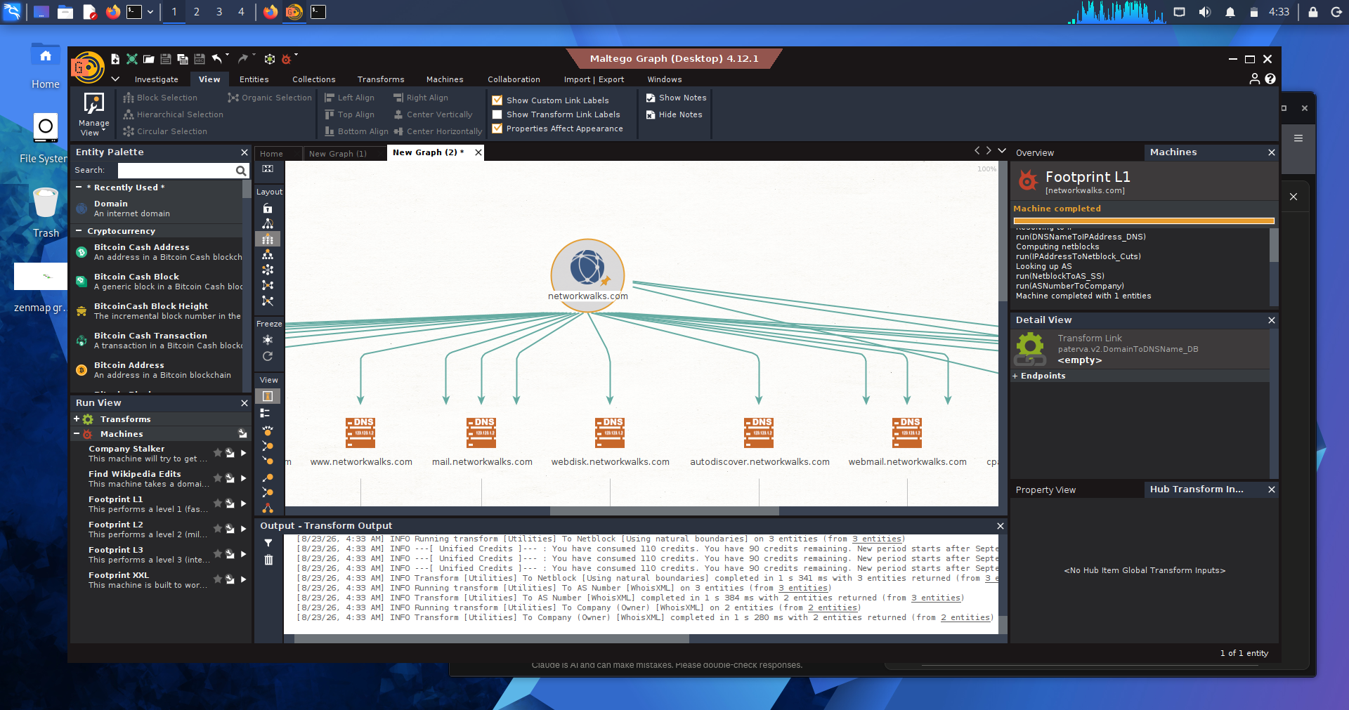
Footprint L1 Machine results — mail server and subdomains discovered

Part 5 — Zenmap Network Scanning
For this part I scanned my own local network instead of networkwalks.com, since this task is about discovering live hosts on a subnet rather than footprinting a specific domain. My machine's IP is 10.0.0.2, on the 10.0.0.0/24 subnet.
Running a scan against that subnet found 2 live hosts: 10.0.0.1 (which is my network's gateway) and 10.0.0.2 (my own Kali machine).
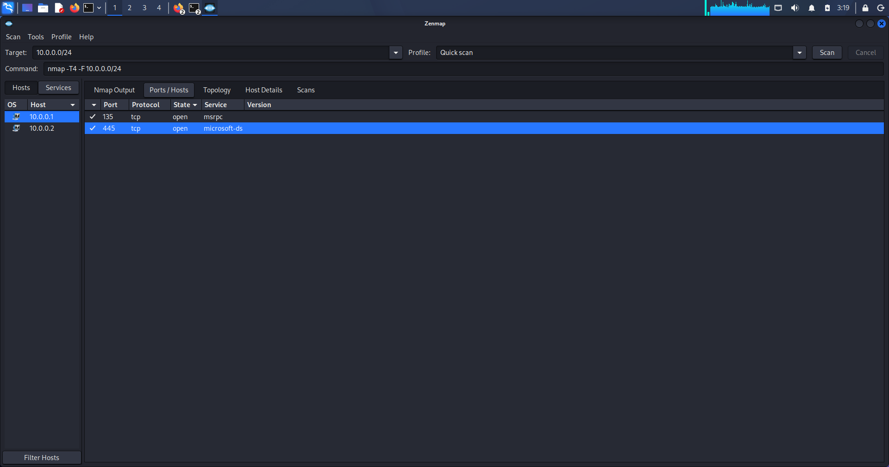
Zenmap Ports/Hosts — open ports for 10.0.0.1 and 10.0.0.2
The gateway (10.0.0.1) had two ports open — 135 and 445, both related to Windows/SMB networking. My own machine (10.0.0.2) had no open ports at all, which makes sense since a fresh Kali install doesn't run any services by default.
I also checked each host's MAC address under the Host Details tab. The gateway's MAC was 52:54:00:12:35:00. My own machine didn't show one, since Nmap doesn't report a MAC address for the host it's running on.
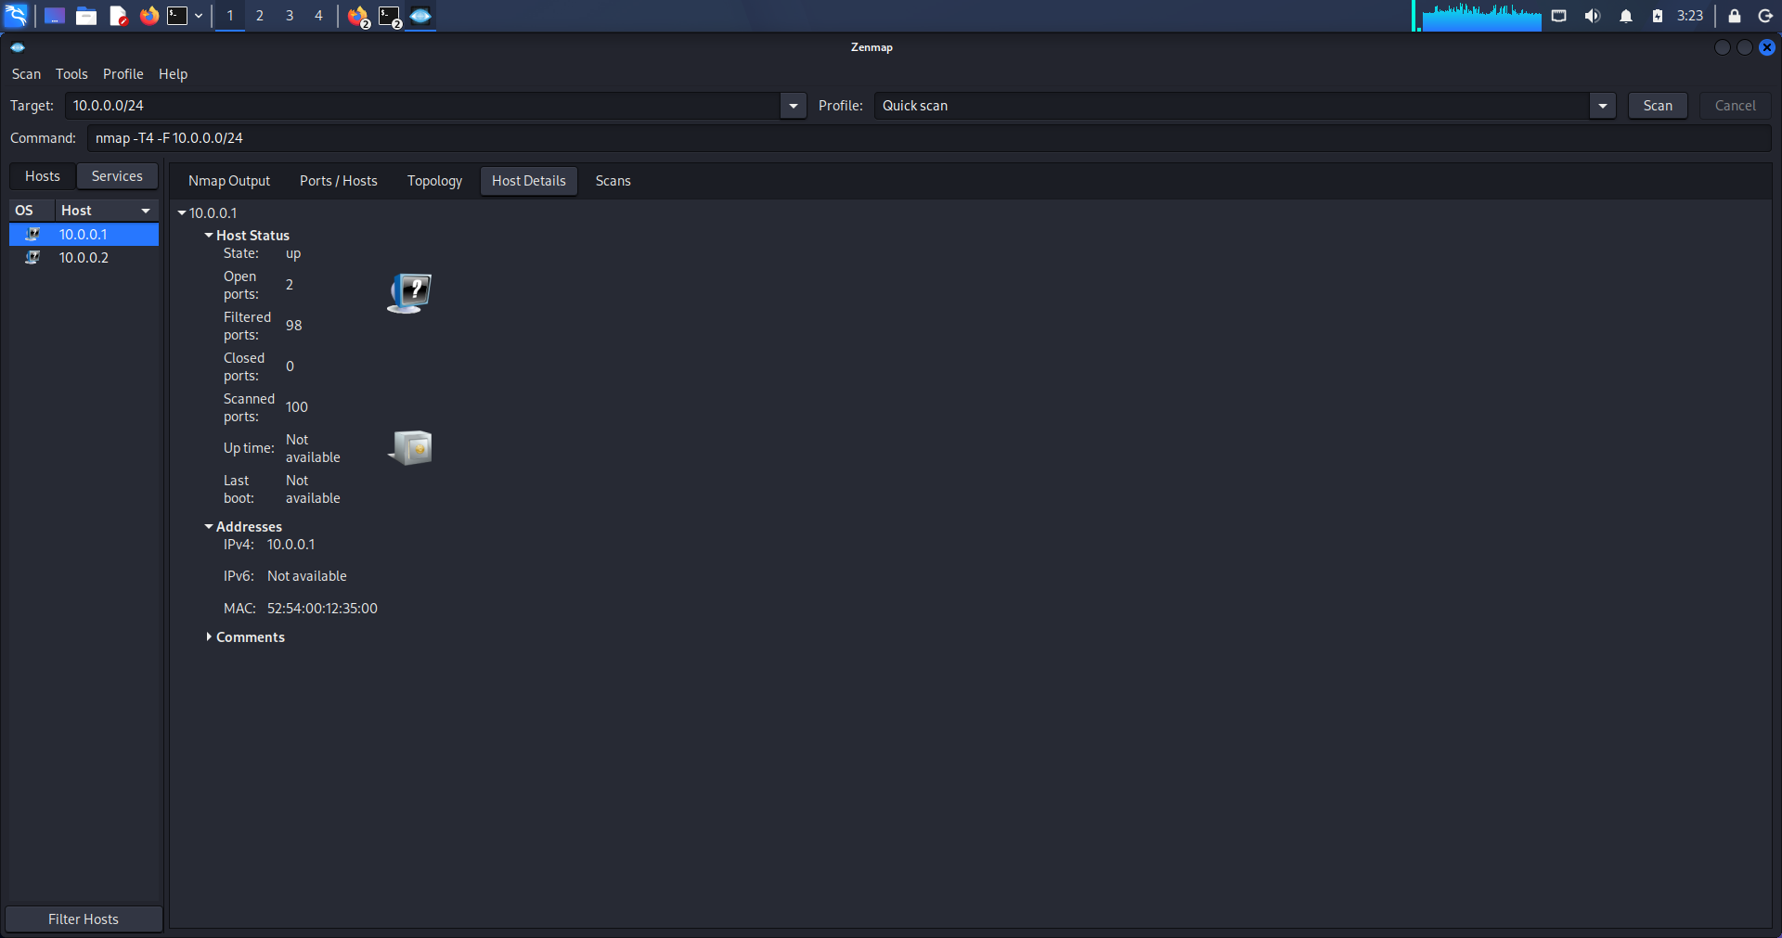
Host Details for 10.0.0.1 — MAC address
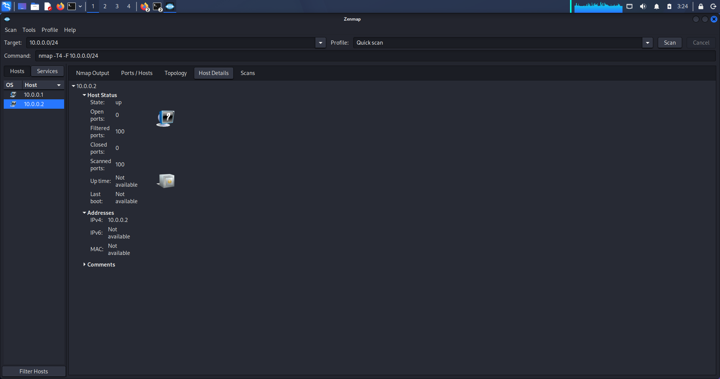
Host Details for 10.0.0.2 — own machine, no MAC shown

Conclusion
This project gave me hands-on practice with the reconnaissance phase of penetration testing, from passive lookups like whois and DNS enumeration, to graph-based tools like Maltego, to active scanning with Zenmap. It was a good reminder of how much information about a target is publicly available before you ever have to touch the target directly, and why reconnaissance is such an important first step.

