- Create a database called "contact"
- Create a collection called "contactlist"
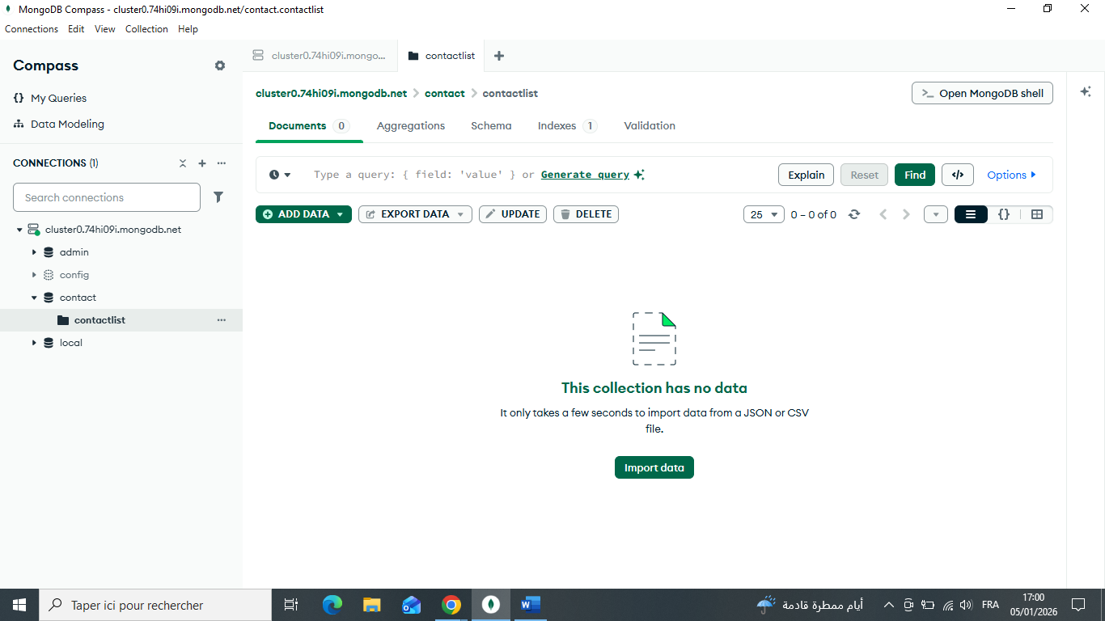
- Insert these documents in "contactlist" :
  - Last name: Ben, First name: Moris, Email: ben@gmail.com, age:26
  - Last name: Kefi, First name: Seif, Email: kefi@gmail.com, age:15
  - Last name: Emilie, First name: brouge, Email: emilie.b@gmail.com, age:40
  - Last name: Alex, First name: brown, age: 4
  - Last name: Denzel, First name: Washington, age:3
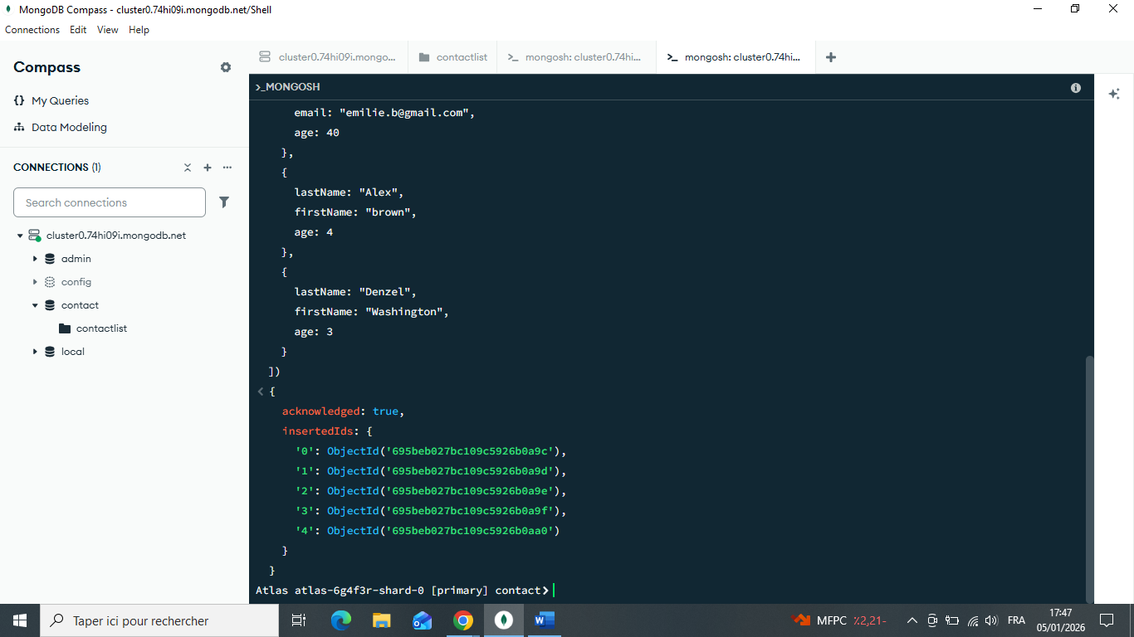
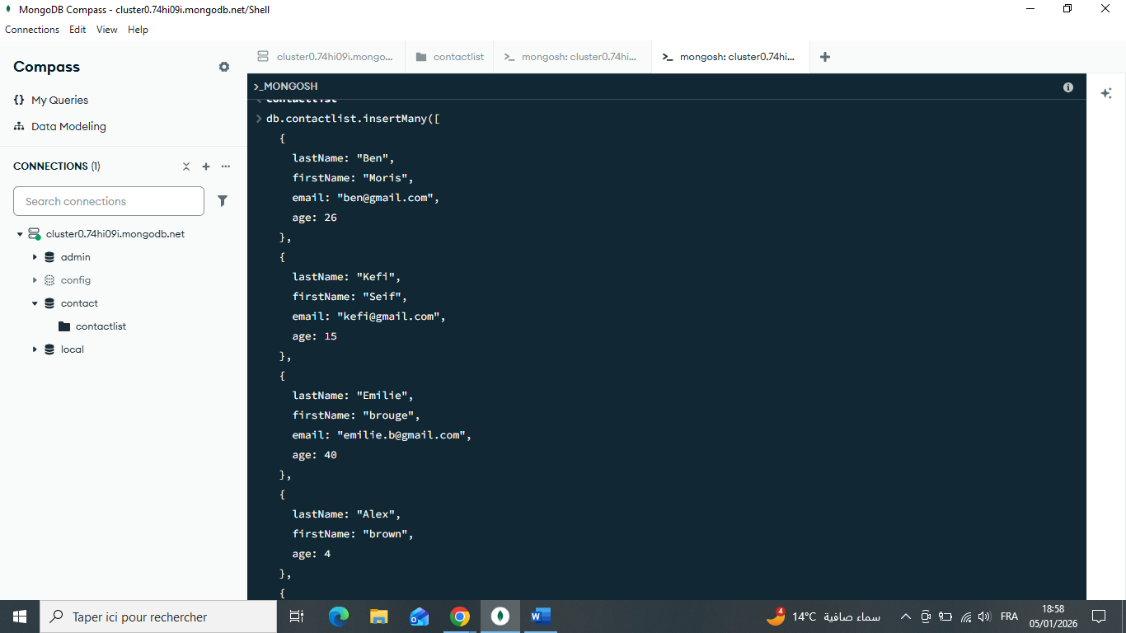

Display all the information about only one person using his ID :
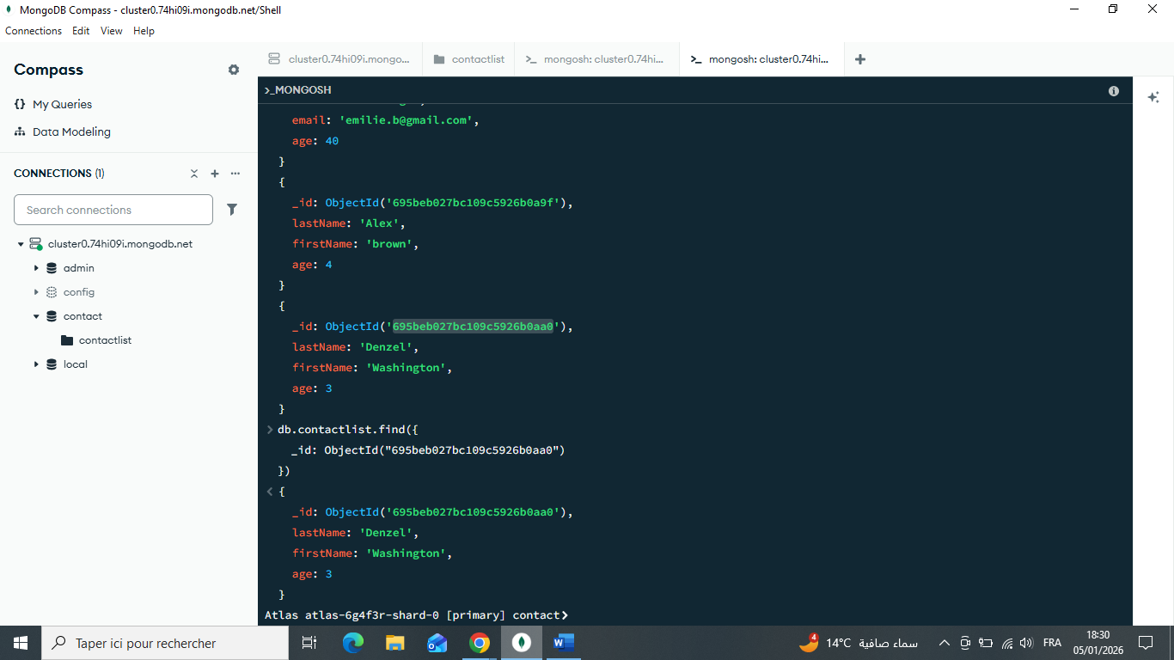

Display all the contacts with an age >18 :
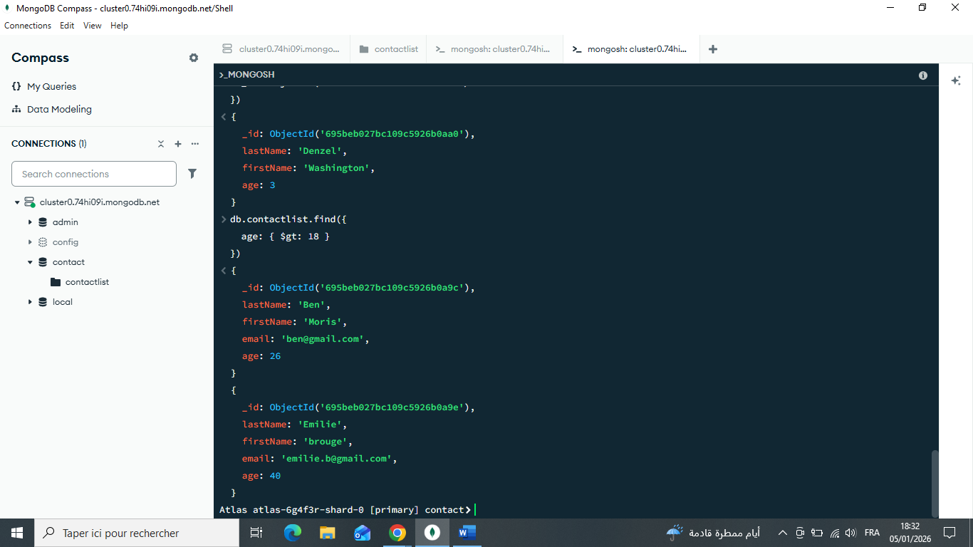

Display all the contacts with an age>18 and name containing "ah" :
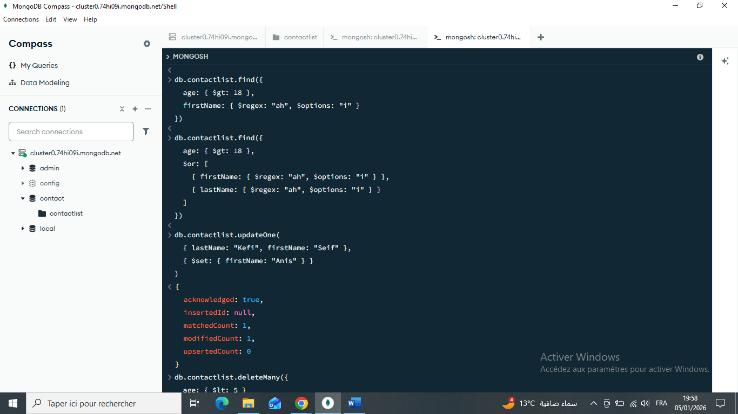

Change the contact's first name from"Kefi Seif" to "Kefi Anis" :
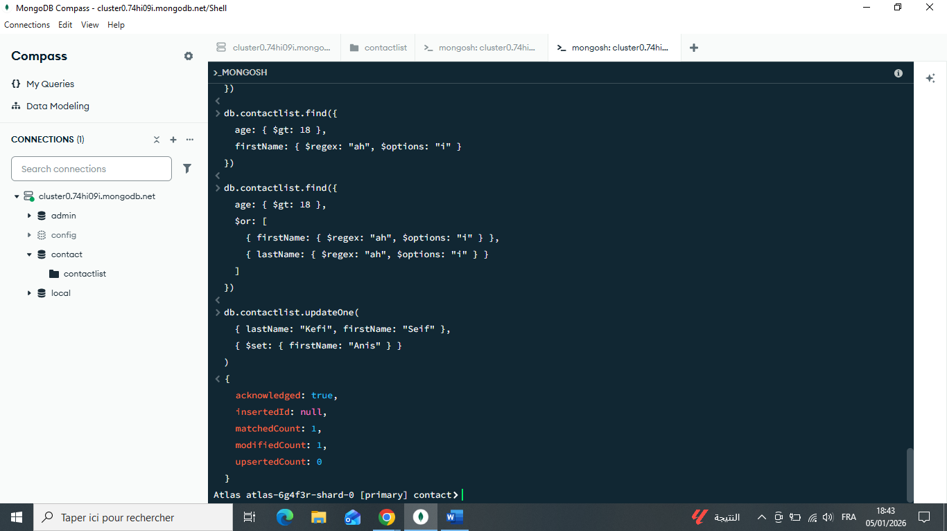

Delete the contacts that are aged under <5 :
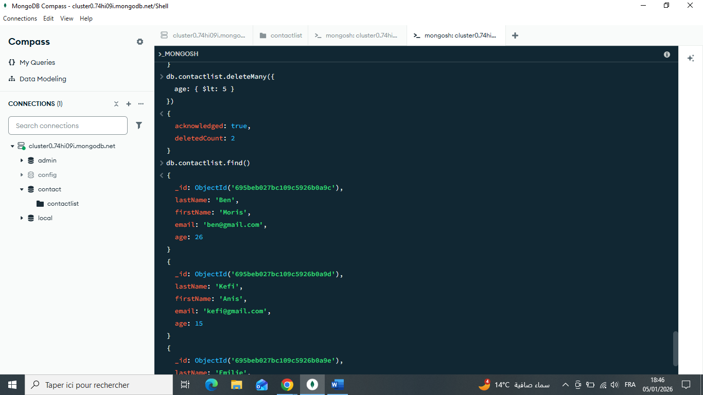

Display all of the contacts list :
